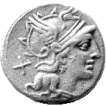
Courses –2011-

Underwater Archaeology

The Port of Sanitja

MENORCA

THE BALEARIC ISLANDS, SPAIN

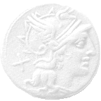
Application (please send this back as an attachment to an email)

Personal Information:
Full Name
Age (date of birth) and Sex
Passport Number and Issuing Country
Home Address
City/state/province
/Postal Code/
country
Home Phone
(area code + number)
Emergency Contact | Include full name, telephone and relation to you.
email
Notes * | For example, include here if you are a vegetarian, diabetic, etc.  * The course does not provide for special diets. Special diets are participants’ responsibility.
Background | Please list any previous fieldwork experience (site, period, type of work performed).
Languages

Groups Please write your name in the group that you will participate in.
Group #1: I have no diving certificate.
Group #2: I have an open water diving certificate from an internationally recognized organization (must have in hand on the first day).

Please type below your name in the session you wish to participate in.
Session #1: May 18th – May 31st

Session #2: June 3rd – June 16th
Session #3: June 25th – July 8th
Session #4: July 11th – July 24th

Session #5: July 28th – August 10th

Session #6: August 13th – August 26th
Session #7: August 30th – September 12th
Session #8: September 20th –October 3rd
Session #9: November 1st – November 14th

^{How did you find out about us?}
(Our webpage, AIA, Professor, etc.)

Please note that your space will not be reserved until we receive your $350 application fee.

