

 | February 2018  Vol. VI, No. 2

Echoes of Nabataean Seafaring

By Ralph Pedersen
When one thinks of the Nabataeans, the desert comes to mind, with wind-blown sands, the red rock-cut architecture of their capital of Petra, and trade routes carrying incense from Arabia to the Mediterranean. There is, however, another aspect of the Nabataeans, one that is only now coming into focus: Seafaring.
The land of the Nabataeans not only included the Jordanian desert but the coast of the Red Sea, reaching southward from Aqaba and down into the northwestern coast of what is now Saudi Arabia. These coasts, mostly barren but containing harbors and access to water, were links to inland trade routes and formed the maritime nexus between Nabataea and the greater world.

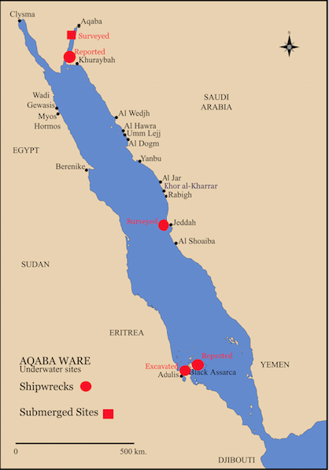
Map of the Red Sea showing sites mentioned in the text.
All images courtesy of Ralph Pedersen.
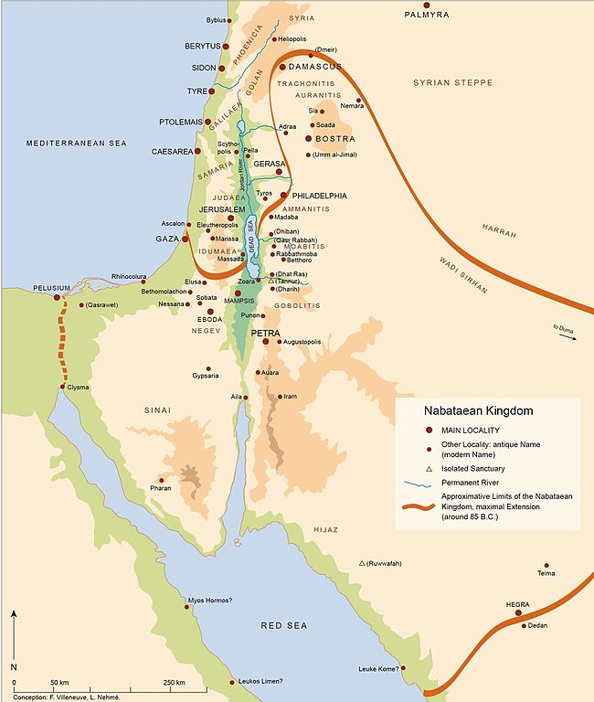
Map of the Nabatean Kingdom.
The Nabataeans were not confined to their harbors. This is seen in various ancient literary sources such as Agatharchides and Strabo and attested by the presence of Nabataean graffiti in Egypt along roads connecting the Nile to the Red Sea. We can also draw inferences for Nabataean maritime activity from finds of Nabataean pottery scattered along the Arabian coast in harbor sites such as al Sawrah, as well as from finds of shipwrecks carrying goods made by the descendants of the Nabataeans.
Indeed, the harbors along the Arabian coast hide one of the greatest mysteries of the Nabataeans—the location of their chief port, Leuke Kome, the gateway for the incense and spice routes into the Levant and beyond to the Mediterranean. Scholars have suggested a number of possibilities, but the first-century CE manuscript Periplus of the Erythraean Sea give us our best clues as to the port’s whereabouts through descriptions of sailing directions and times. Currently, the best match for this information is the Arabian site of Aynunah and its nearby harbor of Khuraybah. The University of Warsaw has been excavating at Aynunah, finding evidence of Nabataean architecture and artifacts, but so far nothing has been found that definitively points to identification as Leuke Kome.
Examining the literary sources, we find that the Greek geographer Strabo (XVI.4, 18) states that the Nabataeans used crude rafts in their initial maritime activities. But the Greek historian and geographer Agatharchides (5.90), writing in the mid-second century BCE, stated that Nabataeans were known for attacking passing ships. Clearly, their piratical ventures quickly earned the Nabataeans a sordid and dangerous reputation.
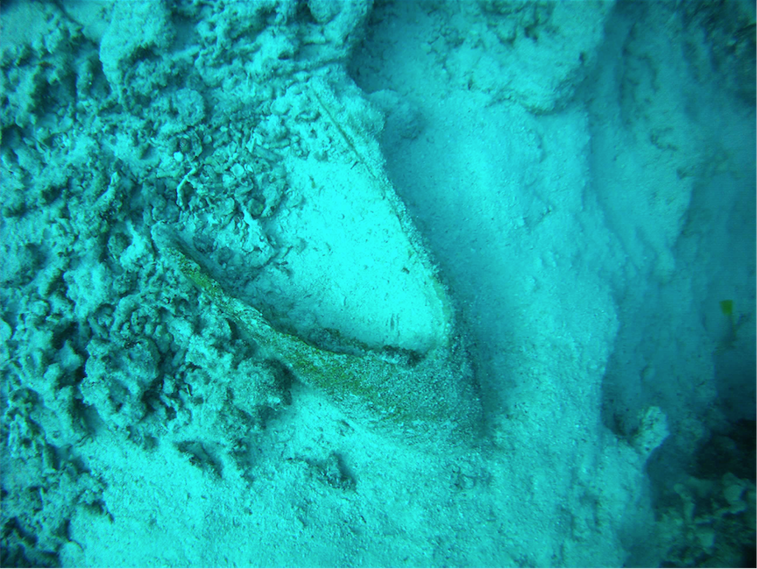
A large sherd of an Aqaba amphora on a shipwreck near Jeddah.
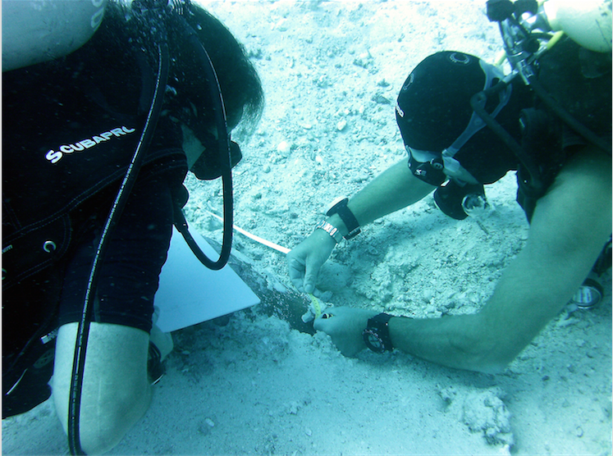
Archaeologist examines a Roman amphora sherd on the seabed near Jeddah, Saudi Arabia.
The Roman essayist Plutarch (Antony 69.3) related perhaps the prime example of Nabataean sea power. Cleopatra had ships built on the Red Sea for an escape from the forces of Octavian, only to have the fleet torched by “Arabians about Petra,” that is, Nabataeans! In doing so, these Nabataean sea raiders changed the course of history by leaving Cleopatra little option beyond her suicide. Furthermore, Strabo (16.4.23) notes that when the Roman general Gallus built a fleet of 210 ships in Egypt for his ill-fated invasion of Arabia in circa C.E. 26, Syllaeus, the Nabataean king’s minister was to guide the fleet to Leuke Kome. In an apparent act of skulduggery Syllaeus crippled the effort by leading many of the ships to ruin on the rocks and reefs of Sinai. If nothing else, this demonstrates Nabataean navigational knowledge of the hazardous areas of the northern Red Sea routes.
It was only with the annexation of Nabataea by the Romans in 106 CE and the absorption of the Nabataean port at Aqaba, then called Ayla or Aila, at the head of the Gulf of Aqaba that seafaring by the Nabataeans became most pacific. Seafaring is a continuum; sailors keep sailing, boat builders keep building, traders keep trading, no matter who is in charge. Nabataean seafarers did not vanish, they simply adapted to the new political and economic situation. Indeed, Nabataean cultural practices continued well into the mid-first millennium before being fully subsumed during the Byzantine period. Seafaring from of Ayla may be seen as a continuation of Nabataean maritime activities. Over the next several centuries of Roman and Byzantine control, goods flowed regularly and peacefully out of the Nabataean port as far as the Indian subcontinent, while Leuke Kome simply vanished from the scene.
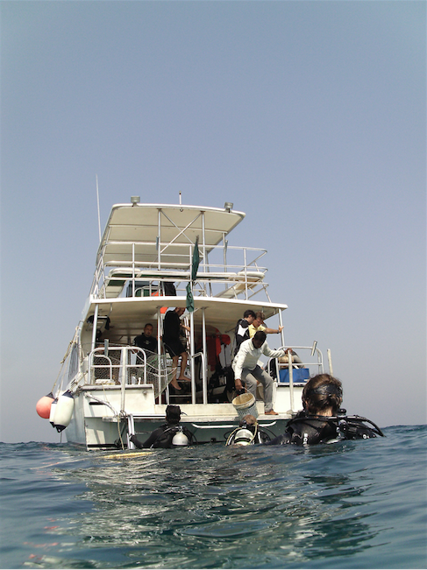
The research vessel used for the 2013 survey near Jeddah.
Since the mid-1990s archaeology around the Red Sea has blossomed. Long lost harbors along the African coast such as Berenike, Myos Hormos, and Adulis, to name only a few, have been located and studied. Archaeology on Arabian shores is also bringing to light previously unknown ancient Arabian maritime activities, and around the Red Sea a number of shipwrecks have been found ranging from the late medieval era back through the Roman imperial period.
While we have yet to locate shipwrecks from the era of the Nabataean kingdom, some can be linked to them through the descendants of the Nabataeans. These shipwrecks are found in both Arabian and African waters, and contain distinctive carrot-shaped amphoras and other ceramics created in Aqaba ringdu Late Antiquity and into the Early Islamic period. It is believed that wine from the Negev was shipped in these containers during the Byzantine era to points along the sea coasts. It is also postulated that dried fruit, grain, and garum, the popular fish paste of the Romans, was shipped in the amphorae, particularly as garum production sites have now been found at Aqaba.

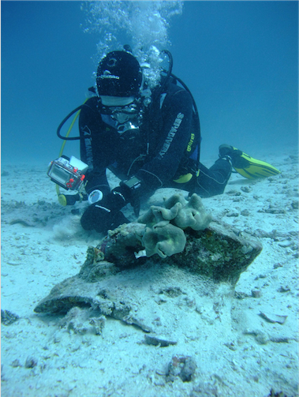
Archaeologists record an amphora on the seabed near Jeddah.

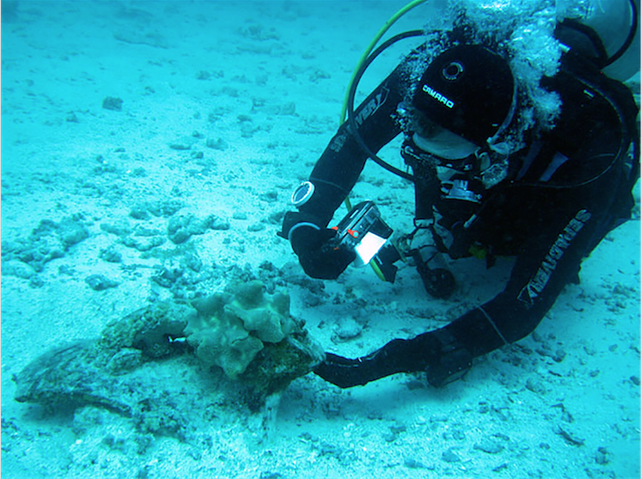
Archaeologist Rupert Brandmeier examines a large Roman amphora top at a shipwreck site near Jeddah.

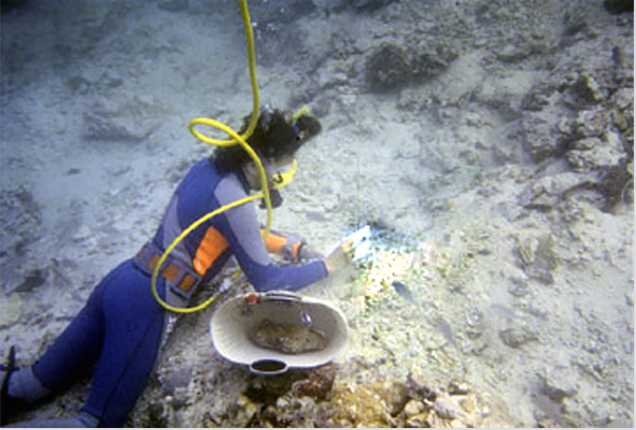
Excavating the shipwreck at Black Assarca
Two newly investigated shipwrecks demonstrate this trade. One was discovered during my survey in 2013 near Jeddah, Saudi Arabia. Although only briefly surveyed, the wreck clearly was carrying a cargo of amphoras from Aqaba. It is a unique find in an area in which little archaeological survey has been done. As no settlement from Late Antiquity has been located in the Jeddah area, it can only be speculated why the ship was in the area. Was it driven there by a storm, or was it heading toward an as yet undiscovered settlement? Whatever the reason, the wreck demonstrates seafaring occurred along the desolate central Arabian coast, an area previously believed to have been avoided by ancient sailors.

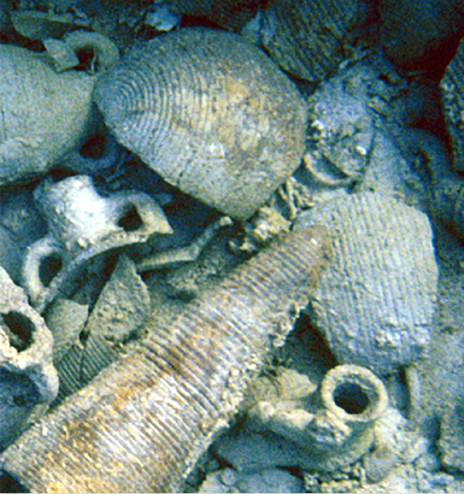
Ceramic types in the shipwreck.

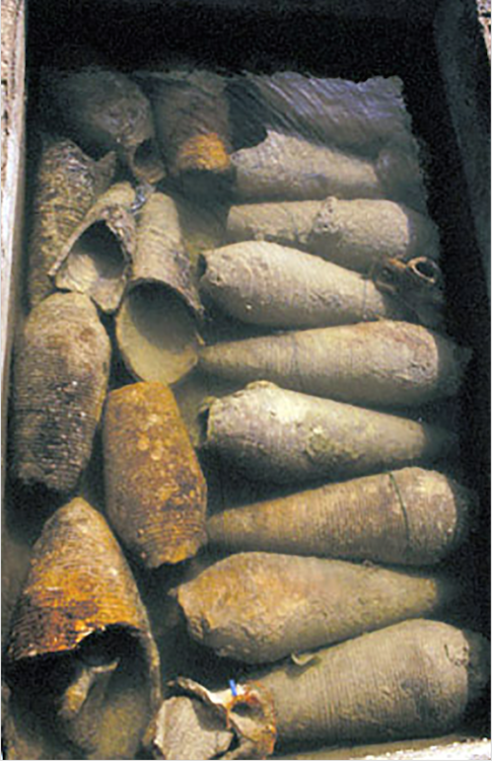
Aqaba amphoras after excavation and in the artifact preservation tank on Black Assarca Island.

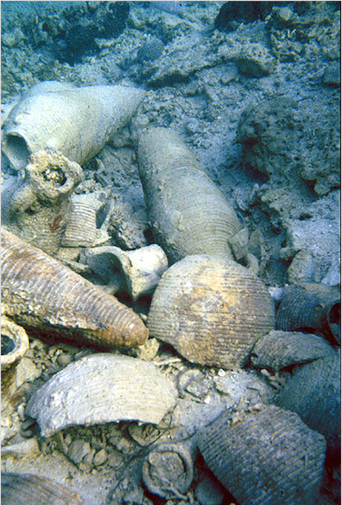
A view of the Aqaba ceramic types on the shipwreck.
The other shipwreck was found on the African side of the sea, at the desert island of Black Assarca in Eritrea. Partially excavated under my direction in 1997, the shipwreck contained not only the carrot-shaped Aqaba amphorae but a globular type of similar fabric and decoration, the remains of a pitcher with a strainer at its mouth, a piece of greenish Mediterranean glass from the base of a wineglass, and a Byzantine-style counterweight for a steelyard. The shipwreck and its cargo, which largely originated in large part in the former Nabataean lands, is the first of its kind to be excavated.

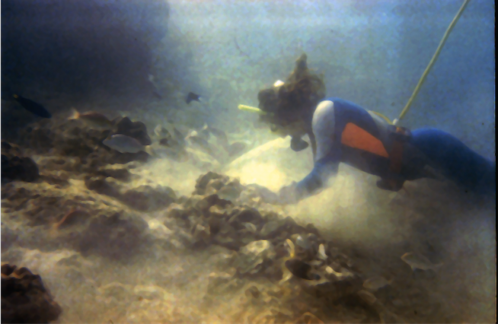Excavating the shipwreck at Black Assarca

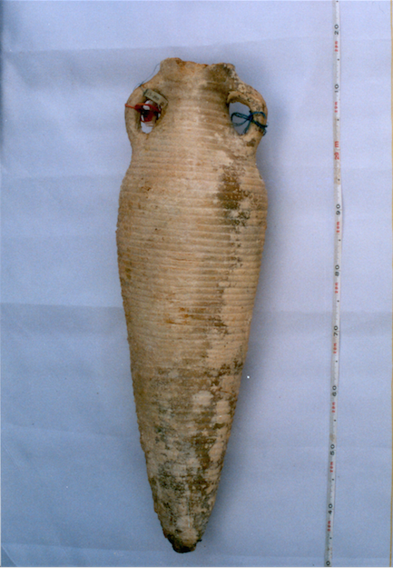
An Aqaba amphora from the shipwreck at Black Assarca Island.

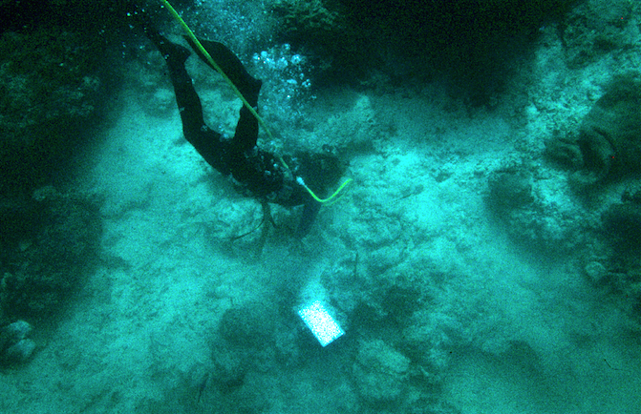Black Assarca excavating the shipwreck. Photo by Gary A Nilsen

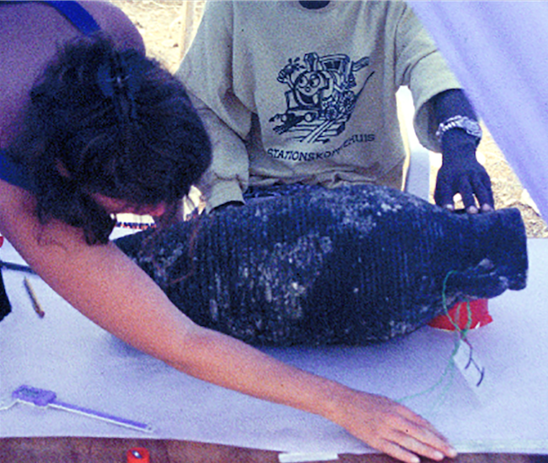Black Assarca artifact drawing Photo by Gary A Nilsen.

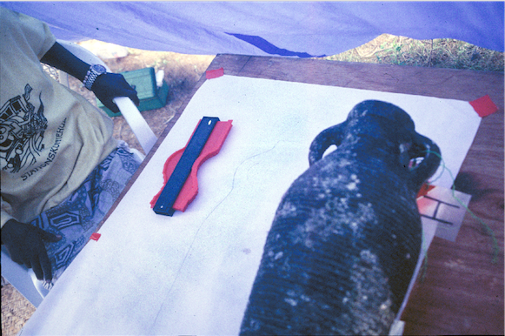Recording an Aqaba amphora excavated from the shipwreck at Black Assarca Island Photo by Gary A Nilsen.
Somewhere beneath the waters of the Red Sea lie undiscovered shipwrecks belonging to the Nabataeans from their heyday. Investigations along both the Arabian and African sides of the sea promise to reveal much more, since where ships sail, they also wreck. When their shipwrecks are finally discovered and studied, the Nabataeans will no longer be seen only a desert people–they will regain their place among the seafaring peoples of the ancient world.

Ralph Pedersen is president of the Red Sea Institute for Anthropological Research
American Society of Overseas Research
The James F. Strange Center
209 Commerce Street
Alexandria, VA 22314
E-mail: info@asor.org
© 2021 ASOR
All rights reserved.
Images licensed under a Creative Commons Attribution-NonCommercial-ShareAlike 4.0 International License

