Metropolis of Rhapta and Azania

By Felix A. Chami

Abstract
Rhapta as the southernmost metropolis known in the Roman world was first mentioned by periplus of the Erythrean Sea in the mid first century AD as the major trading port of Azania, then The coast of East Africa(Edited and Translated by Casson1989, Huntinford1980, and Schoff 1912), also discussed by others (Freeman-Grenville1962, Carry and Warmington1963). Azania itself was first mentioned by Pliny the Elder in the early first century AD in relation to trade of spices particularly, Cinnamon and cassia. These were brought thither by people from south East Asia, probably Austronesians. From Azania the spices were carried to the Nile Valley and then to the Mediterranean world (Miller1969). In Periplus, the Romans are reported to have had found in Rhapta foreign traders, particularly Homerite Arabs who knew the local language and were intermarrying with the locals. In the second century AD, Claudius Ptolemy produced a map of Azania with Phapta placed at latitude 8̊ south at a river today identified as Rufiji in Tanzania because of the same latitude provided by Ptolemy and the identification by Ptolemy of the settlers of the area as Rafiji, which is similar to the name of the modern people in the area, the Wa- Rufiji.

In the same period of Ptolemy, the Chinese identified Azania as Zesan.

Archaeologists working on the delta region and other coastal areas of Tanzania have found sites of the Roman period some with trade artifacts.

Rhapta was an ancient port and also the capital of the ancient territory of Azania, then the coast of East Africa. Rhapta and Azania were reported in the Roman documents of the first three centuries AD. The documents include that of Periplus of the Erythrean Sea and that of Claudius Ptolemy’s Geography. These have been translated in several modern documents (Schoff 1912, (Casson 1989) and Huntingford 1980, and also well reported in others, Freeman- Grenville 1963, and Cary and Warmington 1963, Lacrois1998.

It has to be stressed here that whereas scholars have doubted pre-Roman documents, of the Greeks and Egyptians on their knowledge of East Africa, scholars have not doubted the Roman documents. From the time of Emperor Augustus Cesar the Romans had a firm control of the Indian Ocean all the way to India and beyond.( Cary and Warmington1963, Miller 1969:viii).Surprisingly however, according to Cimino1994:7 The Romans, “adhered to Hiparchus, namely that African coast near Zanzibar proceeded east instead, of south-west, and met the Asiatic territory and formed the Erythrean Lake”.

In understanding about Azania, few points have to be raised in relation to the ancient reports: Pliny the elder is considered the first person to report about Azania. He did this in relation to trade of spices, particularly cinnamon and cassia. ((Pliny/Rackarm1961:63) (Miller1969). He argued that those spices were not African or Arabian as it had been thought from the time of Herodutus(Miller1969:viii), but had arrived in Azania, brought thither by people who had sailed for several years from Indonesia where the spices had arrived from China.(Miller1969:vii). Could the Chinese themselves could have had come to Azania that way?

Jones (1971) and Oliver (1966) have discussed how could Austronesians have had arrived in Azania in the ancient time. According to Pliny, The spices were received on the islands of Azania, Madagascar?, and then to cave dwellers who passed them to the people of the mainland who on their turn carried them to the northern civilizations. It should be noted here that Strabo, who was writing at the time of Emperor Caesar Augustus, BC/AD changeover also reported that the spices were reaching in the northern African civilizations from a territory south of Meroe, suggesting Azania(Miller 1969:105, Jones1960, for conspectus also see (Chami 2006-166-167) Could the cave dwellers of the Azanian Islands, mentioned by Pliny and also by Egyptians in relations to Punt and also by Greeks in Paanch (then East Africa), have had been the people whose cultural remains are now being found in limestone caves on the islands of Zanzibar, Mafia and other East African islands? (See below). There is no doubt today that the ubiquitous sites of Early Iron Working period found all over East Africa are the cultural remains of the mainland Azania (Chami 1999a and Chami 2006).

The exact location of Azania was first provided by the author of the Periplus document in the mid first century AD, suggesting that Azania included the Somali Coast south of Ras Hafun, and then Lamu Archipelago in Kenya, mentioned as Pyralaoi and the island of Zanzibar probably the one mentioned as Menuthias. The final length of Azania continued southward to Rhapta, the main trading port put at the bank of a large sailable river,(Casson 1989: 136-141), now Identified as Rufiji in Tanzania by archaeologists.(Chittic1982, Chami 2006).

In the third century AD, Claudius Ptolemy Produced a map of Azania.(Lacroix1998). Places mentioned by Periplus are now grid referenced in terms of longitudes and latitudes. Few controversial issues in relation to the location of settlements and places mentioned in the Periplus document are solved by using latitudes. In the map, it seems that the coast of East Africa or then Azania was known as far south as Cape Delgado on the Mozambique/ Tanzania border. The Island of Madagascar is definitely shown and named Menuthias. Zanzibar is here named Menan (Lacrox1998Map 8, The Island opposite Rhapton river, the place for Rhapta, is known as Mafiaco. It is today known as Mafia, suggesting that the same name was used from the ancient time.

Different from the author of Periplus document, Ptolemy seems to have known a lot about the deep interior of Africa including the range of mountains he termed as the mountain of the Moon, probably Ruwenzori Mountains at the border between Tanzania, Congo, Burundi, Rwanda and Uganda. He correctly argued that, this place was the source of the Nile. He also knew about the mountain with three peaks with snow. No doubt that this mountain was Kilimanjaro in Tanzania. He also termed the people who lived at Rhapta region as Rafiji Ethiopes which is similar to the modern Rufiji people who live in the Rufiji Delta area. Ethiopes in the ancient time meant black people and Ptolemy shows on his map that people living in Sub Saharan Arica were Ethiopes.

Since the map of Ptolemy has an island of Madagascar, the large island he puts opposite the Mozambican channel, it is obvious that Madagascar and Comoros were known and they were part of Azania. It will be shown below that pottery of the Early Iron Working culture associated with Azanian culture have been found in Comoros.

Whereas The author of Periplus seems to have had been to Azania and Rhapta himself, as he presented about what he saw, Ptolemy’s report was based on hearsay. From people mentioned to have had been to Azania. These include Theophilus who was known to have had been to Azania three times and to have reached cape Delgado at the Mozambique/Tanzania border, and Diogenes is also known to have had reached the mountain of the moon. Dioscorus is also know to have had reached Cape Delgado and even beyond (Cary and warmington 1963: 101,130)

It is also certain that Ptolemy used records accumulated at Alexandria library from previous researchers such as Stabo, Pliny and travelers from the time of Eudoxus.(for conspectus see Carry and Warmington 1963: 123-131., Ptolemy worked at that Library in Alexandria.

At this juncture we should focus on Rhapta and its people, and hence the people of Azania.
Rhapta from the first mention in the document of Periplus is only suggested to be an emporium, a small trading place, but a major trading port of Azania and the southernmost known in the Roman Empire. At Ptolemy’s period, in the third century AD, Rhapta is reported as a metropolis, meaning a capital and major trading city

It is reported in Periplus report that at Rhapta the local people were ‘big bodied’, each living feely like kings. There has been an academic dispute on who were such people at Rhapta, and hence the people of Azania. There are those scholars who argue that they were Cushitic speakers, and others have thought they were Asiatics. there are also scholars who have thought that they were Bantu speakers (for conspectus see Cason 1989:136 and , Sutton 204-05.

It should be stressed here that the Periplus record has a note that people of Rhapta/azania were agricultural or tillers of soil (Casson 1980). In academics, and particularly in archaeology agriculturalists are accepted to be Bantu speakers (Phillipson 2005, Soper 1971, Sanders1969). Similar report about the people of the coast of East Africa being agricultural was provided by two Greeks of 300 BC, Euhemerus and Iambulus. However, as noted earlier, Greek records are thought by some scholars to be fantastic. (Cary and Warrington (1963). Also it should be noted here that Horton (1990) refuted the idea that Azania was of agriculturalists, Bantu speakers.

Actually, as noted earlier, the map of Ptolemy of Azania shows that the people on the region of Rhapta and of the rest of the region were Ethiopes, meaning that they were black. This record supports the opinion of agricultural Bantu speakers, who are current settlers of the region. It was noted earlier that Ptolemy recognized the people at Rhapta area as Rafiji, probably a corruption of Rufiji, the modern name for the modern people living at the Rufiji Delta of Tanzania who are tillers of soil. As noted earlier this place is not thought to be the place of Rhapta (Chittick 1988, Chami 2009).
We should end this debate on who were the people of Azania by citing Carry and Warmington (1963:130) who have argued that the people of Azania were Bantu speakers. As it will be presented later, this debate on who were the people of Azania is now put to rest by Archaeological findings of Early Iron Working sites on the coast and islands of East Africa. Archeologists unanimously accept that the sites belonged to agricultural Bantu speakers (Phillipson2005, Soper 1971, Chami 2006)

It should also be stressed at this juncture that. According to the document ofPeriplus, There were also foreigners living in Rhapta, particularly Homerite Arabs reported to have known the language of the local peopleand intermarried with them. Homerites claimed to the Romans that they traditionally controlled either Rhapta or Azania. As also noted earlier, Pliny also reported that there were people who brought spices form long distances in the ocean, probably South East Far Asia. Who must also have had stayed in Azania for some time before taking off Back to their countries. Could these have been Chinese or Austranesians?

Looking at trade, what were Imports of the Azanians? According to Periplus document, imports were mainly metal tools, wine, grain, glass stones and glass bottles with kohl.

“glass made at Rhodes.. Was shipped in large quantities from the west to various ports along the east coast of Africa and to the Indian sub continent” Some were colored glass (Stern 1991:113).

Exports were ivory, rhinoceros horn, tortoise shells and coconut oil (Casson 1989:61).
In relation to exports I have raised elsewhere the idea that the azanians may also have had exported smelted iron products, such as bloom and finished tools. According to Pliny metal tools or objects were wanted by Asiatic traders. I also noted that the Romans and other civilizations in the north wanted iron for war weapons and ship building (Chami 1999). It should be noted that Azanians’ one major ancient activity found in archeological sites was iron smelting. Some sites such as Limbo in the Rufiji region (Chami 1994), and Kilwa south of Rufiji (Mapunda 202:86) have been found to have had intensive iron smelting activity. Since according to Periplus document iron tools were prominent imported goods, it is likely that Azanians may have had imported finished tools and exported iron bloom (Chami 1999). It should also be noted that Spices such as cinnamon and cassia, brought to Azania from China via Indonesia were only exchanged for gold (Miller 1969:vii). It can therefore be argued that among the exported goods of Azania included gold.

So far we have examined Roman documents on Azania and Rhapta. Probably the other only known record on Azania is that of Chinese, written by Weilue in the3rd c. AD. From the translation by John hill (Internet report).

Some important issues from this Chinese record can be raised here:

First, there was close communication between Azania (What Chinese called Zesan) andAnxi Persia. Could this communication mean trade? We know from archeological records that there was brisk trade communication between the two regions from the third century AD to the Islamic period (Chami 1994, Juma 2004.

Second, Weilue’s report is interesting because, as it was noted earlier, whereas the Romans thought that the Indian Ocean was a sea (lake) which joined South East Asia, the Chinese knew, as The Egyptians knew 500 years before, that Indian Ocean joined Atlantic Ocean at the cape of South Africa. Herodotus was the first scholar to have refused the Egyptian knowledge of circumnavigation of Africa due to the report that Necho’s sailing crew saw the sun in the north while they were at the southern cape of Africa. Actually this is a geographic fact to be used to accept that the episode took place. (casson1974:62).
On the same issue, Carry and Warmington(1963) thought that Azanians themselves may have had sailed south of their territory and hence may have had known about the fact that Indian Ocean turned west to Atlantic Ocean. As it will be noted later, archeologists testify the existence of pottery of Azanians in South Africa, and in relations to that finding, Klapwijkk (1774:22) thought that the azanians were in south Africa because they were taken there as slaves. He does not however, indicate who would have had taken them there (see rebuttal by Chami (2006: 126)

The third point is that, whereas the Chinese report informs that Azania was under the Roman Rule, the Romans reported that Rhapta, was under Homerite Arabs. To support the Chinese report, we know that the Romans were in control of the Red Sea and Indian Ocean from the time of Emperor Caesar Augustus in the early first century AD. (Carry and Warmington 1963).

The fourth point is the report by the Chinese that it was possible to sail south from Azania, and continue west to the Atlantic Ocean and continue as far as Rome (Da Qin). This point is not in Roman records, Although Pliny repotted that Eudoxus of Cyzicus had this information, and he did sail to East Africa via the Cape of Good Hope from Gades in Spain (Cary and Warmington 1963; Jones 1960). It is questionable how the Chinese got this information.

It should be speculated here that it seems that The Chinese knew the coast of East Africa before the time of weilue, in the Hellenistic period. The coast of East Africa, Azania, was then known by the Greeks as Paanch. The Chinese record of that period identified it similarly as Panqi. (Colless on the internet about (Hou Hanshu).
Similar to the Greeks and even Pliny.s reported, the Chinese records reported about cave dwellers of the coast of East Africa, The Chinese seems to have had known about the Rift Valley of East Africa and even about a range of mountain (probably Ruwenzori, also known by Ptolemy as the Mountain of the moon(Synge1938). An upper Nile Valley civilization, probably that of Kush My be the one which the Chinese termed xiwangmu (Fuwei1996:6-7, and Jairazbhoy (1994: 115).

In the period after Weilue’s report, in the fourth century AD, there are no Chinese records about Africa until the 7th century when Tuan Che’ng-shih reports about Bopal a then territory thought to be on the coast of East Africa.(Freeman-Greenville1963). Actually Wheatley 1975 even doubts any Chinese report on Africa before the Tang Dynasty in the mid first millennium AD. Wheatley also thinks that Bopali was on the area of Somali coast. In the 7th and 8th centuries AD, The Tang dynasty seems to have involved the Chinese civilization in a great international trade, particularly that dealing with porcelain (keay2008; 269, 275). As it will be noted later the pottery seems to have reached East Africa.

After the Tang dynasty through the period of Sung or Yuan dynasty all the way to the ming dynasty, contact between the coast of East Africa and China was brisk (Freeman-Grenville1963, Wheatley 1973.
The Chinese coin reported in this work below (Fig. 1., is of this period in the 10th and 11th century. See identification report below, (thanks to Marco Vigano and his Chinese identifier).

The archaeological sites of this period on the coast of East Africa have ubiquitous Pottery from China (Chittick1974, 1984.)
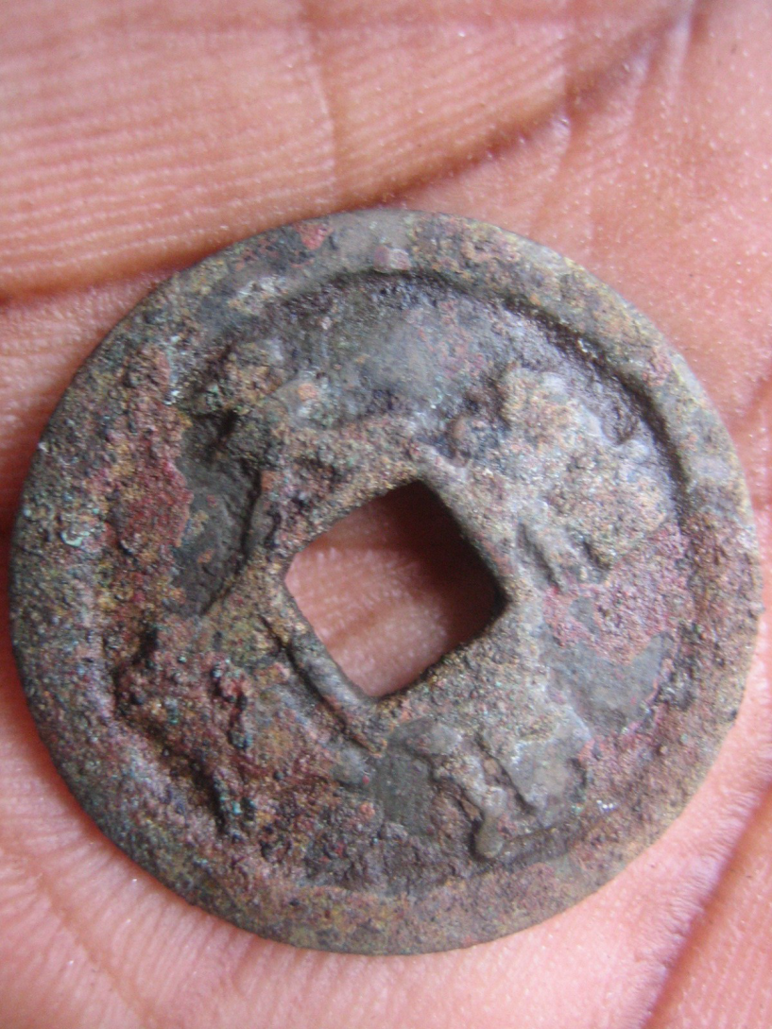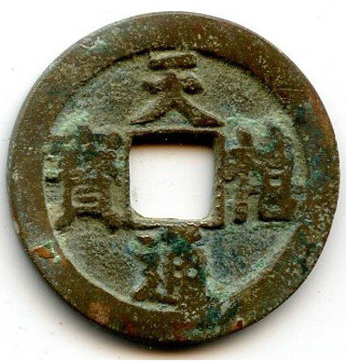

Fig. 1. Identification of a coin from Kuumbi cave Zanzibar
I judge this find to be a Tian Xi Tong Bao.
Catalogues: Hartill 16.68-16.70, Fisher's Ding 893-894, Schjöth 480
Typical weight 4g, Diameter 25 to 25.5 mm. This is a common North Song coin, minted between 1017 and 1021 under the last but one period of Emperor ZhenZong of Song, a major figure, who reined 997 to his death in 1022. These typology of coins, known as Chinese Cash were minted from the III century BC to the XIX century AD and represent by far the longest span of coin serial production in history.

It is also worth to note here, of the Chinese map of Eastern Africa of 11th c. Published by Wheatley 1973) which shows the Nile River originating in the deep interior mountains of East Africa, probably Ruwenzori, where it truly originate from. The map is also showing a Mountain with snow, probably Kilimanjaro. This map is reported to have been produced at the time of Song,Sung dynasty(Wheatley 1975).

It should be noted however, that The Chinese rerecords of that time do not mention of such geography or of expeditions by Chinese travellers to the interior of Africa. Even the Arab Geographers such as al Mas’ud and al al Idrisi of that time do not mention anything beyond the coast (Freeman-Grenville 1963.) The geography of the deep interior of Africa is shown and discussed in Claudius Ptolemy Map of the Third century AD. Is it possible that the 11th century AD Chinese may have had such information in their ancient predecessor’s reports in the time of Weilue or before?

It was noted that the purpose of this paper was to provide knowledge on the ancient East Africa territory of Azania and its capital or main trading town, Rhapta. Up to this juncture the knowledge from ancient documents has been provided. It is time we hear a bit about what is known about Azania from archaeological records.

Good amount of Archaeological sites of the time of the documents of Periplus, Pliny, Claudius Ptolemy and that of Chinese Weilue discused above are now known all over the coast of East Africa from Somali south to South Africa. The islands of Zanzibar, Mafia and Comores have also these sites now known as Early Iron Working cultural sites. Some of these sites have remains of imported goods such as beads and pottery. It is non academic to reiterate what has been reported elsewhere in this paper. For conspectus see Chami 2004, 2006 and 2009, Juma 2004Smith and Wright 1988, Kusimba199, Horton and Middleton 1988, Kwekason 2011.

List of references

Carry M. and E. Warmington 1963. The ancient explorers. Middlesex. Penguin Books.
Casson L. 1974 Travel in the Ancient World . London, George Allen and Unwin Ltd
Casson L.(ed. and transl.) 1989. Periplus Erythraei, Princeton: Princeton University Press.
Casson L. 1980. Periplus Maries erythraei: Three notes on the text. Classical quarterly 30: 495-7
Chami F. 1994. Tanzanian coast in the first millennium AD. Uppsala, Upsaliensis
Chami F. 1999. Greaco-Roman trade link and Bantu Migration theory. Anthropos 94/1-3:205-215

Chami F. 2004. Graeco Romans and Panchea/Azania: sailing in the Erythrean Sea.BAR international Series 1269: 93-105.
Chami F. 2006. The Unity of African ancient Unity, 3000BC to 500 AD. Dar-es Salaam, E&E vision.
Chami 2009. Zanzibar and the Swahili coast from 30,000 years ago. Dare-es Salaam E&D Vision
Chittick, N. 1974. Kilwa : An Islamic trading city on the coast of East Africa. 2Vol. Nairobi, British Institute in Eastern Africa.
Chittick, N. 1984. Manda. Excavations at an island port on the Kenya coast. Nairobi, British Institute in Eastern Africa.
Chittick N. 1988. Reconnaissance in Coastal Tanzania. Nyame Akuma 20 57-58

Cimino R.(ed),1994. Aancient Rome and India. New Dehli, Munshiram Manoherlal.
Freeman-Grenville G. 1963. The East African coast: selected documents from the first to the earliest nineteenth century. Oxford, Clarendon Press.
Fuwei S. 1996. Cultural flow between China and the outside world throughout History. Beijing, Foreign Language Press
Horton M. 1990. The periplus and East Africa. Azania 25: 95-99
Horton M. Middleton J. The Swahili. Oxford, Blackwell
Huntingford G. 1980(ed. and trasl.) The Periplus of the Erythrean Sea. London, The Hakluyt Society.
Jairazbhhoy R. 1974. Ancient Egyptians and Chinese in America. London, George priori association.
Jones A. 1971. Africa and Indonesia. Leiden , E. J. brill.
Jones H.(ed. and Transl.1960. The Geography of Strabo Vol. 1. London: William Heonemann Ltd
Juma A. 2004: Unguja Ukuu on Zanzibar: an archaeological Study of Early Urbanism: Studies in Global archaeology 3. Uppsala, Africa and comparative Archeology.

Keay J. 2008. China A. History. London, Harper Press

Lacroix W 1998. Africa in antiquity. Nijmegen, Catholic University.

Klapwijk M.1974. Preliminary report on Potteryfrom the north-eastern Transvaal, South Africa. South African Archaeological Bulletin 51:84-93
Kusimba C. 1999. The rise and fall of Swahili States. New Dehli, Ata Mira.
Kwekason A.2011. Holocene Archeology of the southern coast of Tanzania. Dar-es Salaam, E&D Vision

Mapunda B. 2002 Iron Metallurgy along the Tanzanian coast. Studies in the African Past 2: 76-88.
Miller C.1969. The spice trade of the Roman Empire,29 B.C. to AD. 641. Oxford, Carendom Press.
Oliver R. 1966. The problem of Bantu expansion. Journal of African History 7, 36-376
Phillipson D. 2005 African Archaeology. Cambridge, Cambridge Univesity Press
Pliny/H. Rackam (ed.and transl.).1961. Natural History.10 volumes) (loeb series). London,William Heinemann/ Cambridge, Massachusetts: Havard University Press (reprint)
Sanders E.1969. The Hamitic hypothesis: Its origin ans function in time perspective. Journal of African History 10 (4) 521-32.
Schoff W. (ed. and transl). 1912 The Periplus of the Eryhrean Sea. New York: Longmans, Green&Co.
Smith M. And Wright H. 1988. The ceramics from Ras Hafun in Somalia. Notes on Classical Maritime site. Azania 23:115-141.
Soprer R. 1071. General Review of Early Iron Age of the southern half of Africa. Aania17:145-162
Stern E.M. 1991. Early Roman Export glass in India. Madson, Univesity of Wisconsin Press.
Suton J. East Africa: interior and coast, Azania29-30:227-232.
Synge, P. 1938. Mountins of the moon. London, Lindsay Dummond ltd.
Wheatley.P. 1975. “Analecta Sino-Africana Recensa” in Chittick N. and Rotberg R. East Africa and the orient. London Africana publishing company.

