**THE MARITIME EXECUTIVE**

**Libya's Governments Agree on Mega Port Project**

By [**MarEx**](https://www.maritime-executive.com/author/marex) 2019-01-24 18:24:16

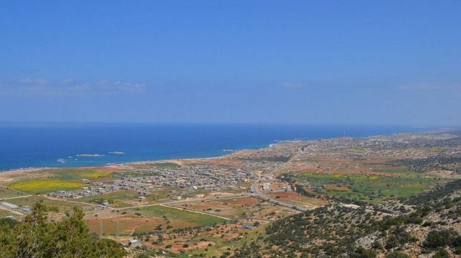Site of Port of Susah development

Libya’s government authorities in the East and West have formally agreed to jointly support what is expected to be one of North Africa’s most automated and largest deep-sea ports near the city of Susah in Libya. Specifically, the United Nations-backed Government of National Accord (GNA), known as the Unity Government, in the West in Tripoli and the House of Representatives Interim Government in the East in Tobruk, will cooperate on the billion-dollar Port of Susah project.

The port will handle containers as well as breakbulk, bulk, general cargo, and potentially oil and gas. It will include a logistics facility fully integrated with a Free Trade Zone and is expected to be operational in 2020.

Phase 1 will include:  
• a quay of length of 1,350m, based on three berths, each 400 meters long   
• a fully automated terminal that is capable of handling over 35 containers moves per hour with each crane  
• initial provision of four container gantry cranes, each capable of multiple container lifts.  
• supporting yard space and handling equipment to ensure efficient operation.

Phase 2 will include an additional berth capable of handling a variety of cargo, among which, additional container traffic (depending upon demand) and other cargo.

When completed, the international trans-shipment hub will be a crossroads in North Africa for mainline cargo vessels traveling to and from Asia and Europe via the Suez Canal, as well as to and from the U.S. The development includes regional cargo-handling facilities, improved road networks, employment for Libyan workers as well as expansion of business opportunities elsewhere within the country.

In 2022, the Port of Susah is expected to generate approximately $60 million in revenue, and this is expected to double by the year 2040. Revenue estimates are based on the port being able to handle around 500,000 TEUs in the first year of operations – Phase 1 of the project – and increasing an anticipated three-times in Phase 2 and 3.

International investment firm, The Guidry Group, will develop the new port. The firm was selected from among a competitive field of nine international firms in 2015 to develop the multi-purpose port following a multi-year world-wide solicitation of proposals by Libya’s Council of Ministers. Founded in 1985, the international investment firm has become increasingly focused on the development of critical infrastructure, including large-scale projects to help revive war-torn countries by assisting them with rebuilding their economies and communities.

The Guidry Group says the Governments' agreement is the result of three years of work, as well as months of discussions between the Seaport Authority officials in the East and West. “These now united representatives of the Libyan people have made it their highest priority to deliver economic opportunity for their people by redeveloping, restoring and modernizing Libya’s critical infrastructure.”

“The Port of Susah will help to grow our economy and create much needed employment opportunities for our nation’s people who are hungry for change,” said Dr. Nasereldeen Mehna, a member of the House of Representatives. “In the near future we will see one united government but, in the meantime, we have to open our country for investment in essential infrastructure projects and guarantee the transfer of knowledge and know-how in Libya.”

The port is the first-ever design-build-operate-transfer public and private-partnership infrastructure project in Libya. At the end of the long-term concession, the entire project will be transferred to Libya’s government.