**One Millenium between al-Idrissi’s map and Ptolemy’s map**

al-Idrissi’s map (Palermo, 1154)

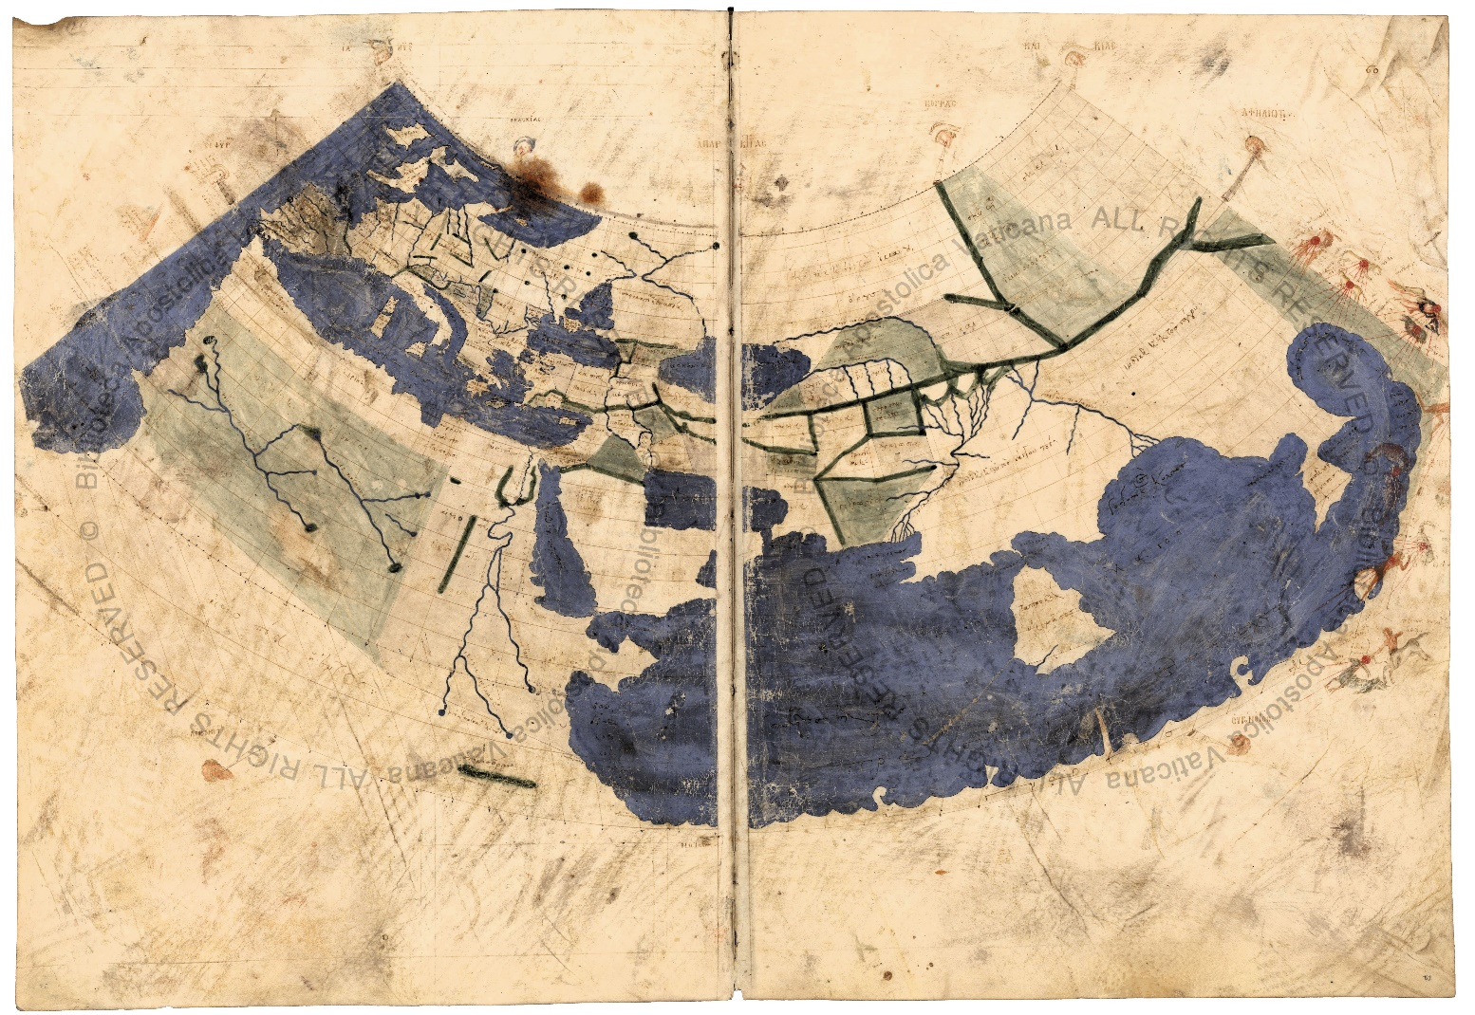  
Map possibly drawn by Planudes (ca. 1300) with Claudius Ptolemaeus’ coordinates (ca. 150 AD)

Early Italian portolan chart-makers had no access to Ptolemy’s work, but it is still unclear if they had access to al Idrissi’s map around 1250, as the Carte Pisane portolan is dated 1270…