**Destruction des brise-lames à talus   
sur le long terme**

**Failure of rubble mound breakwaters in the long term**

**Arthur DE GRAAUW**ARTELIA, Director Port Revel Shiphandling

**Résumé –** Les brise-lames en enrochements existent depuis sans doute 3000 ans et les ingénieurs maritimes modernes les construisent encore pour créer des espaces à l’abri de la houle. Certains brise-lames antiques sont encore en bon état aujourd’hui, alors que beaucoup d’autres sont maintenant érodés et submergés à la suite de plusieurs millénaires de tempêtes.  
La présente étude vise à découvrir une relation simple entre les paramètres qui régissent la position d’équilibre de la crête des brise-lames à talus (profondeur d’eau, hauteur de structure, taille des enrochements) sous l’effet de l’attaque répétée de la houle déferlante pendant de nombreux siècles.  
Il est conclu qu’un brise-lame initialement émergeant mais sous-dimensionné, sera érodé par la houle et finalement réduit à une digue submergée dont la hauteur au-dessus du fond marin dépendra de la taille des enrochements utilisés et de la profondeur d’eau.

**Abstract –** Rubble mound breakwaters have probably existed for around 3000 years and modern coastal engineers still build them to create harbours sheltered from wave action. Some ancient breakwaters are still well preserved today while many others are now eroded and submerged as a consequence of thousands of years of storms.   
The present study aims to find a simple relationship between the governing parameters (water depth, structure height, stone size) and the equilibrium position of the crest of rubble mound breakwaters subject to repeated wave attack in breaking wave conditions over many centuries.  
It is concluded that an initially undersized emerging rubble mound breakwater will be eroded by the waves and finally reduced to a submerged breakwater whose height above the sea bed depends on its stone size and on the water depth.

1. **RUBBLE MOUND BREAKWATERS**

Figure 1

Besides vertical breakwaters made of ashlar blocks or concrete poured into wooden caissons, many rubble mound breakwaters were built in Antiquity to provide better shelter for ships (Haggi, 2005). Rubble-mound breakwaters consist of piles of stones more or less sorted according to their unit weight: smaller stones for the core and larger stones for an armour layer protecting the core from wave action.

This kind of structure has probably existed for around 3000 years (e.g. the Phoenician breakwater at Athlit in Israel is dated to the 9th or early 8th century BC, Haggi, 2005) and modern coastal engineers still build them to create harbours sheltered from wave action. Ancient breakwaters may have been over- or undersized with the result that some are still in good shape today while many others are now submerged as a consequence of thousands of years of storms and wave action. Without going into the details of breakwater design (e.g. Rock Manual, 2007), it can be understood that the stability of a structure made of stones depends primarily on their size in relation to the strength of the waves: breakwaters in open waters exposed to storms acting on large areas and therefore producing high waves must be built with larger stones than breakwaters located in sheltered areas.

The present analysis can be seen as a follow-up of work done previously by Foster (1977), Ahrens (1987), Vidal (1995) and Burcharth (2003). Some of van der Meer's tests (1992) and Ota's test reported by Kobayashi (2013) and a few more scale model tests are also taken into account in the present analysis.   
The goal of this study was to find a simple relationship between the governing parameters (water depth, structure height, stone size) and the equilibrium position of the rubble crest of mound breakwaters subject to long-term wave attack in breaking wave conditions.

Figure 2

Careful examination of Google Earth images enables us to see quite a number of breakwaters in shallow waters. Some remarkable ancient rubble mound breakwaters can be listed as follows:

* Thapsus (Bekalta, Tunisia, Lat: 35.624299°N, Long: 11.051314°E): about 870 m long, submerged in open water (Younès, 2013);
* Leukas/Ligia (Lefkada island, Greece, Lat: 38.845037 °N, Long: 20.718422 °E): about 540 m long, submerged in sheltered water,
* Tieion (Filyos, Turkey, Lat: 41.571794 °N, Long: 32.0247 °E): over 350 m long, submerged in open water;
* Mytilini (Lesbos island, Greece, Lat: 39.113145 °N, Long: 26.55641 °E): about 350 m long, submerged in sheltered water;
* Sabratha (Libya, Lat: 32.810859 °N, Long: 12.477982 °E): about 320 m long, submerged in open water;
* Leptis Magna (Lebda, Libya, Lat: 32.637865 °N, Long: 14.300074 °E): about 300 m long, berm breakwater in open water;
* Methone (Modon, Greece, Lat: 36.813244 °N, Long: 21.709883 °E): about 250 m long, submerged in fairly open water;
* Neftina (Lemnos island, Greece, Lat: 39.98768 °N, Long: 25.351852 °E): about 200 m long, submerged in open water;

and many others, to be found in a more comprehensive publication (de Graauw, 2014).

Obviously, questions remain regarding many of these structures, e.g. was the Thapsus structure a rubble mound breakwater or a vertical breakwater? Is the feature in Kainopolis (60 km West of Apollonia, Libya) a breakwater or just some beach rock?

1. **PROCESS OF BREAKWATER DESTRUCTION BY LONG-TERM WAVE ACTION**

Different types of rubble mound breakwater are usually distinguished (see Rock Manual, 2007):   
**Emerging breakwaters**, which are stable if:   
a) they are not overtopped, i.e. they are high enough, for instance twice the water depth, if waves are breaking at their toe,   
b) they have a stable front armour layer, i.e. the stone size is large enough, say 20% of the water depth, if waves are breaking at their toe (see definition of parameters below).  
As an example of these (conservative) rules of thumb, consider a breakwater in water 5 m deep: the front armour layer stones should have a diameter of 1 m in order to be stable under wave action, and the crest should be at 5 m above Still Water Level (SWL) in order not to be overtopped by waves … this was probably not a common feature of ancient breakwaters, and they therefore suffered damage over time, were eroded and eventually became submerged.  
**Submerged breakwaters** have their crest at or below SWL and have a narrow crest (say 3 to 5 Dn); they are stable if made of large stones (Burcharth's rule: Dn > 0.3 d) and are eroded by offshore movement of front slope stones combined with onshore movement of crest stones falling behind the structure, the result being a lowering of the crest.  
If they have a wide crest (say 50 Dn and more) the eroded stones remain there, the result being a rise in the crest similar to the reconstruction of an S-shaped beach.

Hydraulic scale models are used intensively to study the stability of breakwaters.

1. **HYDRAULIC STUDIES USING SCALE MODELS**

Many research workers, hydraulics specialists and engineers have used scale models for over a century, in particular in towing tanks. Scale models allow testing of a design prior to building, and in many cases are a critical step in the development process. Dimensional analysis is used to express the system with as few independent variables and as many dimensionless parameters as possible. The values of the dimensionless parameters are held to be the same for both the scale model and reality. This can be done because they are *dimensionless* and will ensure dynamic similitude between the model and the reality. The resulting equations are used to derive scaling laws which dictate model testing conditions. It is often impossible to achieve strict similitude during a model test. The greater the departure from the application's operating conditions, the more difficult achieving similitude is. In these cases some aspects of similitude may be neglected, focusing on only the most important parameters (Heller, 2011).

Coastal engineers have chosen to apply the similitude law of William Froude (1810-1879) for their hydraulic models of coastal structures. This means that gravity is considered to be preponderant over the other forces acting on the structure (viscosity, capillarity, cavitation, compressibility, etc.).  
The speed (V) is in agreement with Froude's law and the velocity scale is therefore the square root of the length scale, e.g. for a model with a length scale of 49:

S(V) = S1/2(L) = sqrt(49) = 7 (times slower than in real life)

As time (T) is a distance (L) over speed (V), the time scale is:

S(T) = S(L) / S(V) = S1/2(L) = sqrt(49) = 7 (times faster than in real life)

The present analysis of long-term stability of breakwaters concentrates on cases with waves breaking between the toe and the crest of the submerged structure. These are the worst possible wave conditions and they are used in this study on the assumption that they will eventually occur in the long term. Hence, the local wave climate must include waves large enough to break in the water in front of the submerged structure; breakwaters in very sheltered areas are therefore not considered in this analysis.   
Further details on design waves for coastal structures in the Mediterranean area can be found on: <http://www.ancientportsantiques.com/ancient-port-structures/design-waves/>.

Figure 3

The main limitation of the tests shown in Fig. 3 is that they were performed with non-breaking waves. Hence, wave attack on the structure was not the worst case scenario.   
*This structure was nevertheless changed from an emerging breakwater into a submerged breakwater.*

Some unpublished scale model tests were performed in a wave flume at Sogreah's Laboratory in April 1993 by the author.

Figure 4

1. **RESULTS**

The tests shown in Fig. 4 are of course very limited and modest, but they confirm and extrapolate Kramer & Burcharth’s results (2003), offering a much wider perspective on the processes involved. It is concluded that undersized emerging rubble mound breakwaters which are eroded by wave action reduce to submerged breakwaters and that the crest below SWL can be located as follows after long-term wave action:

**Rc/h = 3.45 Dn/h – 1**

Figure 5

This result is obviously very useful for defining breakwater construction phases, when the core of the structure may be exposed to breaking waves produced by storms, and for near-bed rubble mounds protecting pipelines.   
*It is also useful to determine the long-term equilibrium level of the crest of undersized breakwaters.*

1. **CONCLUSION**

It was concluded that initially undersized emerging rubble mound breakwaters reduce to submerged breakwaters and that, for a given stone size, submerged breakwaters stabilise to a predictable crest level after multi-secular long-term attack in breaking wave conditions.

For ancient rubble mound breakwaters, this means that:

* We may find ancient breakwaters still in perfect condition: they were emerging structures fulfilling modern design conditions (they may also have been lifted by tectonic action, as at Kissamos, or been somewhat oversized!);
* If they were slightly undersized, we may find ancient breakwaters that were reshaped into an S-shape by 2000 years of storms: the seaward side is lowered to below SWL and the landward side may reach SWL, as on Fig. 3b;
* If they were more seriously undersized, ancient breakwaters have been eroded by wave action and eventually have been reduced to become submerged, with their crest located below SWL, as on Fig. 5.

We must also remember that, in tectonically stable areas, the SWL has risen about 0.3 to 0.5 m since Antiquity (Morhange, 2014), so that breakwaters that were stable at that time in shallow water (a few metres water depth) may no longer be stable because larger waves can reach them nowadays. This effect is obviously influenced by additional positive or negative tectonic movements.

In tidal areas, the worst conditions for stability occur when the largest waves occur together with the highest water level. The probability of this happening is lower than for a fixed water level, but that may not change the final result in terms of long-term stability.

1. **PARAMETERS**

Hs: significant wave height in front of breakwater (m)

Tp: peak wave period (s)

h: water depth in front of breakwater (m)

Rc: crest elevation of breakwater above water level (Rc < 0 if under water) (m)

d: height of breakwater above sea-bed (m)

Dn: nominal diameter of rock (m) = (M50/ρ)1/3

ρ: specific mass of rock (kg/m3)

M50: median mass of rock (kg)

SWL: Still Water Level

1. **ACKNOWLEDGEMENTS**

I am deeply grateful to Nic Flemming for having challenged me on this subject and for his support and thoughtful comments. I am also very thankful to the reviewers for their help in improving this paper.

1. **REFERENCES**

AHRENS, J. (1987), *Characteristics of reef breakwaters*, Technical Report CERC 87-17, Vicksburg, MS, 66p.

AURIEMMA, R. & SOLINAS, E., (2009), Archaeological remains as sea level change markers: A review, *Elsevier Quaternary International* 206, p.134–146.

CIRIA, CUR, CETMEF, (2007), *Rock Manual* *- The use of rock in hydraulic engineering,* (2nd edition), Published by C683, CIRIA, London, 1304 p.

DE GRAAUW, A., (2014), *Ancient Ports and Harbours, The Catalogue*, 4th ed., Port Revel, 233 p.  
<http://www.ancientportsantiques.com/wp-content/uploads/pdf/SubmergedBW.pdf>  
<http://www.ancientportsantiques.com/wp-content/uploads/pdf/AncientBWremains.pdf>

FLEMMING, N. & PIRAZZOLI, P., (1981), Archéologie des côtes de la Crète, *Dossiers d'Archéologie* N° 50, p.66-81.

FOSTER, D., (1977), Model simulation of damage to Rosslyn Bay breakwater during cyclone "David", *6th Australian Hydraulics and Fluid Mechanics Conference*, Adelaide, p344-347.

GODA, Y., (2010), Reanalysis of regular and random breaking wave statistics, *Coastal Engineering Journal*, Vol. 52, N° 1, p.71-106.

HAGGI, A., (2005), Underwater excavation at the Phoenician harbor at Athlit, 2002 season, *RIMS newsletter No. 31*, Leon Recanati Institute for Maritime Studies, Univ. Haifa, pp 12-14.

HAMPSA, H., (2006), *Tesi Dottorato, I porti antichi di Creta*, Università degli Studi di Salerno, 341 p.

HELLER, V., (2011), Scale Effects in Physical Hydraulic Engineering Models, *Journal of Hydraulic Research*, Vol. 49, N° 3, pp 293-306. (<http://www.tandfonline.com/doi/pdf/10.1080/00221686.2011.578914>)

KOBAYASHI, N., (2013), Deformation of reef breakwaters and wave transmission, *ASCE J. Waterway, Port, Coastal, Ocean Eng*., 139, p.336-340.

KRAMER, M. & BURCHARTH, H., (2003), Stability of low-crested breakwaters in shallow water short crested waves, *ASCE, 4th Int. Coastal Structures Conf*., Portland, OR, p.137-149.

LARONDE, A., (1983), Kainopolis de Cyrénaïque et la géographie historique, in: *Comptes rendus des séances de l'Académie des Inscriptions et Belles-Lettres*, 127e année, N° 1, p.67-85.

MORHANGE, C., (2014), Ports antiques et variations relatives du niveau marin, *Géochronique* N°130, p.21-24.

SAHOGLU, V., (2010), Ankara University Research Center for Maritime Archeology and its role in the protection of Turkey’s underwater cultural heritage, *Proceedings of the World Universities Congress*, Canakkale, October 2010, p.1572-1590.

VAN DER MEER, J., (1992), Stability of the seaward slope of berm breakwaters, *Coastal Engineering*, 16, p.205-234.

VIDAL, C., LOSADA, M., & MANSARD, E., (1995), Stability of Low-Crested Rubble-Mound Breakwater Heads, *ASCE J. Waterway, Port, Coastal, Ocean Eng*., 121(2), p.114-122.

YOUNES, A., (2013), Le paysage portuaire de Thapsus de l'antiquité à nos jours, *5e Rencontres Internationales du Patrimoine Architectural Méditerranéen*, Marseille, p.38-42.

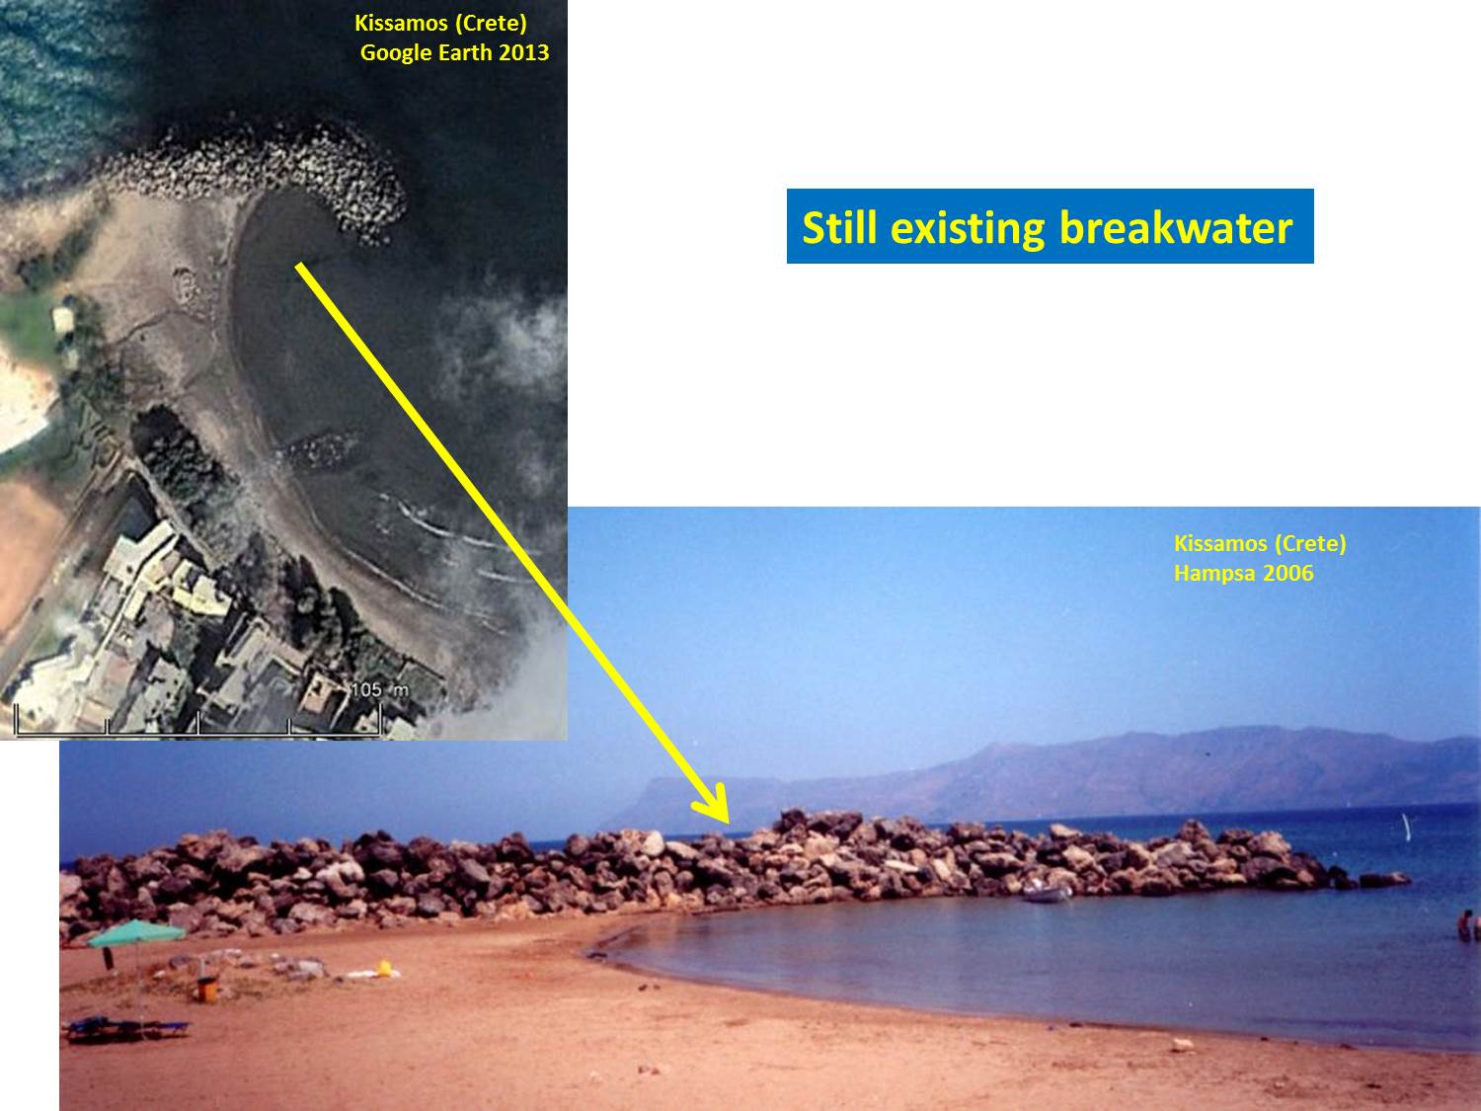

Figure 1 – The Kissamos breakwater (Crete) is a typical example of a rubble mound breakwater (picture from Hariclia Hampsa’s PhD thesis, 2006). This particular structure has luckily been preserved as it has survived 2000 years of wave attack because tectonic action raised it several metres above its initial level (Flemming, 1981). However, most of the ancient breakwaters were destroyed by wave action and their remains are found under water as “submerged breakwaters”.

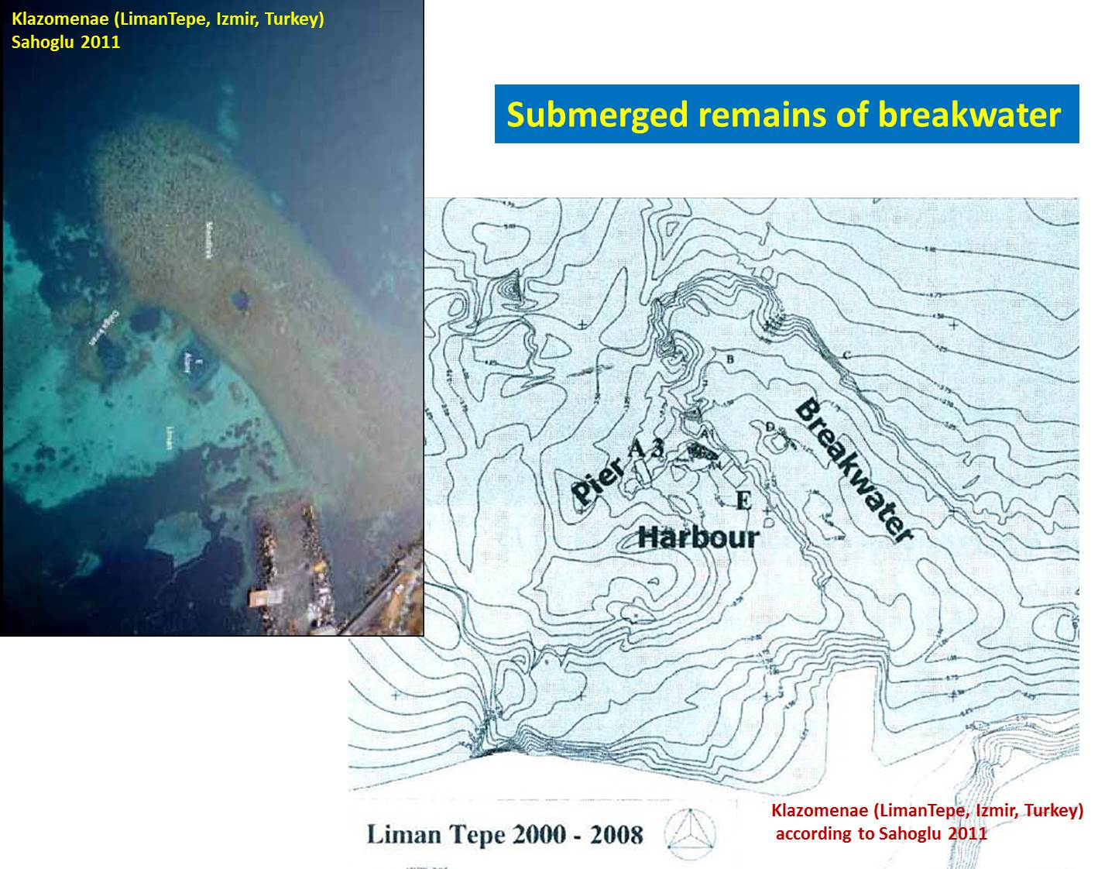

Figure 2 – Klazomenae (Liman Tepe near Izmir, Turkey) is a major Bronze Age harbour settlement and an example of a submerged breakwater dated to the 6th century BC. The remains are 140 m long and 45 m wide in a water depth of around 4 m at its seaward roundhead. The crest of the structure is 1 to 1.5 m below present sea level (NB: the ancient water level was 0.30 to 0.50 m lower, see Morhange, 2014). It should be noted that the location of this structure inside the Bay of Izmir is relatively sheltered from offshore waves and this may explain why it has survived so well over time. This ancient harbour has been intensively studied by Vasif Sahoglu and his colleagues from the Ankara University Research Centre for Maritime Archaeology.

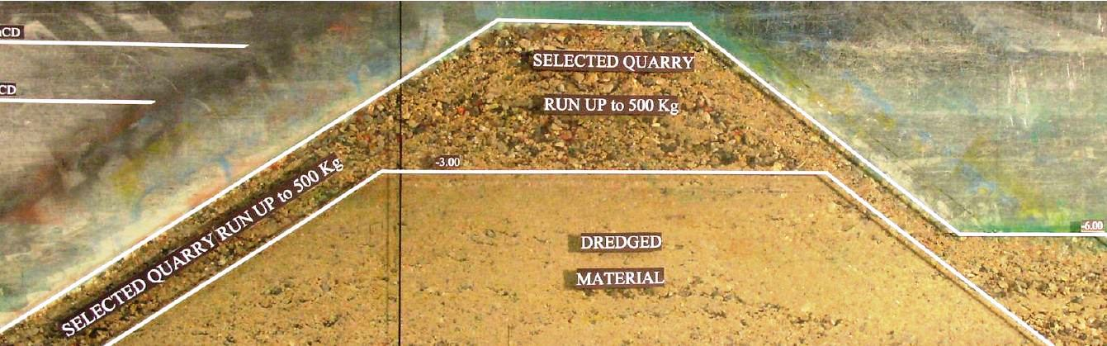

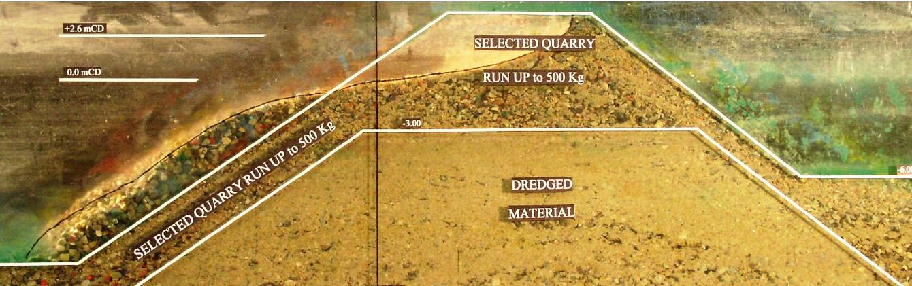

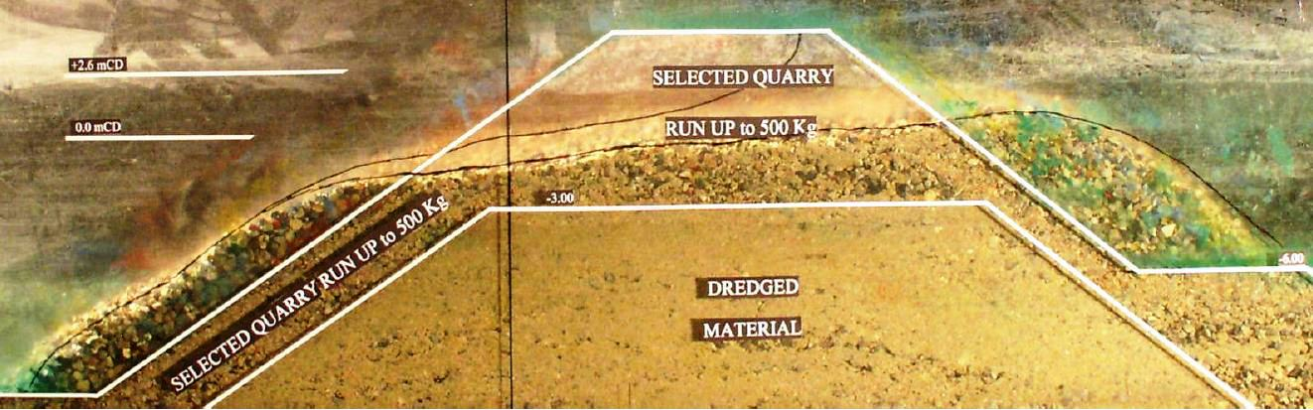

Figure 3 –Process of reshaping of a low crested breakwater consisting of relatively small rubble on a scale model at Sogreah's Laboratory in 2006.   
Fig. 3a shows the initial structure at the beginning of the test. Stone size on the model is Dn = 7 mm. The structure is 545 mm high and placed in a water depth h = 450 and 480 mm.   
Fig. 3b shows the structure after a sequence of around 1700 waves with significant height Hs = 60 mm and peak period Tp = 1.15 s. Waves were obviously not breaking before the seaward toe of the mound as Hs/h = 0.13 only, but broke on the front slope of the structure. This led to erosion of the front slope, moving material from the crest down to the seaward toe, producing an “S-shaped” profile.   
Fig. 3c shows the structure after a sequence of around 1500 waves with Hs = 80 mm and period Tp = 1.35 s. Waves were still breaking on the front slope. This resulted in further erosion of the crest, moving material from the crest to the rear side.

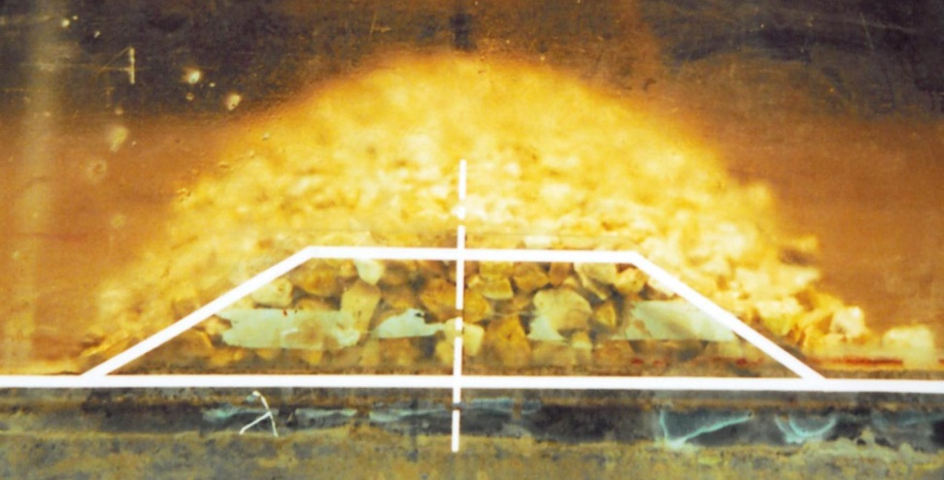

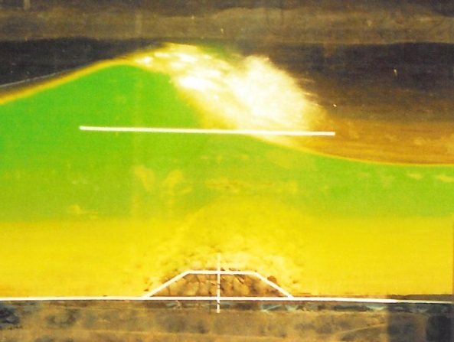

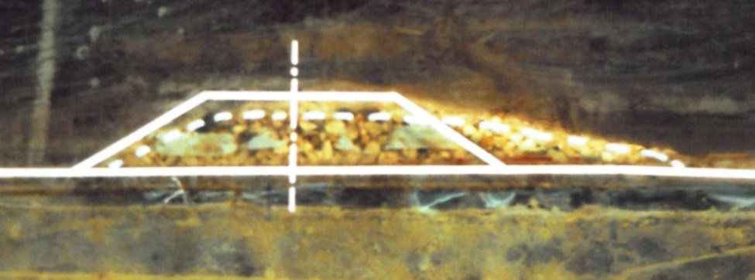

Figure 4 – Scale model tests on a submerged rubble mound structure.  
Fig. 4a - The initial structure at the beginning of the test was given a very simple trapezoidal shape with 1:1.5 slopes, a height of 40 mm and a crest 100 mm long. It was built with one single type of stone defined by its nominal Dn = 5 mm for the smallest size tested. The water depth h was 250 mm for most tests; hence, the 40 mm high structure was largely submerged.   
Fig. 4b - The wave height was increased step by step during the test until full wave breaking occurred and no further increase in significant wave height could be obtained. The wave period was set at Tp = 1.75 s for most tests. Wave breaking was of the "spilling" type in all the tests.   
Fig. 4c - The structure was reshaped by wave attack and finally stabilised in a rounded shape featuring a steeper front slope and a milder rear slope. The crest was lowered somewhat (2 to 3 Dn) and the rear toe moved backwards (about 18 Dn).

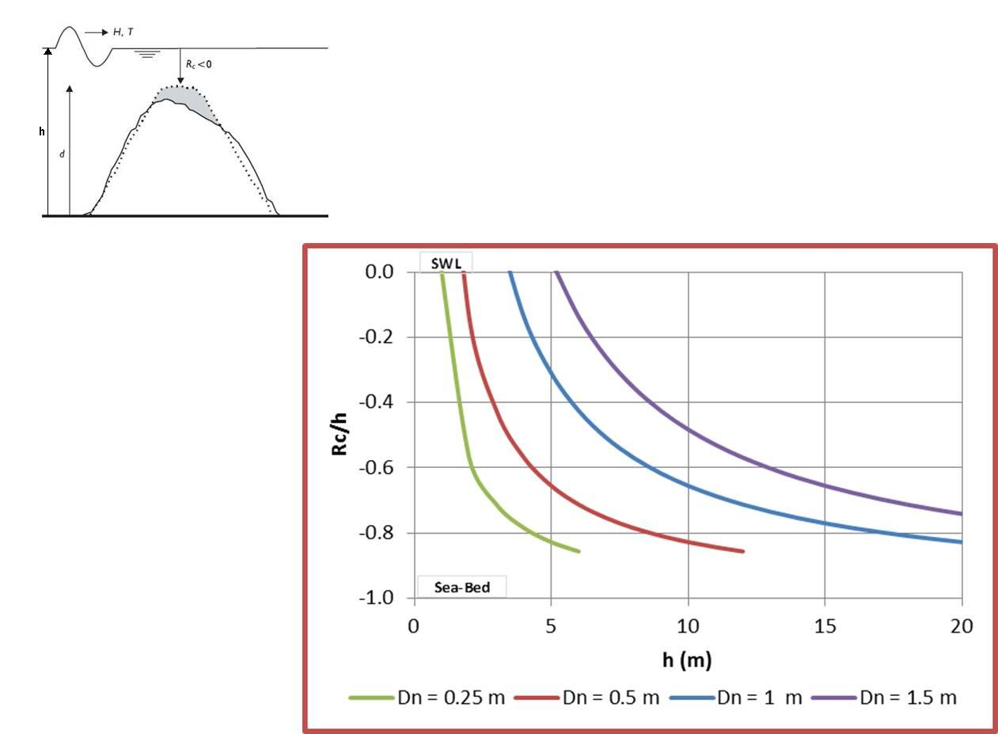

Figure 5 – For a given stone size, submerged breakwaters stabilize to the predicted crest level after long-term wave attack in breaking wave conditions;   
e.g. rock with diameter Dn = 1 m in water 5 m deep will yield a crest level at 30% of the water depth h below the water surface SWL.