**Failure of rubble mound breakwaters   
in the long term**

**Arthur DE GRAAUW**ARTELIA, Director Port Revel Shiphandling

**Résumé –** Les brise-lames en enrochements existent depuis plus de 2000 ans et les ingénieurs maritimes modernes les construisent encore pour créer des espaces à l’abri de la houle. Les brise-lames antiques peuvent avoir été surdimensionnés ou sous dimensionnés avec pour résultat que certains sont encore en bon état aujourd’hui et que beaucoup d’autres sont maintenant submergés à la suite de 2000 ans de tempêtes.  
La présente étude vise à découvrir une relation simple entre les paramètres qui régissent la position d’équilibre de la crête des digues à talus (profondeur d’eau, hauteur de structure, taille des enrochements) sous l’effet de l’attaque de la houle déferlante sur le long terme.  
Il est conclu qu’un brise-lame émergeant sous-dimensionné se réduit à une digue submergée et que, pour une taille donnée d’enrochements et après avoir été soumise à l’attaque de la houle sur le long terme, la crête se stabilise à un niveau prédictible.

**Abstract –** Rubble mound breakwaters have been around for over 2000 years and modern coastal engineers still build them to create harbours sheltered from wave penetration. Ancient breakwaters may have been over- or undersized. The result is that some breakwaters are still in good shape today and many others are now submerged as a consequence of 2000 years of storms.   
The present study aims at finding some simple relation between the governing parameters (water depth, structure height, stone size) and the equilibrium position of the crest of rubble mound breakwaters subject to long term wave attack in breaking wave conditions.  
It is concluded that undersized emerging rubble mound breakwaters reduce to submerged breakwaters and that, for a given stone size, submerged breakwaters stabilize to the predicted crest level after long term wave attack in breaking wave conditions.

1. **RUBBLE MOUND BREAKWATERS**

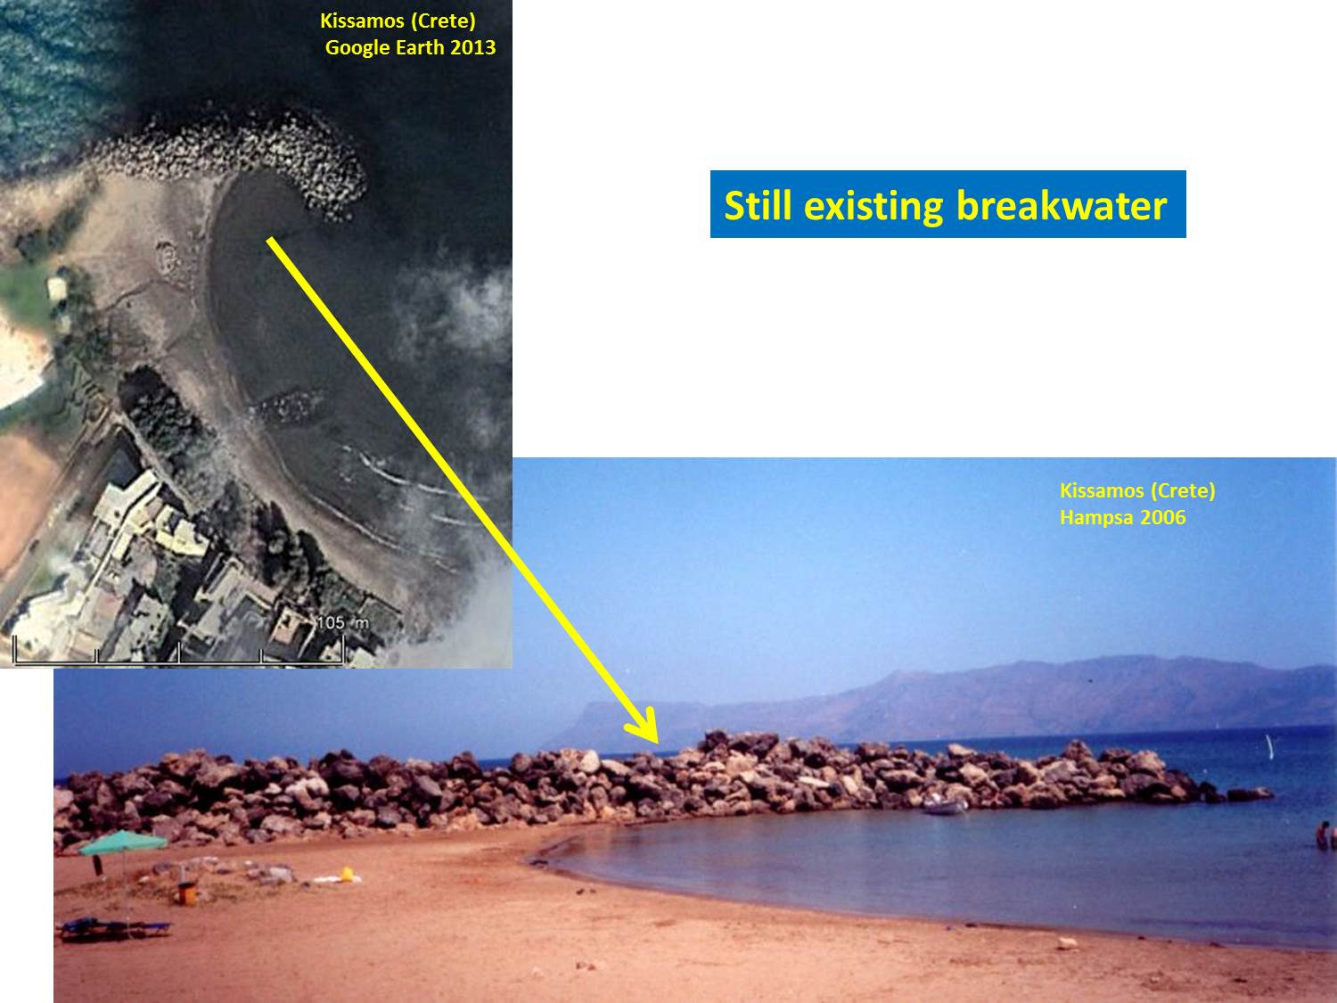

Figure 1 – The Kissamos breakwater (Crete) is a typical example of a rubble mound breakwater (picture from Hariclia Hampsa’s PhD thesis, 2006). This particular structure has been luckily preserved as it survived 2000 years of wave attack. However, most of the ancient breakwaters were destroyed by wave action and remains are found under water as “submerged breakwaters”.

Many rubble mound breakwaters have been built in antiquity to improve sheltering for ships. Rubble-mound breakwaters consist of piles of stones more or less sorted according to their unit weight: smaller stones for the core and larger stones as an armour layer protecting the core from wave attack.

This kind of structure has been around for over 2000 years and modern coastal engineers still build them to create harbours sheltered from wave penetration. Modern design made some progress since ancient times and ancient breakwaters may have been over- or undersized. The result is that some breakwaters are still in good shape today and many others are now submerged as a consequence of 2000 years of storms. Without going into the details of breakwater design, it can be understood easily that stability of a structure made of stones depends primarily on the stone size in relation to the strength of wave action: breakwaters in open waters exposed to storms acting on large areas and therefore inducing high waves, must consist of larger stones than breakwaters located in sheltered areas.

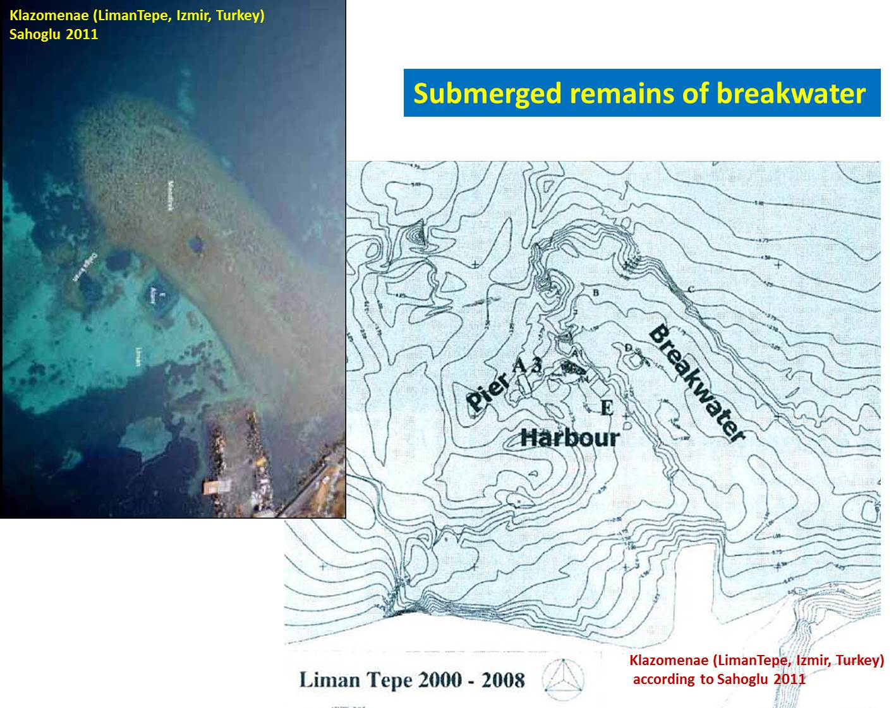

Figure 2 – Klazomenae (Liman Tepe near Izmir, Turkey) is an example of a submerged breakwater. The remains are 140 m long and 45 m wide in a water depth of around 4 m at its seaward roundhead. The crest of the structure is at 1 to 1.5 m below present sea water level (ancient water level was about 0.50 m lower). It must be noted that the location of this structure is rather sheltered from offshore waves and this may explain why this structure has survived so well in time. This ancient harbour has been intensively studied by Vasif Sahoglu and his colleagues from the Ankara University Research Centre for Maritime Archaeology.

Careful examination of historical Google Earth images enables us to see quite a few breakwaters in shallow waters. Some remarkable ancient rubble mound breakwaters can be listed as follows:

* Thapsus (Bekalta, Tunisia): about 870 m long, submerged in open water;
* Leukas/Ligia (Lefkada island, Greece): about 540 m long, submerged in sheltered water,
* Tieion (Filyos, Turkey): over 350 m long, submerged in open water;
* Mytlilini (Lesbos island, Greece): about 350 m long, submerged in sheltered water;
* Sabratha (Libya): about 320 m long, submerged in open water;
* Leptis Magna (Lebda, Libya): about 300 m long, berm breakwater in open water;
* Methone (Modon, Greece): about 250 m long, submerged in fairly open water;
* Neftina (Lemnos island, Greece): about 200 m long, submerged in open water;

and many others, to be found in a more comprehensive pdf publication on “Ancient breakwater remains” (<http://www.ancientportsantiques.com/wp-content/uploads/pdf/AncientBWremains.pdf> ).

Obviously, questions remain on many of these structures, e.g. is the structure at Emporia a breakwater or a city wall falling into the sea? Was the Thapsus structure a rubble mound breakwater or a vertical breakwater? Is the Kainopolis feature a breakwater or just some beach rock? etc.

1. **PROCESS OF BREAKWATER DESTRUCTION BY LONG TERM WAVE ACTION**

The process of destruction by waves was not all that clear and further analysis was undertaken by the author.

The present analysis of long term stability concentrates on the worst possible wave conditions, considering that they will eventually occur in the long term. This means that we consider only cases with waves breaking between the toe and the crest of the submerged structure. Hence, the local wave climate must include waves large enough to break on the water depth in front of the submerged structure and breakwaters in very sheltered areas are not considered in this analysis. Similarly, breakwaters located in water depths larger than say 20 m are not likely to be subjected to breaking waves in the Mediterranean area and are therefore not considered here.

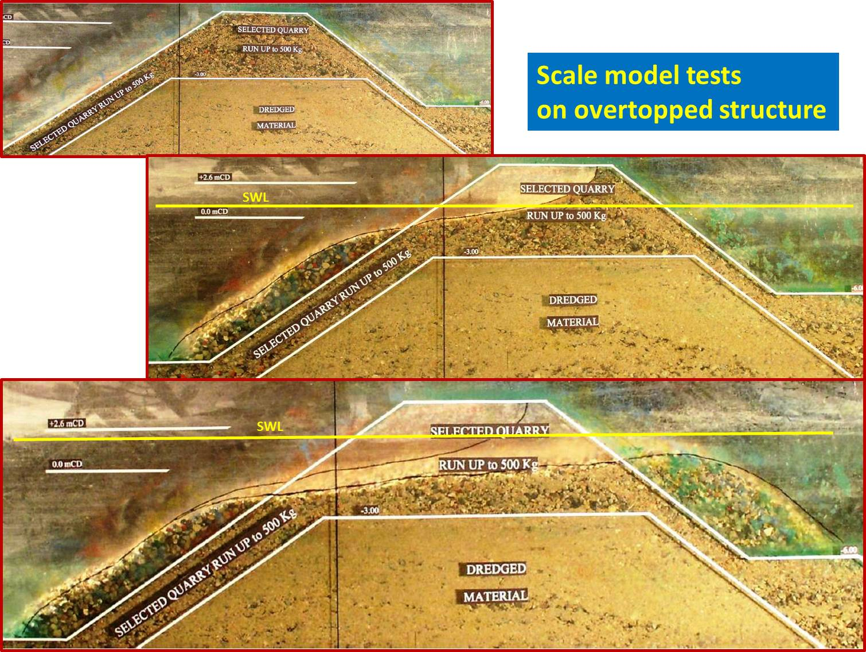

Figure 3 –Process of reshaping of a low crested breakwater consisting of relatively small rubble at SOGREAH's Laboratory in 2006.   
The initial structure is shown above at the top. Stone size on the model is Dn = 7 mm. The structure is 545 mm high and placed in a water depth h = 450 and 480 mm.  
The middle picture shows the structure after a sequence of around 1700 waves with significant height Hs = 60 mm and peak period Tp = 1.15 s. Waves were obviously not breaking before the seaward toe of the mound as Hs/h = 0.13 only, but broke on the structure front slope. This induced an erosion of the front slope, moving material from the crest down to the seaward toe.   
The bottom picture shows the structure after a sequence of around 1500 waves with Hs = 80 mm and period Tp = 1.35 s. Waves were still breaking on the structure front slope. This induced further erosion of the crest, moving material from the crest to the rear side.

The main limitation of the tests shown in Fig. 3 is that they were performed with non-breaking waves. Hence, wave attack on the structure was not the worst possible.   
*This structure was nevertheless changed from an emerging breakwater into a submerged breakwater.*

Some unpublished scale model tests were performed in a wave flume at SOGREAH's Laboratory in April 1993 by the author.

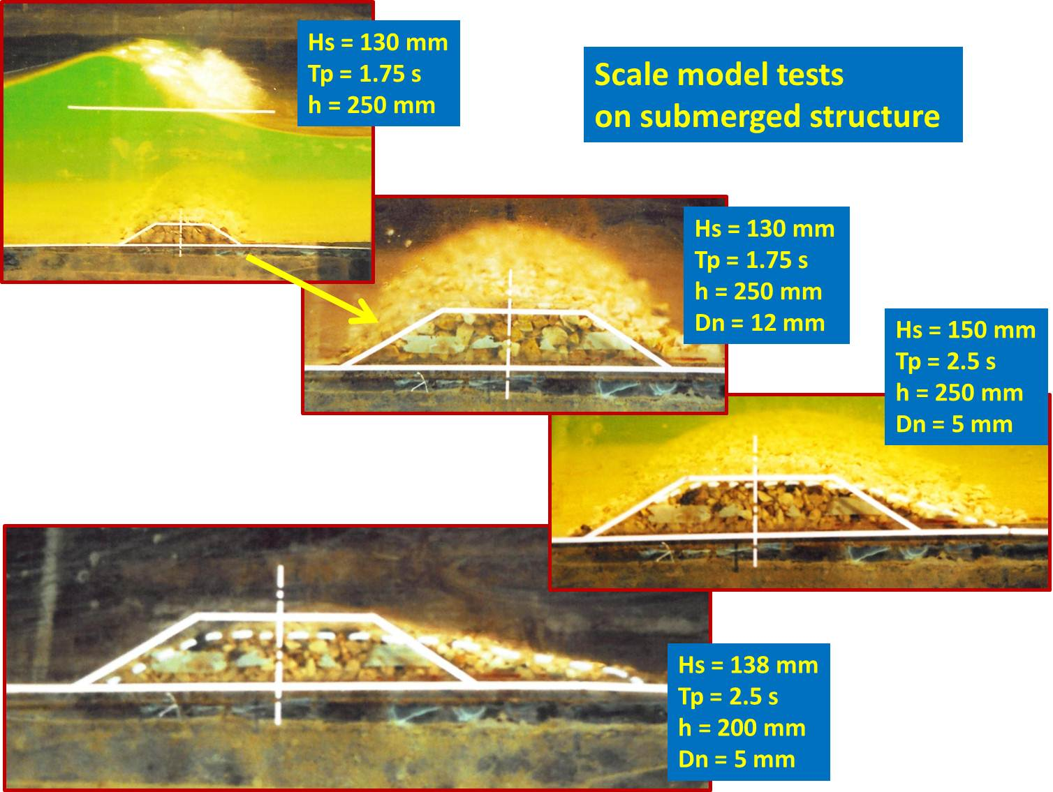

Figure 4 – The submerged rubble mound was given a very simple trapezoidal shape with 1:1.5 slopes, 40 mm high, and 100 mm long on the crest. The water depth h was 250 mm for most tests. The wave height was increased step by step during the test until full wave breaking occurred and no further increase of significant wave height could be obtained. The wave period was set at Tp = 1.75 s for most tests. Wave breaking was of the "spilling" type for all tests. The rubble mound was built with one single type of stone defined by its nominal Dn = 5.0 mm for the smallest size tested.   
The structure was reshaped by wave attack and finally stabilised in a rounded shape featuring a steeper front slope and a milder rear slope. The crest was lowered somewhat (2 to 3 Dn) and the rear toe moved backwards (about 18 Dn).

The tests shown in Fig. 4 are of course very limited and modest, but they confirm Kramer & Burcharth’s results (2003) enabling a much wider perspective on the processes involved. It is concluded that undersized emerging rubble mound breakwaters reduce to submerged breakwaters and that the crest can be located as follows:

**Rc/h = 6 Dn/h – 1**

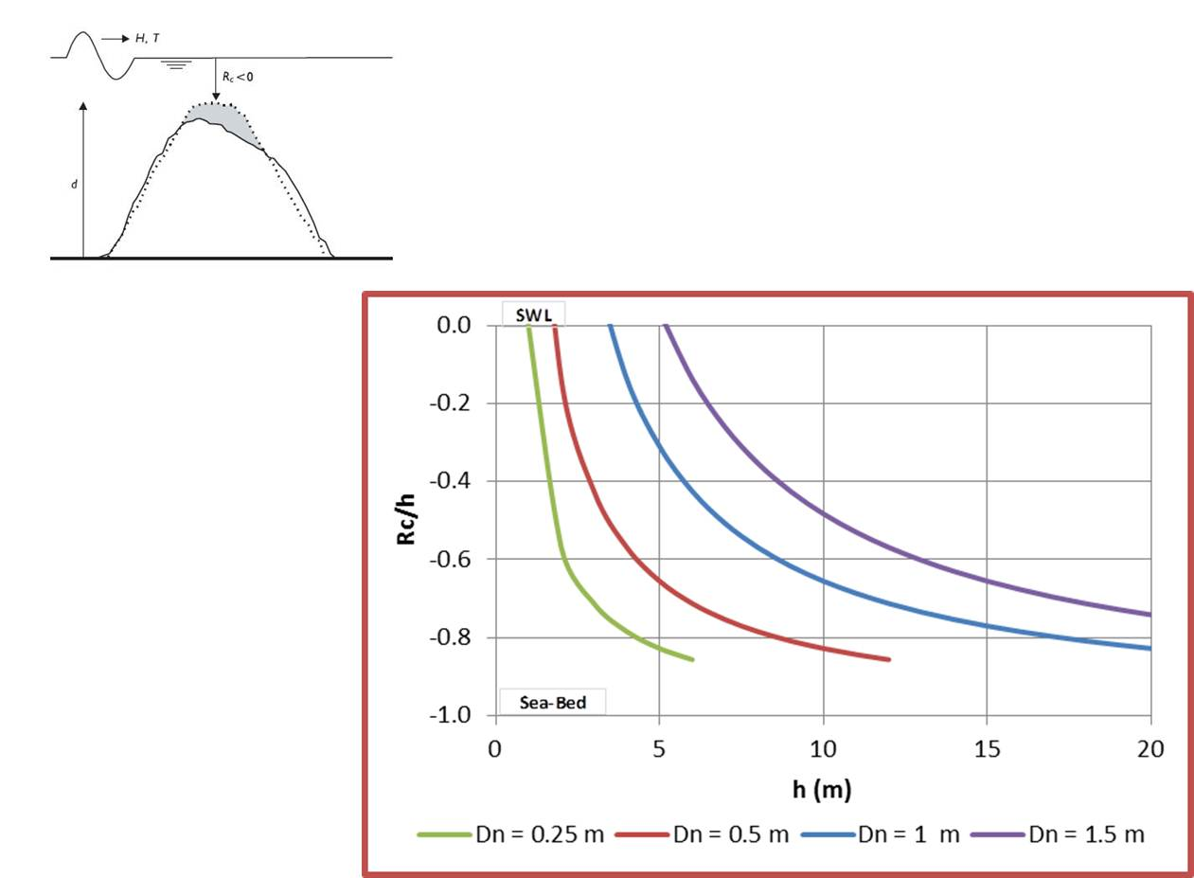

Figure 5 – For a given stone size, submerged breakwaters stabilize to the predicted crest level after long term wave attack in breaking wave conditions.   
e.g. rock with diameter Dn = 1 m in a water depth of h = 5 m will yield a crest level at 30% of the water depth h below the water surface SWL.

This result is obviously very useful for the design of breakwater construction phases, when the core of the structure may be exposed to storms inducing waves breaking on the structure, and for near-bed rubble mounds protecting pipelines. It is also useful to determine the long term equilibrium level of the crest of undersized breakwaters.

1. **CONCLUSION**

The present analysis can be seen as a follow-up of work done previously by Foster (1977), Ahrens (1987), Vidal (1995) and Burcharth (2003). Some of van der Meer's tests (1992) and Ota's test reported by Kobayashi (2013) and a few more scale model tests, are also taken into account in the present analysis.   
This study was carried out to find some simple relation between the governing parameters (water depth, structure height, stone size) and the equilibrium position of the crest of rubble mound breakwaters subject to long term wave attack in breaking wave conditions.

It was concluded that undersized emerging rubble mound breakwaters reduce to submerged breakwaters and that, for a given stone size, submerged breakwaters stabilise to a predictable crest level after long term wave attack in breaking wave conditions.

For ancient breakwaters, this means that:

* We may find ancient breakwaters still in perfect condition: they were emerging and fulfilling modern design conditions (they may also have been lifted by tectonic action, or been somewhat oversized!);
* If slightly undersized, we may find ancient breakwaters that were reshaped into an S-shape by 2000 years of storms: the seaward side is lowered to below SWL and the landward side may reach SWL;
* If more undersized, ancient breakwaters will be lowered by wave action to a level depending on the stone size.

We must also remember that the SWL rose about 0.3 to 0.5 m since antiquity (Morhange, 2014), so that breakwaters that were stable at that time in shallow water (a few meters water depth) may not be stable anymore because larger waves can reach them nowadays.

In tidal areas, the worst conditions for stability occur when the largest waves occur together with the highest water level. The probability of occurrence of this happening is smaller than for a fixed water level, but that may not change the final result for stability in the long term.

Further hydraulic details are to be found in a more comprehensive pdf publication on “Stability of submerged breakwaters” (<http://www.ancientportsantiques.com/wp-content/uploads/pdf/SubmergedBW.pdf> ).

1. **ACKNOWLEDGEMENTS**

I am deeply grateful to Nic Flemming for having challenged me on this subject and for providing me support and thoughtful comments.

1. **PARAMETERS**

Hs: significant wave height in front of breakwater (m)

Tp: peak wave period (s)

h: water depth in front of breakwater (m)

Rc: crest elevation of breakwater above water level (Rc < 0 if under water) (m)

d: height of breakwater above sea-bed (m)

Dn: nominal diameter of rock (m) = (M50/ρ)1/3

ρ: specific mass of rock (kg/m3)

M50: median mass of rock (kg)

SWL: Sea Water Level

1. **REFERENCES**

AHRENS, J. (1987) "Characteristics of reef breakwaters", Technical Report CERC 87-17, Vicksburg, MS.

CIRIA, CUR, CETMEF, Rock Manual (2007) "The use of rock in hydraulic engineering" (2nd edition), Published by C683, CIRIA, London.

DE GRAAUW, A. « Ancient Ports and Harbours, The Catalogue », 4th ed., Port Revel, 2014.  
<http://www.ancientportsantiques.com/wp-content/uploads/pdf/SubmergedBW.pdf>  
<http://www.ancientportsantiques.com/wp-content/uploads/pdf/AncientBWremains.pdf>

FOSTER, D. (1977) "Model simulation of damage to Rosslyn Bay breakwater during cyclone "David"", 6th Australian Hydraulics and Fluid Mehanics Conference, Adelaide.

GODA, Y. (2010) "Reanalysis of regular and random breaking wave statistics", Coastal Engineering Journal, Vol. 52, No. 1, pp 71–106, Japan.

HAMPSA, H., (2006) “ Tesi Dottorato, i porti antichi di creta ”, Università degli Studi di Salerno.

KOBAYASHI, N. (2013) "Deformation of reef breakwaters and wave transmission", ASCE J. Waterway, Port, Coastal, Ocean Eng., 139, 336-340.

KRAMER, M. & BURCHARTH, H. (2003) "Stability of low-crested breakwaters in shallow water short crested waves", ASCE, 4th Int. Coastal Structures Conf., Portland, OR.

MORHANGE, C., (2014) “Ports antiques et variations relatives du niveau marin”, Géochronique n°130, 2014.

SAHOGLU, V., (2010) “Ankara University Research Center for Maritime Archeology and its role in the protection of Turkey’s underwater cultural heritage”, Proceedings of the World Universities Congress, Canakkale, October 2010, p1572-1590.

VAN DER MEER, J. (1992) "Stability of the seaward slope of berm breakwaters", Coastal Engineering, 16, pp 205-234.

VIDAL, C., LOSADA, M., & MANSARD, E. (1995) "Stability of Low-Crested Rubble-Mound Breakwater Heads", ASCE J. Waterway, Port, Coastal, Ocean Eng., 121(2), 114–122.