**MedNav**  
Computation of travel time from one coastal city to another while following a selected route.

1. **Sailing the open seas**

According to Pascal Arnaud (2005: 74-80), the ancients defined distances at sea, as travel times. He deduced this from the fact that nearly all distances mentioned by ancient authors are multiples of 500, 600, 700 or 1000 stadia and combinations thereof:

* one day & night sailing (24 h) yields a travelled distance of 1000 stadia,
* half a day & night (12 h) yields 500 stadia,
* one daylight sailing, "daytime", (15-17 h) yields 600-700 stadia.

Considering that 1000 stadia is 100 nautical miles (1 stadium = 185 m, although other values exist), the average speed on the open sea is **around 4 knots** (nautical miles per hour) on a long-haul trip.

Julian Whitewright (2011) concluded that according to ancient reports, ancient ships sailed at 1 to 2 knots in adverse wind conditions and 4 to 6 knots with favourable winds.

1. **Computing ship speeds**

Use the 1 x 1° grid according to MedAtlas wind stats.

Extract **wind stats** from the MedAtlas for annual, winter, spring, summer, autumn seasons:

* Group wind directions provided by MedAtlas every 15°, into 45° sectors (8 sectors: N, NE, E, SE, S, SW, W, NW).
* Group wind speeds provided by MedAtlas every 1 to 2 m/s, into 4 categories: Calm (0-1 m/s), Light (1-3 m/s), Moderate (3-8 m/s), Heavy (8-20 m/s).
* This results, for each grid cell, in a table with frequencies of occurrence of winds for 8 directions and 4 forces.

Create a **ship model**: ship speed (in knots) for each heading (8 sectors), in light, moderate and heavy wind conditions. This speed is a “Velocity made good” (Vmg) for the heading versus the relative wind direction (called TWA: True Wind Angle), e.g. wind astern gives nice sailing speed in the wind direction, but wind ahead requires tacking, thus much slower progress in that direction[1]. The resulting speed rose resembles a “butterfly diagram”.   
This ShipSpeedRose is a separate table that can be changed anytime. All other tables refer to it. We use the “Arcenas fast ship”[2].

**Combine the wind stats and the ship speed rose**: for each ship heading and corresponding relative wind direction, add up occurrence frequencies of the 4 wind forces x ship speeds. This provides a ship speed for each heading (see Arcenas, 2015 for more details). The results are given in each cell, and manually copied into a separate summary table ShipSpeeds, providing resulting ship speeds for 8 headings and for 4 seasons (+ annual average). This table is the final result of combining wind stats and ship speeds to be used in the next step.  
Note that the ship’s drift (or leeway) is not taken into account. Nor are the currents (tidal currents exist along the Syrte and Gabes coastlines).

1. **Computing sailing routes:**

* Choose a season (annual, winter, spring, summer, autumn).
* Choose the cities of departure and arrival (from a list of predefined places with latitude, Longitudes).
* Choose the route following the MedAtlas grid cells. A 1 x 1° grid cell is defined by its centre point coordinates, e.g. the cell centred on 32°N, 30°E is called “3230. You can choose a route passing through up to 20 cell centres (you must have at least one, meaning that the trip is usually over 24 h long).   
  This step is important, take your time on a good chart!
* From departure to the first cell centre a bearing and a distance is computed (spherical trigonometry).
* Each cell is divided in 2 parts: from entering into the cell to the cell centre, and from the cell centre to exiting the cell (as a change of bearing may occur at the cell centre). The second part of the first cell has the same bearing and distance as the first part of the next cell.
* For each part of cell the Vmg value is searched in the ShipSpeed table, and interpolated (linearly) for the actual bearing (Vmgi).
* The travel time is found by Distance/Vmgi for each part of cell and then added on the whole route.
* The computation must be checked in detail!

**Ship Speed Rose  
Ship speed (kt) vs relative wind direction & force  
Vmg: "made good" ship velocity  
taken from Arcenas (2015)**

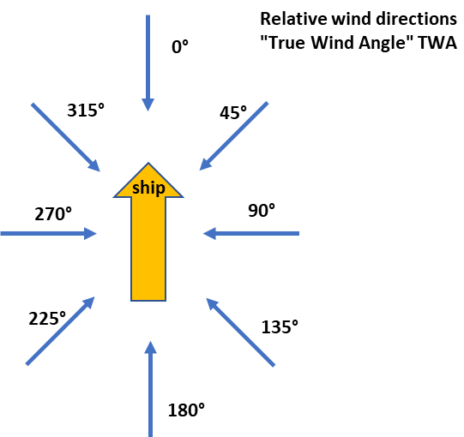



|  |  |
| --- | --- |
|  | **Wind forces:** Calm: 0-1 m/s, Bft 0-1 Light: 1-3 m/s, Bft 1-2 Moderate: 3-8 m/s, Bft 3-4 Heavy: 8-20 m/s, Bft 5-8 |

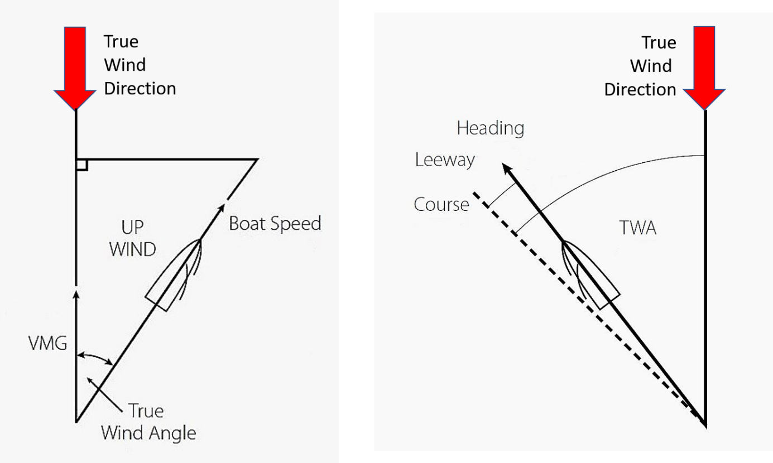

Vmg: velocity made good Drift (or leeway) is not taken into account in this computation

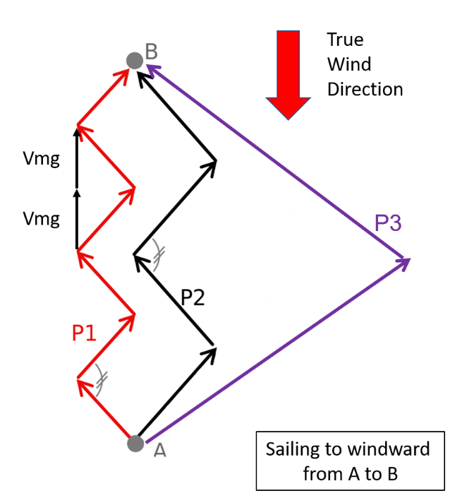

**Tacking strategy**Close-hauled sailing course: P1 requires more turns, thus more time, but the total distance is the same as P2.  
Close-reach sailing course: P3 requires more distance, but this may be faster as the speed is higher.

According to ancient reports, ancient ships sailed at 1 to 2 knots in adverse wind conditions and 4 to 6 knots with favourable winds (Whitewright, 2011).

According to Pascal Arnaud (2005: 74-80), the ancient defined distances at sea, as travel times:

* one day + one night sailing (24 h) yields a 1000 stades travelled distance,
* half a day & night (12 h) yields 500 stades,
* one daylight sailing, "daytime" (15-17 h) yields 600-700 stades.

Considering that 1000 stades is 100 nautical miles (1 stade = 185 m, although other values exist), the average speed on the open sea is around 4 kt on a long-haul trip.

The ORBIS model is a superb tool seems to be still operational, but:

* it is not maintained anymore?
* it works with a coarse 5 x 5° grid for wind stats,
* the choice of the "fastest" track is not explained (black box effect),
* it is "relying on a modest number of segmented routes" and "roughly approximates the preferred routes of sailors in the Roman period",
* it is therefore not open to choosing other routes.

pm: Email à Connor 12/3/2020:

I understand that we are both more interested in seafaring than transport on roads and river. Hence, use of ORBIS is less relevant and I agree that a GIS-based approach like yours is more relevant. You work in a 2D space with a third dimension used to define land masses that are to be avoided (similar to large-wave areas in ORBIS). Anyway, I fully understand that you wish to build your own model in order to have full control on all parameters. But ORBIS can provide some ideas.

Their ship-model is defined by its 8-branches speed-roses for 3 wind velocities (Vmg, see Arcenas, fig 3). Sounds ok to me.

The wind is defined by 8 directions and 4 velocities (calm, light, moderate and heavy) assuming that ancient and modern sailing ships have no limit in sailing in stormy weather.

Wind stats are averaged over 1 month, but 4 seasons are usually ok, depending on the local climate. In ORBIS, they are averaged over 5x5° cells and this must be checked as many places (e.g. Aegean) require smaller cells (e.g. 1x1°). Indeed 1° of latitude is 60 nautical miles (close to one day sailing) and close to the size of the larger islands. In the Aegean, I believe each island has its own wind regime, which is important to take into account when “island-hoping”, like described in the Stadiasmus. Hence, small-scale wind regime is relevant to long-haul sailing routes. On the open sea (e.g. between Egypt and Crete, or Greece and Sicily) 2.5x2.5° cells would be ok.

Another aspect related to wind, is the lateral drift of the ship.

ORBIS seems to use a limited number of sea-routes as defined by Arnaud’s 2005 study. However, this approach is, in a way, providing its own results instead of searching for new routes!   
I believe a “TomTom-like” approach open to many alternative routes should be followed, even if that leads to large computing times. Suppose you leave from Alex heading to Rome. Suppose you have 4 heading options each time you cross the limit of a 2.5x2.5° cell. You cross around 8 cells when sailing from Alex to Rome. Then, you need to compute 65536 segments (4^8), add up the segments that lead to Rome within a reasonable time (e.g. 6 to 60 days), and select the fastest. Am I dreaming that such a computation is feasible??!

I’ll have a look at the MedAtlas data base.

Currents in the Med are negligible (except in the Straits), but should be taken into account in tidal areas. This makes the whole computation process more complex as you have to superimpose wind effects and current effects on the ship’s movement. This would require a second set of data, on currents, similar to wind data. However, tidal currents will help your ship on its way half of the time and counter the ship the other half of the time. A rather rough approximation! Currents might therefore be neglected in a first stage.

1. WHITEWRIGHT, J., 2011, “The Potential Performance of Ancient Mediterranean Sailing Rigs”, IJNA, 40.1: 2-17.
2. ARCENAS, S., 2015, “ORBIS and the Sea: a model for maritime transportation under the Roman Empire”, ORBIS Project, Stanford Univ., (6 p), ([http://orbis.stanford.edu/#](http://orbis.stanford.edu/) ).