Let’s quote Harry R. Neilson’s abstract of a paper about “Aphrodite (Venus) Euploia on Greek and Roman lead anchor stocks” (2009):

*“To date, over one thousand Greek and Roman lead anchor stocks have come to light from the depths of the Mediterranean Sea. Of these, over one hundred are decorated with reliefs. The majority of these decorations comprise symbols relating to Aphrodite (Venus) Euploia. The presence of these symbols demonstrates a close connection with the sea-going manifestation of the goddess whom ancient mariners venerated as a protectress of navigation. An anchor stock recently discovered off western Sicily displays the epithet, Eiinkotu. Four stocks display dolphins and sea shells, well-known attributes relating to Aphrodite’s birth from the sea. Most significantly, over seventy stocks display images of astralogoi (knucklebones) which relate to the high scoring “Venus throw” in the game of chance popular in antiquity.   
Through an analysis of the inscription, the attributes, and the astralogoi, this paper illustrates that, in addition to her general association with ships and ports, mariners specifically relied upon Aphrodite Euploia while anchoring. The large number of anchor stocks with astralogoi reveals the superstitious nature of sailors who equated the precarious manoeuvre of dropping and setting the anchor with a “dice throw,” betting that Aphrodite Euploia would guide the anchor to security and hold the ship fast.   
Furthermore, that Greek and Roman ships carried on board as many as eleven anchors is a testament to how ancient mariners attempted to beat the odds while anchoring.”*

QUEYREL F., I987, “Le motif des quatre osselets ﬁguré sur des jas d’ancre antiques”, Archeonautica, N°7, 1987, pp 207-212.

QUEYREL F., I997, “Le motif des quatre osselets sur un jas d’ancre du Musée d’Apollonia de Cyrénaïque”, Libya Antica, N°3, 1997, pp. 113-117.

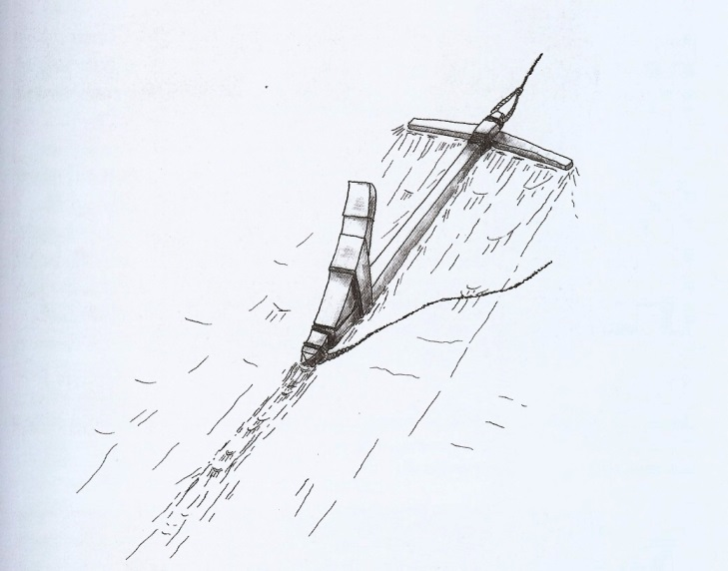

Functioning of a wooden anchor with lead stock



Anchor stock in situ in Apollonia. Pic. by Misson, 1967

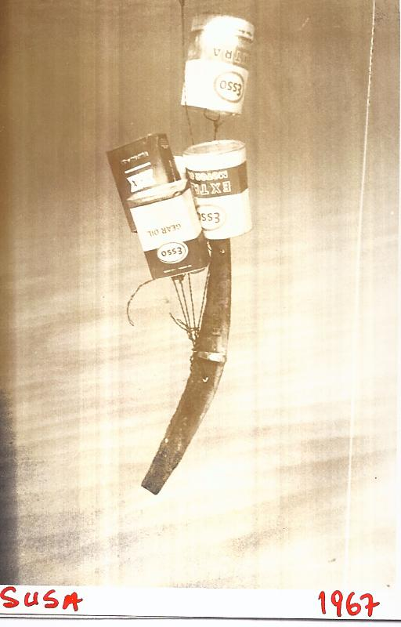

Floating of the Apollonia anchor stock. Pic. by Misson, 1967

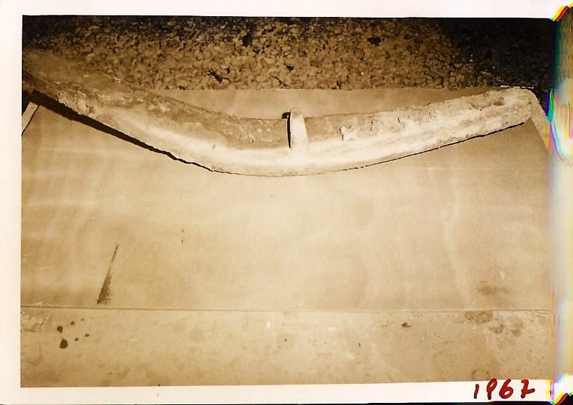

Apollonia anchor stock. Pic. by Misson, 1967

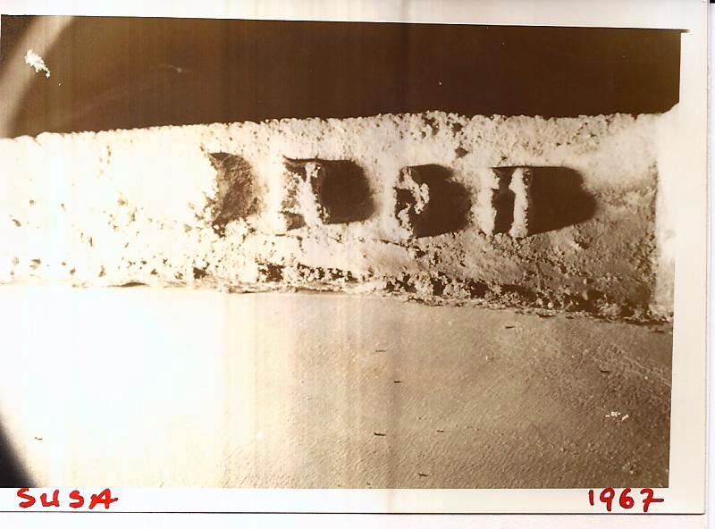

Astralogoi on the Apollonia anchor stock. Pic. by Misson, 1967