PORT ENGINEERING ASPECTS
OF THE MAGNUS PORTUS
IN ALEXANDRIA

A. de Graauw

1. INTRODUCTION

The recent archaeological investigations carried out in Alexandria Bay by Franck Goddio of the European Institute for Underwater Archaeology have revealed the harbour complex from the time of the first Ptolemies (/16/). These royal ports sheltered the Ptolemies' fleets of warships consisting of several hundred galleys, some of which were extraordinarily large. The complex consists of three ports, probably built between 300 and 250 B.C. during the Hellenistic period, more than 200 years before the arrival of Julius Caesar in 48 B.C. They are thus more than 200 years older than the harbours that have been studied so far, such as that at Caesarea (Israel).
Unfortunately there are no extant documents from the period concerning the design of these ports, and we are now forced to make assumptions on the basis of present knowledge and on the principal ancient text concerning maritime structures, by the Roman author Vitruvius.

The main aspects that are of interest to the harbour design specialist are as follows:

- Choice of site. A port is not built simply anywhere. It forms an interface between the land and sea and its location depends on traffic in these two areas and on certain natural conditions.
- Overall layout. The layout of a port depends on navigation conditions (winds and waves) and on the types of ship that use it (sailing ships, galleys). The size of the ships defines the acceptable wave-induced disturbance and the possible need to build a breakwater providing protection against storms. The number of ships using the port defines the length of quays and the area of the basins required.
- Harbour structures. The ships' draught defines the depth at the quayside and thus the height and structure of the quay. Locally available materials (wood, stone and mortar) and construction methods define the specific structures for a region and historical period.

2. CHOICE OF SITE

In a hurry to conquer the world, Alexander the Great cannot have appreciated the fact that the Phoenician city of Tyre resisted for 8 months (January-August 332 B.C.) before he was able to take it. He had to build a causeway linking the island to the mainland and call on the help of Tyre's rivals to succeed in his enterprise. The similarity between the island of Tyre and the island of Pharos is striking, especially when one adds that Alexander built a causeway between the island and the mainland at both sites, and that they both have a double harbour.

The idea of building a double harbour is motivated by the fact that there are two main wind and offshore wave directions.

In this case, which is quite frequent, it is useful to be able to move ships from one harbour to the other in order to obtain the best protection against wave disturbance in all circumstances. After the construction of the Heptastadium, the island of Pharos became a peninsula that perfectly fulfilled this criterion:
- to the west was built the Port of Eunostos (which became the commercial harbour),
- to the east was built the Magnus Portus (the royal harbour),
and, the ultimate subtlety, ships could be transferred from one to the other without going out to sea, via canals cutting through the Heptastadium. Nevertheless, it should be noted that the western part of Alexandria Bay must have begun to silt up progressively after the construction of the Heptastadium, eventually resulting in the curved shoreline that exists today in this part of the bay (figures 1 and 2).
It is likely that other considerations unrelated to the harbour itself also influenced the choice of site, but it is clear today that the island of Pharos was certainly better than Canopus (present-day Abu Kir), which had been chosen by Alexander's Egyptian predecessors and which is exposed to waves from the N-E sector. These waves are less frequent than those from the W-N sector but are nevertheless very problematic in winter. Moreover, this site has a distinct tendency to silt up owing to its proximity to one of the main mouths of the Nile near Rosetta. Sediment carried down by the Nile is transported along the coast by waves from the N-E sector (see oceanographic conditions summarised in annex 1).

But what were these harbours actually used for?

Alexander was definitely not a sailor. He symbolically burnt his boats on disembarking in Asia after crossing the Hellespont with 300 triremes. He needed the assistance of 400 triremes from Sidon and Cyprus to conquer Tyre, and after founding Alexandria on 20 January 331 B.C. and remaining in Egypt for only a few months, he subsequently devoted his attention only to mainland countries. He therefore did not choose this site as a base for his fleet of warships, though his successors (in particular Ptolemy II Philadelphus) based their fleets there.

He must nevertheless have learnt the lesson from his master Aristotle, who 11 years earlier had advised him to create an access to the sea so as to be "easily supported on two fronts at once, from the land and from the sea" in the event of an enemy offensive, and also to "import products that are not found in your lands, and export your own surplus produce" (/2/, pp 9 and 11). The city is indeed situated on a strip of land between the sea and lake Mariotis (the present lake Maryut), on which a river port was built. The river port is connected directly with the Nile and the Red Sea by means of a canal built by Ramses II and restored by Ptolemy II.

Three centuries later, at the time Strabo visited Alexandria (around 25 B.C.), the pirates had disappeared due to the efforts of Pompey's fleets a few decades earlier and trade was booming thanks to the peaceful conditions created by the Romans. Alexandria had almost a million inhabitants of various origins (/1/ p 261). It exported wheat to Rome and papyrus throughout the Mediterranean. It imported wood from Lebanon, wine, oil etc. (/1/ p 302). At the beginning of the Christian era, the city was exporting up to 150 000 t/year of wheat to Rome (/3/ p 297).

Alexandria had thus proved to be in a strategic position from the commercial point of view, as a land-sea interface.

3. OVERALL LAYOUT

Let us begin with what concerns all shipping, namely wind and waves. It may reasonably be assumed that the wind and wave conditions have hardly altered if at all since ancient times. Present statistics show that the winds (and waves) prevailing off Alexandria come from the W-N sector (more than 50% of the time as an annual average and 70-90% of the time during the summer months from June to September). A second important sector is N-E (20-30% of the time during the winter months from October to May). This latter sector has had a considerable importance for the development of the port, as it is the reason for the double harbour arrangement, as pointed out above.

The first logical reaction would be to locate the port against the Heptastadium, in the shelter of Pharos Island, at the place where today's fishermen shelter their boats from prevailing winds from the W-N sector. Yet this argument does not appear to have carried weight as the three ports discovered to date are located at the opposite end, below Cape Lochias (modern Cape Silsileh), where the royal palace used to be. This eastern part of Alexandria Bay is relatively more exposed to offshore NW waves and this meant that it was necessary to built a protective breakwater ("Diabathra") to supplement the natural protection offered by the reefs that emerged above sea level at the time (figure 2).

One explanation of why the ports were located on the eastern side of Alexandria Bay could be the siltation that occurred against the Heptastadium and which dissuaded the Ptolemaic planners, who must have faced the same problem at Canopus. If it is assumed that the construction of the harbour began only during the reign of Ptolemy I Soter at the earliest (he acceded to the throne in 304 B.C.) then almost 25 years had elapsed since the construction of the Heptastadium. This is quite long enough to reveal siltation against the Heptastadium and incite the planners to locate the ports elsewhere.

Access to the ports could therefore only be achieved by skirting the reefs to the west and south. This meant that boats could enter the bay with the wind 3/4 astern before taking in the sail, and then be rowed NE to reach the entrance of one of the three ports (figure 2).

In terms of the types of ship using the port, even though a few large commercial ships have been identified, the fleets of warships are better known. The tables in annexes 2 and 3 give the characteristics of the ships that have so far been found. Not all the ships mentioned stopped at Alexandria, but it was felt of interest to give details for comparative purposes.

At the time the Romans and Carthaginians were battling with triremes and quinqueremes in the western Mediterranean (as at the battle of the Aegates in 241 B.C.), the Macedonians and Alexandrians were building giant galleys, the likes of which would never be seen again. In particular, it should be noted that these huge ships appeared at the time Ptolemy I was ascending the throne. They seem to have existed for several centuries, as Antony aligned a number of them opposite the Romans at the battle of Actium (2 September 31 B.C.). The most productive was undoubtedly Ptolemy II, who, at his death in 246 B.C., left a considerable fleet of warships (/4/ p 42):

- 2 "30"s (i.e. 30 oarsmen on each side, see tables in annexes 2 and 3),
- 1 "20",
- 4 "13"s,
- 2 "12"s,
- 14 "11"s,
- 67 "9"s to "7"s,
- 22 "6"s et "5"s (quinqueremes),
- 4 "3"s (triremes),
- 150 to 200 "2"s (biremes) and smaller.
making a total of around 10 large ships (from 50x10 m to 70x20 m), 80 medium ships (45x8.5 m) and 175 to 225 small ships (from 20x2.5 m to 35x5 m), totalling around 300 ships.

This number is of the same order of magnitude as others found at other periods. Pompey's fleet in his war against the pirates (in 67 and 66 B.C.) consisted of 200 quinqueremes and 30 triremes (/4/ p 82) and Antony's fleet at the battle of Actium consisted of 220 ships (the largest being a "10"). It is also known that at other periods the Alexandrian fleet was smaller: the fleet burnt by Caesar at the battle of Alexandria in 48 B.C. consisted of 50 quinqueremes and triremes, 22 other ships and 38 ships hauled up on land in the arsenals (/1/ p 311).

As an exercise in defining the overall layout of the harbour, we attempted to find space in the discovered ports for all the ships of Ptolemy II's fleet. The areas of water in the ports are approximately as follows:

- first port: about 7 ha,
- second port: about 13 ha with probably around 800 m of quays,
- third port: about 16 ha with probably around 1250 m of quays,
- Heptastadium bay (between the third port and the island of Pharos): about 100 ha with 1000 to 2000 m of beach.

The first port could comfortably accommodate the 10 large ships mentioned above. The 80 medium ships and 25 small ones could be aligned side by side, stern to quay, in the second port. The remaining 150-200 small ships could be sheltered in the third port, which has quay space for up to 250 quinqueremes.

It should also be noted that the beach in the bay, which was the site for the shipyards (/1/ p 283...) must have been covered with slipways for hauling vessels out of the water. Over a distance of 2000 m, it would be possible to accommodate about 200 quinqueremes under construction (with a distance of 5 m between them, which appears to be a minimum for proper working conditions). This number corresponds to the fleet that Pompey had built for his war against the pirates (/4/ p 82).

As regards commercial ships, the "2000 amphorae" and "10 000 amphorae" (cf. annex 3) must have represented a cargo of the order of 100-500 t. The wheat ships could carry 350 t, i.e. 7500 sacks weighing 45 kg each (/3/ p 369). To carry 150 000 t/year of wheat with two return trips a year, a fleet of around 500 of these ships would be required. These would sail during the fine season (from May to September) (/3/ p 270). However, it is likely that these ships called at the port of Eunostos rather than at the Magnus Portus.

By way of comparison, the dimensions of the other large ports of antiquity may be mentioned here (these are described in /4/ p 84, /7/, /8/).

- Athens had the port of Piraeus, consisting of:
- Kantaros (commercial ships): 1000x500 m (50 ha), 100 ( ?) docking spaces,
- Zea (warships): circular, 300 m in diameter (7 ha), 196 docking spaces,
- Munychia: 82 docking spaces (about 5 ha).

- Carthage:
- Commercial harbour: 500x300 m (15 ha) in addition to the Lake of Tunis,
- Cothon (warships): circular, 330 m in diameter with a central island (7 ha basin), 220 docking spaces.

- Rome:
- Portus: Portus Claudius (about 60-80 ha) and Portus Trajanus (33 ha),
- Misenum (warships): the base for Octavian's fleet for the battle of Actium,
- Puteoli (commercial ships): situated next to Misenum in the Bay of Naples.

It is therefore clear that Magnus Portus was among the largest ports of the time.

4. HARBOUR STRUCTURES

Recent archaeological underwater investigations have revealed the existence of the three ports referred to above (/16/). The third port is the largest and uses the island of Antirrhodos as a natural protection against wave disturbance. The island was entirely developed as the site for a royal palace and quays consisting of large blocks of mortar cast in situ.
The remains of wooden structures have been used for carbon 14 dating and reveal the existence of an archaic structure in the form of a double row of piles.

One of the ironies of civilisation is that the ancient warship ports are quite similar to modern marinas in terms of the dimensions and the size of the ships using them (modern luxury yachts range in length from 15 to 70 m and more). However, the draught of the ancient galleys was less, of the order of 1 to 1.5 m. The largest ships (the "40"s of Ptolemy IV Philopator, or the Isis, see annex 2) must nevertheless have had a draught of up to 4 m.

The two principal types of harbour structure were protective breakwaters and quays.

The breakwaters could be rubble mound or vertical-faced structures built of blocks. Among the latter is a typically Roman type of breakwater consisting of arches (Puteoli and Portus Claudius). There is no point is dwelling on this question for Alexandria; the offshore breakwaters have not (yet) been explored, since they are probably located below the modern ones.

The inner breakwaters protecting each of the three ports consist of a sloping mound on the seaward side and in most cases a quay made of mortar blocks on the leeward side (figure 2).

Quay structures may be classified as follows, depending on the material used:

- with wood: wooden platforms on piles or pillars made of blocks of stone,
- without mortar: dressed stone blocks with a possible filling between two facings,
- with mortar, without pozzolana: massive blocks cast in the dry in a wooden form,
- with mortar, with pozzolana: massive blocks cast under water in a wooden form.

The oldest technique is that of dressed stone blocks (large quadrangular bond, the "opus quadratum" of the Romans, /10/). For structures of a certain width, two separate facings were built with blocks of stone and the space between them filled with quarry run. The surface was then covered with slabs. The weight of the blocks must not have exceeded a tonne in order to be handled easily with the lifting tackle available at the time. Blocks found in the southern harbour at Tyre weigh around 500 kg, but blocks weighing 10 t and more were used in areas exposed to wave attack (/11/).

Lime mortar was made from slaked lime, sand and water. It dried in the open air and could not harden under water. It was therefore necessary to build structures in the dry in a previously drained area. One method involved building cofferdams about 1.5 m thick using forms filled with compacted clay (third method described by Vitruvius, /9/ Book V, chapter 12). This nevertheless meant that the sea bed had to be watertight clay. Indeed, the piles holding the forms could not have been driven into a rocky bed, and a sandy bed would have allowed the surrounding water to infiltrate.

More recently, the following ingenious idea was thought of. It was based on the second method of Vitruvius, considered to be fairly unpragmatic by the engineers of our own time. A wooden form was installed in the water at the location of the future quay. It was then filled with sand to a level higher than that of the surrounding water. The block of lime mortar was then cast above the water on this sand mound and could dry in the open air. To lower it to its final position, it was simply a matter of removing the sand by opening gates incorporated in the lower part of the form (/13/).

The introduction of pozzolana by the Romans was a revolution for hydraulic structures, as explained by Vitruvius around 30 B.C. This silica-alumina material of volcanic origin (from Puteoli - Pozzuoli - near Naples) combines with lime in the presence of water and enables the mortar prepared with this mixture to harden under water (/9/, Book II, chapter 6). The ingenious system described above was therefore no longer necessary and the mortar could be cast directly in the form placed on the sea bed. The piles holding the form could therefore be driven into sand. The piles were grooved and the planks slid into the grooves (first method of Vitruvius, /9/, Book V, chapter 12).
As the construction of these forms under water must have been laborious without modern diving equipment, a prefabrication method was imagined, and used at Caesarea by Herod between 21 and 9 B.C. (/14, 15/). The method involved building a double-walled wooden enclosure in the dry. This bottomless caisson was then floated to the desired location and the double walls were filled with pozzolana mortar until the caisson sank on to a previously prepared base. It was then simply a matter of filling the caisson with pozzolana mortar to obtain a gigantic monolith (at Caesarea there is a block measuring 12 x 15 x 2 m).

However, the Alexandrians did not have the advantage of these techniques when they built the Magnus Portus.

The large mortar blocks discovered in the third port at Alexandria (/16/) (typically 5-8 m wide, 10-15 m long and 1-3 m high) do not contain pozzolana and wood dating indicates a period in which pozzolana could not yet have existed in Egypt (around 250 B.C.). The block consists of alternating layers of mortar and flat pieces of limestone measuring about 0.1 x 0.1 m. The existence of planks of pine wood 3-4 cm thick under the block indicates that the form certainly consisted of a watertight floating caisson.
It may therefore be assumed that after the caisson had been floated into position directly above the future quay, it was ballasted until it sank to the bed on to a previously prepared foundation surface. For the mortar to dry in the open air, the caisson must have been sufficiently watertight and buoyant. The caisson thus acted as a barge capable of carrying the block of mortar (it should be recalled that the Egyptians had for centuries transported all kinds of dressed stones, columns and obelisks weighing up to several hundred tonnes by river). It would be enough for the caisson to be about 2.5-3 times larger than the mortar block (which has a relative density of about 2.5) as in this case, the draught of the caisson with its block would be about the same as the height of the block to be lowered into position (figure 3). This explains the presence of timber beams and planks under the block, as well as the existence of vertical and inclined beams held in the mortar, giving the caisson its rigidity during the floating and sinking stages. This also explains the absence of vertical wooden walls, as they must have been dismantled and recovered after the mortar block had descended to the bed.

The double row of elm piles discovered at the eastern end of the island of Antirrhodos (/16/) is older than the large blocks mentioned above (around 400 B.C.). Moreover, it disappears under more recent fill material and large blocks. The presence of mortar at the lower end of the piles indicates that these rows must have been built in the dry, i.e. that they sank under the sea after construction.

The following hypothesis could be put forward, whereby this double row of piles could be the remains of an ancient wooden quay.
The southern row consists of grooved piles (0.14 x 0.14 m section), spaced 0.4-0.5 m apart, into which pine planks 4 cm thick were introduced to form a small wooden curtain capable of holding quarry run fill. The northern row consists of simple piles spaced 0.2-0.4 m apart. These could have supported wooden planks and have been set in water about a metre deep. The northern row is 1.5-1.8 m from the southern row (figure 4).

In conclusion, it is hoped that these investigations will be just the first in a long series, which will give us further information on ancient port engineering techniques.
It is to be hoped that this part of Alexandria Bay will soon be declared off limits for construction or, even better, transformed into an underwater museum.

ANNEXES

1. Oceanographic conditions at Alexandria.
2. Known large ships from antiquity.
3. Other ancient ships.
ANNEX 1: OCEANOGRAPHIC CONDITIONS AT ALEXANDRIA

1. WINDS

The following statistics were provided by Alexandria weather station for the period 1973-1992 (expressed as percentages of time per sector):

Month | 1 | 2 | 3 | 4 | 5 | 6 | 7 | 8 | 9 | 10 | 11 | 12 | Year
N to E | 19 | 20 | 29 | 30 | 30 | 17 | 5 | 7 | 16 | 30 | 30 | 20 | 21
E to S | 15 | 17 | 15 | 15 | 11 | 5 | 2 | 2 | 5 | 12 | 13 | 16 | 11
S to W | 35 | 26 | 15 | 9 | 6 | 6 | 5 | 4 | 5 | 10 | 21 | 35 | 15
W to N | 31 | 37 | 41 | 46 | 53 | 72 | 88 | 87 | 74 | 48 | 36 | 29 | 53
N (E) S | 34 | 37 | 44 | 45 | 41 | 22 | 7 | 9 | 21 | 42 | 43 | 36 | 32
S (W) N | 66 | 63 | 56 | 55 | 59 | 78 | 93 | 91 | 79 | 58 | 57 | 64 | 68

The first four lines of the table give the frequency of occurrence of winds from the four 90° sectors. The last two lines give the figures for the two 180° sectors that might be referred to as “easterlies” for the N (E) S sector and “westerlies” for the S (W) N sector. The last column gives the annual average.

The following features may be noted:

- as an annual average, westerlies blow for 2/3 of the time and easterlies for 1/3 of the time,
- as an annual average, winds blow from the W-N sector ("from NW") for a little more than half of the time; these are therefore clearly the prevailing winds,
- winds in the summer (June-September) blow from NW for more than 3/4 of the time, and it is only during October and in winter up to May that there are between 35% and 45% of winds from the east.

These figures explain why sailing from Rome to Alexandria was much easier than the reverse. The voyage took between 2 and 3 weeks in the first direction and twice that in the opposite direction. Ships made an average of 2 voyages per year during the fine season from May to September in order to avoid storms (/3/ p 270 and 297).

2. WAVES

The following statistics were obtained from observations made on board selected ships in the eastern Mediterranean during the period 1960-1980:

Sector | N285-N325 | N325-N5 | N5-N35 | N35-N65 | Calms | Total
H<0.1m | - | - | - | - | 56 | 56
0.1>H>1m | 10 | 6 | 2 | 2 | - | 20
H>1m | 13 | 7 | 2 | 2 | - | 24
Total | 23 | 13 | 4 | 4 | 56 | 100

The first four columns indicate the frequencies of occurrence of offshore waves in percentages of time for the sectors shown. The fifth column gives the percentage of calms (and other sectors that cannot reach Alexandria). The first line shows calms. The second line shows waves below 1 m and the third line those above 1 m (crest-trough height).

The following features may be noted:

- the sea is calm off the coasts of Egypt and Libya for just over half the time,
- waves of more than 1 m, which are problematic for sailing ships, occur for about a quarter of the time,
- waves from the W-N sector (approximately N285 to N5) represent 36% of the time and those from the N-E (approximately N5 to N65) only 8%.

3. SEA LEVELS

The following levels have been adopted by the Egyptian authorities (with respect to the land datum):

- LLWL (Lowest Low Water Level): -0.43 m
- CD (Chart Datum or hydrographic zero): -0.34 m
- MLWL (Mean Low Water Level): -0.05 m
- MSL (Mean Sea Level): +0.08 m
- MHWL (Mean High Water Level): +0.21 m
- HHWL (Highest High Water Level): +0.74 m

It should be noted that the LLWL is 9 cm below the hydrographic zero and the mean sea level at Alexandria is 8 cm above the Egyptian land datum.

It should be pointed out that mean sea levels have changed over the last 2500 years. Without entering into expert discussions on this subject, it may be estimated that the rise in sea level during the period has been about 1.50 m (/12/, p 116), i.e. about 6 cm/century. It may be added that the present rate of rise is much greater as it has reached about 18 cm during the past century (1880-1980)(/18/) and it is currently estimated that it will be between 30 and 110 cm in the next century.
Oscillations in mean sea level nevertheless seem to have occurred over the past two millennia. It is also very difficult to distinguish eustatic movements (those connected with the sea) from tectonic movements (connected with the land). The example of Crete is a good illustration. Over the past 2000 years the sea level has dropped by 4 to 8 m with respect to the land at the western end of the island, whereas at the eastern end it has risen by 1 to 4 m during the same period (/19/, p 68).

It is currently admitted that the sea level at Alexandria has risen by 1 to 1.5 m and the land level has fallen by 5 to 6 m over the past 2000 years.

It should also be noted that tsunamis have been mentioned on the coasts of the Near East (tsunami is the Japanese word used by specialists to refer to a wave that is generally caused by seismic activity and is independent of local weather conditions). The list given in /17/ is probably incomplete.

4. SEDIMENTOLOGY

The sediments found on the beaches and sea bed near Alexandria Bay consist of sand with a grain size (D50) ranging from 0.20 to 0.50 mm. The sand is certainly ancient deposits carried down by the Nile. For the past few decades the beaches at Alexandria have been suffering from widespread erosion and protective measures have been taken (involving beach nourishment or rockfill structures) with varying degrees of success. This erosion is due mainly to beach sand being carried offshore during storms.

In addition to the offshore transit of sand, there is significant longshore drift to both the east and west. Specialists estimate that the sand transport in each direction amounts to around 100 000 m3/year, and thus cancels out. It is clear that if an obstacle were to be built perpendicular to the coast, sand would be deposited on either side. This is what must have happened after the construction of the Heptastadium, where at least some of this longshore drift must have been deposited each year.

ANNEX 2: KNOWN LARGE SHIPS FROM ANTIQUITY
Length  (m) | Width  (m) |  | No. of levels |  | Oarsmen per side |  |  | Known examples | Owner |  |  | Date of  const. |  | Observations |  | Source
110 | 10 |  | 1 |  | 8 |  |  | 1 | Lysimachus  of Thrace |  |  | in 305 B.C. |  | “Leontophoros”  1600 oarsmen + 1200 soldiers |  | /4/ p39
70 | 20 |  | 2 |  | 15 |  |  | 1 | Demetrius  of Macedonia |  |  | around 300 B.C. |  | Captured by Ptolemy I and then destroyed. |  | /4/ p41
70 | 20 |  | 2 |  | 16 |  |  | 1 | Demetrius  of Macedonia |  |  | in 288 B.C. |  | Demetrius’ flagship against Lysimachus.  Seen again at Rome in -149 by Polybus. |  | /4/ p40
70 | 20 |  | 2 |  | 18 |  |  | 1 | A. Gonatas  of Macedonia |  |  | around 258 B.C. |  | Antigonus Gonatas’ flagship against Ptolemy II. Said to be “from Delos”. |  | /4/ p41
? | 20? |  | 3 |  | 20 |  |  | 1 | Ptolemy II  of Alexandria |  |  | around  255 B.C.? |  |  |  | /4/ p40
? | 20? |  | 3 or 4 ? |  | 30 |  |  | 2 | Ptolemy II  of Alexandria |  |  | around  255 B.C.? |  | The largest galleys that ever sailed. |  | /4/ p40
? | ? |  | ? |  | 0? |  |  | 1 | Ptolemy III  of Alexandria |  |  | around 240 B.C. |  | “Syracusia”. Sailed only from Syracuse to Alexandria. Cargo: 2000 t. |  | /4/ p98  /3/ p185
130 | 45? |  | 3? |  | 40 |  |  | 1 | Ptolemy IV  of Alexandria |  |  | around 220 B.C. |  | Catamaran of 2 (or 4?) connected “20”s.  4000 oarsmen + 3250 soldiers and sailors.  Never sailed well. |  | /1/ p289  /3/ p108  /4/ p40
130 | 45? |  | - |  | - |  |  | 1 | Ptolemy IV  of Alexandria |  |  | around 220 B.C. |  | “Thalamegus”, a floating royal palace.  Probably never left port. |  | /1/ p289
104? | 20 |  | 3 or 4 ? |  | 30 |  |  | 1 | Caligula |  |  | around 40 A.D. |  | Used to carry the Vatican obelisk.  Cargo: 1300 t. |  | /3/ p189  /4/ p46
70 | 20 |  | 2 |  | 18 |  |  | 1 | Caligula |  |  | around 40 A.D. |  | “Nemi I”, a replica of the “18” from Delos.  Used for naval battles on lake Nemi. |  | /4/ p43
55 | >14 |  | - |  | - |  |  | 1 | ? |  |  | 2nd century |  | “Isis”, used to carry wheat between Alexandria and Rome. Cargo: 1200 t. |  | /3/ p186
See notes in annex 3.
ANNEX 3: OTHER ANCIENT SHIPS
Length  (m) |  | Width  (m) |  | No. of levels |  | Oarsmen per side | Known examples |  |  | Owner | Date of  const. |  | Observations |  | Source
20 |  | 2.6 |  | 2 |  | 2 | numerous |  |  | Greeks  Phoenicians | around 700 B.C. |  | Bireme (140 oarsmen) |  | /4/ p63
36 |  | 4.8 |  | 3 |  | 3 | numerous |  |  | Greeks  Phoenicians | around 500 B.C. |  | Famous Greek trireme used in the Median wars (170 oarsmen + 30 sailors) |  | /4/ p22 & 63
35 |  | 5 |  | 3 |  | 5 | numerous |  |  | Romans  Carthaginians | around 400 B.C. |  | Famous quinquereme used in the Punic wars (270 oarsmen + 120 soldiers) |  | /4/ p108  /5/ p337
35 to 40 |  | 10 to 12 |  | - |  | - | numerous |  |  | Romans | around 0 |  | cargo of “10 000 amphorae” of wine and oil |  | /3/ p369
For memory: MALTESE GALLEY

Length  (m) |  | Width  (m) |  | No. of levels |  | Oarsmen per side | Known examples |  |  | Owner | Date of  const. |  | Observations |  | Source
45 |  | 9 |  | 1 |  | 5 | numerous |  |  | Maltese | around 1450 |  | 250 oarsmen + 350 soldiers and sailors |  | /6/ p109...
Length: overall
Width: excluding outriggers
Number of levels: number of superimposed levels of oarsmen (and oars; max. 3-4 levels, /4/ p 38)
Oarsmen per side: number of oarsmen on all levels (max. 9 oarsmen per oar, /4/ p 39)
e.g. a trireme had 1 oarsman/oar and 3 superimposed levels of oars (slightly offset),
a quinquereme had 2 oarsmen/oar on the 2 upper levels and 1 oarsman/oar on the lower level (/4/ p 32),
a Maltese galley had 5 oarsmen/oar on a single level (/6/)
Amphora: an amphora full of wine weighed 35-55 kg (/3/ p 369)
Dead-weight: includes cargo, passengers and consumables (water, food, etc.)

BIBLIOGRAPHY
History
1. BERNAND, A. "Alexandrie la Grande", ed. Hachette Littératures, 1998.
2. BERNAND, A. "Alexandrie des Ptolémées", CNRS Editions, Paris, 1995.
Ancient ships
3. CASSON, L. "Ships and seamanship in the ancient world", Princeton,1971.
4. GUILLERM, A. "La marine dans l’antiquité", Que sais-je? N°2995, ed. Presses Universitaires de France,1995.
5. BASCH, L. "Le musée imaginaire de la marine antique", Hellenic Institute for the Preservation of Nautical Tradition, Athens, 1987, (available at the Musée de la Marine, Paris).
6. PETIET, C. "Ces Messieurs de la religion; l’ordre de Malte au dix-huitième siècle ou le crépuscule d’une épopée", ed. France-Empire, 1992.
Ancient ports
7. BLACKMAN, D. "Ancient harbours in the Mediterranean", International Journal of Nautical Archeology and Underwater Exploration, 11.2 (pp 79-104) et 11.3 (pp 185-211), 1982.
8. REDDE, M. "Mare Nostrum", Ecole française de Rome, Palazzo Farnese, 1986 (available at the Musée de la Marine, Paris).
Ancient structures
9. VITRUVIUS, M. "De Architectura", (written around 30 B.C. and translated into French by
C. PERRAULT in 1684), Pierre Mardaga Editor, Liège, 1988.
10. ADAM, JP. "La construction romaine, matériaux et techniques", ed. Picard, Paris,
1984.
11. POIDEBARD, A. "Un grand port disparu, TYR. Recherches aériennes et sous- marines",
Librairie orientaliste Paul Geuthner, Paris, 1939.
12. FRANCO, L. "Ancient Mediterranean harbours: a heritage to preserve", Ocean & Coastal
Management, vol 30, Nos 2-3, pp 115-151, Elsevier Science Ltd, 1996.
13. PRADA, J. & DE LA PENA, J. "Maritime engineering during the Roman Republic and
the early Empire" Medcoast Conference, Tarragona, 1995.
14. RABAN, A. "Coastal processes and ancient harbour engineering", Proc. Int. Symp. On
cities on the sea - Past and Present, BAR International Series, 404, pp 185-207, 1988.
15. OLESON, J. "The technology of Roman harbours", International Journal of Nautical
Archeology and Underwater Exploration, 17.2, (pp 147-157), 1988.
16. GODDIO, F. "Alexandria - The Submerged Royal Quarters", Publ. Périplus Ltd, London,
1998.
Oceanology
17. SOLOVIEV, S. "Tsunamigenic zones in the Mediterranean Sea", Natural Hazards 3:
183-202, Kluwer Academic Publ., 1990.
18. DOUGLAS, B. "Global sea level rise", J. of Geophysical Research, vol. 96, N° C4,
pp 6981-6992, April 1991.
19. FLEMMING, N. "Archéologie des côtes de la Crète", Les Dossiers de l’Archéologie,
N° 50, February 1981.

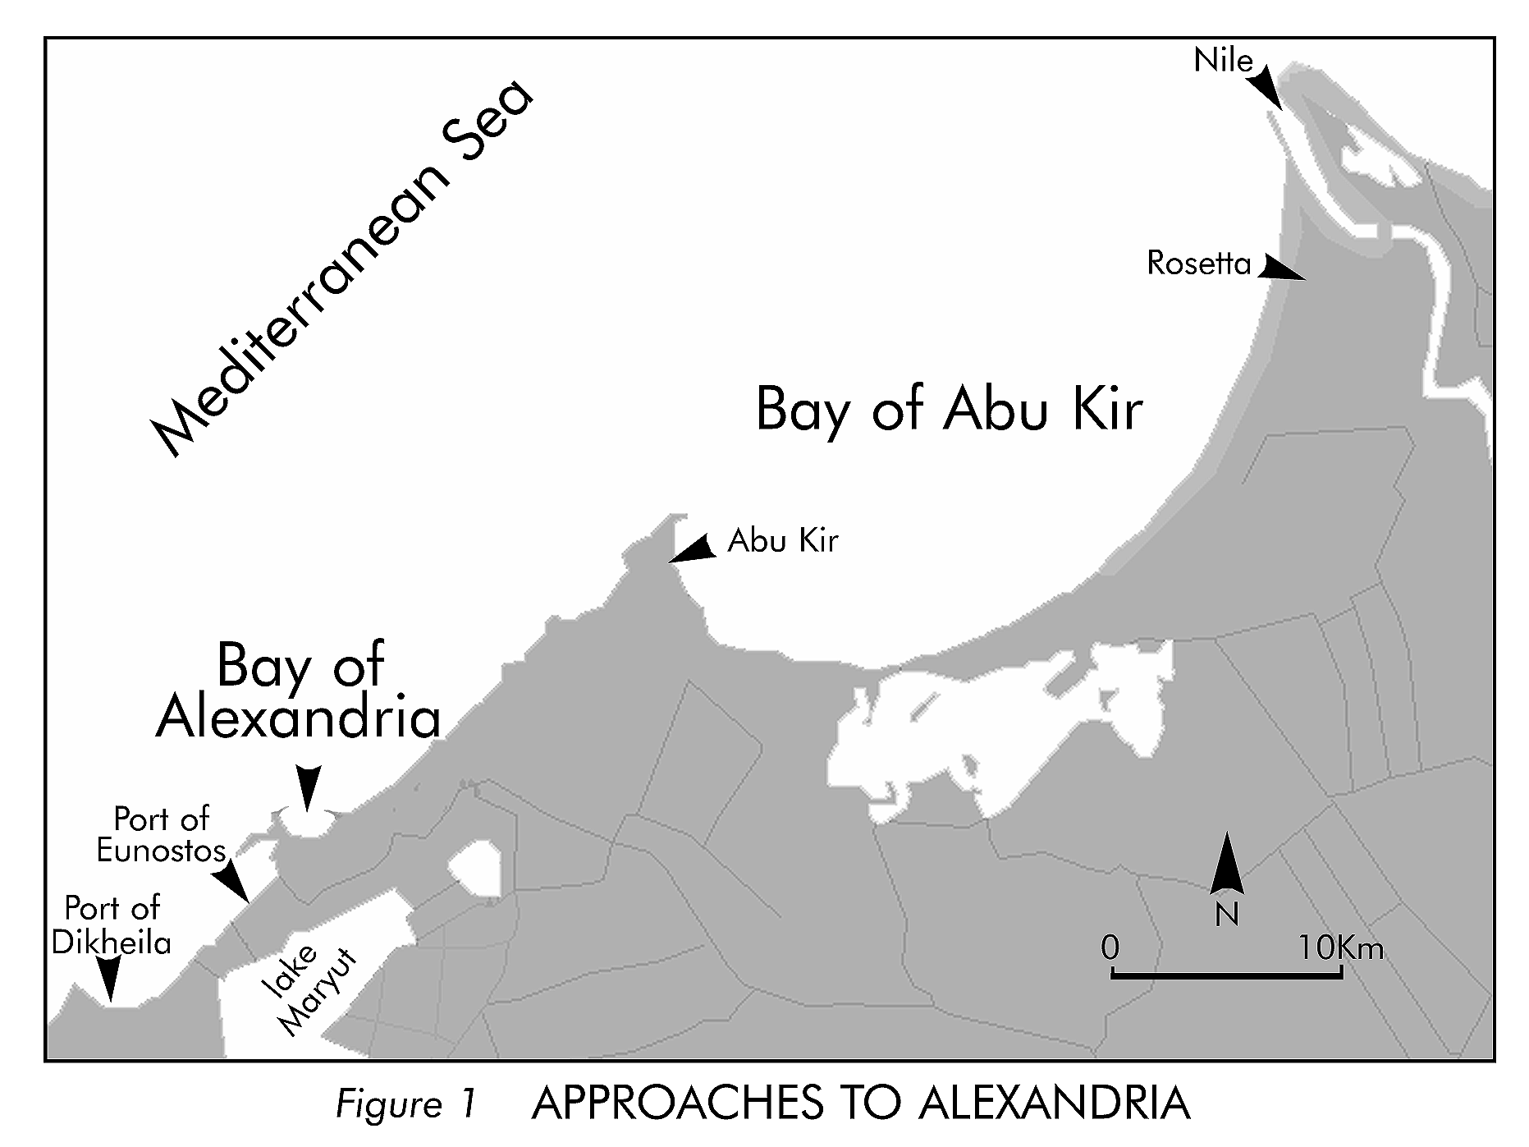
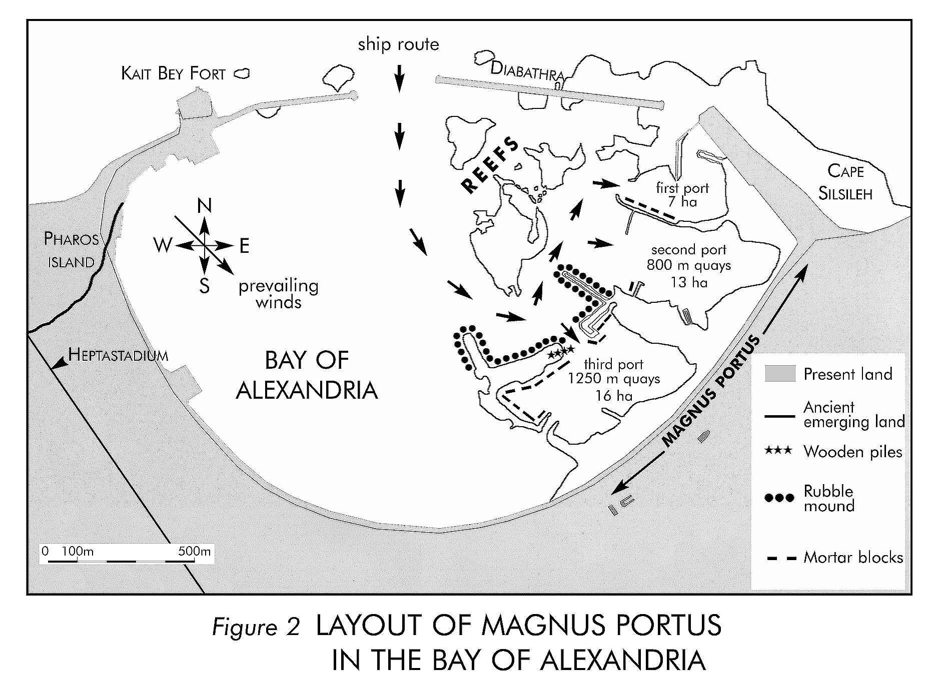

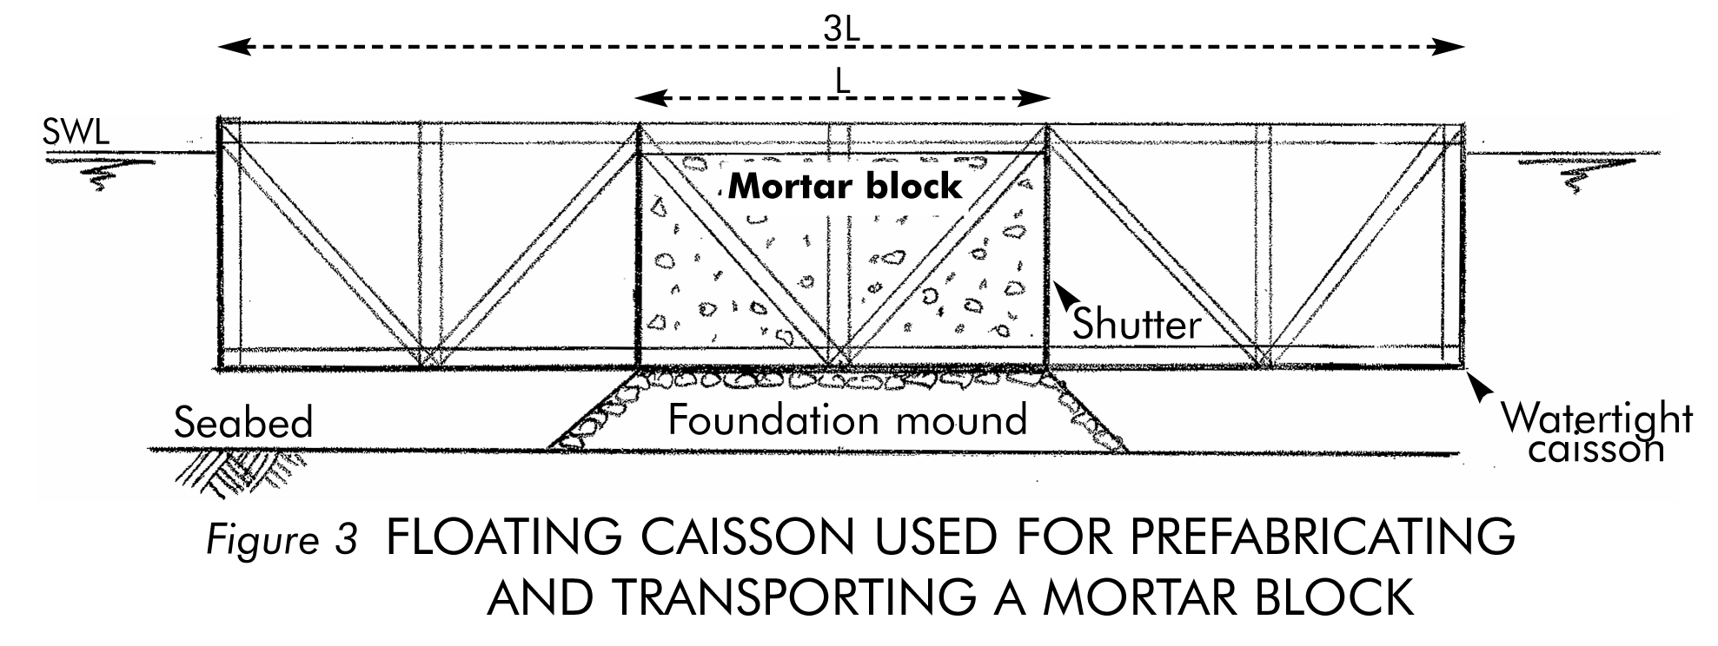

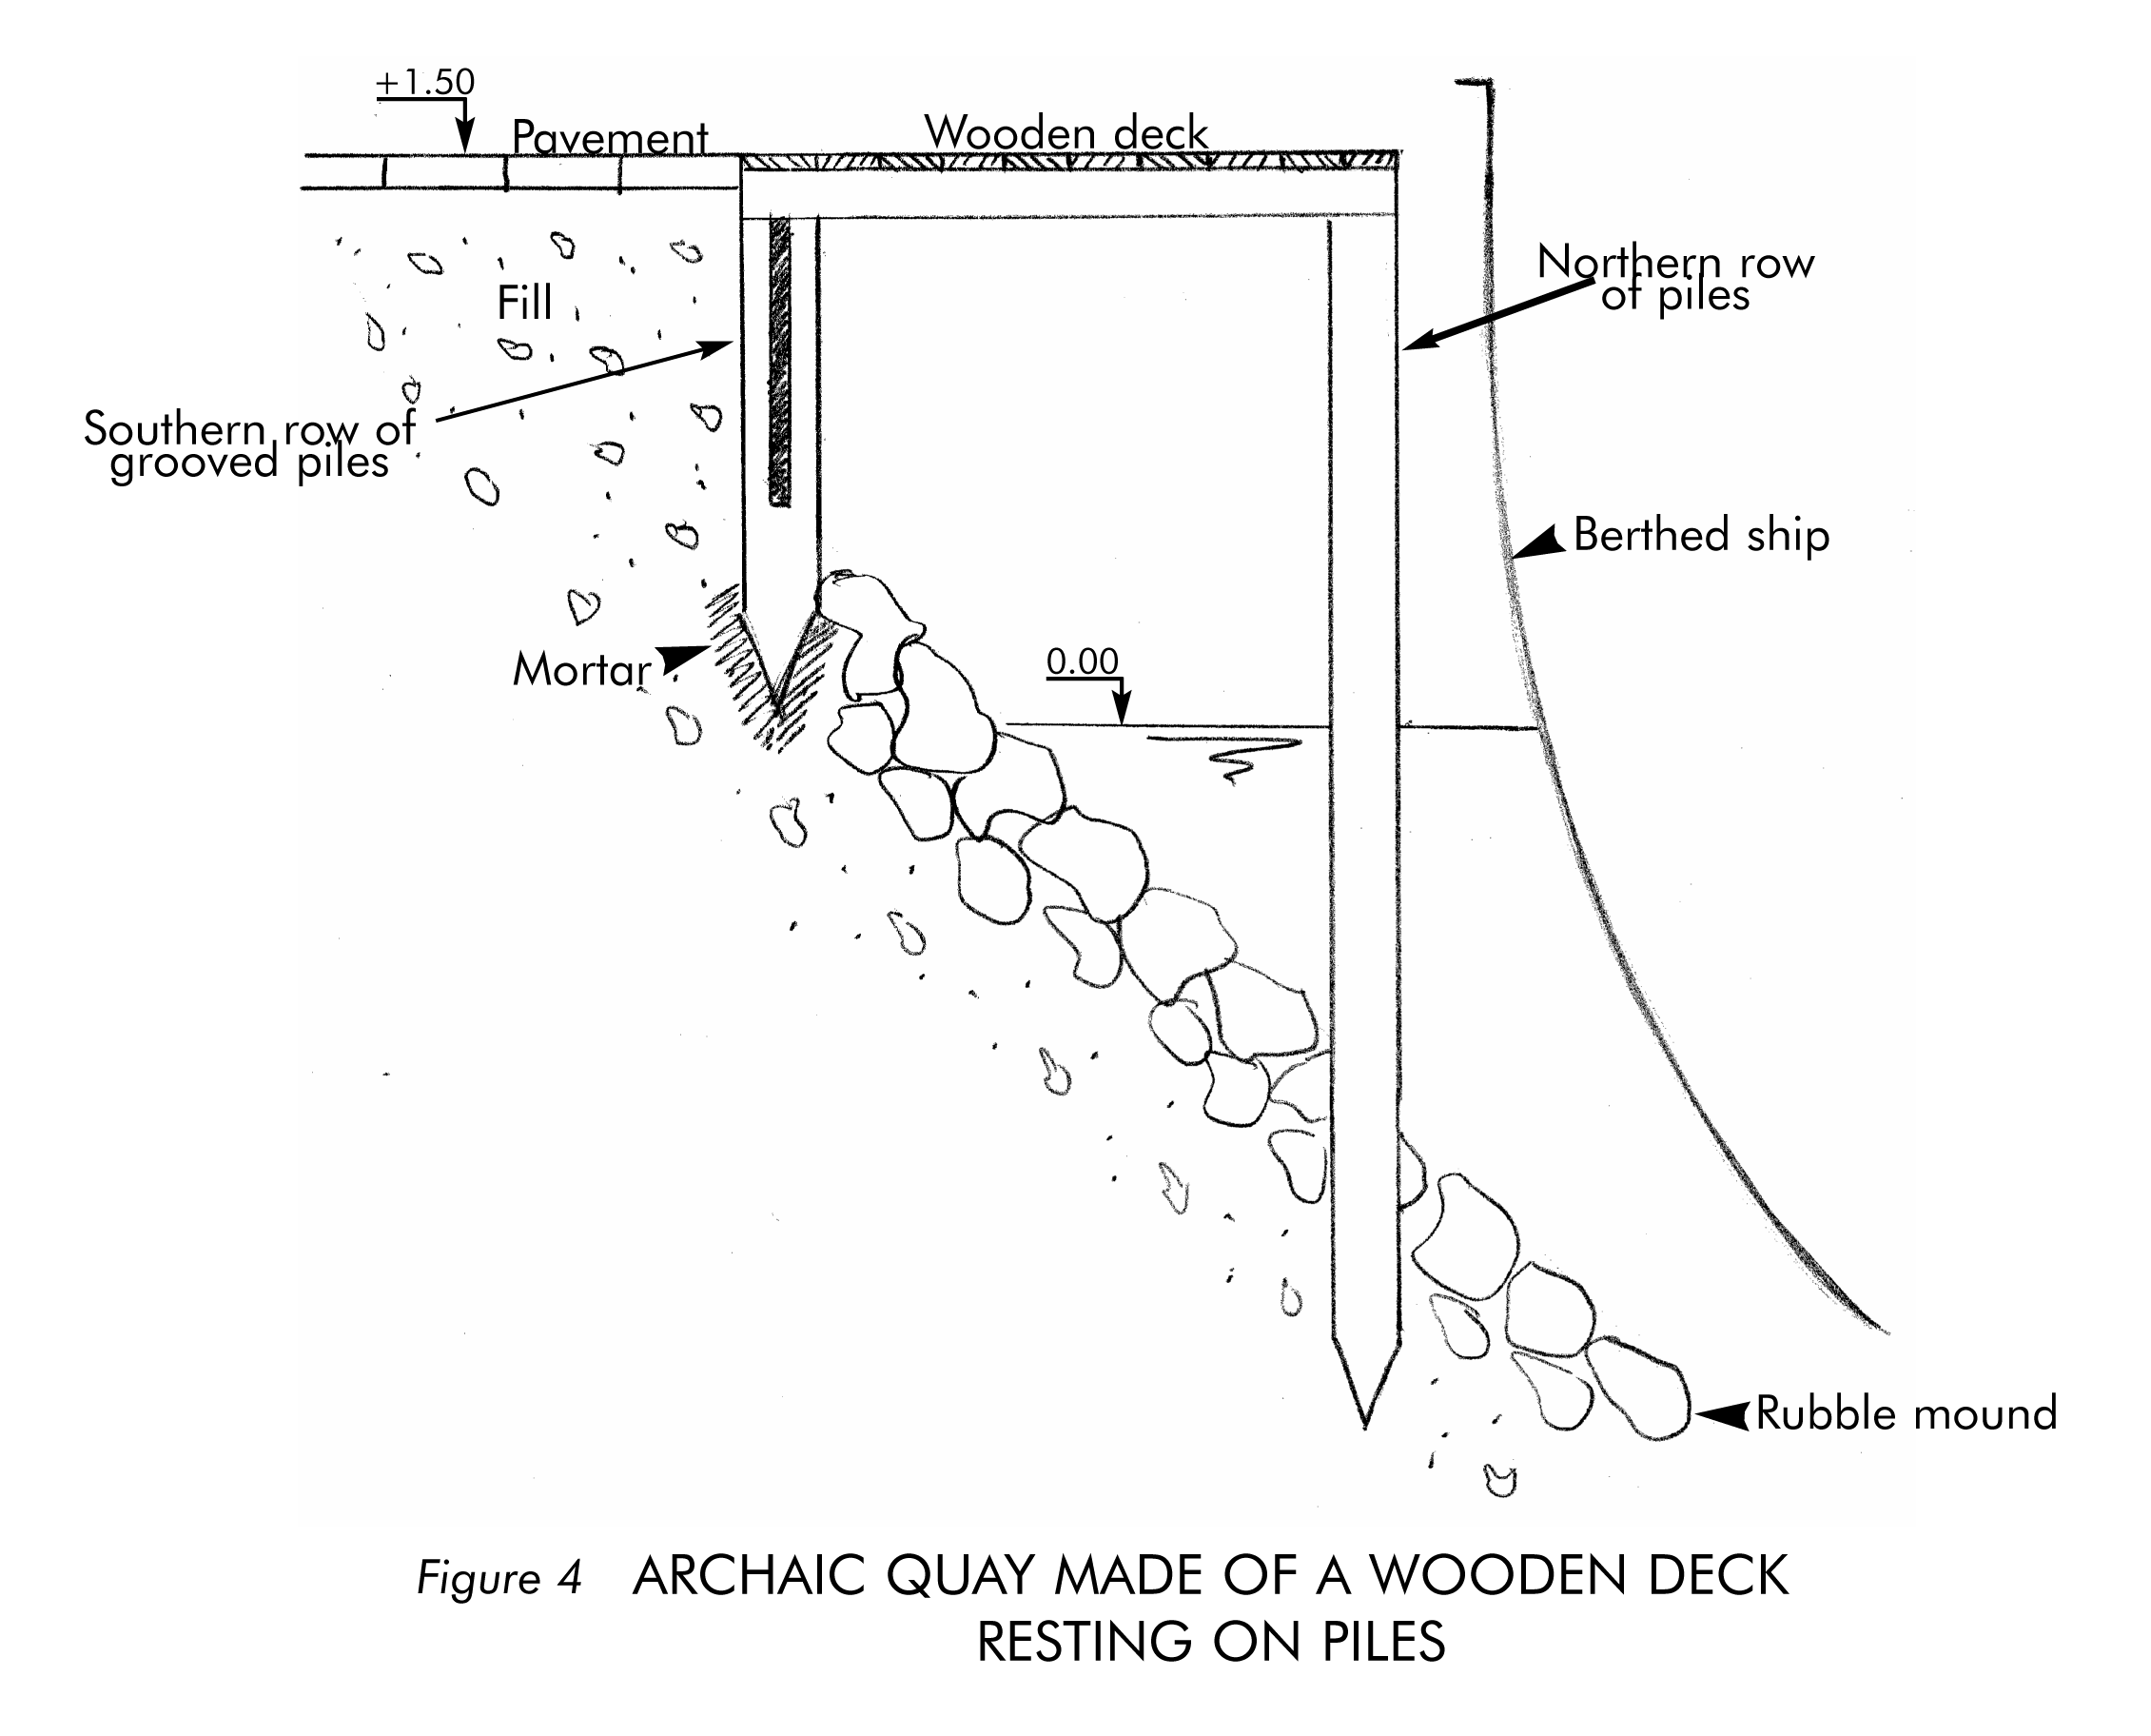

Maritime engineer, SOGREAH Ingénierie, Grenoble, France.

