GREEK MARBLE QUARRIES IN THE ARCHAIC, CLASSICAL, ROMAN AND BYZANTINE ERAS: TECHNIQUES AND ORGANISATION

by Tony Koželj
in Archeology, Knowledge&Means, Origin
http://www.pietradiparagone.com/origin/greek-marble-quarries-in-the-archaic-classical-roman-and-byzantine-eras-techniques-and-organisation/

Many years devoted to studying Greek quarries and close observation of the areas where stone is extracted allow me to affirm that the methods of work employed in Ancient, Roman and Byzantine times were similar (1). On the other hand, the requirements relevant to each period were distinct. In fact, they were conditioned by an understanding of the construction methods used by the architects, as well as of the natural resources available in the various regions.
In Ancient Greece, the walls of public buildings were constructed with large blocks of hewn stone. The buildings were entirely supported by the walls and the colonnades. Evidently, this method of construction necessitated a considerable amount of precision work in the quarries.
In Roman Greece, the building techniques had greatly improved, side by side with the evolving conception of architecture, which was seeking to create more ample and diversified spaces. Although construction with layers of large stones was still carried on, more and more frequently, bricks and mortar were employed for building walls and also for arches and vaulting. The nobler materials such as marble were exclusively used for facing interior walls and for certain kinds of decorative features. There was no longer such a need to open up vast quarries as had been the case in the previous era.
In the Byzantine period, marble was mostly reserved for religious buildings. Before seeking out new quarries the Byzantines recycled blocks and columns from previous ages, re-cutting them in most cases and then installing them with brickwork. Nevertheless, for certain items, such as the paving stones or columns for numerous churches and basilicas, they had, in their turn, to exploit some quarries. Although there was practically no difference in the construction technique, by contrast, I would say that the choice of marble veins differed according to the period.
In Ancient Greek times, white or nearly white marbles (Naxos, Paros, Thasos, Pentelikon, Agrileza, etc.) were the most sought-after for the exteriors of buildings, and this because the reliefs and colonnades of the temples were embellished with coloured paint and a neutral background enhanced the chromatic effect. Coloured marbles and porphyry, which were likewise used, were reserved for strictly structural components and for internal decoration. Among the extremely rare exceptions we can mention the Tholos at Epidaurus, built using white marble for the exterior, black marble for the inside walls and polychrome marbles for the floor. In the Erechtheion on the Athenian Acropolis, grey marble was used for the background of the external frieze.
In Roman times, the decorative effects desired meant that polychrome marbles were sought throughout every Province of the Empire and many quarries were opened producing a great variety of marbles. Just to give a few examples, I would mention the Portasanta quarries (red and grey), those on Chìos (pink and white pavonazzetto) and the green cipollino from Euboea (2).
During the Byzantine period, the recycling of older materials completely did away with any idea of choosing marbles on the basis of their colours (3).

THE TYPES OF QUARRIES
In Greek and Roman times, we can distinguish two types of quarry:
a) on the one hand, temporary extraction sites, serving exclusively for the extraction of blocks required for a specific building or for creating a sculpture. These quarries were generally in the vicinity of the site where the building or sculpture was to be erected and were only opened for this purpose (4).
b) on the other hand, there were the permanent quarries. In this case, there might be a group of small excavation sites such as at on Euboea (Styra), or on Thasos (Alyki), or alternatively, a large site could be divided into different sectors according to the various stages of the work process, such as the one on Chìos. The situation was completely different and, to a certain extent, less complicated than in the previous eras, during the Byzantine period. While some new quarries were opened, in the main, builders recycled blocks from pre-existing constructions, in order to erect their own religious buildings, which therefore occupied the sites of the previous pagan temples. This allowed for the re-adaptation of the building materials themselves according to requirements. The pieces discarded after cutting and the Greek and Roman devotional statues were burned to obtain lime used for plastering the inside walls of the churches and for making mortar. We know from texts and inscriptions that in Ancient and Classical Greece quarrying was mainly a private enterprise, while in Roman times, it was an imperial monopoly. On the entrance walls of many quarries one can read the name of the head quarryman either in full or in abbreviated form (ill. 1).

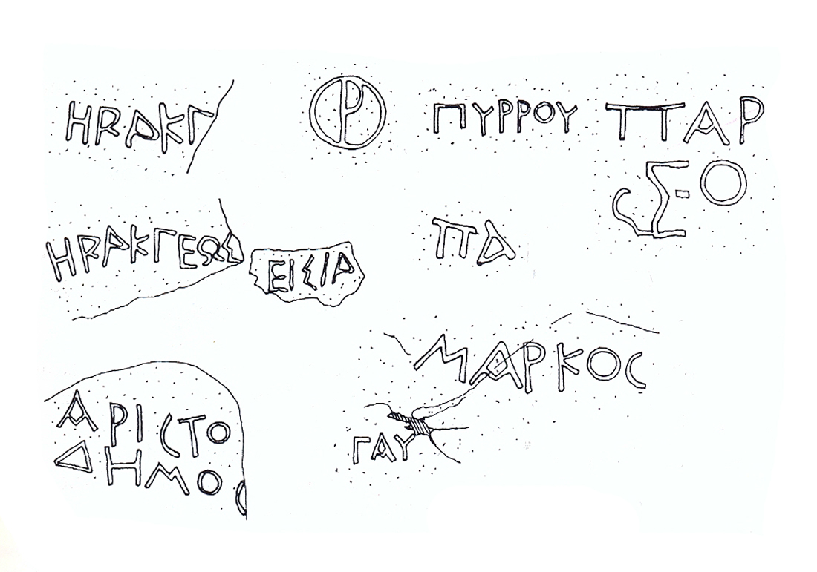
ill.1 The Names of the Quarries (drawing by T. Koželj)

It goes without saying that the choice of quarry depended on the quality of marble required in order to create a particular monument or sculpture. Small samples of marble 30 x 30 x 15 centimetres were removed in order to establish its physical properties, such as the compactness of the grain (5), the aesthetic quality of each vein, the hardness of the marble and its resistance to the implements. In the Vatission quarry on Euboea one can clearly see the marks left by the extraction of samples on a vertical face (ill. 2).

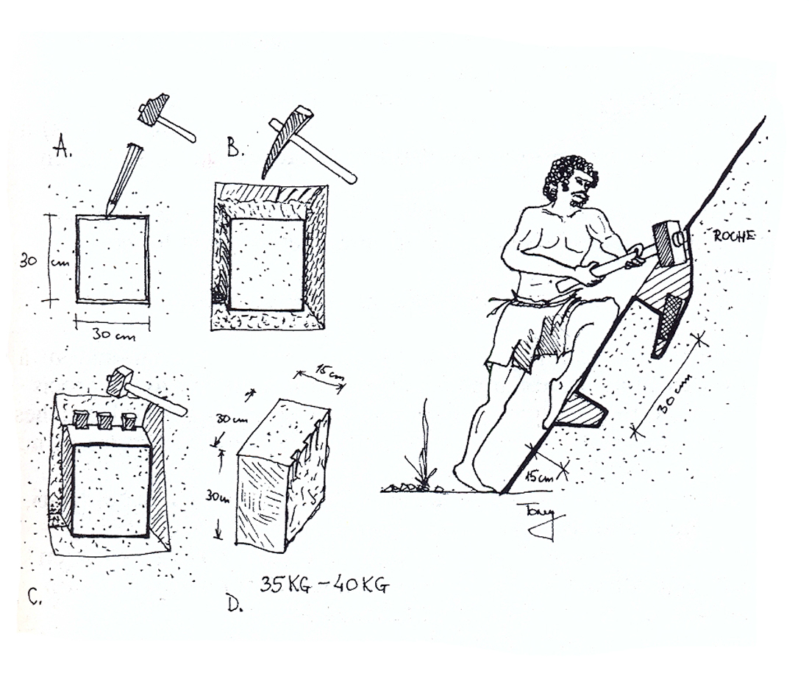
ill. 2. Extracting Samples of Rock (drawing by T. Koželj)

At present, there is only evidence of the practice of sampling during Roman times.

ORGANISATION OF THE QUARRIES
The kind of infrastructure associated with the quarry was dependent on its location and whether it was temporary or permanent.
A temporary quarry was generally in the vicinity of the site where the monument or sculpture was to be installed and so the amount of work required to remove and transport the blocks was not great. Often it was limited to opening up access routes from the quarry to the construction sites or to the sea if maritime transport was needed (6).
The permanent type of quarry had a precise infrastructure reflecting a rational organisation where each single element had its own place.
Luckily, apart from the numerous vestiges which remain, we are also in possession of a great deal of information deriving from important epigraphic evidence (7).

THE DIFFERENT WORK SECTORS OF THE QUARRY
The extraction zone was the first to be determined; after that a platform was created where the blocks could be kept and where they could also be squared and rough-hewn and prepared for transport. Not to be forgotten is the sector where the rubble was piled up and which could sometimes pose a problem because of the straitened configuration of the quarry (ill. 3).

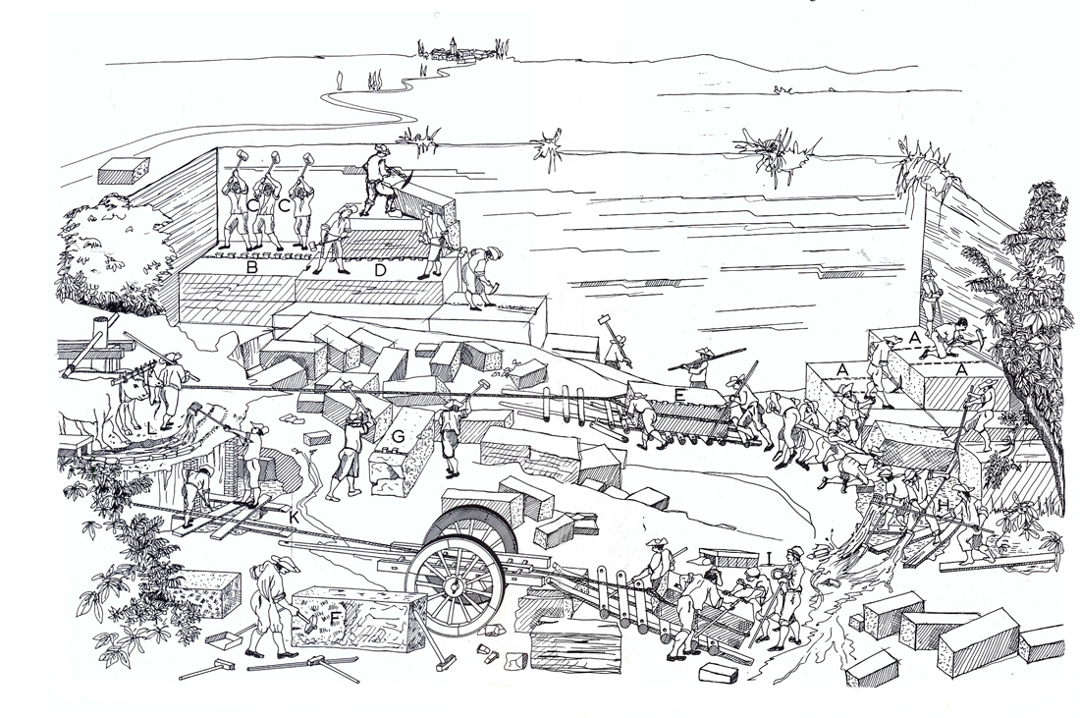
ill. 3 From the 1743 engraving by Nicola Zabaglia, depicting castles and bridges (drawing by T. Koželj).
Contignationes, ac Pontes Nicolai Zabaglia. Una cum quibusdam ingeniosis praxibus, ac descriptione transalsionis, obelisci vaticani, aliorumque per equitem Dominicum Fontana susceptæ (GR F 28 e.f.a. ROMA)
Description of plate XIV from the 1743 engraving
The travertine quarries lay at a distance of about 12 miles from Rome. The quarries on the Tivoli hill were excavated and were the easiest to exploit. The veins of travertine appear at a depth of between 3 and 4 palms below the arable earth. The quarrymen dug out a kind of deep pit until they reached a stratum of clay soil about half a palm deep extending horizontally right across the plain, out of which the groundwater sprang. The best-quality travertine is found below this stratum of clay at a depth of about 30 palms. The quarrymen traced the dimensions of the blocks to be cut out using a pick with a pyramidal point, as shown in A, they then made holes a palm deep where they could place the wedges, drawing B; C shows the workmen positioning the wedges by hitting them in a synchronised way with iron sledge-hammers; D shows them using the same method to cut the blocks horizontally; in drawing E they are pulling the blocks up onto wooden logs with the help of ropes and a wheel; F and G illustrate the quarrymen squaring and rough-hewing the blocks and levelling off the faces; in H they are digging a drainage ditch to channel the water into a reservoir such as the one shown in K; finally, other workers excavated another channel to conduct the water away from the worksite as can be seen in L.

THE WORKSHOPS
In order to ensure that a quarry functioned properly, it was necessary to be able to make and repair the tools and other objects needed to carry out the work. So, in proximity of the areas of extraction there were carpentry workshops, where the wooden wedges were prepared and repaired, as well as the lifting machinery; metal workshops, where it was usual to find hollowed out marble blocks, some of which contained the small fires needed to forge the metal wedges or melt down damaged utensils, while others were used as tubs to contain the water required to cool down metal after smelting or hammering out.
The set of tools used in quarries has hardly changed over the centuries. First and foremost, there were the two types of pick: the pickaxe with a flat cutting edge on one side and a pointed head on the other, which was chiefly for use on soft stone; then there was the short-handled pick with a cap-like head and curved points which was, known as the «martellina», and was used on hard stone or for chipping out a narrow channel to disengage three sides of a block. Both of these instruments are shown on a red-figure Attic vase dating from the IV century B.C. conserved in the Musées Royaux d’Art et d’Histoire in Brussels.
The axhammer (either τύxoς or τύχoς) is the quarryman or stonecutter’s hammer par excellence serving for rough-hewing, facing and rudimentary finishing. One end has a square head and the other is pointed enabling fine blows to be struck (8). The tooth-edged stonecutter’s hammer in the shape of a double-headed axe used for facing quadrangular blocks.
Among the hammers one must distinguish the mason’s hammer with one squared head and the other bevelled. Those figured on vases more usually have two square heads. This hammer was used in the quarry together with the chisel for the most complicated tasks. These were the tools that were employed in the delicate operation of cutting out projecting blocks and for making the holes to hold the wedges.
The borer was used for drilling holes in preparation for detaching the block from the rock face.
The stonecutting was completed at the construction site not in the quarry and included such tasks as levelling, chasing, and smoothing. For these operations, the masons used a variety of instruments such as the point also called broach or awl, the flat-bladed chisel, the gouge, toothed chisels or claws, either a chisel with a narrow blade (κολαπτή), or a rasp or scraper (ξυστήб) with several blades, useful for carving ornamentation and for eliminating any remaining protuberances or bulginess.

LIFTING EQUIPMENT
We know of several different types of machinery from Medieval reproductions. As regards the ancient era, I have been able to establish which kind of lifting machinery was used by the repeated observation of similar sized notches and their position in relation to the extraction faces.
The machines were of different size and strength according to the size of the blocks.
– The smallest had a handle which was turned by one or two workers and could lift a load of between 100 and 120 kg.
– The machine with two cross-shaped handles which required four men to work it and could lift 300kg.
– The drum-shaped machine with a diameter of three meters was operated by two men and could lift about 1000 kg.
– The simple hoist could lift 2 tons.
– The drum hoist and capstan could lift up to 4 tons.
– The single cylinder machine which was operated by two men and fitted with hoisting-gear lifted 10 tons.
– The double cylinder machine requiring four men and complete with hoisting-gear was able to lift up to 25 tons.
There were also machines devised specially for particular constructions. This was the case for the Parthenon where a machine with two lateral hand-winches and a marble counterweight was employed.
The construction of the port of Amathus in Cyprus required the creation of a completely novel piece of lifting equipment. By studying how the quayside blocks, which were all of the same type, had been installed, I was able to reconstruct the equipment used. The blocks placed in the rear of the machine were lifted using an arbour and, thanks to the pendular movement of this, were then able to be placed in exactly the right position. Once the foundations were in place, the machine could advance and repeat these operations.
It could also have been necessary to create special lifting equipment to move blocks inside the quarry itself when it was not of an adequate size to allow the use of traditional machinery.
Two similar devices appeared in the quarries at Latomi on Chios and at Mount Pentelicus in Attica. In narrow extraction areas, holes were bored in the upper parts of the opposing faces so that two cables could then be attached there crossing over in the middle. Hoisting gear could then be fixed to the central point.

ACCESS ROUTES
The difficulty of creating access routes varied according to the location of the quarry. The most favourable position was on or near the coast since maritime transport was the most economical
Once the blocks were squared they were conveyed to the sea by the use of standard lifting equipment and transportation vehicles; then they were shipped on board cargo ships used for standard blocks, and which were tugged by two vessels used for blocks of large dimensions (9) (ill. 4).

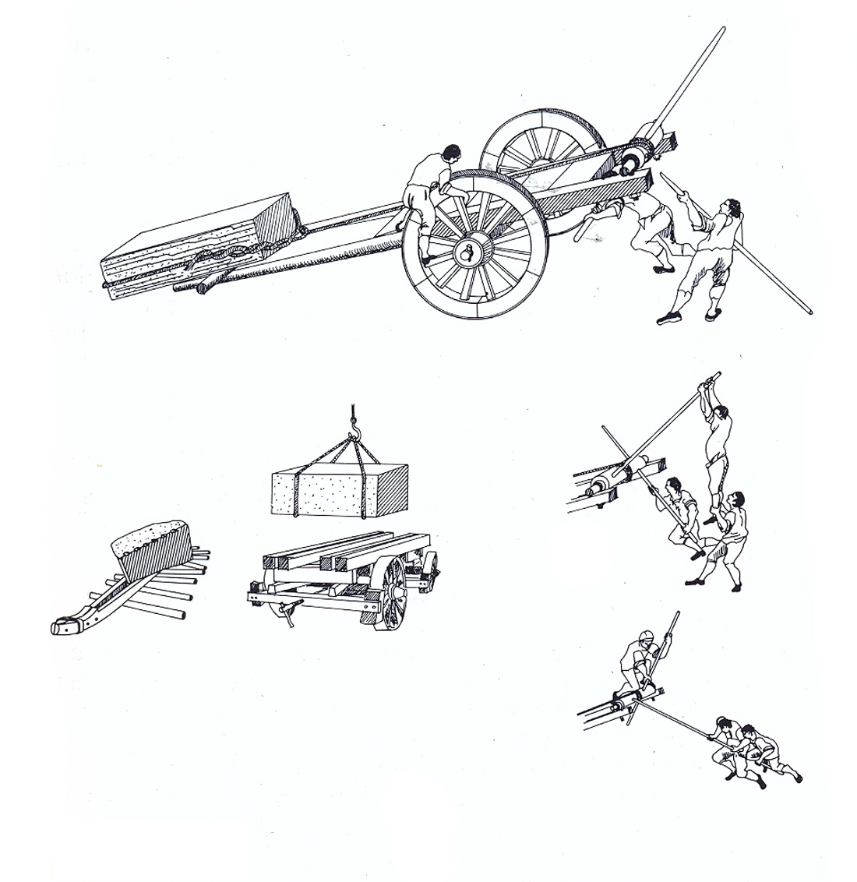
ill. 4 Machinery for transportation (drawing by T. Koželj)

Quarries in the mountains required more sophisticated installations such as sledges rolled down pathways created with timber rollers, a technique known as “lizzatura” (Mount Pentelicus, Styra). There were also pathways linking one logistical area of the quarry to another.

THE SANCTUARIES
These were installed in the immediate vicinity of the quarries. These shrines basically consisted of an image of a deity and an altar on which to place offerings. Usually they were dedicated to Artemis or Hercules, who was often represented in a reclining position (ill. 5).

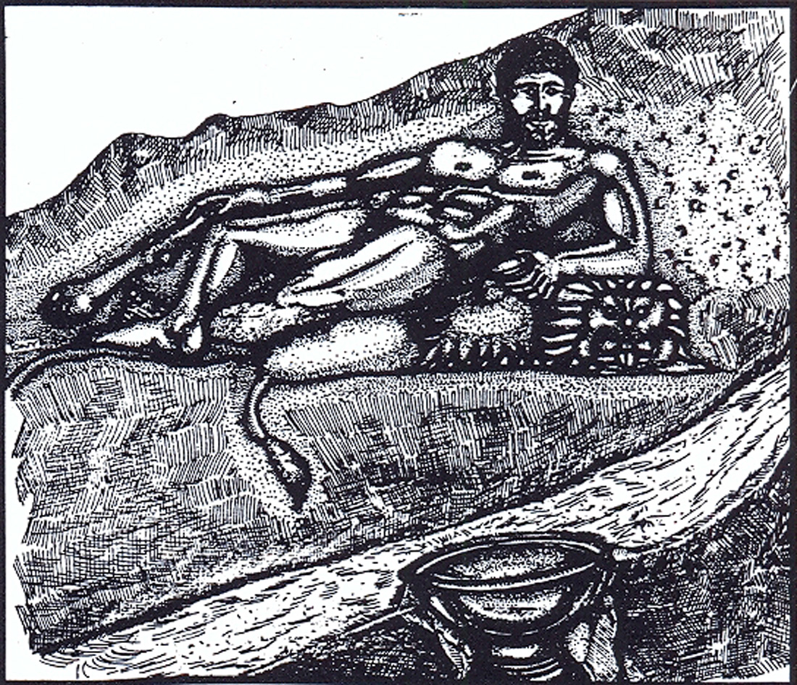
ill. 5 Hercules Reclining (drawing by T. Koželj)

Offerings were made in order to supplicate the divinity to grant the workers their strength, since quarrying was extremely difficult and laborious work (10).
During the Byzantine period, prisoners would secretly paint or carve small shrines to their divinities, while a profusion of crosses and other Christian symbols also began to make an appearance (ill. 6).
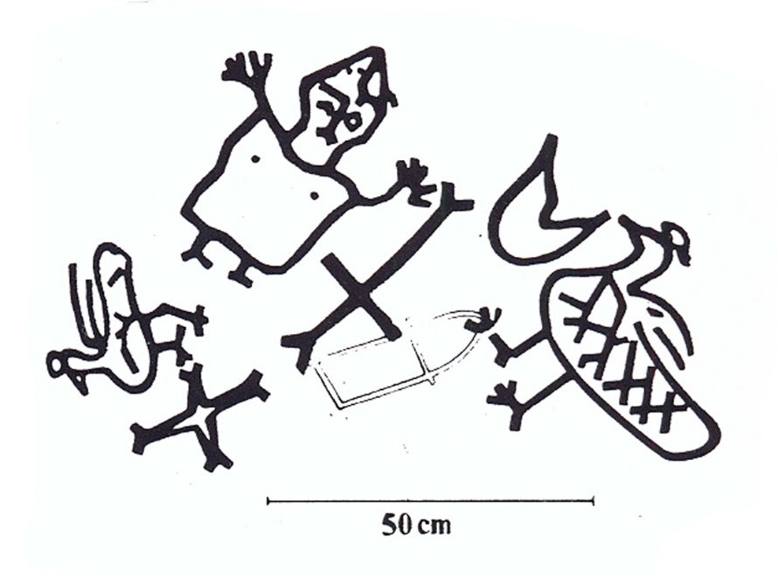
ill. 6 Crosses and Christian Symbols (drawing by T. Koželj)

ONE, OR EVEN TWO WATCHTOWERS
Given that the workforce of the quarries was principally composed of slaves and prisoners a certain number of military overseers were required, first of all, to stand guard over the workers, and secondly to supervise the handling of the blocks (11).

HOUSES IN STONE
Rudimentary houses for the workers were situated in the immediate vicinity of the quarries, and the discovering of a stela at Saliara (Thasos) led us to presume the existence there of a necropolis. In this case, too, we can observe a close link with what was done in the mining district of Laurion. Even nowadays, housing for the quarrymen is located close to the quarries.

SOCIAL ORGANISATION
It is possible to affirm that the workforce in the quarries had a hierarchical structure, and, in order to give a summary outline of this, one can say that the task of the manual labourers was to mark out the size of the blocks and bore the holes for the wedges; the technicians supervised this work and set a mark of approval ‘д’ on one face of the block to be extracted. In Greek times, ‘д’ signified “πελέκηοις” (rough-hewing) or “πελέκίξειυ” (to rough-hew); in Roman times, ‘д’ signified “probavit”, a kind of green light for the extraction to proceed. The excavation work (the quarry supplied a product complete with a protective sheath ready for transportation) and the transport itself were tasks carried out by the labourers under military surveillance (12). The head quarryman numbered the blocks and marked the destination on them using a cipher. It could also happen that the blocks simply bore the name of the destination. The same head quarryman was responsible for delivering the blocks to the quayside.

EXTRACTION TECHNIQUES
Sites for excavating marble were already in existence in the Neolithic Era. Naturally, the organisation of the quarries was very basic, but we can observe that they were located in close proximity to the burial sites. Neolithic people used a system of levers to extract slabs of marble with which to cover their tombs; in other words, they introduced the arm of a lever into a pre-existing fissure and by leverage were able to detach and overturn the layer of stone and thus obtain a slab. This is what happened at Castro on Thasos, for example (ill. 7).

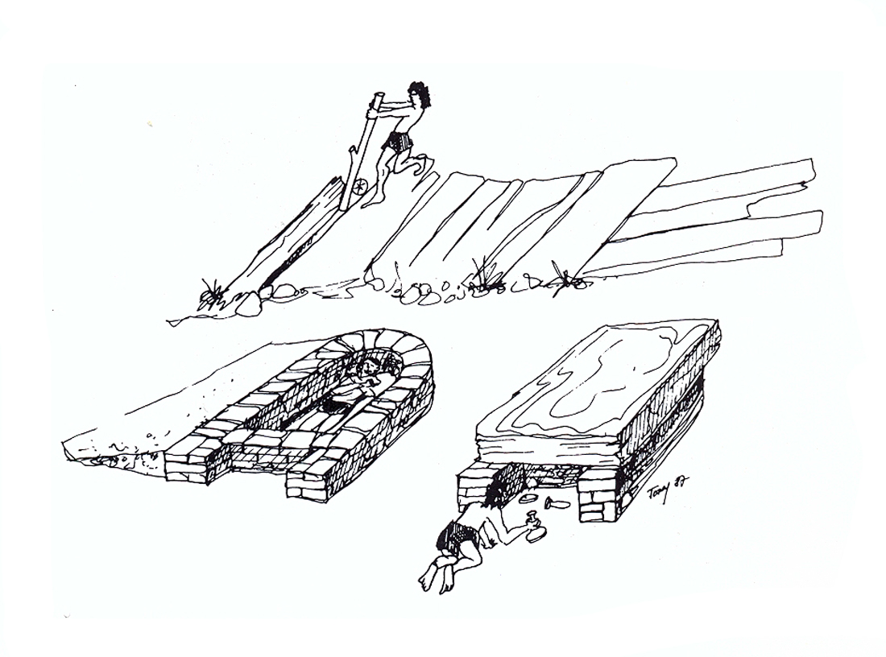
ill. 7 Extraction of a Slab (drawing by T. Koželj)

With regard to the periods under examination, that is to say, Archaic and Classical Greece, and the Roman and Byzantine periods, the methods of extraction were similar.
Having decided upon the extraction site, the first stage consisted of identifying where to place the holes to be bored, in which to position the wedges, taking into account the height and length of the blocks required. This process was repeated as far along the mountainside as necessary in order to obtain the number of blocks needed.
The key factor was the hardness of the stone. This is what determined the choice of wedges, and consequently the size of the holes to be bored and the distance between them. For soft stone, the stonecutter would use wooden wedges which he had soaked in a basin of water overnight and then left to dry out in the sun, in order to make them more resistant. For hard stone, he would use iron or bronze wedges. It goes without saying that the size of the holes depended on the dimensions of the wedges to be used. In the same way, the spacing of the holes depended on the hardness of the stone. The softer the stone, the further away from each other the holes were placed (13).
The second stage was to hollow out a channel around the three enclosed sides whose depth corresponded to the final width of the block. According to the space available to the quarrymen for the extraction and the type of tools used, they would hollow out a channel which could be from ten to thirty-five cm. wide (ill. 8).

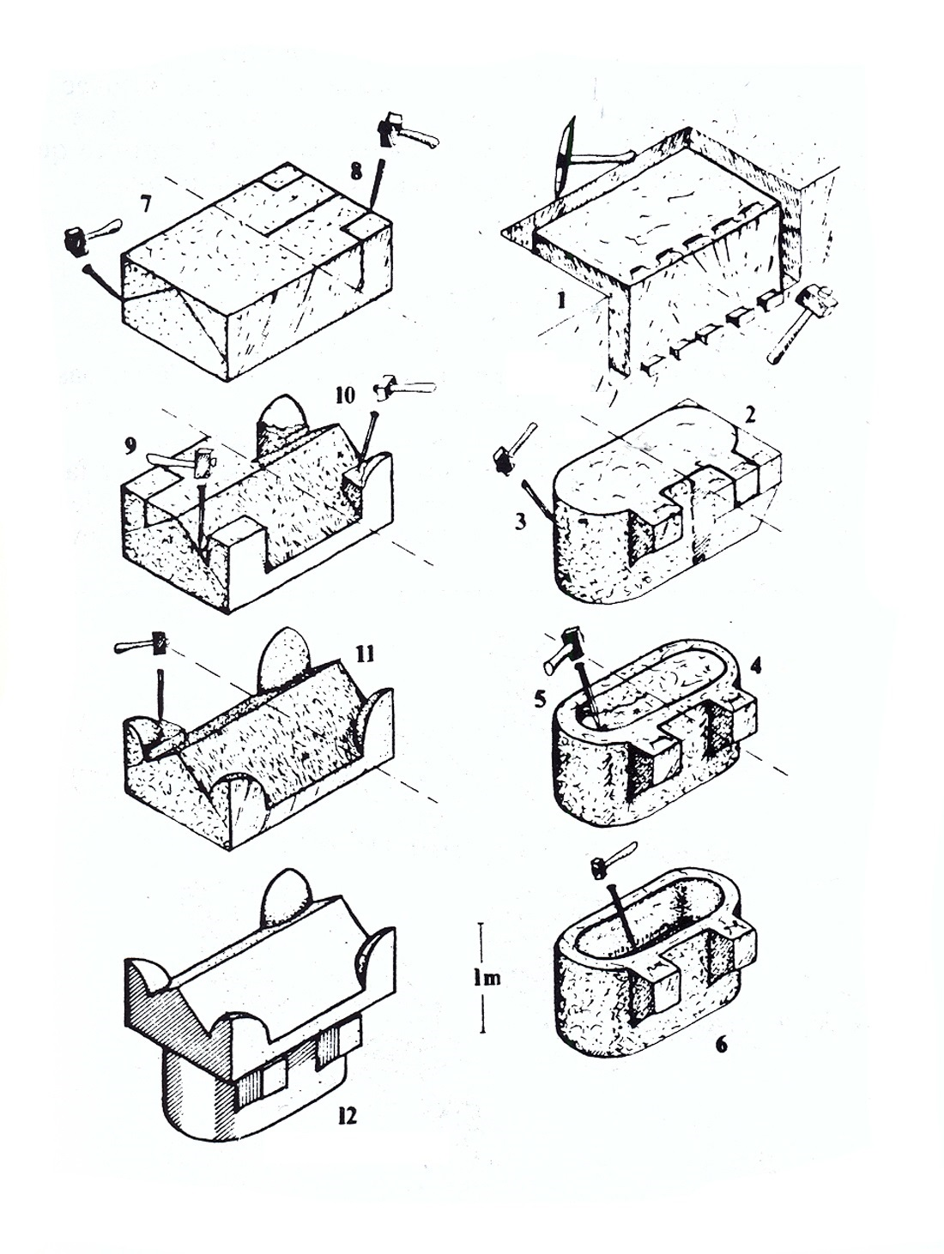
ill. 8 Extraction and Finishing (drawing by T. Koželj)

The blocks were now ready to be detached from the rock face.
Only now were the wedges inserted into the holes bored for that purpose. The wedges were knocked into the holes with a series of synchronised blows using sledge-hammers until the block was completely detached. This co-ordination was absolutely essential to ensure the correct cutting of the block. Naturally, we can observe slight differences according to the period in question.
In the Archaic and Classical periods, the organisational structure of the quarries was already entirely established and the techniques were fairly well-defined according to the type of blocks to be extracted. For example, in the extraction of large blocks, the marks showing the irregular dimensions of the holes for the wedges demonstrate that the latter were not fabricated in a standardised way. Example: Pyrgos (Thasos).
This is also the period when very large blocks were being extracted to be subsequently divided into several more. We can observe either the presence of a natural fissure, which allowed for the easier extraction of huge blocks, or the existence of a channel hollowed out so that a man could slip inside and continue to work at a greater depth until the block was freed from the rock face, in a similar way to what was done in mine galleries. Example: Pyrgos, Phanari (Thasos) (ill. 9).

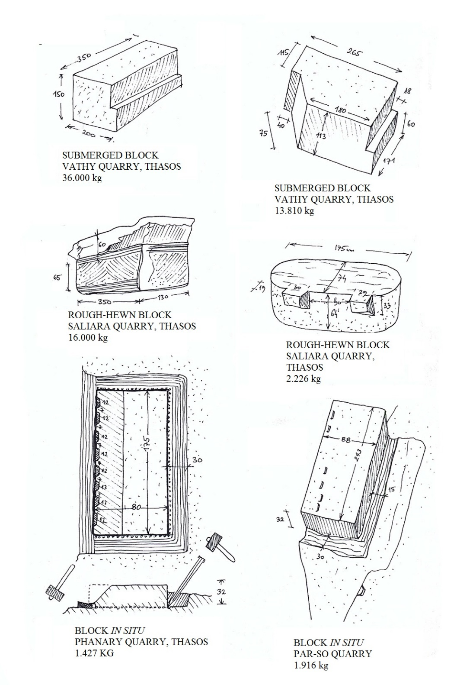
ill. 9a Extraction and Finishing (drawing by T. Koželj)

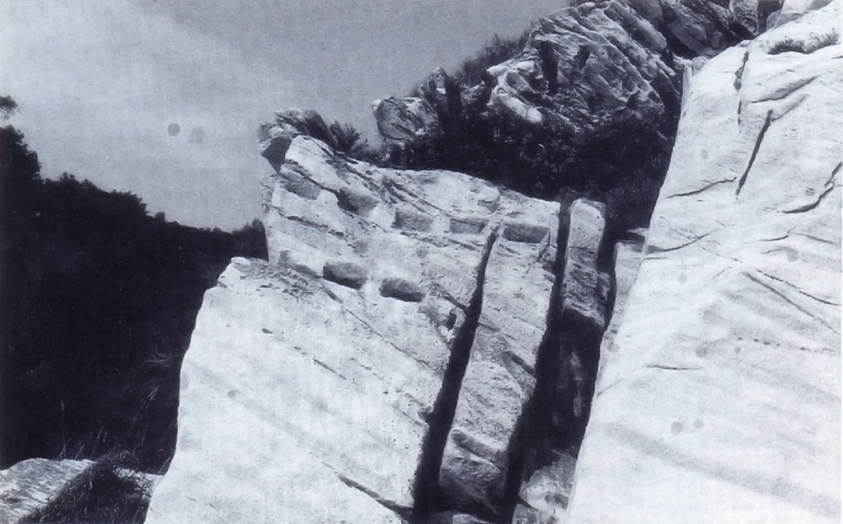
ill. 9b Rock Face with Holes for Wedges

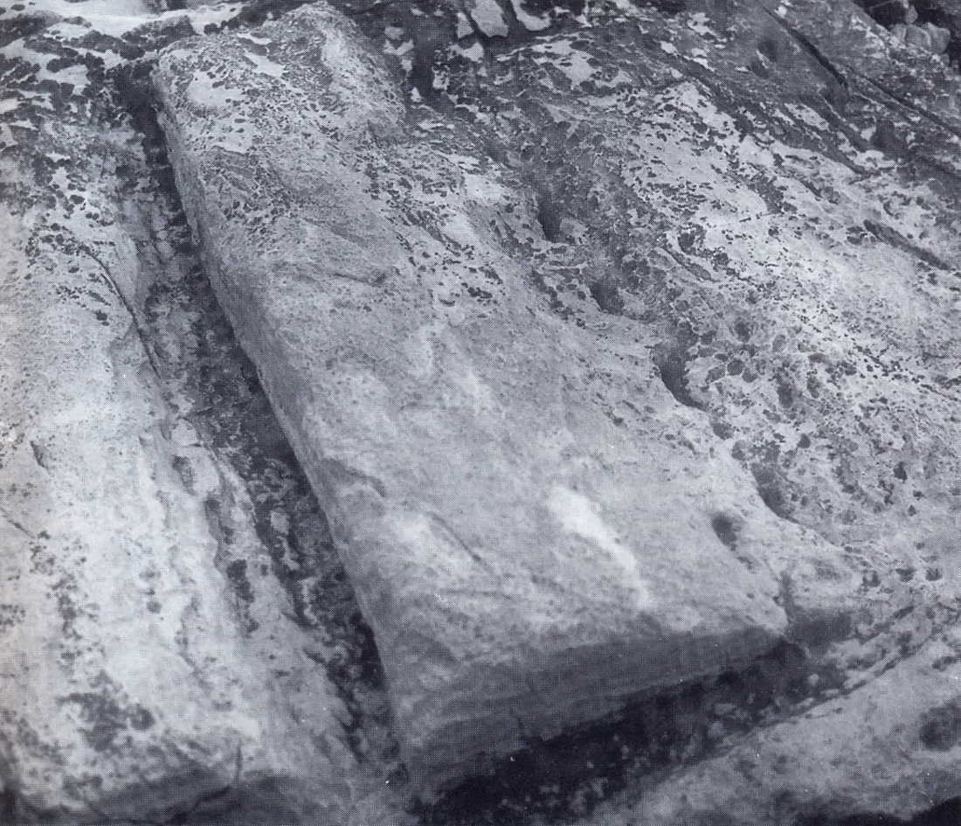
ill. 9c Marble Block with Holes for Wedges

In the case of blocks to be sculpted or used for decorative items, the work of extraction was far more meticulous and chisels were used to reinforce the action of the wedges.
The wedges were of standard dimensions and the spaces between the aligned holes were at regular distances. Before the wedges were put in place, using a chisel with both hands, little holes were made equidistant from each other in the hollowed-out channel. In this case, too it was essential that the blows delivered by the sledge-hammer on the wedges and chisels were strictly synchronised so that the block came cleanly away from the rock face. More precisely, the angle of impact had to be no more than 30° to avoid splintering. In particular, this technique was employed at Phanari (Thasos) and at Naxos in the quarry of the three Kouroi.
I should like to make a rapid comparison with what happened in Egypt, where the extraction of monumental granite obelisks necessitated a special technique for tracing the channel: red-hot bricks were placed on the granite marking out the shape of the obelisk to be extracted. When the stone was hot enough, it was sprayed with cold water rendering it more fragile. At that point it was only necessary to drop roundels of dolerite weighing about 5.5kg. onto the stone, from the height of a man, for the granite to crack open to a depth of between 2-3 cm.
The drums were detached in conformity with their circular shape by the creation of a small gallery in which the quarryman could work. The shaft remained standing supported only by its base which was in turn cut by following a fault line. The drum was then detached using wedges.
In Roman times rational organisation of the work prevailed: the wedges were smaller and all of them were of standardised dimensions. An example could be the Acropolis on Thasos where wooden wedges were used on schist. The holes had the same characteristics whether a block or a column was being extracted. The external appearance, or general form, was determined from the start; a design was made specifying the cylindrical shape of a column and its length (which could be as much as 12 meters). Example: Karystos in Euboea (ill. 10).

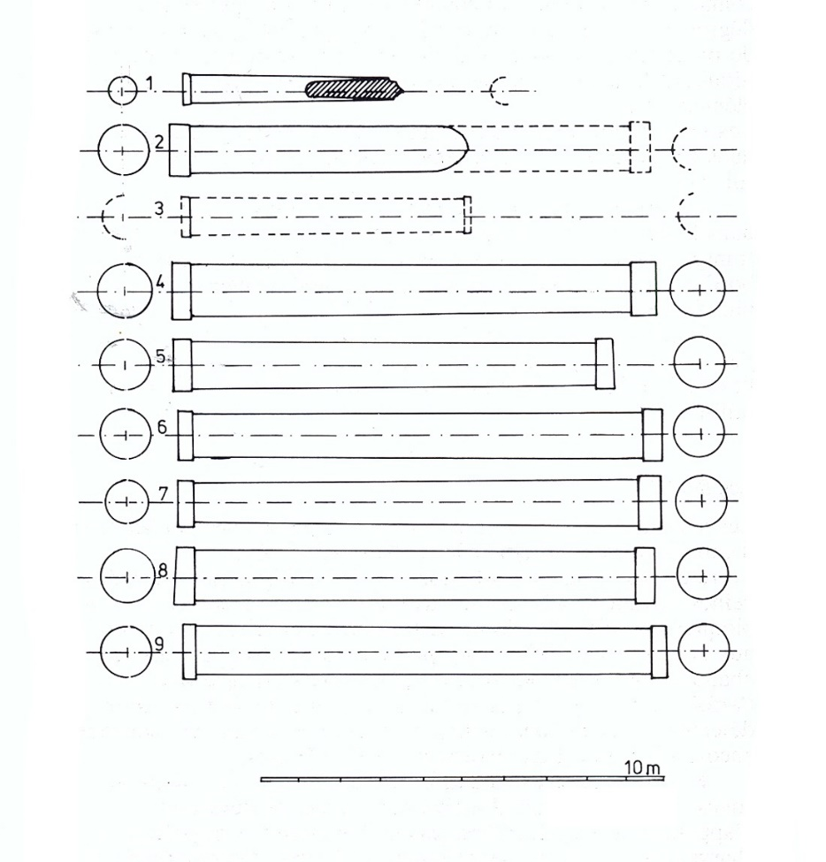
ill. 10 Drawing Determining the Cylindrical Shape of a Column (T. Koželj)

In the Byzantine period, the pagan temples were dismantled and the blocks recovered were used as raw material for the construction of Byzantine buildings (15). Extraction continued in existing quarries and some new ones were opened. Their localisation and organisation were similar to the ones which preceded them. The procedures were practically identical; the technique of wedges was still employed, but only on one side (the line of holes), and the peripheral channel on three sides, where a dotted line of cuts traced the limit of where all the workers had to operate with the same rhythm: cutting with chisels was the standard practice.
For the block to detach itself correctly from the rock face, it was essential that the chisels pierced the rock at an angle of less than 30° and that the work was synchronised. This method allowed for a much faster extraction of blocks.
The blocks extracted were far thinner and principally intended for use as paving slabs or for the decorative vertical facing of interior walls. A certain number of large columns were also quarried.
The squaring of the blocks in the quarry
Once the blocks had been detached from the rock face and conveyed to an open space, a second operation was carried out in the quarry. It was the rough-hewing both of the blocks intended for sculpture and those to be used for decorative items such as capitals. The edges were rough-hewn but the scappled face was left inside the protective sheath, since the point of the procedure was to lighten the weight for easier transportation, without compromising the solidity of the quarried items. The multitude of sculptured and architectural fragments found in ancient quarries testifies to this type of work (ill. 11).

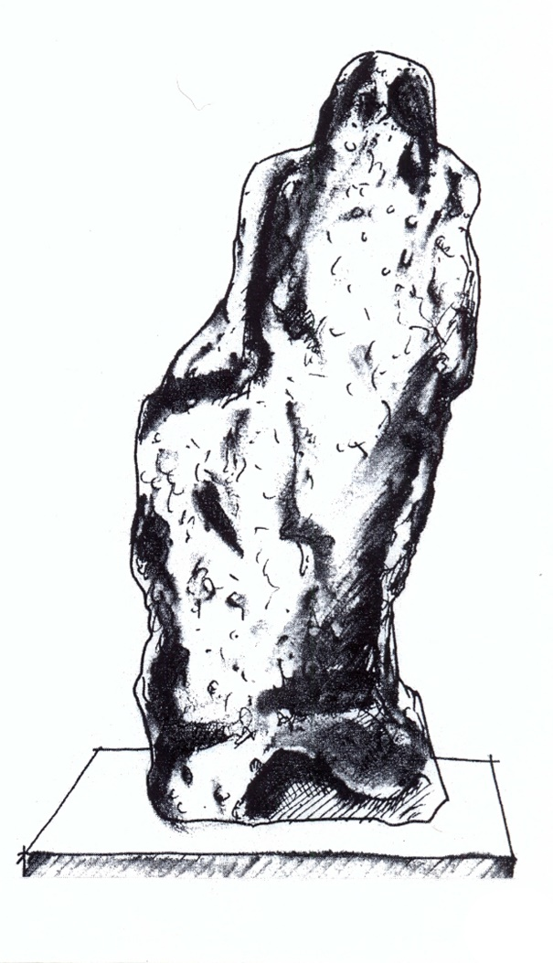
ill. 11 Drawing of an unfinished sculpture (T. Koželj)

In Roman times the greatest part of the squaring was done in the quarries. Nevertheless, as a protective measure, the edges of the blocks were left rough and formed a thicker border which made them easier to load.
In the section dealing with the organisation of the Byzantine quarries, I highlighted the importance of the sites for recycling and, in particular, the fact that the dressing of the stone was carried out at the very place where the material was to be utilised.

THE WASTE MATERIAL
The sites of old quarries are easily identified by the quarried rock faces, but also by the heaps of rubble.
The rubble had to be dumped far enough away from the seams being excavated so as not to interfere with the work being done, or to block the access and transportation routes linking the quarries to the workshops.
Sometimes the rubble was thrown into the abandoned parts of quarries once excavation had shifted to another site.
In other instances, the waste matter was deposited in conical mounds surrounded by walls which allowed for even larger quantities to be amassed. Example: Alyki (Thasos).
As for seaboard quarries, in areas where the coast is very hilly, there may be no heaps of rubble to be seen. In these cases, the quarry owners preferred to load the waste, a certain amount at a time, on board transport ships and dump it in the sea, at a suitable distance from the coast, so that it would not impede navigation. This kind of organisation is attested to at Phanari (Thasos).
There is continuity in the methods adopted for the disposal of waste material.

CONCLUSION
Starting in the final quarter of the last century, a large number of quarries have been opened especially on the island of Thasos. These have usually been set up on the sites of ancient quarries which offers a guarantee to the marble cutters of finding high quality veins and saves them the decidedly costly task of searching for new deposits. The installation of these quarries is the cause of enormous damage being done to the ancient quarries and very often this exploitation is responsible for their systematic destruction. The savage enthusiasm for this novel way of getting rich has up to now prevented any protective measures or intervention on the part of the archaeological authorities. Thus, in March 1986, the site of Saliara was totally destroyed and with it the base of a Roman sculpture, the lower part of a male statue and a Hellenistic relief of Hercules (ill. 12).

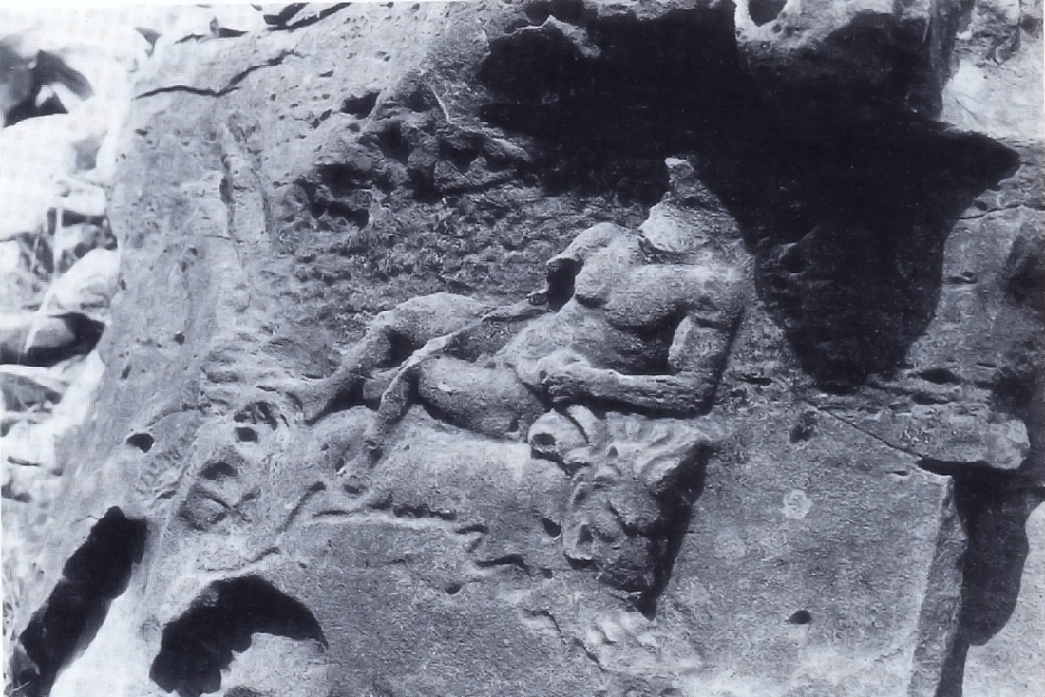
ill. 12a Lost Relief

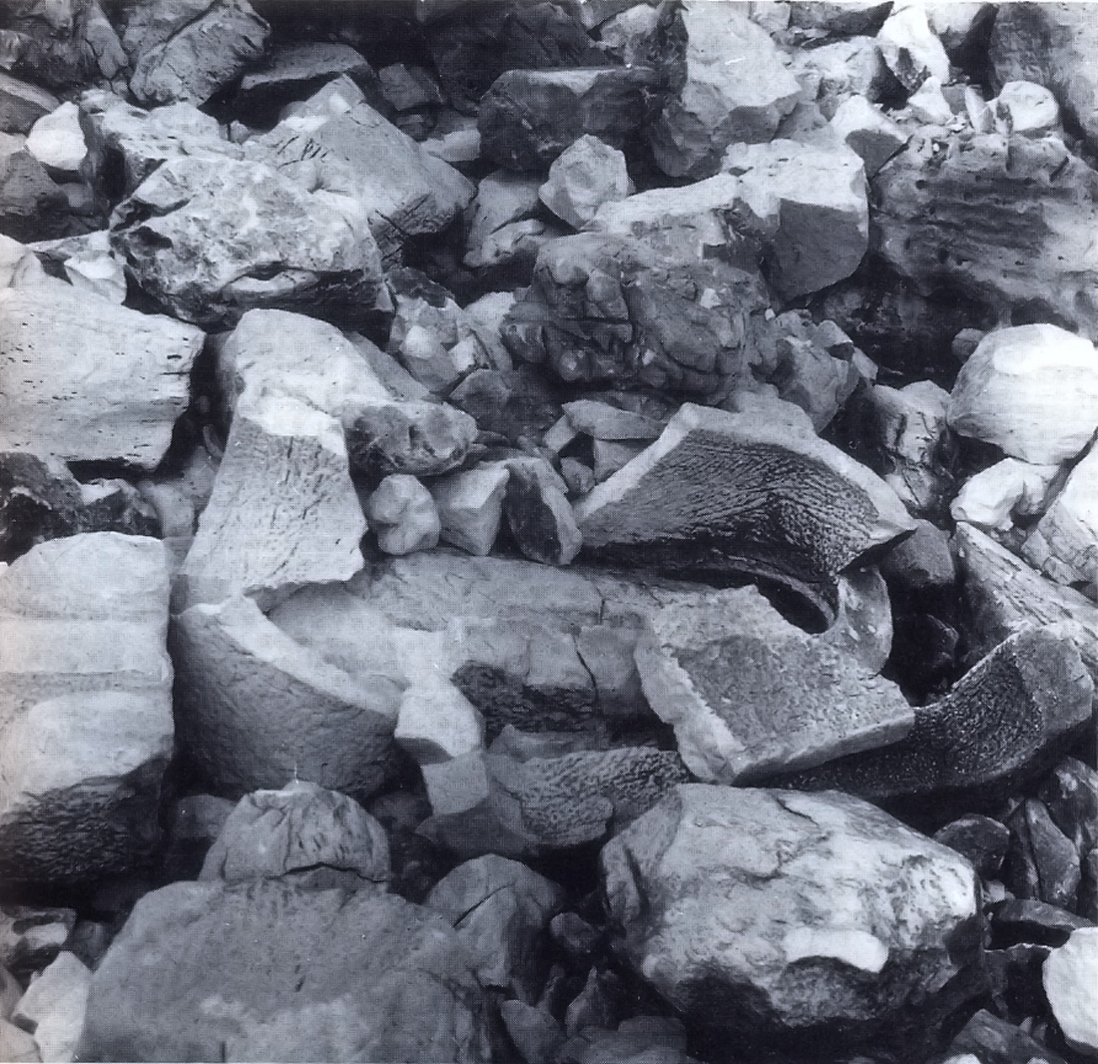
12b Remains of a Marble Tub

The site of Agrileza has been largely destroyed by the creation of terraces, as part of the sale of land plots and real estate speculation.
On Mount Pentelicus, the Greek military thought they would ensure national security by building a number of anti-missile shelters right inside the Spilla quarries themselves. Fortunately, in this case, a group of Greek architects, aware of the value and beauty of the site, were able to have the project aborted.
Above and beyond their historical interest per se, the creation of research programmes would be desirable to ensure these particularly vulnerable sites are protected.
The marble quarries offer us a unique perspective on the technological genius of the Ancient Greeks and of humankind in general. Just as, during the XIX century, a large number of the ancient mines in Laurion were destroyed because of the greediness of modern society, so, too, in the XX century the marble quarries began to be threatened. It is extremely urgent and necessary, in order not to lose more of our historical heritage, that measures should be taken to protect these sites which are particularly under threat.

(English translation by Mary Gabbarelli)

NOTES
(1) T.A. Koželj, 1986, pp. 1-18.
(2) This marble, often called Karystos marble, was widely used in the construction of the Imperial Forums. These quarries were heavily exploited from the time of Julius Caesar (60 BC) up until the death of Antoninus Pius (161 A.D.) One of the most important sites was Styra where there were 65 quarries located at an altitude of about 400 meters ASL. and at a distance of several kilometres from the sea and also the polychrome africano marble from Teos in Turkey.
(3) Gnoli, 1971, Monni et al. 1983, pp. 35-46.
(4) I have been able to examine several temporary extraction sites that I would like to mention as examples, differentiating between ancient marble quarries and those from the Hellenistic period. Ancient Marble Quarries. The quarry on the acropolis of Thasos was opened in order to carve two kouroi. The second one, representing Apollo, is now in the Istanbul Museum, inv. 374 Cf. BCH, 26, 1902, 2, 462-471. One of the two ram-bearing (kriophoros) kouroi, is unfinished and is now in the Thasos Museum, cf. JDAL, 40, 1925, 330-332; Cf. Pakard “Fouilles de Thasos” (1914 and 1920), BCH, 47,1923, 113-128. On Naxos, three kouroi were made. Traces of the extraction of two of them are visible, the third, representing Apollo, has remained in situ. It bears the marks of the stonecutter’s wedges and chisel. The Akeratos quarry on Thasos was used for the construction of the Pyrgos lighthouse, cf. Guide de Thasos, Paris, 1968, 79. The Phanari quarry (Thasos) was also initially used to build a lighthouse and was then exploited from ancient times right up until the Middle Ages. In the modern era, platforms were carved out on which to place cannons. The various phases of its exploitation are due to its strategic position.
Quarries in the Hellenistic Period. At Amathus in Cyprus several extraction sites are visible around the port. The blocks forming the quay of the ancient port were extracted from these sites. Traces of ancient limestone quarries are apparent on the hill at Yerokambos which is located to the east of the Acropolis. There were other quarries being exploited to the west but these have been partially destroyed by modern lime kilns and all that is left of them is the excavated rubble. Further traces of quarrying are visible under the first course of the foundations of the Hellenistic rampart. On the Pnyx hill in Athens the blocks removed after the enlargement of the orators’ platform were employed in other buildings (on the quality of the stone used from Pnyx Cf. Dworakovska 1975, p.13). The situation on the Nymphs’ hill, also in Athens, is the same as at Pnyx. In Corinth, there is a small quarry in the vicinity of the temple. At Argos, the theatre was carved out of the natural rock and this construction was also used to supply limestone. At Aegion in the Peloponnese, a conglomerate quarry was opened for the construction of the theatre and the same holds true for Paphos in Cyprus and in numerous other regions such as Delphi, where the quarry is situated to the north-east of the fortress, above the stadium and at the foot of the Phedriades mountians, Cf. P. Amandry, “ChroniqueDelphique: carrières”, BCH 105, 1981, 714-721; Egina, Cf. W. Wurster, “Antike Steinbrüche an der Westlichen Nordküste Aeginas”, AA 84, 1969, 12-32, and Brauron, Cf. Osborne 1985, 154-172, in Greece and at Selca in Albania (Cf. Ceka 1985, 160-167).
(5) On the island of Paros, the exceptional quality of certain seams of marble led the quarrymen to follow the deposits down into the depths of the hill just as the miners did in the silver-bearing lead mines of Laurion.
(6) This was the case at Apollonia (Naxos).
[(7) On the work in the quarries and problems relating to transport, see e.g.: for Epidaurus, IG IV₂ 1.102 and A. Burford The Greek Temple Builders at Epidaurus (Liverpool 1969), pp.212 ff.
Contract 1: Mnasikles, work in the quarry, transport and laying the foundation.
Contract 2: Likios from Corinth, id. for the columns.
Contract 4: Antimachos from Argos, id. for the foundations of the naos.
Contract 6: Euterpidas from Corinth, id. for construction of half of the naos.
Contract 7: Archikles from Corinth, id.
For Eleusis, IG II2 1666 and 1973 for work in the quarry and transport Cf. G. Raepsaet, “Transport de tambours de colonnes de Pentéliqueà Eleusis”, in A.C. 53 (1984) pp. 101-136; see also Chap. III, note 9.
For the whetting of work implements see e.g. A. Rehm, Didyma II. Die Inschriften (Berlin 1958), n. 38 (p.40); for Eleusis: IG II2 1972, line 121 and also Chap.VI, note 12. For hallmarks and reference marks on blocks see e.g. for Didymes: A: Rehm op. cit. Chap.II, 2 Schriftzeichen und Steinmarken am Tempèel, pp. 68-103. For the krépis of the Ionic temple at Pergamon: R. Martin, Manuel d’Architecture grecque (Paris 1965), p.229.]
(8) Pollux VI, 118, “le Marteau du carrier”: ü ήσϕύρατώνλατόμων. Its use is documented at Eleusis: IG II₂, 1673, 1.26; at Delos: IG XI 2, 161A, 1.87 and 199 A 1.87.
(9) In inland quarries the blocks were loaded onto standard engines of transportation using lifting equipment. This was probably the solution adopted at Archangelou on Thasos. In the coastal quarries, from where transport was by boat, arrangements had to be in place allowing for the passage of machines taking the blocks from the extraction platform to the quayside where the ship was moored. The machine most frequently documented consisted of two wheels 40cm. wide and 2m. in diameter between which the large blocks were laid. Following the topography of the location, the blocks could be trundled along till they reached the sea. The smaller ones were hoisted on board the ship. Whereas the monumental blocks were tightly bound together with ropes, which kept them buoyant on the surface of the water, and towed behind two ships to the port of destination.
(10) Cf. Koželj 1982. Cf. Lambraki 1980, 42. Similar sanctuaries exist on Cyprus at Kourion where on a horizontal face three libation cups were carved, linked one to the other by small spouts in the shape of lion’s heads (discovered by the author). Examples are also to be found in the quarries of Archangelou, on Thasos, and in the mines of Thorikos in Attica.
(11) “After a conquest in time of war, the columns brought home from foreign temples and theatres were esteemed among the choicest of the spoil. In time of peace, when the rules of the city could find nothing better for idle hands to do than persecute the heretics of the age, many thousands of Christians were condemned to labour in the quarries of Asia Minor or one of the Greek Islands, that the supply of marble should not fail” (H.W. Pullen, London 1894).
(12) The first watchtower at Saliara was situated on an elevation overlooking the quarry, the second on the opposite side, was below the level of the quarry.
(13) The wooden wedges used for cutting blocks at Amathus in Cyprus, were 0.20m x 0.20m. For example, for a block measuring 1.5m long and 0.5m high, three wedges had to be distributed in order to achieve a precise cut. For the same size of block to be used in building a jetty one or two wedges would have been used: for example, the breakwaters in the port of Amathus.
(15) Cf. Defner 1923, 108: In the year 399, on the authority of the Emperor, St. John Chrysostom discreetly ordered the destruction of the pagan buildings still standing in the East.
(16) Cf. Sodini et alii 1980.

BIBLIOGRAPHY
AMANDRY, P.
1981 “Chronuque Delphique: carrières 6, Les carrières”, BCH, 105, 714-721.
BESSAC, J.C.
1986 L’outillage traditionnel du tailleur de pierre de l’antiquité à nous jours, Paris.
CARPENTER, J.D.- BOYD, D.
1976 “The Dragon-House of Southern Euboia”, Archaeology, 29, 250-257.
DES COURTILS, J.- KOŽELJ, T.- MÜLLER, A.
1982 “Les mines antiques. Travaux de l’école française en Grèce en 1981”, BCH, 106, 674.
1982 “Des mines d’or à Thasos”, BCH, 106, 409-417.
CRAIG, V.- KRAIK, H.
1972 “Marble Determination of Provenance by isotopic Analysis”, Science, 176, 401-403.
DEFNER, M.
1923 “Τὰ ἆϱχαῖα λατομεῖα τῆς Σϰύϱου (Ta archaia latomeia tês Skurou)”, AE, 102-116.
DWORAKOWSKA, A.
1975 Quarries in Ancient Greece, Varsovie.
FISCHER, H.G.
1959 “A Foreman af Stoneworkers and his Family”, BMM, 17, 6, 145-153.
HERZ, N.
1985 “Stable isotopic signatures applied to problems of classical marble”, National Geographic Society, Research Reports, 20, 353-363.
KOŽELJ, T.
1982 Ήϱαϰλῆς,: Ἀϱχαιολογία (Héraclès Archaiologia), 4, 68-70.
1983 “Une voie d’accès à l’acropole de Thasos”, BCH, 107.
1985 “An example of cutting Marble, using an Handpick and Chisel”, Studi Miscellanei, 26, 127-134.
1987-1988 “Le carrières de marbre dans l’antiquité. Techniques et organisation”, Marbres helléniques. De la carrièr au chef-d’œuvre, Bruxelles.
1988 “Extraction of blocks in antiquity: special methods of analysis”, HERZ, WAELKENS (eds.), Classical Marble: geochemistry, technology and Trade, NATO ASI Series E: Applied sciences 153, ASMOSIA I, Proceedings of the first international Conference on the Association for the study of marble and Other Stones in Antiquity, Il Ciocco, Lucca, 31-39.
KOŽELJ, T.- MÜLLER, A.
1979 “La mine de Thasos. Travaux de l’Ecole française en Grèce en 1978”, BCH, 103, 658.
1981 “Mines antiques. Travaux de l’Ecole française en Grèce en 1980”, BCH, 105, 960-961.
KOŽELJ, T.- MÜLLER, A.- SODINI, J.P.
1980 “Carrières de marbre de la région de Saliari. Travaux de l’Ecole française en Grèce en 1980”, BCH, 105, 961-963.
1982 “Les carrières de marbre. Travaux de l’Ecole française en Grèce en 1981”, BCH, 106, 676-677.
KOŽELJ, T.- LAMBRAKI, A. -MÜLLER, A.
1985 “Sarcophages découverts dans les carrières de Saliari, Thasos”, Studi Miscellanei, 25, 127-134
KOŽELJ, T.- WURCH-KOŽELJ, M.
1992 “Contrast between Ancient and Modern Quarries of white Marble in Thassos”, D. Decrouez, J. Chamay, F. Frezza (éd.), La Conservation des Monuments dans le Bassin Méditerranéen, Actes du 2è Symposium International, Genève 1991, 68-87.
1993 “Les transports dans l’Antiquité”, R. Francovich (a cura di), Archeologia delle attività estrattive e metellurgiche, Edizioni all’Insegna del Giglio, Firenze, 97-142.
2000 “Les Pariens et les Carrières à Thasos”, D.U. Schilardi, D. Katsonopoulou (eds), Paria Lithos. Parian quarries, marble and workshops of sculpture. Proceedings of the first international Conference on the Archaeology of Paros and the Cyclades, Paros, 417-424.
2009 “Les carrieres de marbre à Thasos à l’époque proto-byzantines, extraction et production”, Mélanges Sodini.
LAMBRAKI, A.- MONNA, D.- PENSABENE, P.- SODINI, J.P.
1980 “Le cipolin de la Karystie. Contribution à l’étude des marbres de la Grèce exploités aux époques romaine et paléochrétienne”, RA, I, 31-62.
NICOLE, G.
1905 “Remarques sur une statue inachevée de marbre pentélique”, Mélanges Nicole, Recueil de mémoires de philologie classique et d’archéologie offerts à Jules Nicole, Genève.
NÖEL, P.
1968 “Technologie de la pierre de taille”, Dictionnaire des termes couramment employés dans l’extraction, l’emploi et la conservation de la pierre de taille, Paris.
NOWICKA, M.
1975 Les maisons à tour dans le monde grec, Varsovie.
RAEPSAET, G.
1984 “Transport de tambours de colonnes di Pentélique à Eleusis ai IVe siécle avant notre ére”, L’Antiquité Classique, 53, 101-136.
SODINI, J.P.- LAMBRAKI, A.- KOŽELJ, T.
1980 “Aliki, I: Les carrières de marbre à l’époque paléochrétienne”, Etudes Thasiennes, 9, 81-146.
VARÈNE, P.
1974 Sur la taille de la pierre antique, médiévale et modern, Dijon.
WÜRSTER, W.
1969 Antike Steinbrüche an der Westlichen Nordküste Aeginas, AA, 12-32.

