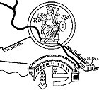 | OSTIA A MEDITERRANEAN PORT
 | Information about the Mediterranean sea, its harbours and ports, ships and sailors.

INDEX (the links below lead to sections on this same page)
1 Introduction
2 The Mediterranean
2.1 A Landlocked Sea
2.2 Subdivisions
2.3 Mountains and Rivers
2.4 "Mediterranean Seas"
2.5 Currents
2.6 Tidal Range
2.7 Winds
3 Harbours and Ports
3.1 Definition
3.2 Hinterland and Foreland
3.3 Small and Large Harbours and Ports
4 Roman Harbours and Ports
4.1 General Studies
4.2 Rivers, Swamps and Lagoons
4.3 Construction Considerations

5 Roman Maritime Traffic
5.1 The Ships
5.2 Size and Cargo of the Ships
5.3 Navigation
5.4 Travelling Time
5.5 The Shipping Season

6 Trade
6.1 The People
6.2 Not All Roads Led to Rome
7 Rome's Harbours on the West Coast of Italy
7.1 From Centumcellae to Puteoli
7.2 The Account of an Eye-Witness
7 Appendix: list of harbours
7 Select bibliography

1 Introduction
This article is a short introduction to Roman Imperial harbours and ports. It is not an original study. For the most part it is a summary of a number of key publications, for example by Karmon, Rickman and Sirks. Two maps accompany the article.
- The first map shows harbours in the western Mediterranean basin that were of at least some importance. By no means does the map show all harbours. One should also be aware of the chronological restrictions. For example, Misenum (in the Bay of Naples) replaced Portus Iulius during the early Empire.
Click here to open the map in a separate window
- The second map shows several natural features: modern names of subdivisions of the sea, winds etc.
Click here to open the map in a separate window
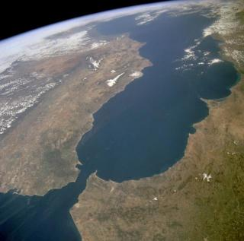
The western Med seen from a Space Shuttle.
In the lower part is the Strait of Gibraltar.
Back to index

2 The Mediterranean

2.1 A Landlocked Sea
The Romans called the Mediterranean Sea Mare Internum ("Internal Sea") and Mare Nostrum ("Our Sea"). Isidore of Seville was the first to use the name Mare Mediterraneum ("Landlocked Sea"), in the seventh century AD. The names "Internal Sea" and "Landlocked Sea" stress its major characteristic: it is connected to other seas only through narrow straits. The Atlantic Ocean can be reached through the Strait of Gibraltar (a little under 13 kilometres wide at its narrowest point and 320 metres deep). The Black Sea is reached through the Dardanelles (depth 70 metres), the Sea of Marmara, and the Strait of the Bosporus. The Suez Canal is a modern, man-made break-through to the Red Sea. Large islands are Corsica, Sardinia, Sicily, Crete, and Cyprus.
Back to index

2.2 Subdivisions
A submarine ridge (at a depth of c. 360 metres) between Sicily and the African coast divides the Med in a western and eastern part. The western part is subdivided into three large submarine basins. The Alborán basin is to the east of Gibraltar, between Spain and Morocco. To the east, and to the west of Corsica and Sardinia, is the Algerian basin. The Tyrrhenian basin is between these islands and Italy. The eastern Med is subdivided into two major basins. The Ionian basin is to the south of Italy and Greece. The Levantine basin is to the south of Turkey. Between Greece and Turkey is the Aegean Sea.
Back to index

2.3 Mountains and Rivers
Important mountain ranges surrounding the western half of the Med (on which we will focus) are the Sistema Ibérico, the Pyrenees, the Massif Central, the Alps, the Apennines, mountain ridges running parallel to the coast of Dalmatia, and the Atlas Mountains in the Maghreb. Many rivers reach this part of the sea, through and between the mountains: the Ebro in Spain, the Rhône in the south of France, the Po in the north of Italy, and the Tiber ... to name but a few.
Back to index

2.4 "Mediterranean Seas"
The Med has given its name to "mediterranean seas". Mediterranean seas are characterized by very restricted water exchange with the oceans. Two types can be distinguished. If precipitation and river input exceed evaporation such a sea is called a humid mediterranean sea. An example is the Black Sea. Because evaporation does not compensate the supply of water, another outlet is needed: the excess water flows out through the Bosporus. In other seas, such as the Mediterranean Sea, evaporation exceeds precipitation and river input. Such a sea is called an arid mediterranean sea. The Med receives from the Rhone, Po, Ebro etcetera, and from precipitation only about one-third of the amount of water that it loses by evaporation. Therefore an extra supply of water is needed. It comes from the Black Sea and especially from the Atlantic Ocean, through the Strait of Gibraltar. For shipping an important result is, that the currents in the Med are not wind-driven, but created by the Atlantic water inflow.
The general water budget is shown below (table from the Encyclopaedia Britannica):
Gains | Cu m/sec | Losses | Cu m/sec
Inflow from the Atlantic | 1,750,000 | Outflow to the Atlantic | 1,680,000
Inflow from the Black Sea | 12,600 | Outflow to the Black Sea | 6,100
Precipitation and rivers | 38,900 | Evaporation | 115,400
Total | 1,801,500 | Total | 1,801,500
Back to index

2.5 Currents
The main circulation in the Med is a counterclockwise movement of the water. The water coming in through the Strait of Gibraltar flows eastward along the north coast of Africa, and then branches off. A counterclockwise current is created in the eastern Med. In the western Med the current continues along the north coast of Sicily, and then moves to the north, west and south, along the coasts of Italy, France and Spain, back to Gibraltar. The outflow to the Atlantic Ocean is a subsurface current below the inward current. The current flows with a speed of one to two knots (one knot = one nautical mile or 1852 metres per hour). It is more powerful in summer than in winter, because there is more evaporation during the summer. There are a few secondary currents moving in the same direction: there is one to the north of Algiers, and another one to the west of the Tiber. These special currents are strong and dangerous in narrow channels, such as the Strait of Messina.
Back to index

2.6 Tidal Range
Seas that are almost completely closed have, like lakes, only a very small tidal range, i.e. a small difference in sea level between high and low water. In the Med tides are only significant in the Gulf of Gabes (to the south-east of Tunisia) and the northern Adriatic. The general mediterranean tidal range is about 28 centimetres. In the Adriatic it is about 90 centimetres. The latter sea can almost be regarded as a channel, between the straight Italian coast, and the coast of the Balkan peninsula, with many small islands, most of which run parallel to the coast. In the Adriatic Sea not only the tidal range is different: the surface currents are created primarily by the wind. They can reach a speed of three and a half knots.
Back to index

2.7 Winds
As to the general climate of the Med: it is windy, with mild, wet winters and relatively calm, hot, dry summers. Spring is changeable, autumn is relatively short. The flow of the air into the Med takes place through gaps in the mountain ranges. In the summer most mediterranean winds come from the north. A number of special winds occurs. Some of these are:
- Levanter. A strong, cold E-wind of the western Med and the southern coasts of France and Spain. It is mild, damp and rainy, and most common in spring and fall. It reaches its maximum intensity in the Strait of Gibraltar.
- Gibleh (also called Khamsin). A hot, dry, dusty S/SE-wind in North Africa and Arabia in late winter and early spring.
- Sirocco (called in Spain the Leveche, in the Gulf of Lyon the Marin, and in Morocco, Algeria and Tunisia the Chili). It is a warm, humid S/SE-wind over the Med and southern Europe. It is frequent in spring, early summer and fall. It starts in North Africa as a dry wind (the "dry Sirocco"), transporting dust from the Sahara and the Arabian desert. It picks up moisture as it crosses the Med (the "damp Sirocco"), and then brings rain and fog. It blows evenly and the maximum force is 6, so it does not become a gale.
- Mistral (or Maestrale). A cold and dry, strong N/NW-wind in southern France along the lower Rhône Valley and the Alps-Pyrenees gap. It is strongest and most frequent in winter and spring. The velocity is intensified because it blows through narrow valleys. It begins very suddenly, and can reach gale force.
- Libeccio. A SW-wind blowing over Corsica and Sardinia.
- Tramontana. A dry, cold, strong N-wind of the west coast of Italy.
- Bora. A very strong, cold NE-wind, passing through the Trieste gap. It can blow throughout the year, but is commonest in winter. In the summer it usually lasts two days, in the winter up to fourteen. It begins very suddenly. The strength ranges from a light breeze to storm with gusts of wind. At the foot of mountains it reaches hurricane force.
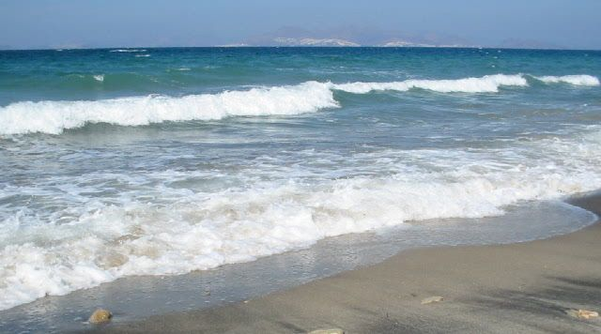
Back to index

3 Harbours and Ports

3.1 Definition
A harbour is a protected area of water. A port is a harbour, plus terminal facilities: piers, wharves, docks, store buildings, and an infrastructure of roads and rivers or canals. Therefore a harbour is merely a very important part of a port. The Romans used the same word for a harbour and a port: portus.
Back to index

3.2 Hinterland and Foreland
When studying harbours one should understand two basic concepts, as is explained in an excellent study by Y. Karmon (see bibliography). "Hinterland" (originally a German word) is the area where traffic demand originates. It is connected to a port by means of inland communications: roads and rivers. The "Vorland" or foreland is made up of the seas accessed from the ports.
One can distinguish four types of hinterland: continental, semi-continental, regional, and local. In case of a continental hinterland gaps or passes through mountain barriers are used to reach vast areas. An example of such a route is the Rhône valley. Spain is a semi-continental hinterland: it is large, but the Pyrenees block access to the rest of Europe. In Italy we find examples of the regional hinterland. It is a long, narrow peninsula, and no place is farther from the sea than 100 kilometres. Here a typical, regional hinterland could have a sea front of 60-80, and a depth of 100 kilometres. The local hinterland is served by small ports in river mouths or bays, which are visited by small boats coming from the regional ports.
Things were different of course when military harbours were constructed, for example at Ravenna, Misenum and Carthago.
Back to index

3.3 Small and Large Harbours and Ports
The various kinds of hinterland and the varying size of ships lead to ports of a different size. Long-distance traffic usually takes place only between the ports of a large hinterland. Here local distribution begins, and here a return cargo can be found. The ships that are active on these long-distance routes are of a considerable size, for several reasons. They need a supply of water and food, sleeping quarters, and so on. A long journey makes the transported goods more expensive and is economical only if the ship carries a large cargo (on the other hand, a very large cargo means a great loss in case of shipwreck). These large ships obviously need large harbours, with good facilities.
The ports of a local hinterland are visited only by ships engaging in local traffic. As the ports are small and shallow, the ships have a shallow draught. There is no space on these ships for large supplies of water and food, or for sleeping quarters. They must seek shelter in a harbour every night and stay near the coast. Such ships also sailed to the larger harbours, in order to load and unload.
Back to index

4 Roman Harbours and Ports

4.1 General Studies
K. Lehmann-Hartleben published the last synthesis of ancient harbours in the Med, in 1923 (see bibliography). His book contains a catalogue of 303 harbours. It mentions 184 out of at least 240 major ports in the eastern Med, and 84 of around 180 major ports in the western Med. G.E. Rickman (known to Ostia specialists because of his studies of the grain supply of Rome, and of store buildings) is preparing a new synthesis, beginning with the western part. Preliminary results have been presented in penetrating articles (see bibliography).
Back to index

4.2 Rivers, Swamps and Lagoons
Rivers were important gates to the hinterland. They emptied into the Med via deltas, which owed their existence to the absence of tides, and contained swamps and lagoons. The swamps of the smaller rivers had already been drained in antiquity. They were then used for irrigated agriculture and cities were built here. Many of the new towns became harbour cities. Harbours or ports were not necessarily coastal cities however. Some lie behind the coast on lagoons, canals or rivers. Roman ships were often quite small, so that a good harbour was not necessarily big or deep. For many ships a depth of two metres was sufficient. For the same reason lagoons were navigable. Narbo Martius (Narbonne) was 20 kilometres from the sea, but on a lagoon. Hispalis (Sevilla) was 86 kilometres inland up the river Guadalquivir.
Back to index

4.3 Construction Considerations
The northern shore of the Med is often steep, but contains many small natural harbours and landing places. The southern shore has very few natural harbours, and here artificial harbours had to be built. Generally speaking however, harbours could be built with relative ease in the Med, because of the almost complete absence of tides. Things were different outside the Strait of Gibraltar, for example in Gades (Cádiz), at the mouth of the Guadalquivir - this was a tidal harbour.
What did create a problem was the silt that the rivers took to the sea. It was carried along the coast by the mediterranean current - as we have seen in a counterclockwise direction. Harbours were therefore usually built at the opposite side of the delta. The harbour of Alexandria for example was to the west of the Nile delta and therefore safe from the river silt. The Imperial harbours of Ostia on the other hand suffered from being to the north of the Tiber mouth: the counterclockwise current took silt to the harbours. During many centuries the coastline slowly moved seaward, and the harbours are now several kilometres inland.
The winds were another factor influencing construction. Rickman notes that virtually all the best known ancient ports on the Tyrrhenian Sea shelter themselves from winds from the west and north. It is surprising that the Claudian harbour at Ostia had an entrance facing north. Rickman therefore suggests that there may originally have been another entrance to the south.
Often the construction of a harbour was a huge effort. The river port of Arles was, during the Republic, connected to the sea through channels, the Fossae Marianae. They made the Rhône delta navigable. The Romans sometimes used concrete that could set under water. Moles and breakwaters were constructed to provide protection against storms. Usually they were solid structures. Arched moles were built in the Bay of Naples during the early Empire. The idea behind the arches may have been, that the water passing through them removed silt. The experiment was apparently not successful. In the second century moles without a connection to the land were built, possibly with the same purpose.
Back to index

5 Roman Maritime Traffic

5.1 The Ships
Roman merchant ships in the Med were sailing ships. Larger ships had auxiliary oars, used for entering and leaving a port, or during a calm, when there was not enough wind. A different type of ship must have been used in the Atlantic Ocean, which is characterized by storms and high waves: here the ships needed a greater draught and stronger sails. The use of oars would be impossible. Harbours could here be entered by using the tides.
Back to index

5.2 Size and Cargo of the Ships
The size of the ships was expressed in amphorae or grain-measures. A ship with a carrying capacity of 240 tons must have been about 10 metres wide and 30 metres long. A ship with a cargo of 450 tons was 10 to 12 metres wide and 35 to 40 metres long. We know through legal texts that the Romans were capable of building ships with a capacity of 300 to 400 tons, and it is most likely that ships with a capacity of over 1000 tons were built. Technically speaking there were no obstacles. Underwater archaeology indicates that very large ships did indeed exist (especially for the transport of grain), but that smaller ships (70 tons or less), with a mixed cargo, were more common. The average capacity of ships sailing to Rome - an exceptional case - may have been about 250 tons.
Very large ships required large harbours. The number of such harbours will have been restricted: most harbours were constructed for the smaller ships. Generally speaking the unloading of a ship of 150 tons will have taken two to four days. A cargo of 250 tons required six to eight days. Certain cargoes required special loading and unloading facilities. Sacks of grain and lighter amphorae could be carried by dockhands. Heavier amphorae were carried by two men, using poles slipped through the handles. Mobile cranes were used for lifting heavy objects such as marble sarcophagi and wild animals in cages. For the unloading of an obelisk, weighing many tons, exceptionally strong cranes must have been built.
Passenger traffic was mainly made up of merchants and government officials.
Back to index

5.3 Navigation
Orientation on the sea was based on the stars and, during the day, the characteristics of the land. Navigation in the Med can be arranged so as to remain in sight of the mainland or of islands for most of the time. Characteristic mountains, promontories, and man-made structures such as temples and of course lighthouses served as beacons.
Back to index

5.4 Travelling Time
In the summer the common mediterranean winds usually come from the north, speeding up the journeys of ships going to the south. Ships going to the north had to travel twice as long. Some usual sailing times are listed below:
Alexandria - Puteoli | 15-20 days
Ostia - Carthago | 3- 5 days
Gades - Ostia | 9 days
Tarraco - Ostia | 6 days
Narbo Martius - Ostia | 3 days
For a distance along the coast of about 50 kilometres a small ship, with favourable winds and currents, would need about eight to ten hours. A land caravan consisting of beasts of burden would need at least two days.
Back to index

5.5 The Shipping Season
The best sailing season was from May 27th to September 14th. March 10th to May 27th, and September 14th to November 10th were also considered reasonable periods. In the winter shipping came to an almost complete standstill. This period was called the mare clausum ("closed sea"). In this season the force of the gales was too great, and bad visibility at sea hampered navigation. Shipwreck or jettison were almost inevitable.
Back to index

6 Trade

6.1 The People
A navicularius was a person who exploited a ship commercially, whether he owned it or not, a characteristic aspect being that he had to account for the profit or loss. He could sail with his ship or remain ashore. He was also called exercitor or nauta exercens, i.e. a seaman running a business (a sailor was called a nauta). A magister navis (shipmaster, captain) was the person charged with the care of the entire ship in case the navicularius did not sail. Especially on larger ships he was assisted by a gubernator (steersman, navigating officer), a person taking care of the technical side of the ship and its navigation. Domini navium were people who had ships built. Merchants were called negotiatores or mercatores: people who hoped to make a profit on the capital invested, for example mercatores olearii (oil merchants).
Part of the export to Rome was organised by the Emperors, for example the transport of grain for free distributions. The Emperors preferred not to draw up contracts with individual people and therefore organised the trade through guilds, corpora (but only part of the trade: the part for which the Emperor was responsible). In Arles five guilds of navicularii are documented, the navicularii marini Arelatenses corporum quinque. The guilds should not be compared to mediaeval guilds. Their purpose was a better organization of the Imperial export and import.
Back to index

6.2 Not All Roads Led to Rome
Goods that were exported were produced throughout the Empire. Spain produced metals (gold, silver, and copper), olive oil around Gades (Cádiz), and wine around Tarraco (Taragona). In France metals were produced in the south, wine in the area around Burdigala (Bordeaux) and Massilia (Marseille). Sardinia exported grain and metals, Sicily grain. Oil and wine came from the land between the Po Delta and Aquileia. Africa exported animals for the arena, such as the rhinoceros and leopard. Tunisia produced grain and oil, Tripolis oil.
In our sources (legal texts, ancient historians, inscriptions) the export to Rome is documented very well. But of course goods were exchanged between many small and large cities. A good example is trade between Aquileia and Libya through the Adriatic Sea. The Mare Hadriaticum was in antiquity the sea composed of the area between Italy and Dalmatia, but also the sea to the south, bordered by Sicily, Malta and Crete. According to Sirks the sea presumably extended until the coast of Libya (Cyrenaica). The following legal text (Digesta 19.2.61.1) would therefore be about trade in this sea:
"Someone hired a ship to transport a cargo of 3000 measures of olive oil and 8000 modii of grain from Cyrenaica province to Aquileia, for a fixed price."
"Navem conduxit, ut de provincia Cyrenensi Aquileiam navigaret olei metretis tribus milibus impositis et frumenti modiis octo milibus certa mercede."
An inscription (CIL VI, 1101) documents negotiantes vini supernatis et Ariminensis (traders in wine from the coast of the Adriatic sea and Rimini). We also hear of a corpus naviculariorum maris Hadriatici. The members seem to have been people in Ostia, trading in goods from the Adriatic area, such as wine.
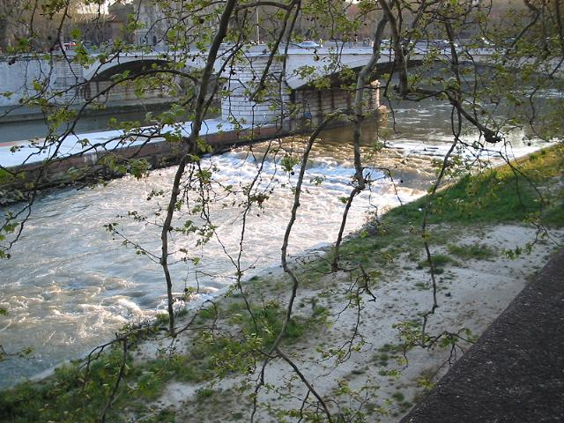
The Tiber in Rome, near the Tiber Island. Photograph: Jan Theo Bakker.
Back to index

7 Rome's Harbours on the West Coast of Italy

7.1 From Centumcellae to Puteoli
Ostia and Portus became the main ports of Rome in the later first and second century AD. This was the result of the construction of artificial harbour basins by Claudius, Nero and Trajan; Ostia did not have a good, natural harbour. We must stress however that during Ostia's hey-day Rome was served by several ports. This system included harbours from Centumcellae to Puteoli in the Bay of Naples. During the early Empire Puteoli was Rome's main harbour. From there goods were transported to Rome in small ships, along the coast and the Tiber. Puteoli lost much of its importance after the construction of the artificial harbours at Ostia, but it remained a major port of Rome. To the south of Ostia a large harbour was built by Nero: Antium. The building began right after the completion of work at Ostia. Two harbours, each covering an area of some 100.000 square metres, were built by Trajan: Tarracina, to the south of Antium, and Centumcellae, sixty kilometres north of the Tiber. Good roads and inland channels connected these harbours with Rome.
Back to index

7.2 The Account of an Eye-Witness
Pliny the Younger witnessed the construction of the harbour at Centumcellae by Trajan:
"I was delighted to be summoned by the Emperor [Trajanus] to act as his assessor at Centum Cellae [Civitavecchia], where I am now."
[...]
"The house is really beautiful: it is surrounded by green fields and faces the sea-shore, where a natural bay is being converted with all speed into a harbour. The left arm has already been reinforced by a solid mole and the right is in process of construction. At the entrance to the harbour an island is rising out of the water to act as a breakwater when the wind blows inland, and so give a safe passage to ships entering from either side. Its construction is well worth seeing. Huge stones are brought by large barges and thrown out one on top of another facing the harbour; their weight keeps them in position and the pile gradually rises in a sort of rampart. A hump of rocks can already be seen sticking up, which breaks the waves beating against it and tosses them high into the air with a resounding crash, so that the sea all round is white with foam. Later on piers will be built on the stone foundation, and as time goes on it will look like a natural island. The harbour will be called after its maker, and is in fact already known by his name; and it will save countless lives by providing a haven on this long stretch of harbourless coast."
"Evocatus in consilium a Caesare nostro ad Centum Cellas (hoc loco nomen) magnam cepi voluptatem."
[...]
"Villa pulcherrima cingitur viridissimis agris, imminet litori, cuius in sinu fit cum maxime portus. Huius sinistrum brachium firmissimo opere munitum est, dextrum elaboratur. In ore portus insula adsurgit, quae inlatum vento mare obiacens frangat tutumque ab utroque latere decursum navibus praestet. Adsurgit autem arte visenda: ingentia saxa latissima navis provehit contra; haec alia super alia deiecta ipso pondere manent ac sensim quodam velut aggere construuntur. Eminet iam et apparet saxeum dorsum impactosque fluctus in immensum elidit et tollit. Vastus illic fragor canumque circa mare. Saxis deinde pilae adicientur, quae procedente tempore enatam insulam imitentur. Habebit hic portus et iam habet nomen auctoris eritque vel maxime salutaris. Nam per longissimum spatium litus importuosum hoc receptaculo utetur."
Plinius Junior, Epistulae 6,31 (translation: Penguin, B. Radice)
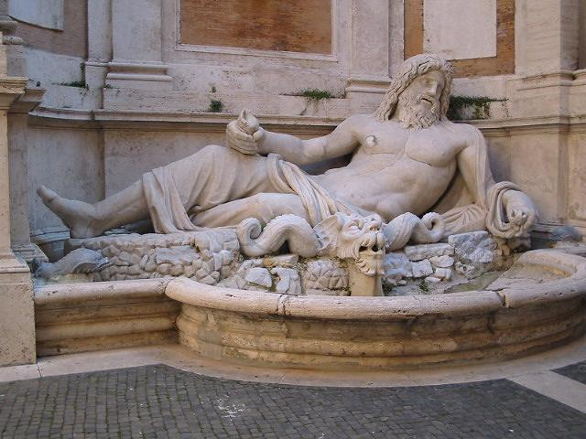
River-god in the Capitoline museums. Photograph: Jan Theo Bakker.
Back to index

Appendix
List of harbours on the map of the western Med, with modern place names.
Atlantic coast
Burdigala | Bordeaux
Olisipo | Lisboa
Gades | Cádiz
North part of the Med, west to east
Hispalis | Sevilla
Malaca | Málaga
Nova Karthago | Cartagena
Valentia | Valencia
Saguntum | Sagunto
Tarraco | Taragona
Emporiae | Ampurias
Narbo Martius | Narbonne
Arelate | Arles
Massilia | Marseille
Forum Iulii | Fréjus
Turris Libyssonis | Porto Torres (Sardinia)
Carales | Cagliari (Sardinia)
Album Intimilium | Ventimiglia
Album Ingaunum | Albenga
Genua | Genoa
Luna | Carrara
Portus Pisanus | Livorno
Graviscae | Porto Clementino
Centumcellae | Civitavecchia
Antium | Anzio
Astura | Torre Astura
Circei | S. Felice Circeo
Tarracina | Terracina
Caieta | Gaeta
Minturnae | Minturno
Sinuessa | Sinuessa
Misenum | Capo Miseno
Portus Iulius | In between Misenum and Puteoli
Puteoli | Pozzuoli
Panormus | Palermo
Tarentum | Taranto
Hydruntum | Otranto
Lupia | Lecce
Brundisium | Brindisi
Sipontum | Santa Maria di Siponto
Ancona | Ancona
Ariminum | Rimini
Ravenna | Ravenna
Aquileia | Aquileia
Tergeste | Trieste
Parentium | Parenzo
Pola | Pola / Pula
Salonae | Salona / Solin
Lissus | Alessio / Lesh
Dyrrhachium | Durazzo / Durres
Apollonia | Poian
South part of the Med, west to east
Tingis | Tanger
Rusaddir | Melilla
Siga | Takembrit
Portus Magnus | Vieil-Arzeu-Saint-Leu
Cartennae | Ténès
Iol Caesarea | Cherchel
Tipasa | Tipasa
Rusguniae | Tametfoust
Rusuccuru | Dellys
Rusazus | Azeffoun
Saldae | Bougie / Bejaia
Musluvium
Igilgili | Djidjelli
Rusicade | Skikda
Hippo Regius | Hippone
Thabraca | Tabarka
Hippo Diarrhytus | Bizerte
Utica | Hr. bou Chateur
Karthago | Tunis
Misua | Sidi Daoud
Clupea | Kélibia
Curubis | Korba
Neapolis | Nabeul
Horrea Caelia | North of Sousse
Hadrumetum | Sousse
Ruspina | Monastir
Leptis Minor | Lemta
Thapsus | Hr. ed-Dimas
Gummi | El Mahdia
Acholla | Bou-Tria
Takape | Gabès
Sabratha | Sabratha
Oea | Tripoli
Leptis Magna | Lebda
Back to index

Select bibliography
- D. Blackman, "Ancient harbours in the Mediterranean", Parts 1 and 2, IJNA 11 (1982), 79 ff.
- R. Bussi - V. Vandelli eds., Misurare la terra: centuriazione e coloni nel mondo romano. Città, agricoltura, commercio: materiali da Roma e dal suburbio, Mostra Roma 1985, Modena 1985.
- L. Casson, The Ancient Mariners, London 1959.
- L. Casson, Ships and Seamanship in the Ancient World, Princeton 1971.
- A. Degrassi, "I porti Romani dell’Istria", Anthemon, Scritti in onore di C. Anti, Firenze 1954, 154ff.
- Encyclopaedia Britannica
- U. Fellmeth, ‘Die Hafen von Ostia und ihre wirtschaftliche Bedeutung für die Stadt Rom’, Münstersche Beiträge zur Antiken Handelsgeschichte 10 (1991), 1-31.
- H. Fischer, ‘Zur Entwicklung Ostias und Puteolis vom 1. Jahrhundert v.u.Z. bis zum 3. Jahrhundert’, Münstersche Beiträge zur Antiken Handelsgeschichte 7 (1986), 3-16.
- R.L. Hohlfelder, "The Ports of Roman Baetica: A Preliminary Reconnaissance", Journal of Field Archaeology 3 (1976), 465 ff.
- G.W. Houston, "The administration of Italian seaports during the first three centuries of the Roman Empire", MAAR 36 (1980), 157ff.
- Y. Karmon, ‘Geographical Components in the Study of Ancient Mediterranean Ports’, in Raban 1985, 1-6.
- K. Lehmann-Hartleben, ‘Die antiken Hafenanlagen des Mittelmeeres. Beiträge zur Geschichte des Städtebaues im Altertum’, Klio, Beiheft 14 (1923).
- P. Pomey and A. Tchernia, "Le tonnage maximum des navires de commerce romains", Archaeonautica 2 (1978), 233 ff.
- A. Raban ed., ‘Harbour Archaeology. Proceedings of the First International Workshop on Ancient Mediterranean Harbours, Caesarea Maritima’, 1983, Bar International Series 257 (1985).
- G.E. Rickman, ‘Towards a Study of Roman Ports’, in Raban 1985, 105-114.
- G.E. Rickman, ‘Portus in Perspective’, in 'Roman Ostia' Revisited, A. Gallina Zevi - A. Claridge eds., Roma 1996, 281-291.
- J. Rougé, Recherches sur l’organisation du commerce maritime en Méditerranée sous l’Empire romain, Paris 1966.
- J. Rougé, "Les ports romains de Méditerranée", Hist. et Arch., Les Dossiers 29 (1978), 10ff.
- A.J.B. Sirks, Food for Rome, Amsterdam 1991.
Back to index

[JThB - 18-Oct-1999; for this page I would like to thank Bill Thayer and Domenico Carro]

