Design waves for coastal structures on the Mediterranean coasts

The analysis of long term breakwater stability described in the paper above concentrates on the worst possible wave conditions, considering that they will eventually occur in the long term. For this reason the resulting Fig. 5 does not take a wave height into account. In other words, only cases with waves breaking between the toe and the crest of the submerged structure are considered. Hence, the local wave climate must include waves large enough to reach the submerged structure. How do we know this?
Waves are generated offshore by friction of the wind on the sea surface (such waves are called ‘wind waves’). Waves travel on the sea surface over hundreds (even thousands) of kilometres after they were generated (such waves are called ‘swell’). When they reach the coastal shallow waters, they change in height and in direction due to shoaling, refraction and diffraction effects.

Modern design of coastal structures exposed to wave attack is based on a sound knowledge of the local wave climate. Wave generation and propagation are complex processes and statistics play an important role in the description of the wave climate in a given coastal location. A simple way to define a sea state is to mention its ‘significant wave height Hs’ which is defined as the average of the one third highest waves of that sea state. This Hs is considered to be close to the visual estimate which would be given by an experienced observer of the sea.
Design of coastal structures is based on the principle of ‘accepting a certain level of damage to the structure, for a certain probability of occurrence of the waves’. One could indeed accept a lot of damage for a very rare event, or very little damage for a more frequent event. For modern coastal structures, it is usually accepted to have very little damage for a one in hundred years storm event. Hence, coastal engineers will speak about the ‘1 in 100 years Hs’ to define the design wave conditions. Assuming an average of 10 ‘big’ storms per year (which leads to 1000 storms over 100 years), this means that the design storm is the largest storm in this series of 1000 and therefore has a probability of occurrence of around 10⁻³, that is 0.1% … not much!
As they usually do not have wave measurements over 100 years, coastal engineers use a computational approach (called hindcasting) to generate wave data over a period of say 20-30 years, they perform a ‘Peak Over Threshold’ analysis of the largest storms and they extrapolate this data to provide an estimate of the 100-year storm (see Mazas & Hamm, 2011).

Let us now go back to the Mediterranean Sea where we know that winds blow from North and NW most of the year. Data taken from the Wind and Waves Atlas of the Mediterranean Sea (2004) show this effect in more detail.

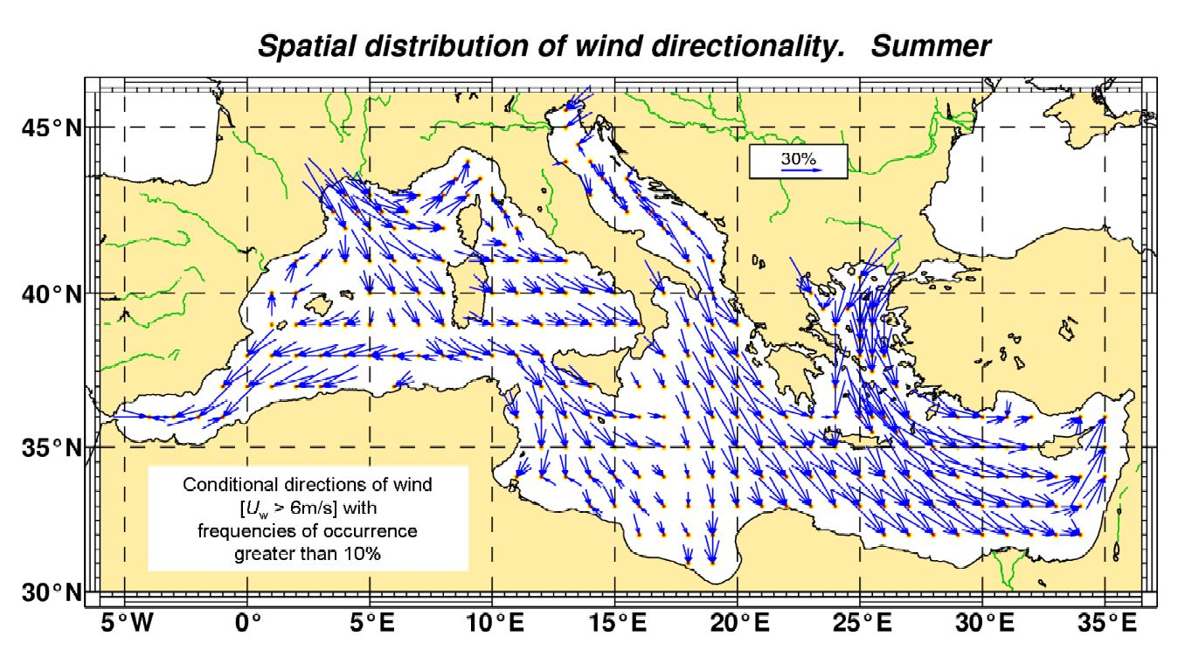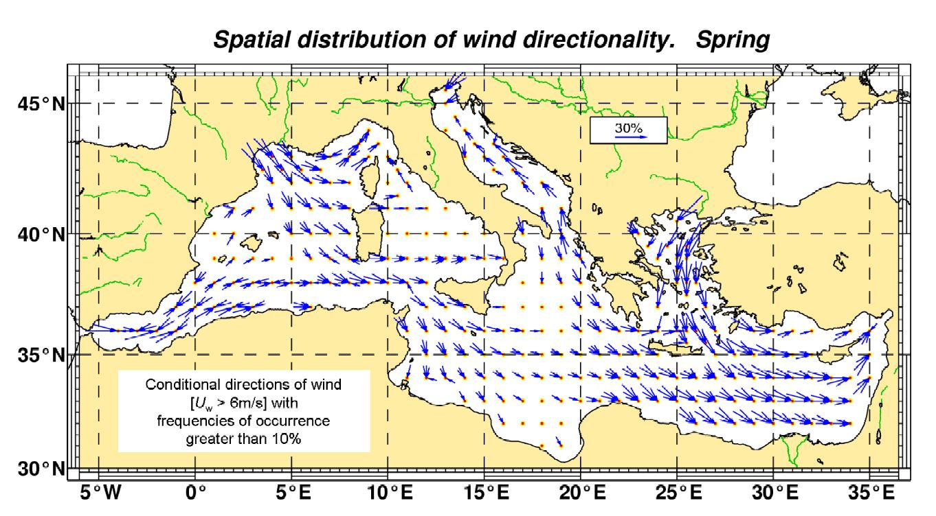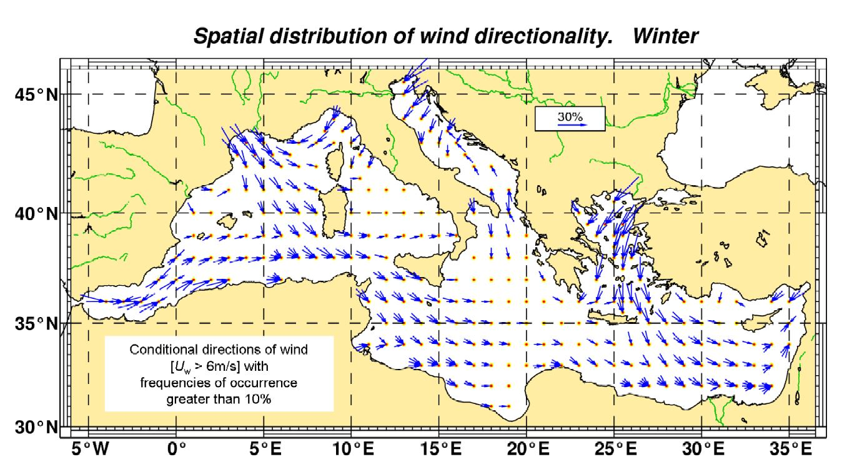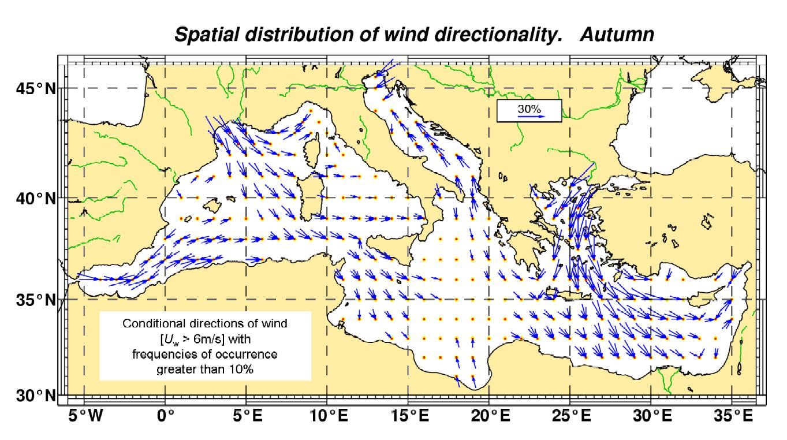
These pictures show the strong summer winds from NW: the Tramontane and Mistral in France, The Bora in the Adriatic and the Meltem in the Egean. They reduce somewhat in autumn, but this would be more obvious on monthly charts instead of the above seasonal charts.
These winds induce waves travelling on the sea from NW to SE, towards the African coasts. For this reason the East coasts of Spain, Corsica-Sardinia, Italy-Sicily, Tunisia, and Greece are relatively less exposed to large waves than the North coasts of Algeria, Tunisia, Cyrenaica-Egypt.
Note that places with reduced exposure to waves are safe for coastal structures; these places may still be exposed to strong land winds, which is not safe at all for navigation as ships are taken away offshore by the wind where they will finally encounter large waves.
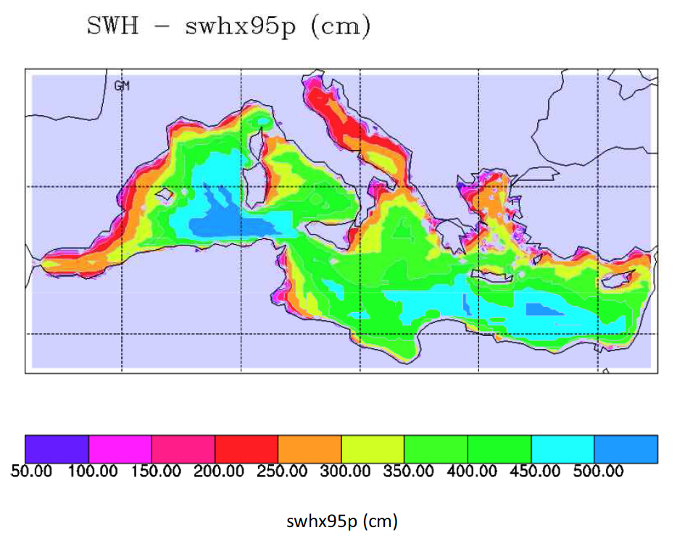
Results are based on 30-year long simulations of the wind wave field in the Mediterranean Sea carried out with the WAM model. The wave model has been forced by the wind field computed by the RegCM regional climate model at a 50 km resolution. The results are shown as a 5% exceedance significant wave height which is exceeded during 5% of the time, that is around 2 weeks/year. Depending on the area, this wave heights near the coastlines range from 1 to 4 m, with the highest values along the North-African coasts.
The design wave heights for coastal structures are obviously larger. Depending on local wave statistics, the design wave height is a factor 2 to 2.5 times larger than the above mentioned 5% exceedance significant wave height, leading to Hs = 10 m in areas exposed to offshore waves.
The wave heights are shown for deep water (say over 100 m) and it must be stressed again that waves change in height and in direction from this limit up to the coastline where they will ultimately break due to the shoaling sea bed. A first approach is to say that waves break when their height is around 0.6 times the local water depth, e.g. a wave with significant height Hs = 6 m will break on a water depth h = 10 m. Hence, if an ancient breakwater was built in 5 m water depth, the largest Hs reaching the structure would have been 3 m. Storms with Hs = 3 m are numerous. For a modern breakwater built in 20 m water depth, the largest Hs reaching the structure is 12 m which is a fairly large value that corresponds to exceptional storms in the Mediterranean Sea (less exceptional in the Atlantic).
So do not use the map above for the design of your next breakwater! Just use it to realize that some areas are more subject to severe wave attack than others.

NB: we usually suppose that the ancient wave climate is similar to the present one. This is not true for all ancient times as some climate changes have been identified, inducing cooler and warmer periods. The climate of the period from 200 BC to 500 AD is considered fairly close to ours, with a cooler period before that and after that (Beresford, 2013, p 60).

NB: Sailing was (and still is) considered comfortable with winds of 3-4 Bft (up to 15 knots), it becomes quite ‘sportive’ with 5-6 Bft and critical above 7 Bft (over 30 knots). According to Pascal Arnaud (2005, p 22): “dans la définition du vent favorable, la force est le critère primordial, et l’orientation un critère secondaire. Un vent est considéré comme praticable dans les petits airs jusqu’au maximum des capacités théoriques de remontée du navire. Dans la brise, il l’est normalement aux seules allures portantes (vent arrière et largue)”, which means that as long as a sea state (wind and waves) does not exceed say 4 Bft, the sailor is free to manoeuvre his ship in various directions, but that for higher sea states he loses this freedom and has to sail downwind. The 1986 Kyrenia II experiment (small 30 ton freighter of 14.5 x 4.5 m) has shown that an ancient merchant ship could resist well in a 9 Bft storm (45 knots wind). Surely much better than any ancient battle ship that would probably not resist more than 6 Bft (25 knots wind) as shown during the Olympias (50 ton trireme of 37 x 5.5 m) sea trials in 1992.

References

ARNAUD, P., (2005), Les routes de la navigation antique, ed. Errance, 248 p.

BERESFORD, J., (2013), The ancient sailing season, ed. Brill, 364 p.

CIRIA, CUR, CETMEF, (2007), Rock Manual - The use of rock in hydraulic engineering, (2nd edition), ed. C683, CIRIA, London, 1304 p.

DE GRAAUW, A., (1986), Wave statistics based on ship’s observations, Elsevier, Coastal Engineering, 10, p 105-118.

GALANIS, G. et al., (2011), Wave height characteristics in the Mediterranean Sea by means of numerical modeling, satellite data, statistical and geometrical techniques, Mar Geophys Res, Springer Science+Business Media BV, 2011.

GODA, Y. (2010), Reanalysis of regular and random breaking wave statistics, Coastal Engineering Journal, Japan, Vol. 52, No. 1, p 71–106.

LIONELLO P. and A. SANNA (2005), Mediterranean wave climate variability and its links with NAO and Indian Monsoon Clim.Dyn., 25, pp 611-623.
See also: ftp://ftp.marine.csiro.au/pub/hemer/COWCLIP/PDFs/Lionello_COWCLIP.pdf (2011) (contact: piero.lionello@pd.infn.it ).

MAZAS, F. and HAMM, L., (2011), A multi-distribution approach to POT methods for determining extreme wave heights, Coastal Engineering, 58, 2011, pp 385–394.

WESTERN EUROPEAN UNION (2004), Wind and Waves Atlas of the Mediterranean Sea, ed. Western European Armaments Organisation Research Cell, 386 p.

George Galanis et al., (2011),
Wave height characteristics in the Mediterranean Sea by means of numerical modeling, satellite data, statistical and geometrical techniques,
Mar Geophys Res, Springer Science+Business Media BV, 2011.

Mean value of Hs from WAM with Currents model
(in m)

The mean value of Hs has little value for design of coastal structures, but general trends are shown.
It is seen easily that:
- Winter waves are higher than summer waves,
- Cyrenaica and East Algeria have highest waves in winter,
- This confirms a trend for winds blowing from North and NW in winter,
- Highest offshore waves are generated by the Tramontane in the area between the Balearic Islands and the Corsica-Sardinia islands.

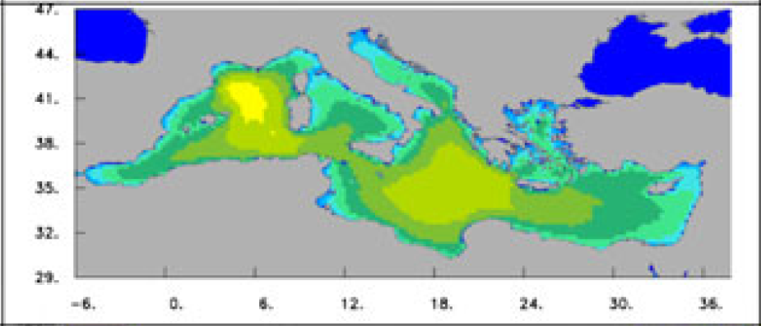
Mean value of Hs for Dec-Jan-Feb: Winter
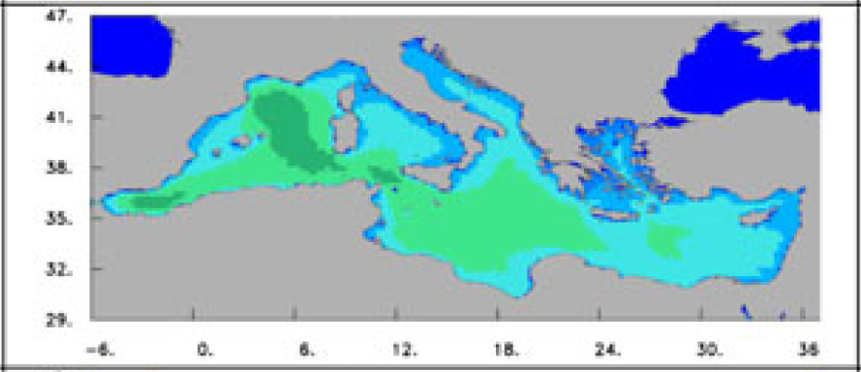
Mean value of Hs for Mar-Apr-May: Spring
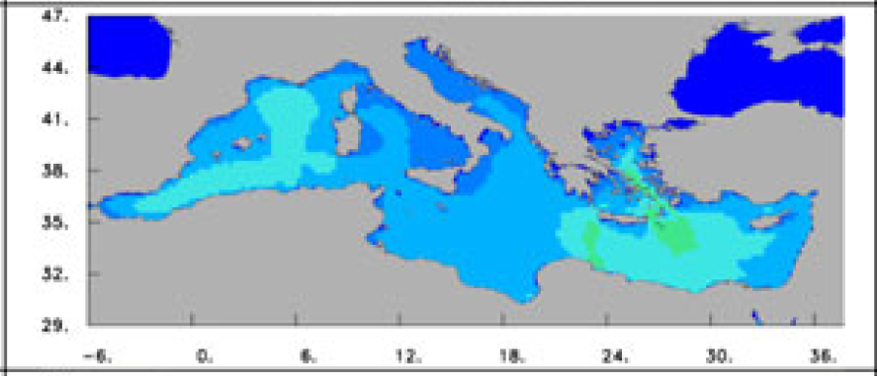
Mean value of Hs for Jun-Jul-Aug: Summer
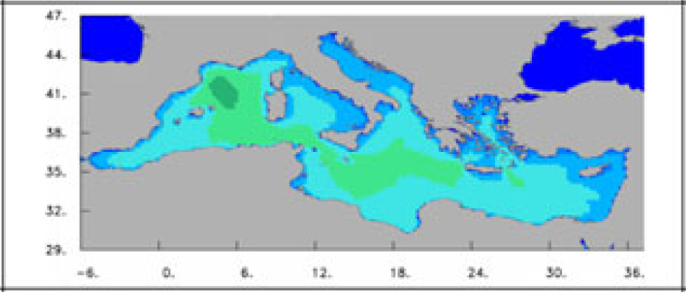
Mean value of Hs for Sep-Oct-Nov: Autumn
P. Lionello, (2011),
Regional wave climate projection studies in the Mediterranean Sea,
WCRP / JCOMM Workshop on Coordinated Global Wave Climate Projections, 11-13 April, 2011, WMO, Geneva.
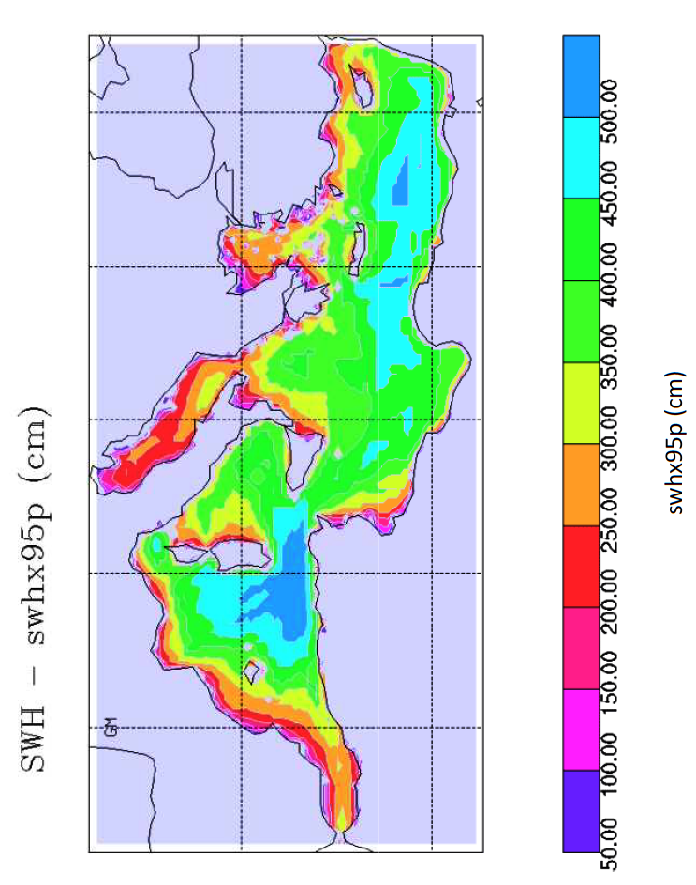
swhx95p: 95th percentile of the daily maximum SWH (Hs)
NB: care for reversed colour sytem!
Same trend as with Galanis: highest waves in Cyrenaica and East Algeria

