DO MODERN WINDS EQUAL ANCIENT WINDS?
WILLIAM M. MURRAY
Mediterranean Historical Review, 2, (1987), p 139-167 (published online: 02 Jun 2008)
INTRODUCTION
Today, most of us routinely ignore the presence or absence of the wind unless we are caught in a violent storm or swelter in the heat of a still day. Nevertheless, the wind - its varying strength and direction- was a critically important matter for maritime civilizations before the advent of steam. The winds had a strong influence over human interaction with the sea, and for the ancient cultures of the Mediterranean basin this had far-reaching effects. The winds determined the ease or difficulty of sea-borne communications between cities of the same coast, between the mainland and the islands, and indeed, between the different regions of the Mediterranean basin. Places easily reached on the prevailing winds were visited frequently, and if the presence of sufficient resources warranted, were settled in preference to other areas less open to the sea lanes.¹ This recurring tendency helped to shape settlement patterns, and on a smaller scale, determined the precise placement of harbours and the sites of the cities they serviced.² In addition, the winds determined both coastal and offshore sailing routes, defined navigational hazards, and at times, affected the outcomes of naval battles.³ It follows that our knowledge of their precise behaviour in a particular area might help to locate ancient harbours and wreck sites, to explain anomalies in settlement patterns and to 'flesh out' or even explain confusing accounts of ancient sea battles.⁴
Stated simply, understanding a coastal area's wind regime (its recurring, annual wind patterns) could be an important factor in helping to reconstruct and evaluate the record of human activity along that coast. And such a factor becomes all the more important when our historical and archaeological evidence is scanty. There is a problem, however, involved in defining the wind conditions which prevailed in a given area more than 20 centuries ago. If we could establish that ancient conditions were essentially the same as those prevailing today, we could apply the current rich body of modern wind data available from most areas of the Mediterranean to topics of ancient interest.
Some scholars have, in fact, already utilized modern wind data, albeit at times uneasily. For example, prevailing wind conditions in the Adriatic, eastern Mediterranean, and at Drepanum in Sicily are used by S.L. Mohler to analyse certain passages in Vergil's Aeneid.⁵ Nineteenth-century wind patterns in the Black Sea are used by B.W. Labaree to reconstruct the ancient techniques of navigation through the Bosporus.⁶ A.T. Hodge analyses the Persian voyage to Athens after the battle at Marathon with reference to modern wind patterns.⁷ A pair of meteorologists, J. Neumann and D.A. Metaxas, have tried to square modern conditions in the Gulf of Corinth with the Thucydidean account of a naval battle in 429 BCE.⁸ And finally, L. Casson utilizes modern wind conditions to reconstruct the nature of the ancient voyages from Rome to Africa and India.⁹
These studies are not intended to comprise an exhaustive list. They are presented, however, to demonstrate the potential usefulness of modern wind data if only their reliability as ancient indicators could be established. Since this has yet to be demonstrated, most of these authors express a degree of uneasiness with their methodology.¹⁰ Their apprehension is warranted. Prevailing winds are set in motion by very large-scale pressure patterns. In the case of the Mediterranean, they stretch from the Azores to India and from continental Asia to the Atlas Mountains of northern Africa. These patterns are not static over time and change according to climatic variations. Since the current view among climatologists is that the Mediterranean area was somewhat cooler and wetter (during the last five centuries BCE) than it is today, one wonders what effect this had on the winds.¹¹ Can we assume without question that the winds of this period in time blew from the same directions and at the same times of the year as they do today? Clearly, the assumption frequently made, that the conditions are the same, must be tested if at all possible.
First, one must find ancient wind observations stated in such a way as to compare to modern statistics compiled by national meteorological services. In the modern format, winds (observed at land stations and on ships at sea) are described according to an eight-part division of the compass rose, with each section comprising an arc of 45° - north, north-east, east, south-east, south, south-west, west, and north-west (Fig. 1).¹² Standard procedure dictates that observations are made three times a day - at 0800 hours (8 a.m.), 1400 hours (2 p.m.) and at 2000hours (8 p.m.) - although this practice is not always followed (especially with the sea data). Both the wind's speed and direction are recorded as are calms (namely the lack of a detectable wind). These daily observations are collected over a period of years, averaged, and then expressed in monthly tables. Each table presents the eight winds and calms, along with their average frequency of occurrence (expressed as a percentage) during the month. The frequencies for each of the eight winds are broken down further into the following five degrees of strength: 1-10kn., 11-16 kn., 17-27 kn., 28-33 kn., and above 33 kn. (1 kn. = 1.15m.p.h.).
From Table 1 it can be seen that the north-west wind was observed 46 per cent of the time at the meteorological station on Zakynthos at the0800 observation during the month of July. Additional information published with the table tells us that observations were taken daily during the years 1933-39 from a station 20 feet above sea level at 37°47'N., 20°53' E. The north-west wind blew predominantly (42 per cent) at speeds between one and ten knots. Calms were observed only two percent of the time.¹³
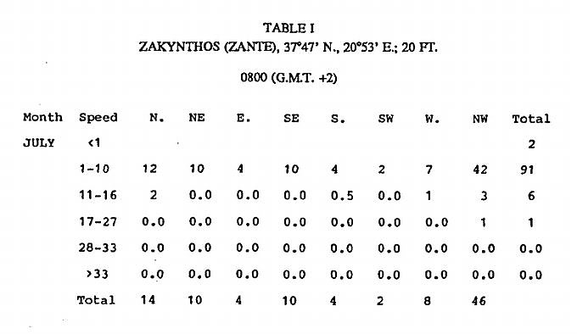
For the ancient period, we fortunately possess two excellent sources of wind observations from the late fourth century BCE: Book 2 of Aristotle’s Meteorologica and the De Ventis of his pupil and successor at the Academy, Theoprastos.¹⁴ From references to local winds in Theophrastos' text, one can also detect the principal areas included in his analysis. Of the 30 different places he mentions, over two-thirds are located on mainland Greece or in the Aegean, and no place is mentioned further west than Italy and Sicily.¹⁵ There is no reason to believe that Aristotle's sources were any different from those of his pupil. As for the observations, they are for the most part clear, systematic (winds from all points of the compass are mentioned), and, we should assume, reliable.¹⁶ Although they adhere to a different set of standards and stem from different sources of observation than do our modern data, they roughly compare to averaged sets of data such as those recorded from ships at sea (see Appendix 1).
The importance of Theophrastos' work as an indicator of the fourth-century BC climate has been pointed out by V. Coutant and V.L. Eichenlaub, editors of a recent edition of the De Ventis (see n. 15),although they do not seem to appreciate fully the usefulness of the wind observations contained in the text. Working from a theory developed by H.H. Lamb that modern wind patterns roughly coincide with those circa 500 BCE (see n. 18, below), they extrapolate a similar coincidence of patterns circa 300 BCE. They then attempt to show the 'accuracy' of Theophrastos by comparing his observations with modern conditions.¹⁷ I believe their priorities are reversed. Since accurate observation is the foundation of the Aristotelian method, there is no need to test Theophrastos' accuracy; the man's high reputation as a disciple of, and successor to Aristotle would be otherwise unexplainable. Rather, the wind observations of this text (and the Meteorolgica) allow us to test Lamb's theory concerning wind patterns circa 500 BCE, and such an opportunity is rare.¹⁸
There exist, furthermore, some basic problems with Coutant's and Eichenlaub's comparison of ancient and modern wind conditions, especially as concerns the seasonal frequency and force of the winds -observations most easily compared with modern data. Their treatment of these statements is superficial and extremely selective. Only a few of the many observations are examined and reference is made primarily to modern data from Athens.¹⁹ I believe that these are the observations which provide the best source for ancient wind conditions. Frequently stated in a matter of fact way, these general observations provide a rare view of the prevailing annual winds affecting Greece and the eastern Mediterranean in the fourth century BCE. It is the purpose of the present study to compare these ancient conditions with those prevailing today.
A CORRELATION ANALYSIS OF ANCIENT
AND MODERN WIND OBSERVATIONS
In theory, the task involved in such a study is quite straightforward: one simply compares an ancient observation with modern statistics. Special attention should be given to the eastern Mediterranean, and particularly to Greece, although data from the entire Mediterranean basin might be utilized to test for geographical bias in the ancient observations. If the modern data agree with the ancient observation, the statement is classified as a 'good' correlation. Partial agreement results in a 'fair' correlation, while total disagreement rates a 'poor' correlation.
In practice, however, the task is far from easy. Careful interpretation is first required to compile an acceptable list of observations. Then all judgements must be justified by a standardized set of tests based on statistical comparisons. But before this can be attempted, two matters of prime importance must be understood: (1) the wind system, or anemology, in which the ancient observations are reported, and (2) the chronological system used to date the occurrence of individual phenomena.
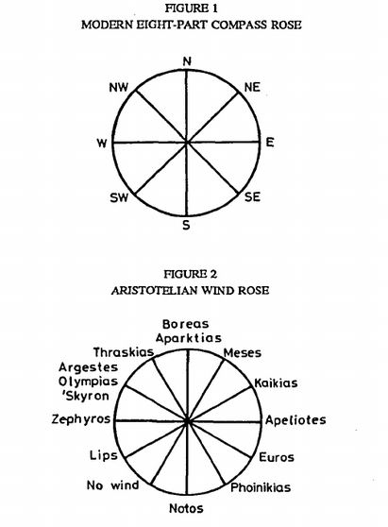
ANEMOLOGY
The anemology employed by both authors is described by Aristotle in Meteorologica 2.6 (see Fig. 2) where all winds are defined as blowing from points along the exterior of a 360 circle (namely the circle of the horizon). The major divisions of this circle are identical with those of a modern compass rose: north, south, east, and west. Subdivisions are determined by the positions of the summer and winter solstitial sunrises and sunsets as viewed from Athens, with further subdivisions falling between these points and the poles.²⁰ By comparing Figures 1 and 2, one can translate the ancient wind directions into modern terms. Table2 presents the ancient winds with their modern equivalents.
TABLE 2
WIND EQUIVALENTS
N. = Boreas, Aparktias
NNE= Meses
NE= Kaikias
E. = Apeliotes
ESE= Euros
SE= Phoinikias
S. = Notos
WSW= Lips
W. = Zephyros
NW= Argestes, Olympias, Skyron
NNW= Thraskias
This method of 'translation' should not be taken to extremes; a rigid application of directional distinctions can result in serious errors since direction is only one of the characteristics of a wind as perceived by the ancients (more on this later). I have therefore allowed a variance between the ancient and modern observations of up to 45° on both sides of a wind's direction as still constituting a 'good' correlation. Thus, when Theophrastos writes that winds blow from the east in winter (Vent. 47), I consider modern data from the entire eastern quadrant (namely north-east, east, and south-east).²¹ This may seem a bit generous, but I believe it necessary to check the entire quadrant for three reasons. First, irregularities of the local topography near observation stations can slightly change the apparent wind direction.²² Second, the ancients of Aristotle's day did not possess an orientation device such as a compass, and therefore precise recording of a wind's direction relative to the exact points on Aristotle's wind rose would have been impossible.²³ And finally, even though this wind rose is slightly different from the one in use today, the major wind divisions are still north, south, east, and west, and 45° represents the greatest variation allowable from the midpoint of the four main quadrants(north to east, east to south, south to west, and west to north) without crossing from one quadrant into the next. In practical terms, this means that a north-east wind might be perceived as a north wind, but it is unlikely to be perceived as a north-west wind. For this reason, Meses will be treated as a north-east wind, Euros as a south-east one, Lips as a south-west one, and Thraskias as a north-west wind.
CHRONOLOGY
We must now consider the dating system used by Aristotle and Theophrastos, because this will determine which monthly tables are consulted for each observation. Four systems are used: a wind is either said to blow (1) during a particular season of the year, (2) during the rising and setting of certain constellations, (3) at the time of the equinox, or (4) at the solstice. These dates, relative to our modern calendar, have been convincingly worked out by A. Rehm, and I will adhere to his computations (see Table 3).
TABLE 3
DATING ELEMENTS
Winter = early November to mid-February
Spring = mid-February to early May
Summer = early May to mid-September
Autumn = mid-September to early November²⁵
Winter solstice = December 24
Spring equinox = March 23
Summer solstice = June 26
Autumn equinox = September 26
‘At the time of the Dog Star' (Sirius) =
July 15-25 to November 22-December 1
Rising of Orion = late June/early July
Setting of Orion = mid- to late November
Advent of Etesians and precursors = late July
A summation of what has been established is now in order. (1) A set of appropriate observations is preserved by Aristotle and Theophrastos from the fourth century BCE. (2) These observations contain a bias towards Greece and the eastern Mediterranean. (3) Both authors use the same wind system or anemology. (4) The ancient system can be translated satisfactorily into our modern one based on the compass rose if rigid directional definitions are avoided. (5) Both authors use the same chronology or method of dating their observations. (6) This chronology, based on the occurrence of seasons and astronomical phenomena, is defined in the parapegma of Euktemon. (7) The dates recorded by Euktemon, translated into our modern system by A. Rehm, will be used in this study to define the time of an ancient observation’s occurrence.
METHOD OF ANALYSIS
With this information in mind, we are now ready to consider some of the difficulties encountered in performing a correlation analysis. The chief problem lies in the fact that the ancient and modern observations adhere to two different standards of accuracy. As a result, every possibility must be examined before it is concluded that an ancient observation disagrees with modern conditions. A few examples will suffice to demonstrate the method utilized in this study. Let us first take the relatively simple observation of Met. 364a32-364b3: 'As a rule, opposite winds prevail [or 'especially blow'] in opposite seasons: for instance, at the time of the vernal equinox [23March], it is Kaikias [ENE] and winds from north of the summer sunrise; in the autumn, Lips [WSW]; at the summer solstice [26 June], Zephyros [W.]; in the winter, Euros [ESE].' The winds are directionally defined as opposites on the wind rose (compare Fig. 2) and the observation is clear: the winds prevail or blow at specifically cited, opposite times of the solar year (kata de tas horas tas enantias hoi enantioi malista pneousin). If, as here, the ancient source states that 'x 'wind blows at 'y' time of the year, I have allowed for two possibilities: either the frequency of 'x' is highest when compared to all other winds at 'y' time of the year, or the frequency of 'x' is highest at 'y' time of the year when compared with its own frequencies at other times of theyear.²⁶ If either or both of these conditions prevail, I conclude that the ancient statement correlates well with the modern data and rates a G ('good'). In this particular case, the statement does correspond well except for the WSW wind Lips, which shows only partial agreement; it thus rates an F ('fair'). Not all observations are so straightforward. In a passage from Theophrastos (Vent. 38), the Zephyros is called the mildest of all winds, blowing in two seasons only, the spring and late autumn. If the tables are checked for the spring (particularly March and April), and late autumn (October), we find that the west winds do prevail, but we will also see that winds from the west blow most frequently during the summer. Have the winds changed slightly so that now they blow in the summer too? The answer is negative, because Theophrastos is not discussing west winds in general, but rather, a particular kind of west wind. For the ancients a wind's name was just as descriptive of its physical characteristics as it was of its direction (and perhaps more so).²⁷ Theophrastos deals with the simple directional west winds in section 47; according to him, these winds, called ta zephyria, and more generally, 'the winds from the west', do blow most frequently in the summertime, as our modern data show. But the particular wind he calls the Zephyros is different from these 'zephyria'. In sections 38, 40, and41, he describes it as 'the gentlest of the winds', 'soft', 'cool', and blowing at sunset towards the land. These are the characteristics of the sea-breeze experienced by many areas of Greece in the spring, summer, and autumn. When the modern data are checked for a light breeze blowing from the west in the afternoon, we find that this condition starts up in the spring, prevails in the summer and continues into the autumn. Thus, the weak sea-breeze does occur primarily during the spring and autumn when it is starting up and winding down. Only after arriving at this point, therefore, can we conclude that the correlation of this ancient observation is in fact 'good' in the area of Greece.²⁸
CORRUPT PASSAGES
Before presenting my list of ancient observations, four passages deemed unacceptable for comparison must be presented and explained. Because they appear corrupt or faulty on the grounds of internal inconsistencies they have been excluded in part or entirely from consideration:
(1) Met. 361b3O-35; (2) Vent. 55. A clear corruption occurs indifferent forms in both the texts of Aristotle and Theophrastos where unsettled winds are reported as occurring at both the rising and setting of Orion. Aristotle equates the rising of the constellation with the change from spring to summer (in early May), but Theophrastos equates it with the change from summer to autumn (in mid-September). Both texts are wrong: from other sources (including Euktemon), we know that Orion rose during the second half of June and the first half of July, right in the middle of the summer season.²⁹ I have, therefore, disregarded the statement that the winds are unsettled at the time of Orion's rising. Although it might be best to disregard both statements, I have decided to include the statement that unsettled conditions prevailed in mid-November.³⁰ Both authors are in agreement about this fact, and indeed it agrees with modern observations in the eastern Mediterranean.
(3) Met. 362all- l6, 22-31; (4) Vent. 11. Aristotle defines the ornithiai and leuknotoi as weak winds that blow intermittently in response to the summer Etesians. The ornithiai, or 'bird winds' are characterized as 'feeble Etesians, blowing later and with less force than the Etesian winds proper', which do not begin to blow until the seventieth day after the winter solstice (4 March). From this point on they continue to blow intermittently until the true Etesians rise at the summer solstice (26 June). As for the leuknotoi, or 'white southerlies’, both authors agree that they to balance the Etesians. Theophrastos explains:
From this arises the puzzlement as to why there are northerly Etesians but not southerly ones, as though this were a fact; but it appears that there are southerly Etesians. For the south winds in the spring are Etesians, those which are called leuknotoi; they are fair weather winds and cloudless on the whole. At the same time, being remote from us, they are not noticed (my italics; the translation is taken largely from Coutant's and Eichenlaub's edition [n. 15]).
As described in these passages, the two winds must be one and the same. And yet being 'unnoticed' by the general populace, they clearly owe their existence more to Aristotle's anemology of balancing winds than to the fact of observation. I have thought it best, therefore, to exclude both the ornithiai and leuknotoi from consideration.³¹
ANCIENT WIND OBSERVATIONS
Here follows a list of those statements deemed capable of comparison with modern data. Translations from H.D.P. Lee's Loeb edition of the Meteorologica (L) and Coutant's and Eichenlaub's edition of the De Ventis (C&E) are noted after the appropriate passages. Unmarked translations are the author's.
1. Winds: N., NNW, NW; References: (i) Met. 364b3ff.: 'Aparktias[N.], Thraskias [NNW] and Argestes [NW] are the winds that most often interrupt and stop others. For because their source is nearest to us, they blow with the greatest frequency and strength of all the winds.'(L)
2. NW, N., NE (i) Met. 364a32-364b3: 'As a rule, opposite winds blow in opposite seasons; for instance, at the time of the vernal equinox Kaikias [NE] and winds from the north of the summer sunrise prevail; in the autumn Lips [WSW]; at the summer solstice Zephyros [W.], at the winter Euros [ESE].' (L)
3. WSE
4. W.
5. ESE
6. N., S.; (i) Met. 361a4-7: '... for most winds are in fact either northerly or southerly'(L). (ii) Met. 363a3-4: 'But because our region of habitation lies toward the north, most of our winds are north winds.'(L) (iii) Met. 364a5-7: "There are two reasons for there being more winds from the northerly than from the southerly regions.'(L)The reasons do not concern us here, (iv) Met. 363a6:'.. . just as here it is the north and south winds that blow'. (L) (v) Vent. 2: ' ... for both [the north wind and the south wind] are strong winds and blow the longest time'.
7. N., NE, NW, S., SW; (i) Vent. 10: "The north and south winds being the most frequent, as was said, there is a certain orderliness about their periods. The north winds blow during the winter and summer, and throughout autumn until the end of the season, while the south winds blow during the winter, at the beginning of spring, and at the end of autumn.'
8. E., W.; (i) Vent. 47: "The reason why winds blow from the east in winter and at dawn, but from the west in summer and in the afternoon must be considered to be the following....' (C&E) The reason does not concern us here.
9. S. and all others except the Etesians, namely, SW, S., SE, E.; (i)Vent. 48: 'The south wind customarily blows, like any other of the regular winds, at the time of the Dog Star.... Many winds would blow if they were not suppressed by the Etesians.' For the directions of the Etesian winds, see #12 below.
10. W. sea-breeze; (i) Vent. 38: 'The Zephyros [W.] is the mildest of the winds; it blows in the afternoon toward land and it is cool; during the year, it blows in two seasons only, spring and autumn'.
11. Etesians; (i) Met. 361b35-362a2: "The Etesian winds blow after the summer solstice and the rise of the Dog Star, they do not blow when the sun is at its nearest nor when it is far off. They blow in the day-time and drop at night.'(L) (ii) Vent. 12: "The reason why these winds [the Etesians] cease with the sun's setting and do not blow at night is ... '. The reason does not concern us here.
12. Etesians (N. quadrant); (i) Met. 362all-12: 'Some people find it difficult to see why the north winds which we call Etesian blow continuously after the summer solstice [June 26], but there are no corresponding [namely strong and noticeable] south winds after the winter solstice [24 Dec.].'(L) (ii) Met. 365a6-10: 'The Etesian winds veer round, for people living in the west, from Aparktias [N.] to Thraskias [NNW], Argestes [NW] and Zephyros [W.], beginning from the north and ending further south; for people living in the east, they veer from the north to Apeliotes [E.].'(L)
13. Unsettled winds; (i) Vent. 55: 'The winds which come when Orion are of no fixed character because during transitions all phenomena are especially uncertain. Orion sets at the beginning of winter...and so the star is called stormy when setting because of the unsettled character of the season. The winds are then bound to be turbulent and variable.' (ii) Met. 361b30-35: "The reason why Orion is commonly regarded as a constellation which brings uncertain and stormy weather when it <rise and> sets is that its <rising and> setting occur[s] at a change of season (winter) ....' (L) I have chosen to exclude those portions of each statement enclosed within angle brackets; cf. p. 147-8 above.
14. Gales [eknephiai; see n. 40]; (i) Met. 365al-3: 'Gales occur most often in autumn, and next in spring: and Aparktias [N.], Thraskias[NNW], and Argestes [NW] most often cause them.'
15. Calms; (i) Met. 361b23-24: 'Wherefore, calms particularly occur in the period around the rise of Orion [mid-June to mid-July] to the coming of the Etesian winds and their precursors.'
MODERN OBSERVATIONS
The next step is to identify an appropriate set of modern data and this is not an easy task. First of all, modern and ancient observations adhere to a different set of standards and stem from very different types of 'instruments'. Most modern data come from land stations where standardized instruments objectively display and record information. But our ancient observations stem from living people, not calibrated instruments, moving about their valleys or sailing from region to region. These were the people who composed and repeated the sailors' and fanners' proverbs appearing in the ancient texts. Travellers contributed additional information as did the authors' (and their students') own personal experiences.³² We can not expect, therefore, complete agreement between ancient and modern observations because they do not record wind conditions from the same viewpoint or according to the same degree of accuracy.
The following example demonstrates the point. A modern station near the acropolis records the sea-breeze as a south to south-west wind, although an Athenian captain trading with Italy and western Greece would tell you the sea-breeze along his routes blows primarily from W.to NW. Aristotle must have ignored the local conditions in Athens in preference for the captain's more general observation because he was attempting to define a single, unified wind system for those who lived in the Greek world.
This ‘unified’ characteristic of the ancient data must be kept in mind when we attempt to compare them with modern data from Greece. It is a documented fact that the wind regimes of Greece's east and west coasts differ markedly, a condition determined in part by the geography of the Balkan Peninsula. Since this factor has not changed since antiquity, different wind regimes must have affected these two coasts in the fourth century BCE. And yet both authors define a single wind regime affecting the Greek world. We must conclude that Aristotle and Theophrastos somehow averaged observations known to them from numerous areas in developing their wind theories. How they managed to do this without statistics is impossible to know (and perhaps their results are not always accurate), but it is certain that this was their method.
Since the ancient statements are of a general or 'averaged' nature, it would be most appropriate to search for modern observations of an equally general nature, and also ones that define the overall wind patterns of both the eastern Mediterranean area and Greece. Such a set exists in the second volume of Weather in the Mediterranean published by Great Britain's Meteorological Office where observations from ships at sea have been cast into 15 tables representing all of the Mediterranean basin.³³ These particular observations suit our purposes well. Coming from ships moving from place to place within each region, these data present an 'averaged', overall picture of the winds.
Correlations will be carried out for all 15 regions of the Mediterranean, even though the ancient observations are presumably biased towards the eastern Mediterranean as noted above. Should the correlations from the area of Greece be overwhelmingly positive, yet negative elsewhere, a complete correlation from all 15 regions will be necessary to determine the precise nature of the ancient bias. Table 4 presents some important information concerning the nature of the data from each region and Figure 3 shows the locations of the areas covered. In order to answer possible objections to the reliability of data from the area of Greece (where two wind regimes are known to exist), I have also chosen data from five land stations within region 11 for comparison with the ancient observations. The analysis of these results appears in Appendix 1.
SPECIFIC METHODOLOGY
We can now turn to the 'simple task' described at the outset of this analysis, namely the comparison of ancient observations with modern data.
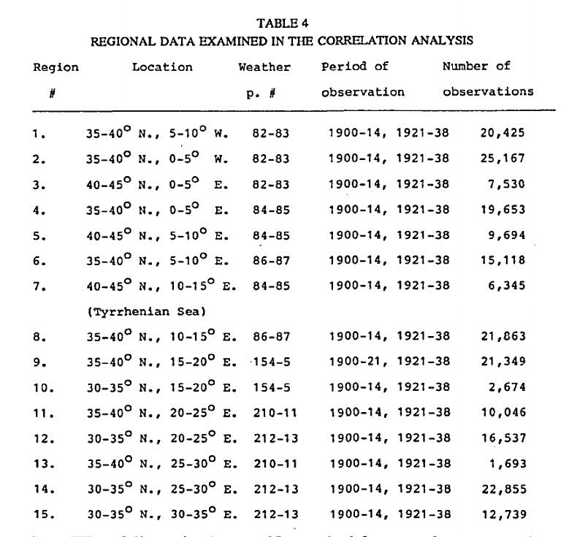
What follows is the specific methodology used to test each observation. The observation number is listed at the left of each entry, and is followed by the specific winds or quadrant to be examined.³⁴ Finally, the specific tests employed to arrive at a 'good' (G) correlation are presented. If the data do not support a good correlation, partial agreement results in a 'good to fair' (G-F), 'fair' (F), or 'fair to poor' (F-P) rating, and total disagreement in a 'poor' (P) rating. The results of this analysis are discussed after the following list.
1. N. to NW: If the annual average frequency total of N. + NW is greater than those of NW + W., W. + SW, SW + S., S. + SE, SE + E.,E. + NE, or NE + N., - or if either N. or NW is clearly the highest of all other annual average frequencies, then the statements rate a G.³⁵ If the annual frequency total of NW + W. is highest, followed by N. + NW, then the statement rates an F.
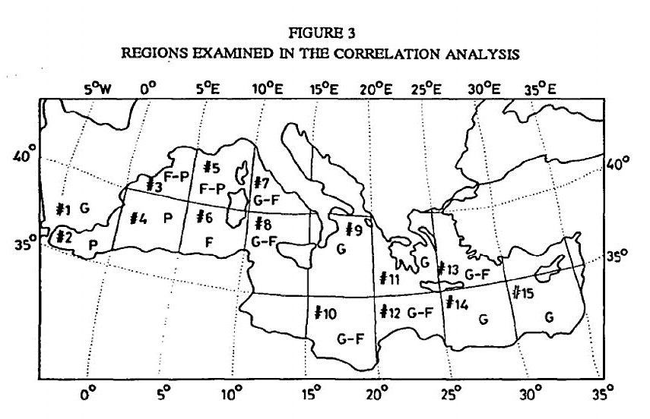
2. N. quadrant (see n. 21): If the frequency total (see n. 35) of NW + N.+ NE (= N. quadrant) is greater than that of NE + E. + SE (= E. quadrant), SE + S. + SW (= S. quadrant), or SW + W. + NW (= W. quadrant) in March and April, then the statement rates a G.
3. WSW: If either the frequency of SW or the total of W. + SW reaches an annual high in September, October, and November, then the statement rates a G. If the total is above the corresponding annual average value, the statement rates an F.
4. W. quadrant: If either the frequency total of the W. quadrant is greater than those of the other quadrants in June and July, or if the frequency total of the W. quadrant reaches an annual high (relative to itself) in June and July, then the statement rates a G.³⁶
5. ESE: If the frequency total of E. + SE reaches annual highs in December and January, then the statement rates a G. If the total is above the corresponding annual average, the statement rates an F.
6. N. quadrant, S. quadrant: (a) If (1) the annual average frequency total of the N. quadrant is highest (in comparison to the totals of the other quadrants), or (2) if the annual average frequency of either the NW, N. or NE wind is clearly dominant over the other winds, then this statement rates a G. (b) If (1) the annual average frequency total of the S. quadrant is the second highest in comparison to the total of the other quadrants, or (2) if the annual frequency total of the S., S W, or SE wind is clearly dominant over the other winds, but still less than a NW, N. or NE wind, then this portion of the statement rates a G.³⁷
7. N. quadrant, S. quadrant: If the frequency total of the N. quadrant in(a) winter (November to February), (b) summer (May to September)and (c) autumn (September to November) is highest relative to the other quadrant totals, or above the annual average N. quadrant total, then each portion of the statement (i.e., 'a', ' b \ and 'c') rates a G. And if the frequency total of the S. quadrant in (d) winter (November to February), (e) late autumn/beginning of winter (November), and (f) at the beginning of spring (February) is second only to the N. quadrant total, or if the S. quadrant total is at its highest annual values at these same times of the year, then each portion of the statement (i.e., ' d \ ' e \and T ) rates a G.
8. E. quadrant, W. quadrant: (a) If the frequency total of the E. quadrant reaches an annual high during the winter, the statement rates a G. Sea data do not list the time of the observation, (b) If the frequency total of the W. quadrant reaches an annual high in the summer, the statement rates a G. Sea data do not list the time of the observation.
9. Non-Etesians: If the frequencies of SW, S., SE, and E. are roughly equal, or if they are all clearly dominated by winds from the N. and W. (in July and August), the statement rates a G.
10. W. sea-breeze: If a weak 'sea-breeze effect' (namely winds of one to ten knots blowing from the sea towards the land which rise during the mid-morning and afternoon and die down after sunset) is noticeable in spring (February to April) and late autumn (October, November),the statement rates a G (cf. pp. 146-7 and n. 28 above). This particular statement cannot be tested with data coming from observations made at sea (for correlations in the area of Greece, see Appendix 1).
11. Etesians: If the frequency total of the N. quadrant reaches annual highs in July and August, the statement rates a G. Sea data do not list the time of the observation.³⁸
12. Etesians: (a) If the frequency total of NW + N. during the months of July and August is greater than the total of N. + NE (during the same period) for the western Greek mainland, then this portion of the statement rates a G. (b) If the frequency total of N. + NE during this same period is greater than the total of N. + NW for the eastern Greek mainland and the Aegean islands, then this portion of the statement rates a G. These tests apply only to appropriate data from regions 11 and13 (see Appendix 1).
13. Unsettled winds: If the sum of all deviations from 12.5 per cent (computed from the monthly frequency totals for each wind) is the lowest in November, the statement rates a G.³⁹
14. Gales: If the highest total of wind frequencies from winds of 28 knots and higher occurs (a) in autumn (September to November) and then (b) in spring (February to April), both portions of the statement rate a G.⁴⁰ If the seasons are ranked in descending order according to the frequency totals of winds with speeds of 28 knots and higher, the following sequences receive the following ratings: (1) winter, (2)autumn, (3) spring = autumn rates F-P, spring rates F-P; (1) winter, (2)spring, (3) autumn = autumn rates P, spring rates G; (1) winter and autumn frequency totals are equal, followed by (2) spring = autumn rates G-F, spring rates G-F. (c) If the annual frequency total of N. +NW (of winds 28 kn. and above) is higher than that of N. + NE, NE +E., E. + SE, SE + S., S. + SW, SW + W., or W. + NW, this portion of the statement rates a G. Failing this, if the annual frequency of either W., NW, N. or NE is dominant over all other directions (of winds 28 kn. and above), this statement rates a G.
15. Calms: If the highest frequency of calms occurs in June and July, the statement rates a G.

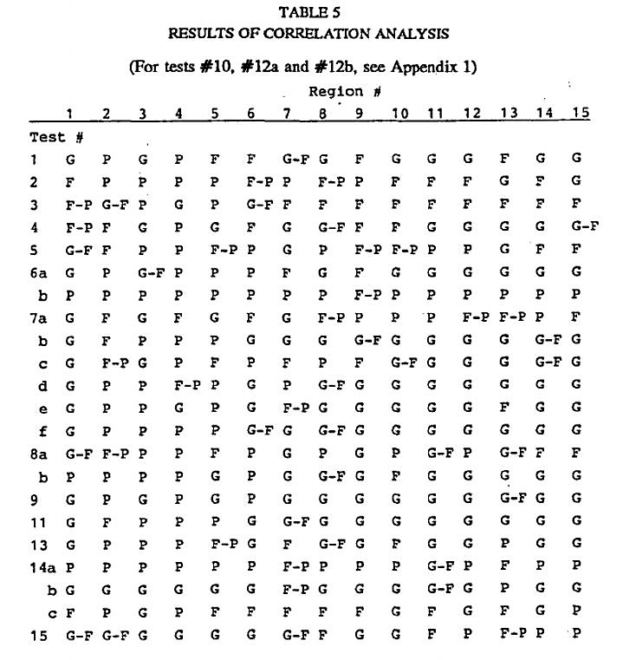

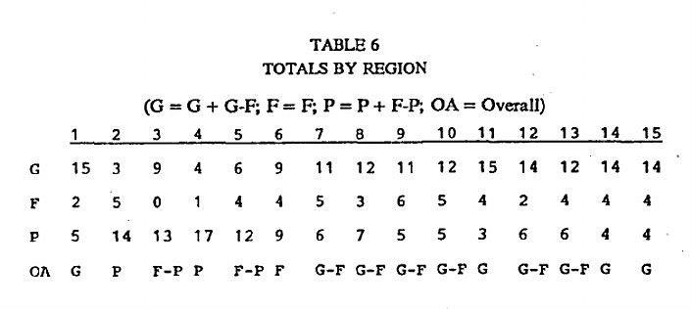
ANALYSIS OF REGIONS
Table 6 and Figure 3 show a striking pattern. The degree of agreement between the ancient and modern data rises as one approaches Greece from the west. The progression is clear and unmistakable. At Gibraltar the agreement is 'poor' overall; west of Sardinia, it becomes 'fair to poor'; south of the island it rises to 'fair'; in the region adjacent to Italy it rates 'good to fair'; while east of the Italian peninsula, the agreement is either 'good to fair' or 'good'. This pattern cannot be the result of random coincidence and is what one would expect from observers residing in Greece, who drew their information from individuals living or trading within regions 7 to 15. The most striking evidence for this conclusion is the fact that the highest total of 'good' (G + G-F) and lowest number of 'poor' (P + F-P) correlations come from region 11, the area of mainland Greece. The overall impression, therefore, is not that wind patterns have somehow 'changed' in the western Mediterranean (an unlikely fact considering the size of the pressure patterns affecting the Mediterranean) but that Aristotle and Theophrastos relied most heavily on Greek sources in developing their wind analyses. This is precisely what was inferred earlier from the high proportion of Greek place names appearing in Theophrastos' text. The high correlation between ancient and modern conditions from southern Italy to the Levant is, therefore, significant and must represent an eastern Mediterranean (and especially a Greek) bias in the regions analysed by Aristotle and Theophrastos. For this reason, regions 1 to 6 are excluded from the following two tables (7 and 8) and the accompanying analysis.

ANALYSIS OF INDIVIDUAL OBSERVATIONS: REGIONS 7-15
If the 'overall values' for the statements are totalled, we find 14 'good'(including 'good to fair') statements (=64 per cent), 4 'fair' statements (=18 per cent), and 4 'poor' statements (including one 'fair to poor' statement) (=18 per cent).
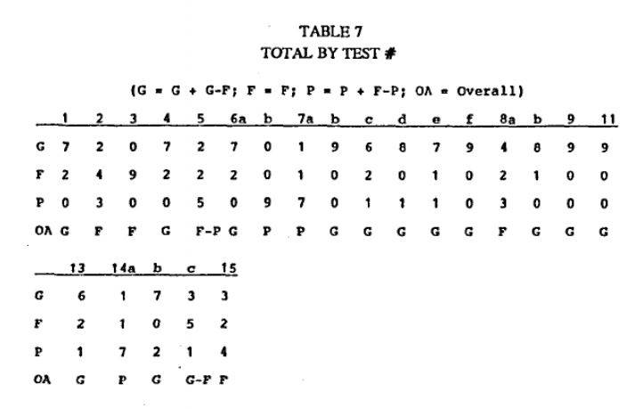
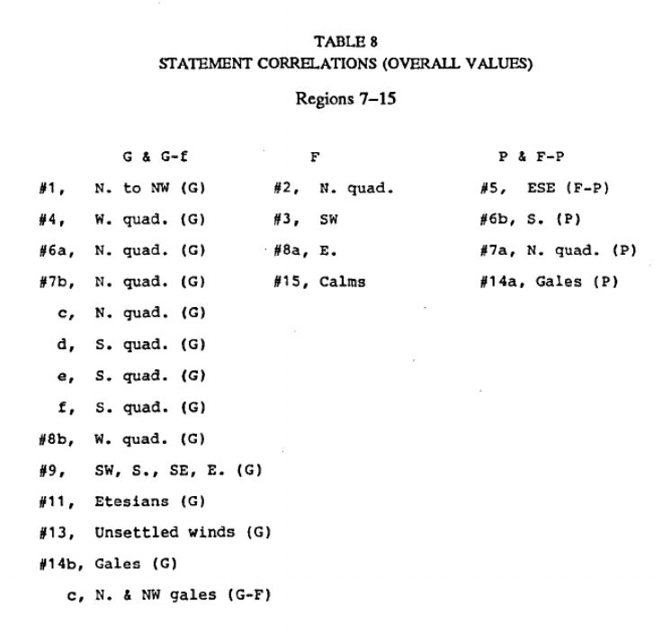
Some agreement can be seen, therefore, between ancient and modern conditions for 82 per cent of the time. If attention is paid, furthermore, to the directions of the winds involved, good correlations are seen for aspects of winds from all points of the compass. And if the Greek bias of our ancient data is taken into account, the results improve further. Of the four statements rating an F, two correlate well in the region of Greece: #8a rates G-F in regions11 and 13, and #2 earns a G in region 13. Of the four statements rating a P, two earn better marks in Greece: # 14a rates a G-F and F in regions 11 .and 13 (cf., however, Appendix 1), and # 5 earns a G in region 13.
We are still left, however, with two statements (#6b, #7a) whose poor correlations cannot be easily explained. It is striking that the first statement (that winds are mostly from the north and south quadrants) does not receive a 'good' or 'fair' rating anywhere in the Mediterranean basin, let alone in the area of Greece. Two possibilities might explain this anomaly: (1) Conditions have changed since antiquity, and the frequency of south quadrant winds has decreased. (2) Aristotle and Theophrastos are mistaken and have been led into recording a faulty observation by their views concerning the need for winds to balance one another. The clear dominance of north winds (an undisputed fact) must, therefore, be balanced by south winds which blow almost as frequently and in response to the north winds. Their anemology with balanced and opposing winds has accordingly obscured the fact that the west quadrant is close to the north in annual frequency.
I leave the scientific possibility of the first explanation to climatologists more competent than myself to evaluate such matters. As for the second alternative, I believe it is quite possible that Aristotle and Theophrastos 'created' a balance between winds from the north and south quadrants where none really existed. Such an attempt was noted above (p. 148) in their discussion of the ornithiai and leuknotoi as spring Etesians which balanced the summer ones. In the end, however, both authors had to admit that they blew so weakly and intermittently that no one noticed them (Met. 362all-16; Vent. 11). In other words, Aristotle made a fuss over winds that normally went unnoticed by the general populace in order to adhere to a principle of his anemology, and Theophrastos followed his mentor without comment.
It is also possible that Aristotle may have generalized conditions existing in the Attic plain into a universal statement because it appealed to his sense of a balanced order.41 Observations taken at the Zappion (37°58' N., 23°43' E.; 253 ft.) between 1932 and 1940 reveal an ambiguous pattern that could have been stretched by Aristotle to support observation #6b. If the daily 0800,1400 and 2000 observations are combined and then averaged into one annual table, we see that winds from the north quadrant are dominant. Those from the south and east quadrants blow approximately the same amount of time and are followed by winds from the west quadrant.⁴² Since Aristotle believed east winds were part of the south wind group, and west winds part of the north group (Met. 364al9-22), north winds emerge dominant in frequency, followed by those from the south. Some such explanation may help to explain the dismal correlations for observation #6bwithout positing an actual change in wind patterns.
The other poor observation (#7a) may stem from the fact that the winds in Greece tend to ‘back’ or change in direction from north to south with the passing of low-pressure systems. Since these systems do not affect Greece until the onset of winter in November, it is not surprising that Aristotle may have interpreted this phenomenon as proof that north winds balanced south winds during the winter. I have personally experienced this backing of winds from north to south many times on the western coast of Greece, but the data utilized in this analysis are not detailed enough to reflect its occurrence.⁴³ As in the previous case, it is thus unnecessary to posit some change in wind conditions to explain the poor correlations for observation #7a.
CONCLUSION
Because Aristotle and Theophrastos present us with a single set of observations that attempt to explain a balanced system of winds, we cannot hope for sensational results. Nevertheless, if the difficulties inherent in comparing ancient and modern observations are kept in mind, the degree of agreement (in the area of the eastern Mediterranean) between conditions of the fourth century BCE and the present-day is striking. Overall, some agreement is noticed for approximately 82 per cent of the time in regions 7-15. And if the Greek bias of the ancient observations is admitted, the level of agreement (an F rating or more) rises even higher. Since large-scale pressure patterns determine the wind regimes of the entire Mediterranean basin, it is reasonable to assume that conditions in the western Mediterranean have remained approximately the same as well, even though correlation values here are much less impressive.
The results of this study, therefore, fully support the view that the winds of classical antiquity were essentially the same as they are today. If allowances are made for slight variances in the directions and frequencies of individual winds, we can be reasonably certain that the winds throughout the Mediterranean blew from the same general directions and at the same general times of the year as they do today. We are fully justified, therefore, in applying modern wind data to the problems of classical antiquity.
APPENDIX 1
The Suitability of Sea Data for Region 11
In order to define more fully the picture of wind patterns in region 11 (Greece), data from additional land stations within the region have been correlated with the ancient observations. Observations #10 and #12a-b have been included in this analysis because some of the data allows the appropriate conditions to be checked (sea-breezes and the directional flow of the Etesians in Greece). To avoid an overwhelming mass of conflicting results, I have limited this analysis to data from seven stations, carefully selected to represent differing conditions throughout the region. Others just as representative could be substituted. Figure 4 shows the locations of these seven stations.⁴⁴
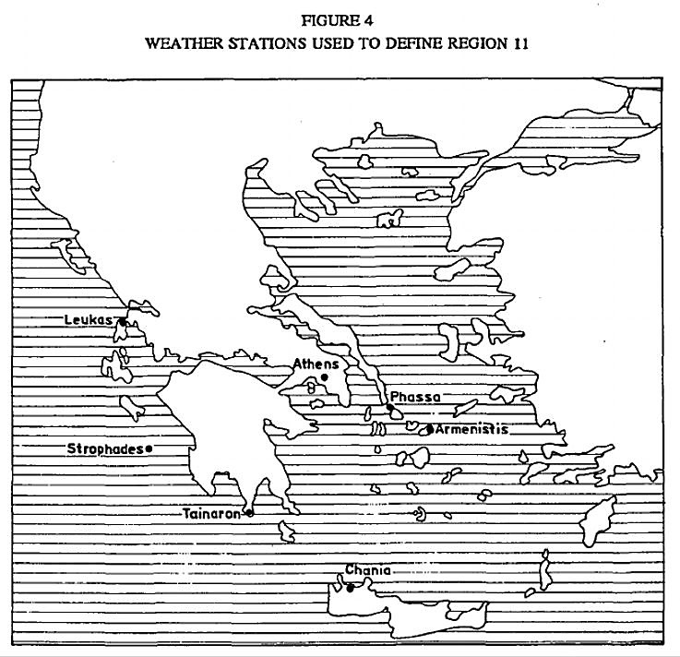
TABLE 9
CORRELATION ANALYSIS FOR REGION 11
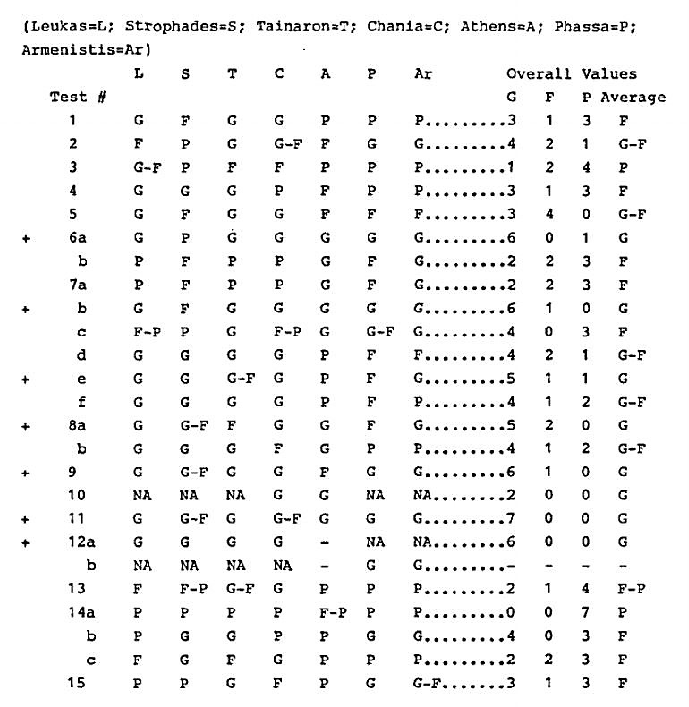
The results of the above correlation analysis are quite revealing. Within region 11, one can find good and poor correlations for almost every statement included in this study. On average, however, some agreement is noted in 21 of the 24 statements (87.5 per cent). Tests dealing with the dominance of north winds (#6a, #7b), the blowing of the Etesians (#9, #11, #12a), and the increased frequencies of east and south winds in the winter (#8a, #7e) rated consistently well. And every other statement, except for #14a, registers at least one 'good' correlation from within the region. If we compare the overall averaged results from this analysis with those recorded from region 11 in Table5, we find a similar situation. Except for #8a (which rated a G-F in Table 5), all 'good' statements (marked with a + in the Table 9) also rated G's in Table 5.
The only remarkable difference comes from the one overwhelmingly 'poor' correlation #14a, the high frequency of gales in autumn. Although this statement earned a G-F in Table 5, its true nature may be more accurately assessed in this analysis. The 'poor' correlation here is much more in line with the dismal correlations it exhibits elsewhere in the eastern Mediterranean. Either the ancient sources overemphasized the noticeable increase in frequencies of gale force winds in November (with the onset of winter), or some change has taken place since the fourth century BCE. I leave the evaluation of this possibility to others.
In general, the above analysis supports the position taken in the text that Aristotle and Theophrastos 'averaged' their data by comparing and combining sources of observations from many areas throughout Greece. There should be no overwhelming objections, therefore, to representing region 11 with the sea data utilized in Table 5.

NOTES
This article originates in an appendix to my dissertation, originally completed in 1982.Since that time 1 have substantially enlarged and rewritten my analysis of ancient winds. In this task, I have been aided considerably by the observations of Demitris Lalas, Professor of Meteorology at Wayne State University, Michigan; Professor Lalas also alerted me to most of the data utilized in Appendix I. Michael L. Katsev, vice president of the Institute of Nautical Archaeology, also read a draft of this article, and his comments forced me to rethink some of my conclusions. I sincerely thank both for then-help and guidance. Any errors in method or conclusions that remain in my text are entirely my own responsibility.
1. The lack of substantial Bronze Age sites along the western coast of Akarnania, in contrast to the numerous sites on the offshore islands, may be the result of such a process. It is possible that the Leukas strait was blocked by an isthmus until the seventh century BCE, thereby making the coastal zone north of Astakos more difficult to reach than the offshore islands. For the evidence behind this theory, see W.M. Murray, The Coastal Sites of Akarnania: A Topographical Historical Survey,Diss., University of Pennsylvania (Ann Arbor, MI, 1982), pp. 277-81. Occasionally, some ship would be blown into an unexplored area by a storm or a freak wind (cf. Hdt. 4.151.2-152.3 who mentions Korobios' voyage to Libya and Kolaios' to Tartessos) and a new area would be 'discovered'. It follows, therefore, that many places not easily reached on the regular winds would remain undiscovered until extraordinary circumstances prevailed.
2. I. Malkin and N. Shmueli have recently suggested that wind and current patterns may explain why Chalkedon was settled before Byzantium, a seemingly superior site; cf. Cities on the Sea Past and Present. 1st International Symposium on Harbours, Port Cities and Coastal Topography: Summaries (Haifa, Israel, 22-29Sept. 1986), p. 117. The close relationship between the Greek polis and its harbour is a well-known fact; cf. Arist. Pol. 1327a 11-1327b 18. It is particularly seen in the sites chosen by Greek colonists during the eighth to sixth centuries BCE; cf. F.E.Winter, Greek Fortifications (Toronto, 1971), pp. 7-12. An excellent example is provided by Corcyra whose favourable placement on a major sea lane between Greece and the West resulted in its prosperity and political independence before the Peloponnesian War, cf. Thuc. 1.36.2, 37.3, 44.3; 6.30.1, 44.2. In general, on the relationship in antiquity between city and harbour, see K. Lehmann-Hartleben, Die antiken Hafenanlagen des Mittelmeeres, Klio Beiheft 14 (Leipzig, 1923).
3. The overall wind patterns or 'wind regime' of an area combine with the topographical features of its coast (such as capes, submerged rocks, shoals, offshore islands, and harbourless lee shores) to determine the routes habitually used and areas to be avoided in coastal navigation. Recognized danger spots abound in the literature of the Greeks and Romans - Cape Malea, the Straits of Messina, the Magnesian and Athos peninsulas, the south-eastern coast of Euboea, the Bosporus, etc. Certain sea lanes are also known. For example, Thucydides mentions two standard routes between Greece and Italy (6.13.1). And Homer's Odyssey reveals that to sail from Phoenicia to Libya, one had to proceed north to Cyprus, then westwards, north of Crete, before turning south towards Libya (14.285-309). For evidence of these lanes dating from the period of the Roman empire, see J. Rouge, Recherches sur l'organisation du commerce maritime en Méditerranée sous l'empire Romain (Paris, 1966), pp. 81-105; for the routes between Rome, the Near East and India, cf. E.H. Warmington, The Commerce between the Roman Empire and India,2nd ed. (New York, 1974), pp. 5-18, 35-83. Two well-known examples where the wind affected a naval battle are at Salamis in 480 BCE and in 429 BCE in the Gulf of Corinth; both victorious commanders (Themistocles and Phormio, respectively) were said to have used local conditions, namely the onset of a wind-induced chop, to their benefit. For Themistocles, Plutarch (Them. 14) is our sole authority, although others repeated the story after his time (cf. the note on this passage in F. J. Frost's second edition of A. Bauer's Themistokles [Chicago, 1967], n. 4, p. 52); for Phormio, cf. Thuc. 2.84.2-3.
4. The ancient harbour moles of Palairos and Alyzeia (in Akarnania) have been located by analysing local wind patterns in the appropriate bays; cf. W.M. Murray,'The Ancient Harbour of Palairos', in Harbour Archaeology, ed. A. Raban, Vol.257 of British Archaeological Reports: International Series (1985), pp. 67-80, esp.67; and Murray, The Coastal Sites of Akarnania, pp. 114-21. In 256 BCE a Roman and Carthaginian fleet fought a battle off Mt. Ecnomus in southern Sicily (Polyb.1.25-28). The Romans attempted a crossing to Africa and the Carthaginians moved off the coast of Sicily to block their voyage. The strange fact that the Romans towed their horse transports was probably due to the prevailing north westerlies that affect this area; cf. G.K. Tipps, 'The Battle of Ecnomus', Historia 34 (1985), 447.
5. S.L. Mohler, 'Sails and Oars in the Aeneid', Transactions of the American Philological Association (hereafter TAPA), 79 (1948), pp. 46-62, esp. 58-62.
6. B.W. Labaree, 'How the Greeks Sailed into the Black Sea', American Journal of Archaeology, 61 (1957), 29-33. He expresses his reservations on p. 32: 'The calculations based on observations taking place in the nineteenth century are not necessarily applicable to the ancient period, with which we are primarily concerned here. And yet in the absence of evidence to the contrary, we can only assume that conditions were basically the same then as now.'
7. A.T. Hodge, 'Marathon: The Persians' Voyage', TAPA, 105 (1975), 155-73.
8. J. Neumann and D.A. Metaxas, 'The Battle between the Athenians and Peloponnesian Fleets, 429 B.C., and Thucydides' "Wind from the Gulf (of Corinth)"', Meteorologische Rundschau, 32 (December 1979), 182-8.
9. Cf. L. Casson, 'Rome's Trade with the East: The Sea Voyage to Africa and India', TAPA, 110 (1980), 21-36; and 'The Sea Route to India: Periplus Maris Erythraei57', Classical Quarterly, 34.2 (1984), 473-9 (= Vol. 78 of continuous series).
10. The two meteorologists are the most cautious of the scholars mentioned in the text; cf. Neumann and Metaxas, 'The Battle between the Athenians and the Peloponnesian Fleets', 185: 'Some of the difficulties [of using modern data] are as follows:(a) The climate of the area of concern in the 5th century BC was probably cooler than in recent decades...' etc. Casson seems to be the least bothered; cf. Ships and Seamanship in the Ancient World (Princeton, 1971), p. 282, n. 47: 'The same winds prevail today as in the days of the ancients.' This statement (although it may be correct) seems rather bold for being based on two slender examples. Presumably, Casson’s extensive knowledge of documented ancient voyages (cf. pp. 282- 99) is behind his opinion.
11. Cf. H.H. Lamb, The Changing Climate (London, 1966), pp. 7, 63; id., Climate: Present, Past and Future, Vol. II (London, 1977), pp. 3-5, 424-35; cf. also n. 18below.
12. It should be noted that a wind is described as blowing from a point of origin. Thus, a west wind blows from the west towards the east, a north-west wind from the north-west to the south-east, and so forth.
13. This table is taken from Great Britain, Weather in the Mediterranean, Vol. II, 2nd edn. (London, 1964), p. 193. Although the precise format of tables published by other governments may vary slightly, the same types of information are presented. A recent study shows that at least five years of observations are desirable for making statistically accurate, long-term estimates of an area's local wind characteristics; see D.P. Lalas, H. Tselepidaki and G. Theoharatos, 'An Analysis of Wind Power Potential in Greece', Solar Energy (1982), 3. All data utilized in this study were averaged from observation-periods of longer than five years (cf. Table IV).
14. The twenty-sixth chapter of the Aristotelian Problemata also preserves wind observations. Because this work seems to be a later compilation of uncertain date and because it repeats, for the most part, observations contained in the Meteorologica and De Ventis, it has not been utilized as a source of ancient observations.
15. The place names are cited when the author introduces a particular local example to support a general theory. For the section references of the following places referred to by Theophrastos, see the indices in V. Coutant and V.L. Eichenlaub, Theophrastus: De Ventis (Notre Dame, IN, 1975), pp. 92-105: Aegae (or Aigeiai, Macedonia), Egypt, Argos, Babylon, Boeotia, Gortyn, the Hellespont, Euboea, Thessaly, Italy, Karystos (Euboea), Keos, Kithairon, Knidos, Crete, Libya, Lokris, Macedonia, Memphis, the Nile River, Oite, Olympos, Ossa, Plataea, the Pontos, Rhodes, Sicily, Susa, Phaistos, Chalkis, and Oropos.
16. Conceptually, it is clear in most cases that a wind observation came first, and then a theory was developed to explain its occurrence. By this, it is meant that the abstract theory grew out of and was substantiated by the observation of concrete natural phenomena. For the place of the Meteorologica in Aristotle's philosophical development, see W. Jaeger, Aristotle: Fundamentals of the History of his Development, trans. R. Robinson (Oxford, 1948), 2nd edn., p. 307, n. 1 and pp.328-31. The methodology employed by Theophrastos is essentially the same as that of his mentor. And although many of their theories on wind generation have since been discredited, the observations behind them remain unaffected. Accepted as valid by their contemporaries who could have easily objected if they were inaccurate, these observations are, therefore, reliable.
17. See Coutant and Eichenlaub, Theophrastus: De Ventis, pp. XXIV-XXXV.
18. The theory applying to circa 500 BCE is based on 'temperature departures from modern values, summer and winter, derived from pollen analysis and vegetation boundary displacements on land, and from microfaunal analysis of ocean-bed deposits ...' (Lamb, The Changing Climate, II, p. 380). These temperature values, derived for four major periods c. 6500, c. 4500, c. 2500, and c. 500 were used by Lamb et al. to map prevailing atmospheric circulation patterns in each time period; cf. H.H. Lamb, R.P.W. Lewis and A. Woodroffe, 'Atmospheric Circulation and the Main Climatic Variables between 8000 and 0 B.C.: Meteorological Evidence’, in World Climate from 8000 to 0 B.C., International Symposium on World Climate, Imperial College, London, 1966: Proceedings, ed. J.S. Sawyer (London, 1966), pp.174-217; the results are summarized in Lamb, The Changing Climate, II, pp.380-86. According to Lamb (p. 385), the reliability of the maps for the first two periods is high, but for the third (c. 2500) the patterns are less pronounced and thus potentially less reliable. The map for the fourth period (c. 500) displays increased thermal gradients and stronger circulation patterns, and is thus more reliable than the previous period. In general, however, the usefulness of these maps lies in the broad outlines of climatic change that they portray, and not in their ability to reconstruct precise local wind patterns. For this one needs contemporary observations, which is exactly the type of evidence provided by Aristotle and Theophrastos. Their observations, therefore, provide the means to substantiate the theories of Lamb et al..
19. This criticism concerns Theophrastos' observations of the winds' frequencies and force; cf. Coutant and Eichenlaub, Theophrastus: De Ventis, pp. XXVII-XXX. Only four of Theophrastos' many observations of this nature are examined: (1) the greater force of N. and S. winds relative to the others, (2) the variability and (3) afternoon periodicity of the W. wind, and (4) the incorrect statement that S. winds prevail most often in Egypt. With the exception of the statements concerning local winds, Coutant and Eichenlaub assume that the observations are applicable only to Athens. It should be noted that the authors do examine other wind statements included in this work (i.e., statements not dealing with seasonal frequencies and force; cf. pp. XXX-XXXIV), but their selection is not comprehensive here either. It is the position of this study, however, that the statements most suitable for comparison are those concerning the annual frequency and force of the winds.
20. A controversy exists concerning the position of the observer. The alternate view is expressed by R. Bökker, Paulys Realencyclopdie der klassischen Altertumswissenschaft, ed. G. Wissowa el al. (Stuttgart, 1904-) (hereafter RE) (Winde) VIII A (1958), cols. 2344-47, who believes the observer's position is at the equator; the result is a wind rose with asymmetrical subdivisions. For a brief explanation of the problem and the reasons for preferring the symmetrical wind rose, see Coutant and Eichenlaub, Theophrastos: De Ventis, pp. LII-LIII. Both interpretations of the system yield similar results for our purposes.
21. The four 90° quadrants used in this study for analysing ancient observations are defined as follows: N. quad. = NW + N. + NE; E. quad. = NE + E. + SE; S. quad. = SE + S. + SW; W. quad. = SW + W. + NW.
22. This observation is less applicable to sea data coming from stations on board ships constantly changing position in relation to the surrounding land mass.
23. In the late autumn of 1980, a NW gale blew down through the Leukas strait when I was living in the western Greek village of Plagia. I asked a fisherman how long it would last and was told that the 'Tramoundana' (i.e., a N. wind) could blow for days. Surprised at the word (I had previously only heard about the 'Boras'), I said 'Don't you mean the "Skyron"?' (or 'Garbis', the local name for the NW wind). 'Ohno', came the reply, 'the "Tramoundana" blows down through the strait'. Regardless of its compass direction (which is NW), this gentleman (as well as others in the village), knew the wind as a 'Tramoundana.' I expect that these villagers, unaccustomed to naming winds by a strict application of the compass rose, are much the same in their outlook as the inhabitants of ancient Greece. In fact, the 'Tramoundana' or 'Tramontana' is an Italian term, meaning a wind that blows across the Alps, i.e., a blustery, cold wind from the north. The Akarnanian dialect is full of Italian loan words, particularly those relating to seafaring and fishing. The name for this wind, then, was originally picked up from Italian seafarers to describe a particular kind of north wind whose principal characteristics (its cold, blustery nature) were more important than its precise direction. This is only one example; might there not be others? For this reason, I prefer to allow for some leeway in assigning rigid compass directions to the names of Greek winds.
24. A. Rehm, 'Griechische Kalendar. III', Sitzungsberichte der HeidelbergerAkademie der Wissenschaften. Philosophisch-historische Klasse (hereafter SBFleid.), 3,3 (1913), examines the sources we have for reconstructing the parapegma, or inscribed calendar of Euktemon, an astronomer of the fifth century BCE who noted the various dates of the constellations' risings and settings, dates of the seasons, winds, weather, etc. Calendars of other astronomers exist from antiquity, but I have chosen Euktemon as the most complete authority who is closest in time to the late fourth century. For a general discussion of this type of calendar, see also A. Rehm, RE (Parapegma), XVIII.2 (1949), cols. 1295-1366.When referring to the dates of solstices and equinoxes, I will adhere to the dates of Euktemon's calendar despite the fact that they vary from what is known to be astronomically correct (i.e., 24 December instead of 21 December). Since the modern data are averaged in monthly tables, the precise day of the equinox or solstice is meaningless for the purposes of this study. What really matters is the month in which the solstice or equinox falls.
25. The Greek word for autumn - metoporon - is sometimes translated as 'late autumn'(cf. H.G. Liddel, R. Scott, H.S. Jones, A Greek-English Lexicon with a Supplement (Oxford, 1968), s.v.; this is also the term employed by Coutant and Eichenlaub in their translation of Theophrastus: De Ventis. Euktemon used the term to represent one of the four main seasons and thus equated it with our word 'autumn'. This also seems to have been the meaning intended by Aristotle (cf. Gen. An. 784a 19) and presumably Theophrastus took over this terminology from his mentor. For this reason, I translate the word as 'autumn' rather than 'late autumn'.
26. The precise wording of the Greek allows for two possible meanings. The operative words, malista pneousin, may mean that (1) opposite winds 'prevail', i.e., are dominant over other winds, in opposite seasons, or (2) that opposite winds 'especially blow', i.e., reach annual high frequency values (when compared to their frequencies at other times of the year), in opposite seasons. As a result, an 'either ...or' test has been applied.
27. Cf. R. Bökker, RE (Winde), VIII A (1958), col. 2247; cf. also n. 23 above.
28. That the sea-breeze should be perceived primarily as a westerly wind is attributable to the large-scale pressure patterns affecting Greece. During the spring, summer, and autumn, when the sea-breeze system operates, the upper level winds are flowing from NW to SE. As a result, the western sea-breeze is reinforced (i.e., made more noticeable), while sea-breezes from other directions are diminished in influence or completely negated, particularly during the months of July, August, and September. In general on the sea-breeze, see A. Watts, Wind Pilot (Lymington, Hampshire, 1975), pp. 79-119.
29. Cf. A.Rehm, 'Griechische Kalendar III', 14. A later (circa 200 CE), more complete calendar attributed to a certain Antiochus, dates Orion's rising between 13 June and 14 July; cf. F. Boll, 'Griechische Kalendar. I', SBHeid. 1,16 (1910), pp. 13,26-7.
30. In the case of Aristotle, perhaps one ought to read 'Pleiades' in place of Orion, a constellation which does rise and set as he indicates, in early May and mid-November. Rather than guess the process of transmission, I have chosen to act as described in the text.
31. It is clear from another passage that either Aristotle or his subsequent editors (or both) were confused about these 'bird winds'; in De Mundo 395a 4, he refers to these winds as being northerly, not southerly. This is further indication (if such were needed) that these winds are defined by too many vague and conflicting observations to be included in this study.
32. For an example of a sailor's proverb, see Theophr. Vent. 5: hothen kai he paroimia symbouleuei ta peri tous plous ('from whence [comes] the proverb which advises about sea voyages'). For an ex ample with a rural twang to it, see Theophr. Vent. 46: ho de boreas ho epi ton pelon ton noton, hon phesi palin he paroimia cheimona poiein, dia ten autn aitian poiei ('and the north wind which comes upon the mud of the south winds, which again, the proverb says makes stormy weather does so for the same reason'). For the likelihood that Aristotle used the reports of travellers concerning the physical nature of the winds in order to fill out his regularized wind rose (on this, see text below), see R. Bökker, 'Winde', RE. VIIIA (1958), cols.2251-52.
33. Great Britain, Weather in the Mediterranean, n. 13. It should be noted that a few small areas are not represented in this set of observations (cf. Fig. 3). Lack of data from these areas will not affect the results of this analysis.
34. The quadrants defined in this study for analysing ancient observations are given in n. 21. When a frequency total is specified from a particular quadrant, the sum of the individual wind frequencies that comprise the quadrant is intended. For the term 'frequency total', see n. 35 below.
35. The annual average frequencies of the eight winds are not presented in the tables utilized for this study. To arrive at the appropriate values, I simply added up the monthly frequencies of each wind and divided by 12 to get the annual average. By the term 'frequency total' I mean the sum of the appropriate frequencies for the winds listed after the term. Using Table 1 as our example, the July frequency total for N. + NW equals 60 per cent (14 + 46). Unless a particular wind velocity is specified, it is assumed that all frequency values are total values (i.e., taken from the ‘total' line at the bottom of the table; cf. Table 1).
36. Aristotle, unlike Theophrastos, uses the term zephyros to refer to the directional west wind (cf. Met. 363a7, bl2; 364al8, b3, 23; and 365a8). It is best, therefore, to consider all velocities of W. winds; for Theophrastos' definition of the wind, see p. 147 above.
37. This set of tests can best be illustrated by reference to the annual average frequency totals from Othonoi, Greece: N. = 3.34; NE = 0.96; E. = 7.22; SE = 4.73; S. =27.54; SW = 8.77; W. =5.46; NW = 38.76; Calms = 3.20. Test #6al reveals that the W. quad, total is dominant, and this would result in a 'poor' correlation. Yet one can clearly see that since the NW and S. winds are dominant over the other directions, an observer could get the impression that north and south winds were dominant. Tests #6a2 and #6b2 have been instituted to detect this situation.
38. Although the daily variation in the wind speed of the Etesian winds is not detectable in the data utilized for this analysis, its occurrence as stated by Aristotle and Theophrastos is a documented fact; cf. L.N. Carapiperis, 'The Etesian Winds. (VI)On the Daily Variation of the Velocity of the Etesian Winds in Athens',Hypomnemata tou Ethnikou Astroskopeiou Athnon: Meteorologia 17, series II(1968).
39. If all the winds blew an equal amount of the time, no wind would dominate and the impression would be a period of 'unsettled winds'. The frequency of each wind in such a condition would be 12.5 per cent (100+8). If the winds were completely unsettled, each frequency would be 12.5 per cent, and the sum of each wind frequency’s deviation from 12.5 would equal zero. Such a condition is unlikely ever to occur, so my test totals the deviations from 12.5 and judges the month with the lowest total as the one with the most unsettled winds.
40. I believe the standard translation 'hurricane' for eknephias is too restrictive a term, and that Aristotle would have considered winds with velocities far below those of hurricane strength to qualify as eknephiai. My reasons for believing this stem from Aristotle's own definition of the term. According to him, eknephiai can attend the eruption of volcanoes (Met. 366b 31-367a 8), and are paired conceptually with lightning, thunder and rain (i.e., they result from the same conditions that produce violent thunderstorms; Met. 369al9-21; 370b5-10, 15-17). Further information is given in his description of 'whirlwinds' or typhones. These winds are described as 'unripe eknephiai', unable to break free from the clouds that produced them (Met. 371a9-ll), and although their strength is considerable (a typhon overturns anything that lies in its path; cf. Met. 371al3) they are likened to a 'wind that is forced from a wide into a narrow place in a gateway or road' (Met.370b17-19). True hurricane-force winds begin at 75 mph., and this is clearly too high for what he describes. I have, therefore, decided to check winds beginning with a force one expects to come from thunderstorms, i.e., 28 kn. (32 mph.) and above. At this velocity, the sea heaps up and white foam from waves begins to be blown in streaks. On land, whole trees move and it is difficult to walk against the wind.
41. For an example of the 'balance' concept in Aristotle's anemology, see Met.364a32-364b3 = observation nos. 2-5 (p. 148-9).
42. The following annual frequency totals have been calculated from observations published in Great Britain, Weather in the Mediterranean, pp. 220-21:
N. = 11.7 S. = 11.25 Calms = 30
NE = 20.7 SW = 12.1
E. = 3.5 W. = 3.2
SE = 3.9 NW = 3.65
43. For a description of this 'backing' effect, see Watts, Wind Pilot, pp. 20-23; the map on p. 49 shows the tracks of depressions affecting Greece at the beginning of winter (in November).
44. Data from Leukas, Strophades Light and Tainaron come from S. Ginis, Hai Anemologikai Synthekai tou lonfou Pelagous, Diss. (Athens, 1974), Tables 6, 23and 24 respectively; data from Chania and Athens come from Great Britain,Weather in the Mediterranean, pp. 216-17 and 220-21 respectively; and data from Phassa Light (Andros) and Armenistis Light (Mykonos) come from G. Theoharatos, To Klima to Kykladon, Diss. (Athens, 1978), Tables 53 and 58 respectively. The period of observation exceeds five years in every case.
-oOo-

