ArcGIS ancient and modern geography Notes:
When considering which factors best explain the location over cities over time, accurate data on geographical changes over time are needed. Of greatest import is data concerning changes to the coastline or location of rivers. We are using ArcGIS to process shapefiles of both the ancient and modern geography, to be able to establish changes.
Date Sources and process:
Ancient Coastline: Shapefiles of the Ancient Coastline are taken from the Ancient World Mapping Centre’s shapefiles, free to download here: http://awmc.unc.edu/awmc/map_data/ .
The specific coastline shown below is coastline.shp located here: http://awmc.unc.edu/awmc/map_data/shapefiles/physical_data/coastline/
Modern Coastline: The Ancient World Mapping Centre also has modern coastline data available, but there appear to be projection issues in parts of the map. In particular, areas such as the Greek Islands, Great Britain and the Maghrebian coast are systematically different by around 1km.
In order to overcome this, a modern coast shapefile was created from the ESRI’s dataset ‘World Water Bodies’. The original data can be downloaded here: https://www.arcgis.com/home/item.html?id=e750071279bf450cbd510454a80f2e63
The following process was applied, to turn the single polygon layer into a polyline coast.
- Using the ‘select by attributes’ feature, the Ocean and Perennial Inland Water polygons were separated from the original layer. Two new layers were created.
- The new ‘Perennial Inland Water’ layer was edited further. All polygons smaller than a threshold area (say 0.001) were deleted, once again using the ‘select by attributes’ feature. This was memory intensive, so it was best to do this in smaller batches. This was done with the aim of removing very small inland lakes, improving computing performance later on. This new layer was named ‘Large Inland Water’.
- Next, using the ‘select by location’ feature, those polygons in ‘Large Inland Water’ within 100m of polygons in the Ocean layer were selected, and a new layer created.
- This new Layer was then merged with the Ocean layer, and renamed ‘OceanInlandWater_1’.
- Steps 3)-5) was repeated 10 times. This process was done to include areas such as the Black Sea and the Sea of Marmara, as well as various straights and inlets, which are regarded as ‘Inland Water’ by World Water Bodies, but many would identify as forming a part of the coast.
- The polygons of this final layer were then aggregated using the ‘Dissolve’ tool (as well as frequent use of the ‘Repair Geometry’ tool). This was also memory-intensive process - it was useful to intermittently delete areas of the global map which were not of use (i.e. SE Asia, southern Africa etc).
- Finally, the Caspian Sea was added by manually highlighting the polygons in the ‘Perennial Inland Water’ layer, creating a new layer, and ‘merging’ this with layer containing our progress so far.
- The final polygon was then passed through the ‘Polygon to Line’ tool, creating a polyline of the coastline.
- The one drawback of repeating steps 3)-5) means that some rivers are included within the final coastline. These were removed from the final map manually. The edges of the map also had to be removed manually too. The ’Split Line’ tool was helpful here.
The final result is a very detailed outline of the modern coastline, which doesn’t appear to succumb to the same projection issues that the AWMC coastline does. Below, various types of differences between the two shapefiles are discussed.
Highlighted differences between the two coastlines:
In the examples that follow, the ancient coastline is shown in red, the modern coastline is shown in green. The modern oceans and inland bodies of water are also shown. Many of the examples shown below are from Great Britain – this is only for the reason that the author is familiar with the British coastline.
Natural Changes:
Roughly speaking, there are two major types of coastal difference we would like the shapefiles to capture – those that are man-made, and those that are natural.
1. Natural changes – silting, longshore drift and coastal erosion:
Natural changes to the coastline are the primary source of change that we hope to capture. The two primary ways in which a coastline may ‘gain’ material, are silting and longshore drift. Both of these processes are much more likely to have been caused by factors beyond human intervention. Artificial changes on the other hand - such as land reclamation – of course trivially involve human action. As our question concerns city formation, one can see how natural changes are more ‘exogenous’ to the city formation process than artificial changes may be. Put another way, whether or not a change has been caused by human activity or not, is salient to whether or not a city forms in a locale.
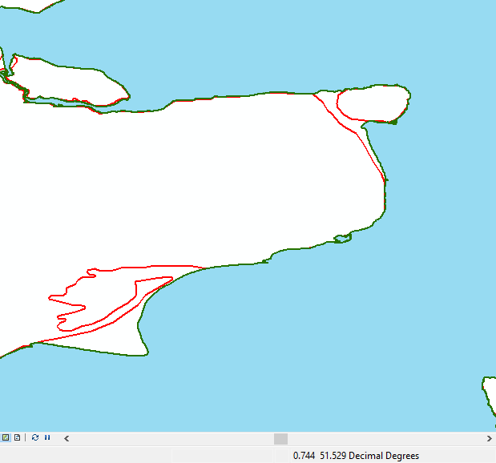
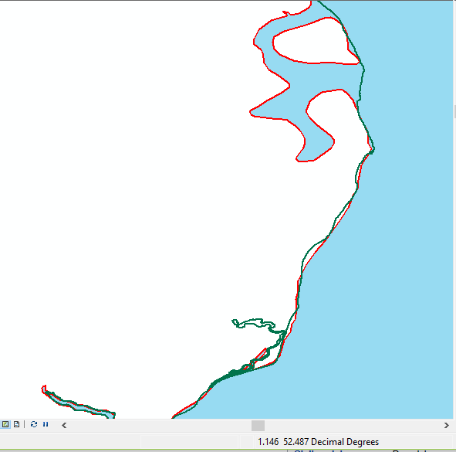To provide an example of both of these coastline changes, consider the coastline of Kent, England. This is shown below to the left. To the east is Thanet, which in ancient times was an island. The Wantsum Channel, which separated Thanet from the mainland, was a major shipping route for roman traders. However over time, silting caused the channel to eventually drain. Thanet is now connected to the mainland.
To the South West of the Kentish coast is the headland at Dungeness. Dungeness on the other hand, is a cuspate foreland, created by longshore drift. Silting and longshore drift represent the two ways in which material can be added to a landmass.
Of course, coastal erosion, can also take material away. For an example of this, see the coast of Suffolk, England, shown on the previous page, to the right. Note that in this picture, the ancient ocean is shown rather than the modern ocean, so as to not obscure the feature.
Note that the modern coastline is in parts closer inland than the ancient coastline. In particular, at Dunwich (located at the area of greatest coastal erosion in the map shown above), the coastline has retreated by approximately 1km over the last 2000 years. It was once an important port. Having lost the harbour and much of the town during the 13th and 14th centuries all that is left now is a small village.
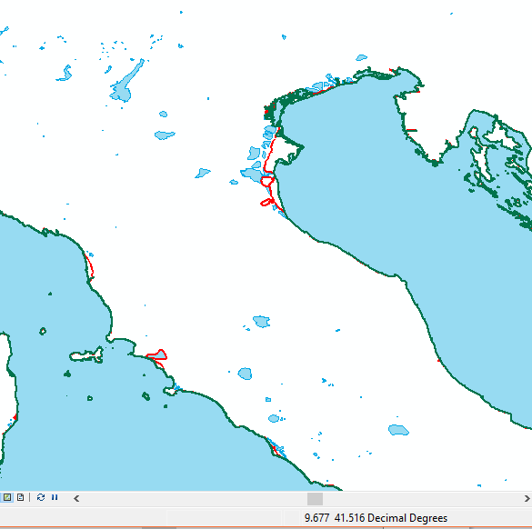
2. Material Changes at River Deltas:
Deltas are common sites of coastal change. For example, to the left, north Italy is shown. In particular, the Po river delta is at the northwest corner of the Adriatic Sea. Note that the modern coastline, at its greatest extent, is around 25km further away from the ancient coastline.

3. Definitional issues at Deltas:
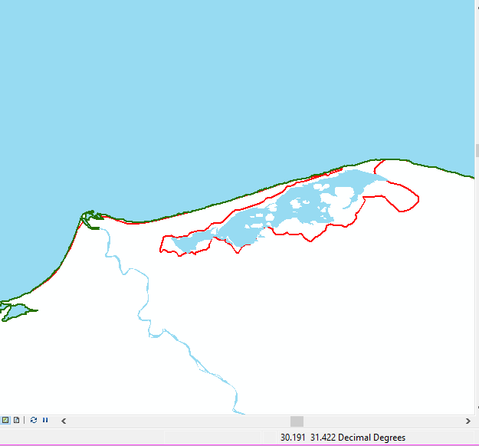River deltas provide another source of change in the observed coastline over time. The liminal zone of a delta can be hard to identify – exactly where a river delta ends, and the ocean begins, is a matter of debate. The difference between the two coastlines will come down to an arbitrary definition in many cases. To the right, is the Nile River delta. Whether or not a river delta is considered the coast or not between each shapefile will depend on a relatively arbitrary classification.

4. River Mouths:
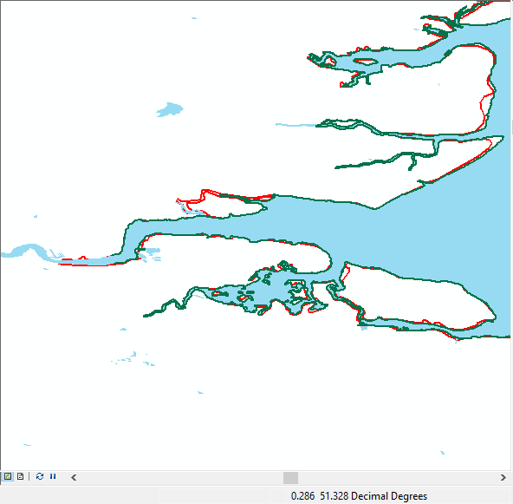
Related to the definitional issue deltas, but perhaps to a lesser degree, river mouths can present a similar form of inconsistency – below to the left the Isle of Wight, England is shown. Exactly where the ocean - and coast - ends and a river begins is an arbitrary decision. When comparing between the two shapefiles, areas that are actually quite far inland may be considered coastal if they’re near to a significant river. Of course, it would be preferred if such areas could be listed as being near to a river, rather than being on the coast. A further example is shown to the bottom right - the Thames Estuary in England.
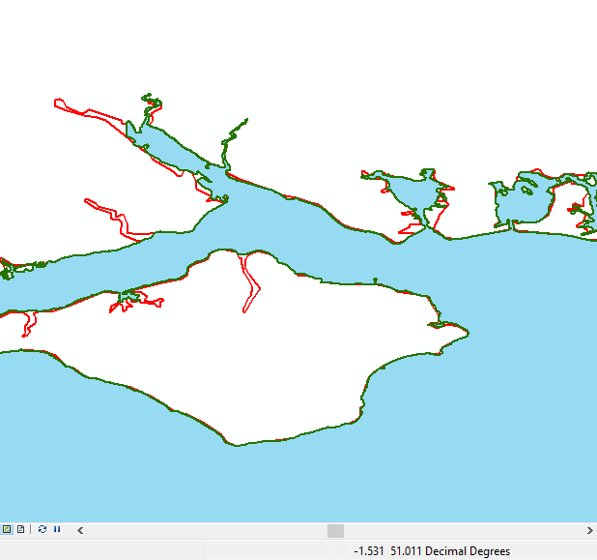

Artificial Changes:
Whilst the differences discussed so far are natural changes to some degree, humans also intervene in the coastlines around them.
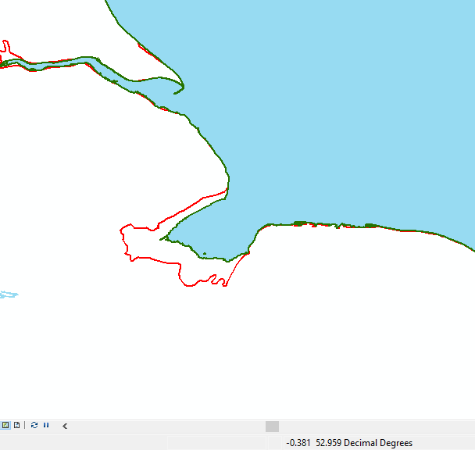5. Reclaimed Land:
Of course, the most major way that this happens is through land reclamation. For example, to the right the Wash in the East of England is shown. As a low-lying area that would flood with seawater regularly, the Romans built embankments around the perimeter of the Wash to protect agricultural land. Indeed, up until the Middle-Ages, as far inland as the Fens in Cambridgeshire would regularly flood. In the 12th century, efforts were made to separate the land from the estuary. Land reclamation began in this area in the mid-17th century – King Charles I employed a Dutch engineer to oversee the works.
Being able to distinguish between cases such as this, and cases where land may have formed without intervention would be of great use to our project.
6. Strips of land and dykes:
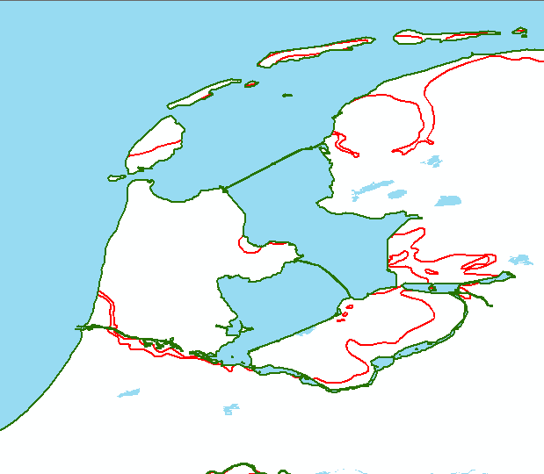Shown to the right is North Holland and Friesland, in the Netherlands (Amsterdam is located to the SW of the southernmost lake shown). Note the two green strips located in the inlet. These are not errors in the map – they are dykes, built in the 20th century in order to reclaim land. The two bodies of water contained by the dykes are seawater lakes. The dykes however are ‘land’ – the northern most is called the ‘Afsluitdijk’ and is around 90m wide. It is in fact a causeway, as a large road passes over the dyke. However, whether or not one considers this to be the ‘coast’ is questionable. This is even more pertinent when the dyke further in land.
The example of the Netherlands demonstrates that many of these categories overlap with one another. Whilst the dykes may not seem like ‘true’ coastal change, the reclaimed land further inland most certainly is. It also serves to highlight that what one might consider a ‘material’ change is essentially an appeal to our intuitions on the matter. By categorising the differences we can reduce the arbitrariness of what one considers a ‘material’ change, but not remove it all together.

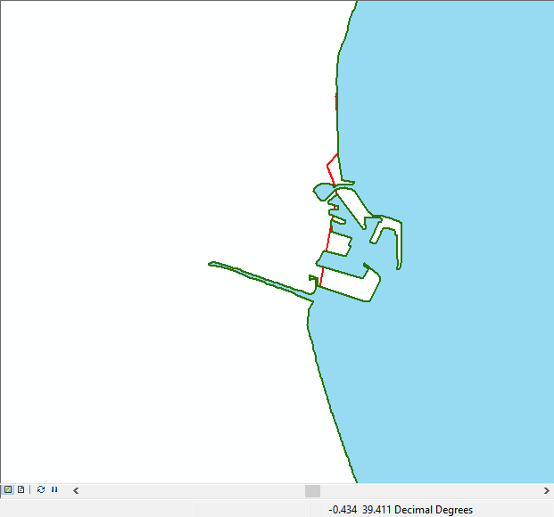7. Ports and manmade coastal structures:
To the right is Valencia, Spain. The ESRI derived map file is detailed enough to capture manmade coastal structures, particularly ports and piers. My intuition would be that these structures extend into the sea – that is, the ‘coastline’ proper, is further inland. Working on this basis, the modern coastline would follow the ancient coastline more closely. However, finding a practicable way to overcome this issue may be difficult.

8. Measurement Errors:
There are still small measurement errors where the shapefiles appear slightly misaligned, or at least one of them is incorrect. This is particularly noticeable among small groups of islands for example. However, these errors are of a small magnitude. Indeed, they may capture local variation in sea level rise, but discerning this from the shapefiles is impossible. The signal to noise ratio is too low for this variation to be useful for our purposes.
[Example of the Princes Islands, Istanbul]
Another issue is the level of detail and accuracy of the modern shapefile is much greater – in some areas, it appears that were the ancient shapefile accurate up to a smaller distance, the difference between the two shapefiles would be reduced somewhat. However, these differences are typically of a magnitude of 100-300m.

