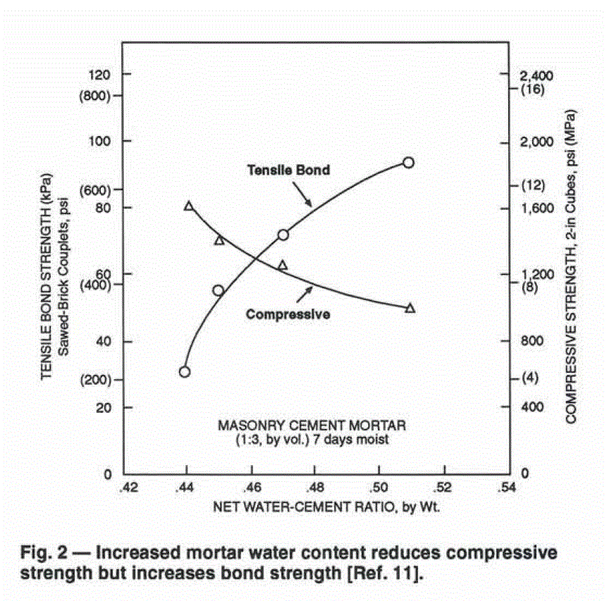

Ref. 11. Isberner, A. W., "Properties of Masonry Cement Mortars,"
Designing Engineering and Constructing with Masonry
Products, F. B. Johnson, Ed., Gulf Publishing Company,
Houston, 1969, pp. 42-50.

1 psi = 6895 Pa = 6.9 kPa = 0.007 MPa

