From Amphora to TEU: Journey of a container
An engineer’s perspective
Arthur DE GRAAUW
Coastal Engineering & Shiphandling
Grenoble, France
Abstract
This presentation aims to compare aspects of ancient and modern maritime logistics such as stowage on board ships, loading & unloading, exporting & importing of goods, and merchant ships & sailing. A few major nodal points are known to have formed a network for trade in the Mediterranean area (Rome, Alexandria, Baetica, Proconsular Africa), and many smaller nodes created imbricated networks. The number of ships sailing the oceans has increased by a factor of ten and large ship sizes have increased from 40-50 m in length to 300-400 m, but the number of shipwrecks per year has remained fairly steady, showing that ancient sailing was more dangerous than modern sailing. Sailing routes on the Mediterranean Sea and on the Red Sea are analysed briefly and show that sailing to windward was required, probably with a brailed sail as seen on the Kelenderis mosaic. The value of cargo on each ship, based on an exchange rate of 1 sesterce = 6.50 euro, has also increased by a factor of ten. It can hence be concluded that today’s maritime logistics were already in use more than 2000 years ago, but in ancient times, today’s “time is money” was less important than “have a safe trip back home”.

- Introduction
Merchant ships have been sailing the Mediterranean Sea and the Red Sea for 5000 years, gradually leading to a ‘Mediterranisation’ of the economy. Today’s globalised economy extends across the whole planet.
Goods (also called ‘commodities’) have always been shipped either as loose units or as dry or liquid bulk. Ancient units were amphorae, dolia, barrels and sacks that could be placed on a ship, a cart, a camel or a donkey. Until 100 years ago, this cargo, called ‘break bulk’, had to be loaded on board almost individually. Wooden ‘pallets’ moved by forklifts were introduced during WW2. They were quickly followed by larger ‘containers’ made of steel providing better protection and easier transportation as they could be placed on a ship (sea and river), a train and a truck. As a matter of fact, containers opened the way to ‘globalisation’, .
Amphorae were used mainly for liquids, and today’s containers are used mainly for dry goods, but exceptions exist for both.
Containers were standardised to optimise storage on land and on board ships and trucks. This aim has been achieved quite well in modern times (so far), taking around 50 years to reach right around the planet, but was not achieved in ancient times, since it took around 1000 years to reach across the Mediterranean area alone.

This presentation aims to compare ancient and modern maritime logistics rather than to give an exhaustive description of various types of container. We will hence focus on one type of container for each period: the ancient Dressel 1B amphora and the modern TEU container.
After a short presentation of ancient and modern containers, we will attempt to put ancient and modern logistics side by side by examining the following aspects, proceeding from detailed to general:
- Stowage on board,
- Loading & unloading,
- Exporting & importing,
- Ships & sailing,
- Return cargo,
We will end this presentation with a few words on the Roman economy and some conclusions.

- Definitions
  - Amphorae
Many different types of amphora have been identified, depending on their date and place of production, . The first amphorae were used for transporting wine and date from around 350 BC (the so-called ‘Greco-Italic‘ type). Millions of them were produced, especially during the Roman Empire.
As a volume, one amphora quadrantal is equivalent to one Roman cubic foot (nearly one modern cubic foot) = 2/3 artaba = 2 modii castrensis = 3 (Italic) modii = 8 congii = 48 sextarii, or 26 litres. A full amphora (containing olive oil, wine or fish sauce) weights around 50 kg, around half of which is the tare.
It should be noted that Egyptian grain was transported in sacks weighing one artaba (39 litres) with a unit weight of around 30 kg.
It should also be noted that wooden oak barrels (500 to 1000 litres) gradually took over from amphorae (and dolia) for storing wine during the Roman Empire.
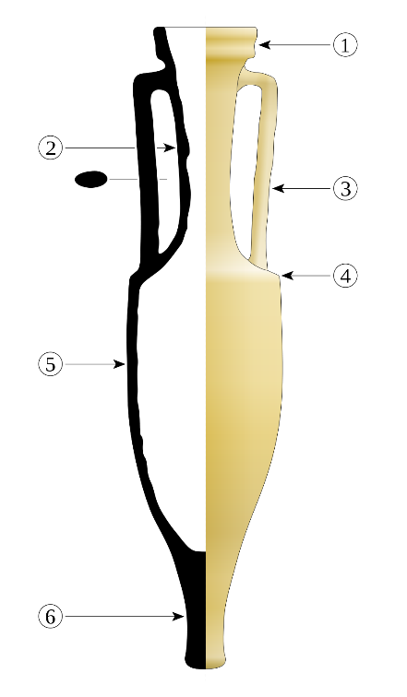  Dressel 1B amphora (from https://commons.wikimedia) | Legend:  1- rim (lèvre)  2- neck (col)  3- handle (anse)  4- shoulder (épaule)  5- belly or body (panse)  6- foot (pilon ou pied)  Dimensions:  - Height: 100 to 122 cm  - Diameter of the belly: 28 to 30 cm  - Diameter of the opening: 15 to 18 cm  - Height of the rim: about 6 cm  - Weight: 24 to 26 kg (empty)  - Capacity: 24 to 26 l.  Original place of manufacture: Tyrrhenian  coast (Etruria, Latium and Campania)  Late Republic period, until 10 BC

  - TEU container
So-called ‘containerisation’ was introduced in the 1960s and the number of containers transported has increased exponentially over the past 50 years; it has multiplied by a factor of 10 in the last 20 years. It is viewed as a major development in the transportation of goods. Around 700 million container movements are recorded yearly in the world’s ports involved in seaborne trade, in over 100 countries.
The standard intermodal container is twenty feet long (6.1 m) and 8 feet (2.44 m) wide, and ‘TEU’ stands for ‘Twenty-foot Equivalent Unit’. There is also a standard container with the same width but a doubled length of forty feet called a 40-foot container, which has found wider acceptance since it can be pulled by semi-trailer truck. Some containers may reach 48 ft and even 53 ft long (in the USA). Their height is 8 ft 6 inch (2.59 m). More sizes have been gradually introduced, but they were designed to fit each other during stacking.
In terms of volume, one TEU is around 33 m³ and the total weight may not exceed 30 tons, including a tare of around 2 tons.
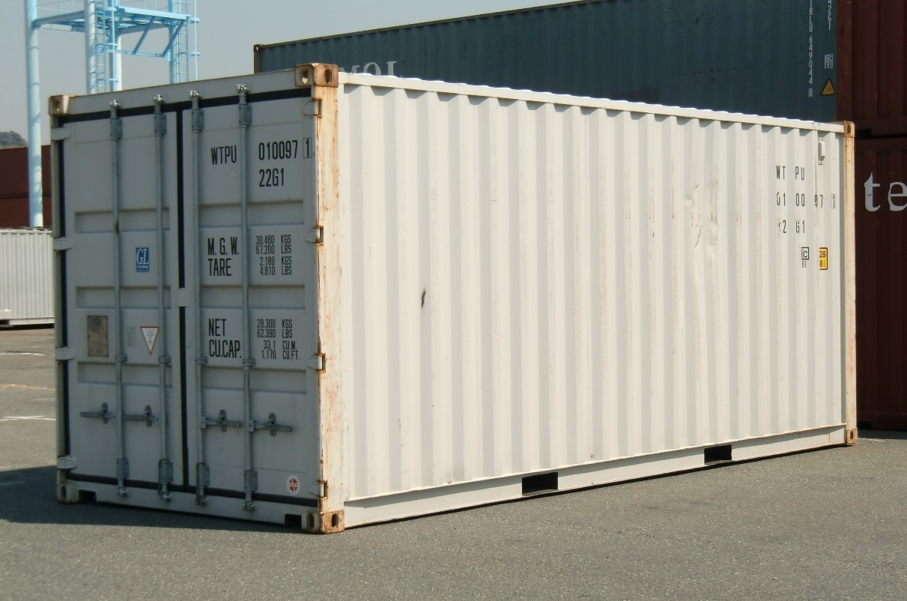
Twenty-foot equivalent unit (TEU).

- Stowage on board
Ancient  The largest shipwrecks of ‘merchantmen’ found to date are located on the French and Italian Riviera. The Madrague de Giens shipwreck (ca. 75-60 BC), discovered in 1967 near Giens in France, had an estimated cargo capacity of 8000 Dressel 1B type amhorae for wine. This is a cargo weighing 400 tons for a 40 x 9 m ship with a draught of around 3.5 m.  The Albenga shipwreck (ca. 100-80 BC) could carry an estimated 12 000 amphorae. Thousands of smaller ceramics, or other valuable small cargo items, were often placed between the amphorae as a secondary cargo.  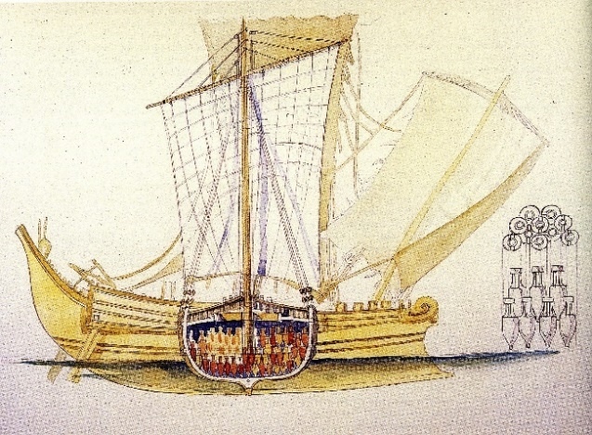  Arrangement of amphorae on board a ship like the Madrague de Giens (drawing JM. Gassend, 2005).  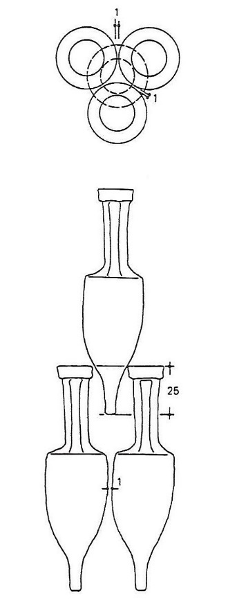  Typical arrangement suggested by P. Pomey (1997) based on his work for the Madrague de Giens.  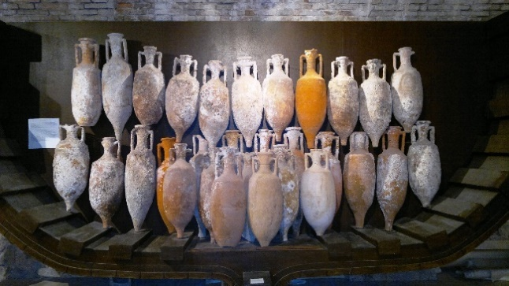  Reproduction of an amphorae arrangement at Antibes’ Musée d’Histoire et d’Archéologie (picture A. de Graauw, 2012). This arrangement with many different types of amphora is obviously not optimised.  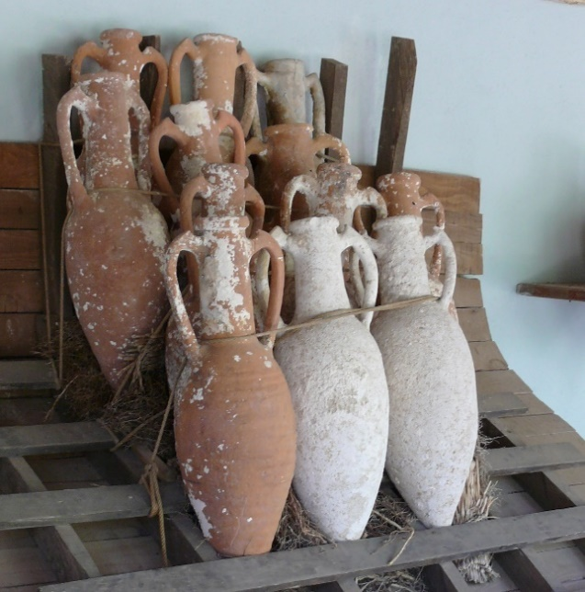  Rack and roping device to illustrate how the cargo might have been kept from shifting, at Bodrum Museum of Underwater Archaeology.  The foot of the amphora could obviously not be placed directly on the ship’s hull as it would perforate it during the trip at sea. The bottom row of amphorae was hence placed on some protective layers of straw as shown above. Sand (or perhaps more valuable pozzolana?) may also have been used both for protecting the hull from the bottom row of amphorae and for ballasting the ship. | Modern  One of the largest container ships is the Marco Polo with a capacity of 16 000 TEU, i.e. a cargo of nearly 200 000 tons for a 396 x 54 m ship. In 2016 It seems that the length is not increasing over 400 m, but the width is approaching 60 m to achieve an on-board capacity of 20 000 TEU. This width may become a problem for gantry cranes required to load and unload these ships in ports.  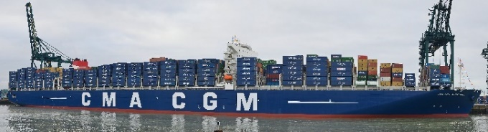  The 16 000 TEU Marco Polo container ship (picture CMA-CGM).  Container ships have a draught of nearly 15 m requiring quay walls around 20 m in height and adequate dredging to maintain the required water depth. Bulk carriers (oil, coal, iron ore) may even have a draught of over 20 m.  Containers are stacked on 15 to 20 tiers or levels, half of them in the hold below deck and half on deck. They must be securely fastened to each other with twist-locks and to the ship’s structure with lashing bars.  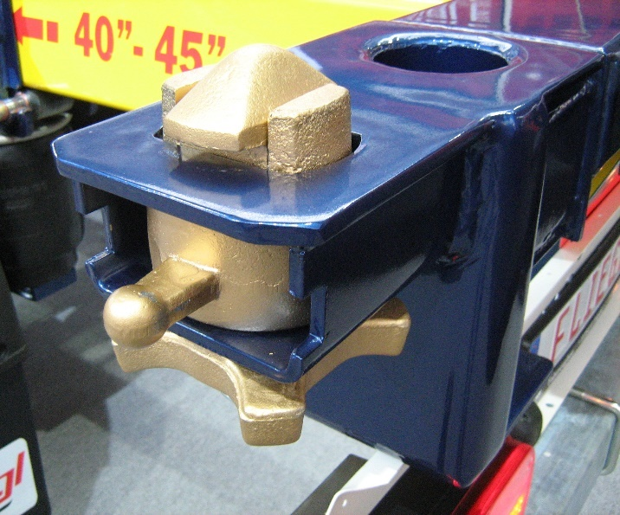  Twist-lock on a rear corner of a container semi-trailer; the container corner is placed over it and has to be turned 90° to close the lock (picture Wikipedia).  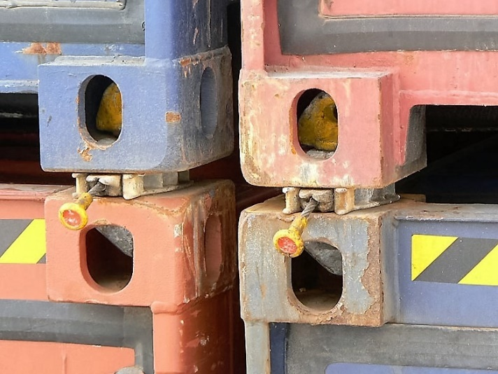  Containers connected to each other by twist-locks (picture F. Massard, 2007).  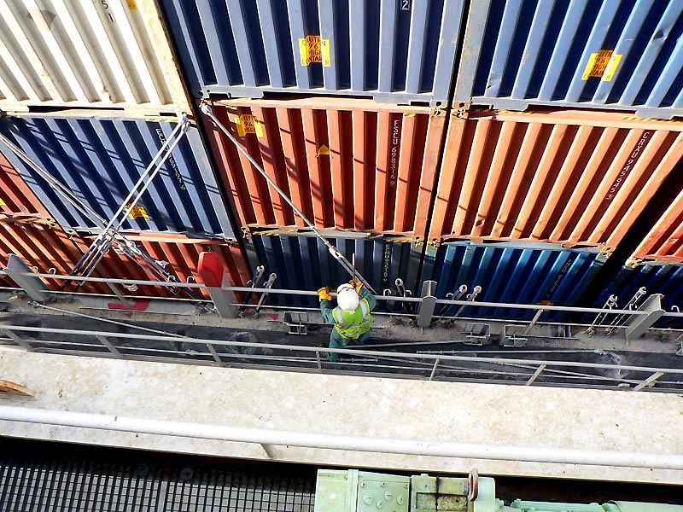  Checking twist-locks and lashing bars (picture F. Massard, 2007).  Although they are securely fastened, containers are sometimes lost at sea during storms. In addition to the loss of cargo, they are a danger for shipping as they often float near the water surface.  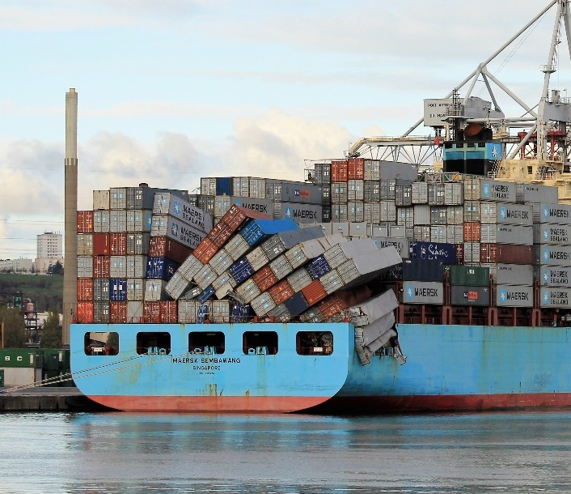  Accidents rarely happen … (picture http://www.vessels-in-france.net )

- Loading and unloading
Ancient  One means of unloading a large seagoing ship that could not enter rivers was to transfer the goods onto smaller ships called lighters (lenunculus or navis caudicaria) that were rowed or towed up-river.  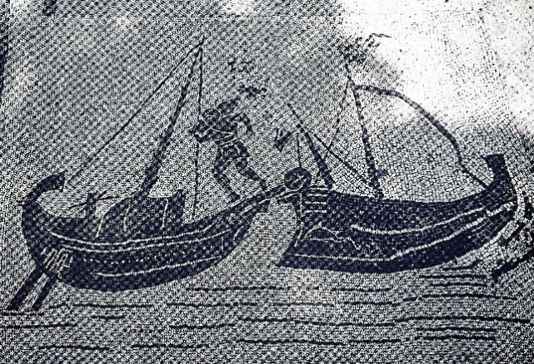  Detail of unloading on a lenunculus at Piazzale delle Corporazioni, Statio 25 (from Pomey, 1997).  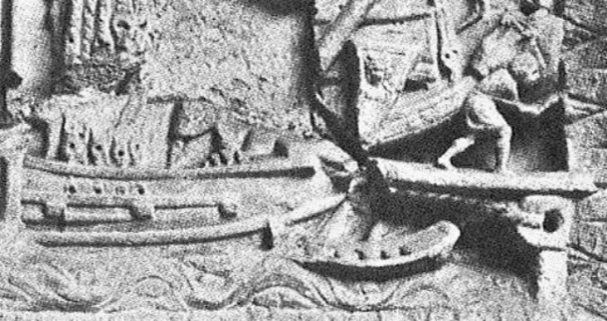  Detail of the Torlonia relief showing a ship moored bow first to a mooring ring with a dock-worker (saccarius) carrying an amphora and walking on a gangplank from the ship to the quay. Note the linesmen boat just below the mooring line (picture Testaguzza, 1970, on www.ostia-antica.org).  Early Kerkouros ships usually docked stern first, while later ships also docked bow first as shown on the Torlonia relief above. Alongside docking was required if heavy cargo (live animals, barrels) was to be lifted by cranes or derricks.  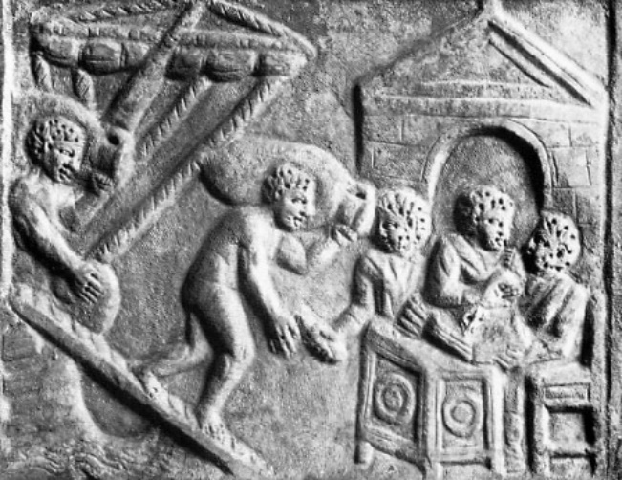  This relief was found in Portus. Amphorae are being carried from a ship to the quay by dock-workers (saccarii). The three civil servants (tabularii) are taking notes. The first porter is receiving a token of receipt (picture Pavolini, 1986, on www.ostia-antica.org).  Weights, measures and coins were under the control of agoranoms (in the East) and aediles (in the West). Mensores and sacomarii were legally in charge of measuring and weighing as ships were loaded and unloaded. Togati oversaw the validation of the trade procedure, including weighing and measuring.  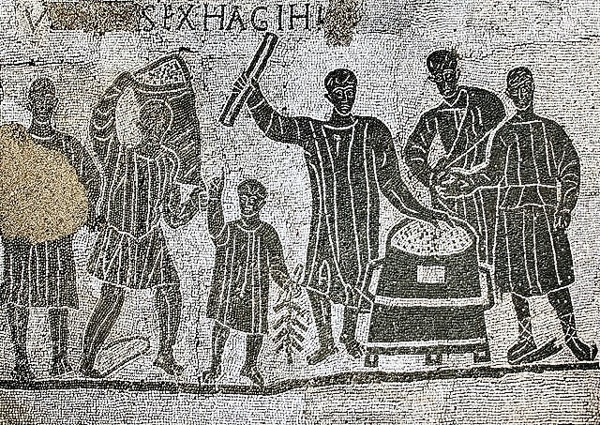  Grain measuring at Aula dei Mensores in Ostia. On the left, a porter is bringing in a sack of grain; the small man is counting the number of sacks, up to 9 to fill the grain measure placed in the centre of the picture; he gives a token to the porter for each sack delivered. The mensor, holding a measuring rod, is in the centre of the picture (from www.ostia-antica.org). According to Arnaud (2015) the man with a toga behind the grain measure might be a togati and the man on the right the navicularius.  Following measurement, the goods were stored in warehouses (horrea).  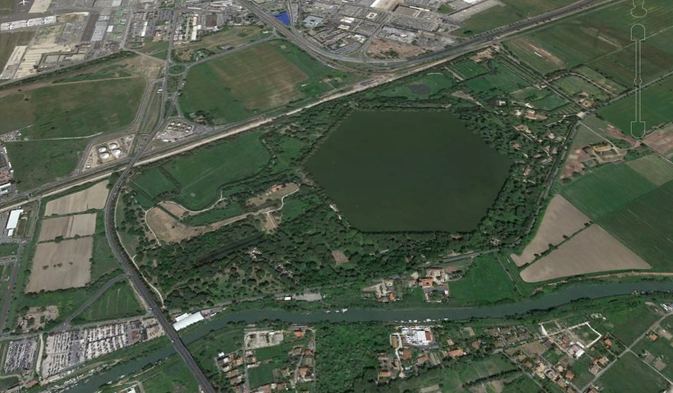  Portus Trajanus with nearly 300 berths along 2 km of quays, very few cranes and a vast storage area (horrea) (picture Google Earth, 2016). Note: the earlier Portus Claudius has an additional 2-3 km of quays. | Modern  Container ships are loaded and unloaded by means of giant gantry cranes that can reach over the whole width of the ship, i.e. they must lift up to 120 tons (4 TEU) simultaneously at a distance of up to 60 m. This means that modern container ships are always moored alongside the quay, enabling loading/unloading to be carried out by several cranes simultaneously in order to have the ship at berth no more than a few days.  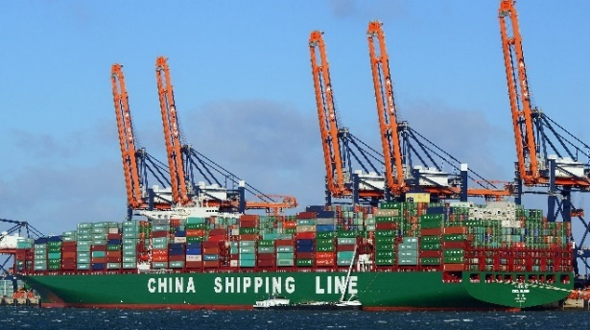  Five gantry cranes with arms lifted allowing ship movement. A berth of this type can move around 150 TEU per hour (picture https://www.marinetraffic.com).  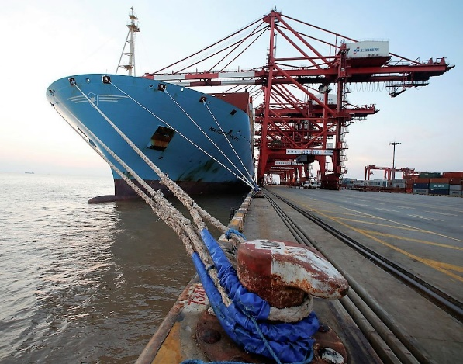  Large Maersk container ship berthed port-side (picture https://gcaptain.com).  Shipowners have to optimise the loading of their ship in order to have the boxes ready to be unloaded on reaching each port of call during the trip. They also have to take into account the weight of the boxes and the distribution of loads on board, and many other constraints. This job is no longer conducted by the captain of the ship, but by the company’s headquarters using sophisticated computer programmes designed for this task.  The same holds for the giant container storage areas where each container is registered in an x,y,z position with the aid of computers.  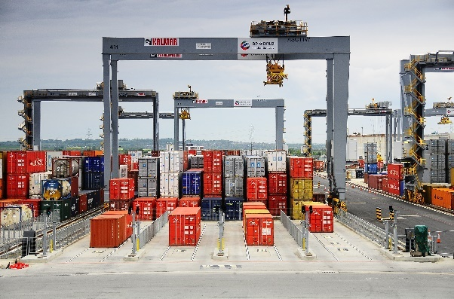  Fully automated container park at the London Gateway (picture http://www.kalmar.fr).  Goods in bulk are stored in silos (grain), in tank farms (oil) or on open stockyards (coal and ore).  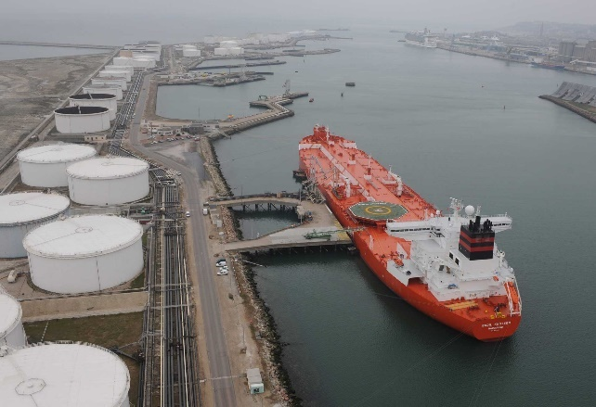  Le Havre oil terminal with tank farm for oil storage (picture http://www.meretmarine.com).  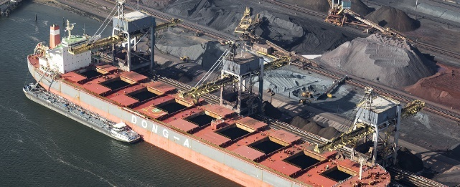  Oakland coal terminal with stockyard (picture  http://www.globaltrademag.com/  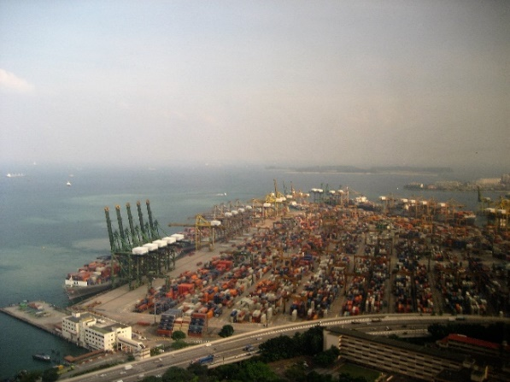  Singapore’s container terminals total nearly 60 berths along 17 km of quays, with over 200 gantry cranes and large areas for container storage (Wikipedia).

- Exporting and importing
Maritime trade is of course a rather complex discipline, and we may start by making a very useful distinction between more or less regular coastal sailing between a succession of ports, called ‘short-sea shipping’ (French: ‘cabotage’, i.e. cape to cape sailing), and long-haul offshore sailing between major hubs, also called ‘deep-sea shipping’ (French: ‘navigation hauturière’). Major hubs (ancient emporia) redistribute goods to smaller ports by means of short sea shipping. Long-haul shipping is usually performed with larger ships than in the case of short-sea shipping, which uses so-called ‘feeder’ ships. One might say that a fine-mesh network is imbricated into a larger-mesh network.
In large modern European ports, short-sea shipping accounts for 50 to 80% of the total volume of goods transported by sea.
In addition, a more opportunistic type of shipping, called tramping (French: ‘tramping’!), has always existed. It is still used widely for speculative goods such as oil, ore and cereals.

One fact remains constant: fair trade cannot exist without a certain level of trust between the parties, at least at managerial level. This means that the nodes of the above-mentioned networks are connected on a social or even friendly basis.
Another fact that remains constant: trade is regulated by supply and demand on the markets. If demand (and price) for a given commodity is reducing, so does its transportation.

Ancient  Interregional trade was organised by the state for the needs of Rome and of the army (cura annonae), but also by individuals from some cities (civitas libera) that had friendly ties with other cities.  Typical players in maritime trade were:  Negotiator: businessman involved in goods trading at the wholesale market (emporion). He could act as a charterer of a ship.  Mercator: local merchant trading at the retail market (agora).  Argentarius: banker keeping books (tabulae) and recording contracts, which were considered as legal proof by the courts.  Mensarius: public banker appointed by the state.  Stationarius: custom officer in charge of controling goods and collecting taxes (ellimenion).  Gubernator: helmsman/pilot/master knowing the location of safe shelters and how to handle the ship to enter them.  Magister navis: supercargo travelling on board the ship and representing the owner of the cargo who empowered him to trade it on his behalf.  Dominus navis: shipowner, who entrusts his ship to a gubernator.  Navicularius: the meaning of this word seems to have changed over time (ship owner, ship master, maritime trader) and in space (Italy, Egypt). He was a member of his city’s professional guild who could negotiate privileges and shipping prices with the emperor’s Annona and therefore belonged to the Roman elite. He could also act as a negotiator for his own business.  It seems that certain cities had a local representative at Ostia (curator navium) who would assist the supercargo (magister navis) upon arrival at the port. These people were long-term residents, part of a trading diaspora, sometimes enjoying double citizenship. They had their own statio where traders could meet and obtain certain services, such as with finding their way around a highly corrupt administration, somewhat like a local branch of a Chamber of Commerce of their home-city.  The Muziris Papyrus (ca. 150 AD) is a fragmentary document found in 1985. On its verso side, it provides a list of cargo which has been reconstructed as follows: 544 tons of pepper, 76 tons of malabathron (cinnamomum tamala leaves), 3 tons of ivory tusks and 0.5 ton of ivory fragments, 2 tons of tortoise shell, and 80 boxes of Gangetic nard (possibly 1 or 2 tons) . That makes around 625 tons, requiring a very large Roman ship (this one was called the Hermapollon). The total value of this cargo reaches a stunning amount of 9.2 million Roman sesterces, which is around 60 million modern Euros.  Note that the value mentioned in the Muziris Papyrus is based on a Roman customs evaluation, which uses the price level of goods in Rome and not their purchase price in India, which is probably many times lower (incidentally, import taxes amount to 25% of the goods, and are thus independent of the value).  Some merchants able to raise this kind of money to buy goods in India and to bear the risk of losing them at sea must certainly have been ‘Roman billionaires’. But for other merchants, the question of financing and insurance was vital. Most of what we know about these legal aspects is deduced from Demosthenes’ speeches, and it appears that maritime loans also worked as an insurance (‘bottomry’): if the ship was lost underway the loan was not repaid, but if the trip was successful the loan was repaid with an interest rate of 20 to 30% (depending on risks related to the sailing season). These loans were independent of time, but were supposed to have a duration of no more than one year, which was a common duration for a return trip.  Upon safe arrival, the borrower had a few weeks to sell the cargo and to repay the loan. If the borrower did not want to repay the loan, the lender was entitled to seize the ship and/or its cargo.  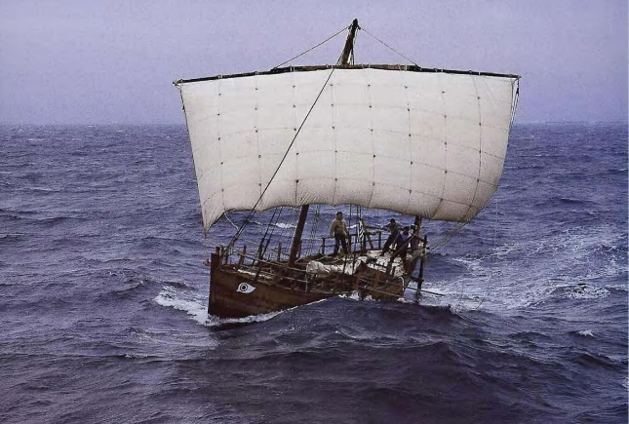  Kyrenia II (3rd c. BC) sailing in storm on the Aegean Sea in 1987 (picture in Tzalas, 2007).  This leads us to analyse the maritime accidents and shipwrecks that are known today:  - 500 BC – 500 AD: 1500 shipwrecks, or approx. 1.5 shipwrecks/year,  - 150 BC – 150 AD: 800 shipwrecks,  or approx. 2.7 shipwrecks/year.  The number of shipwrecks for both periods is obviously approximate as the dating of shipwrecks is often uncertain. Furthermore, many shipwrecks may still be unknown. The numbers are surprisingly close to modern numbers, but the number of ships sailing was probably over 10 times smaller than today, as we will see hereafter.  This perhaps shows that ancient sailors were somewhat more ‘wreck’less than modern sailors … | Modern  Contractual documents are intended to specify the object of trade (i.e. the goods), the prices, the conditions of payment, the conditions of termination of the contract in case of unexpected events, and the applicable law in case of a dispute.  Insurance policies are intended to cover the risk of damage or loss of the goods during their transportation.  Banks use their network to pay the seller in his place of residence with money provided by the buyer in his own place of residence. Banks have no personal opinion on the delivery, they merely pay according to the contractual conditions which are carried over to a so-called Letter of Credit. This document is put together by intensive use of modern encrypted telecommunications from bank to bank.  A specific document, the Bill of Lading (B/L), is prepared by the carrier for the seller upon loading the goods on board his ship. The seller transfers the B/L and his invoice to his bank, who will send it to the buyer’s bank, who will pay for the goods so that the buyer can collect the goods from the carrier.  In order to avoid any fraud, each container is sealed in presence of the seller after the goods have been loaded. The seals will be broken upon arrival in the buyer’s presence.  Several people may be involved in this process, such as a charterer who will look for the right shipping company, customs agents who will conduct custom formalities and pay taxes, shipping agents who will assist the captain with all formalities, etc.  Modern cargoes valued at around €100m are quite common:  - 2 million barrels of oil at $50/barrel (on a 300 000 ton VLCC, around 350 m long),  - 5000 cars at €20,000/car (on a 180 m car carrier),  - 1500 TEU average value (on a 180 m container ship).  These cargoes are usually owned by a single company, but container contents are often owned by a large number of people.  A modern company able to send over 5000 cars from say Japan to Europe is not an individual, but a multinational corporation which might be compared to a ‘Roman billionaire’. The same can be said of oil companies that have oil or gas moved from the Gulf to Europe or Japan. The case of containers is slightly different, as their content is owned by a multitude of individuals. However, the total value of the ship at sea is covered by an insurance company that may have to refund amounts of many hundreds of millions of euros in case of a total loss: the largest container ships, moving up to nearly 20 000 TEU, may be valued at up to a billion euros in 2016, for both the ship and its transported cargo. The material cost of the Costa Concordia disaster in 2012 was even more than that.  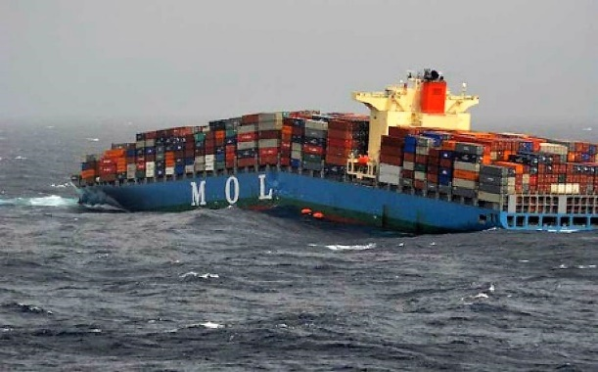  MOL Comfort (316 m long) broken in two parts during a storm in the Indian Ocean and sunk in June 2013 (picture http://www.meretmarine.com).  Ships are still lost at sea. Although the truth never is totally clear, the MOL Comfort was probably broken up by wave action due to the combined effects of some structural weaknesses and some possible excessive load concentrations on board. Something similar happened in 2007 to the 275 m long MSC Napoli container ship.  A recent study shows that an average of one major accident with loss of lives has occurred each year in the past 150 years, but this is increasing:  - 18th c.: 0.3 shipwrecks/year  with 142 deaths/yr,  - 19th c.: 1.1 shipwrecks/year  with 323 deaths/yr,  - 20th c.: 1.4 shipwrecks/year  with 475 deaths/yr,  - 21st c.: 3.5 shipwrecks/year with 755 deaths/yr.  This increase of shipwrecks is mainly due to increased seafaring, but the dramatic rise in the death toll in the 21st century is also because of ferries sinking in SE Asia and migrant boats sinking on the Mediterranean Sea. These figures should obviously be further analysed.

- Ships and Sailing
Ancient  Ships were usually associated with a city of origin, like the ‘ship of Alexandria’ in the Acts of the Apostles. It is hard to give numbers, but an estimated 1000-2000 ships provided food for Rome. The number of sizable ships trading on the Mediterranean, Red Sea and Indian Ocean must hence have totalled several thousand.  Ship sizes increased between around 300 BC and 300 AD, from around 20-40 tons (the Kyrenia) to 600-1200 tons (the Hermapollon and the Isis), i.e. a factor of 30 over 600 years. The largest freighter known in Antiquity (the Syracusia) was built by Hieron of Syracusa with help from Archimedes, and described by Moschion (possibly ca. 2000 tons of cargo); it was probably too large and did not sail many trips.  According to Pliny (around 75 AD), Indian imports seem to have been sold in Rome for 50 million sesterces per year (and bought in India for a hundredth of that price). This is only 5 times the value (in Rome) of the Hermapollon cargo (around 150 AD). A small number of these large ships could hence do the job.  According to Strabo (around 25 BC, one century before Pliny), 120 ships set sail from Myos Hormos for India every year. They must therefore have been much smaller than the Hermapollon. De Romanis explains that trade with India possibly shifted from Myos Hormos to Berenike between 25 BC and 75 AD, while the ships’ size increased. | Modern  Ships are officially registered in their ‘flag state’; 17% of the world’s fleet of over 50 000 ships larger than 500 tons is registered in Panama or in Liberia (in 2014). The flag state is supposed to enforce international minimum social, safety and environmental standards, and other international recommendations, on its vessels. Around 20 000 ships are involved in inter-regional trade by means of ‘deep-sea shipping’ from one ‘hub’ to another. Smaller ships are involved in ‘short-sea shipping’, distributing cargo within a region.  The first true container ship (Japanese shipowner NYK) started sailing in 1968 and could carry 752 TEU containers. Since then the size of container ships has increased rapidly up to nearly 20 000 TEU in 2016, i.e. a factor of nearly 30 over nearly 50 years.  The same factor of 30 found over 50 years in modern times is found over 600 years in ancient times. This can perhaps be seen as another sign of the ‘acceleration of history’.  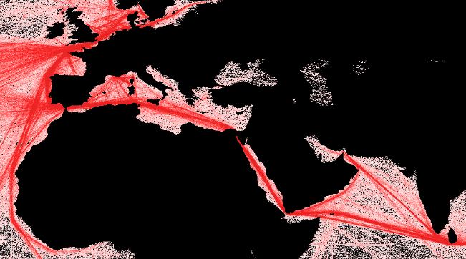  Present-day merchant shipping routes in the Mediterranean Sea and Indian Ocean (Wikipedia).

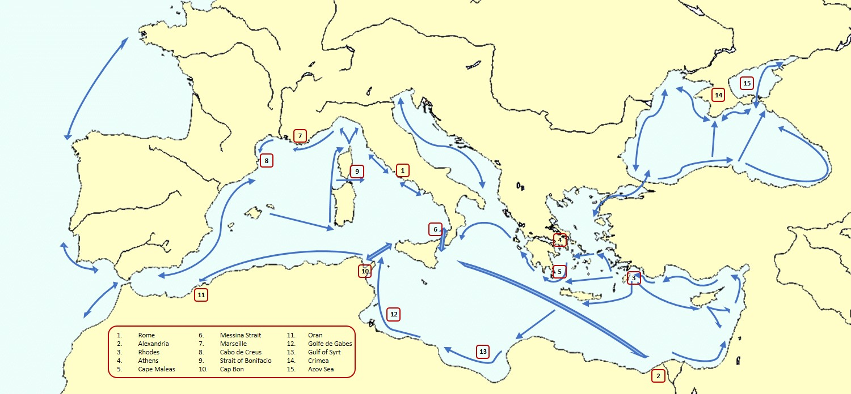
Main ancient Mediterranean sailing routes.

At first glance, present-day Mediterranean shipping routes seem to be not that different from ancient times! But traffic from China to Europe via the Suez Canal and in oil & gas from the Gulf are completely new trades.
To understand ancient sailing routes, wind patterns must be analysed in the assumption that the meteorological sailing conditions have changed little over the past few millennia.
The prevailing wind direction almost everywhere on the Mediterranean Sea is NW (note that 'prevailing' usually means 'over 50% of time', but not 100%!).
In addition, a constant wind direction is required for long-haul offshore sailing. This is typically the case from Sicily to Alexandria in summer time, but other prevailing wind directions may exist locally, e.g. north on the Aegean Sea, north and NE on the Black Sea and east along the coasts of Algeria. Obviously, a more detailed analysis is needed to find a way back to Rome from Alexandria. This trip is achieved by using sea breezes blowing in the afternoon from the sea to the land. These winds are best felt within a few miles off the coast. They blow more or less perpendicular to the coast, but may locally reach an angle of 45° or even be parallel to the coast. One may hence conclude:
Eastward journeys can be made by long-haul offshore sailing, and
westward journeys must be made by coastal navigation.

The trip to Alexandria is therefore much faster than the trip to Rome, since as well as being longer in distance it also involves much waiting for favourable wind conditions: this could take one or two months and more, as opposed to one or two weeks.
The trip from Alexandria to Rome goes north along the Levantine coast, then west along the Turkish coast to Rhodes, then through the Aegean. The Aegean Sea is famous for its northerly wind the called Meltem, which makes an east-west crossing a subtle operation using local winds around the islands. The route through the Aegean Sea is still a matter of debate, with some favouring the northern route, while those not going to Athens prefer the southern route avoiding the dangerous Cape Maleas. West of the Peloponnese, the Ionian Sea with prevailing NW winds must be crossed, usually by following the Greek coast to Corfu before crossing over to Calabria and to the Messina Strait.

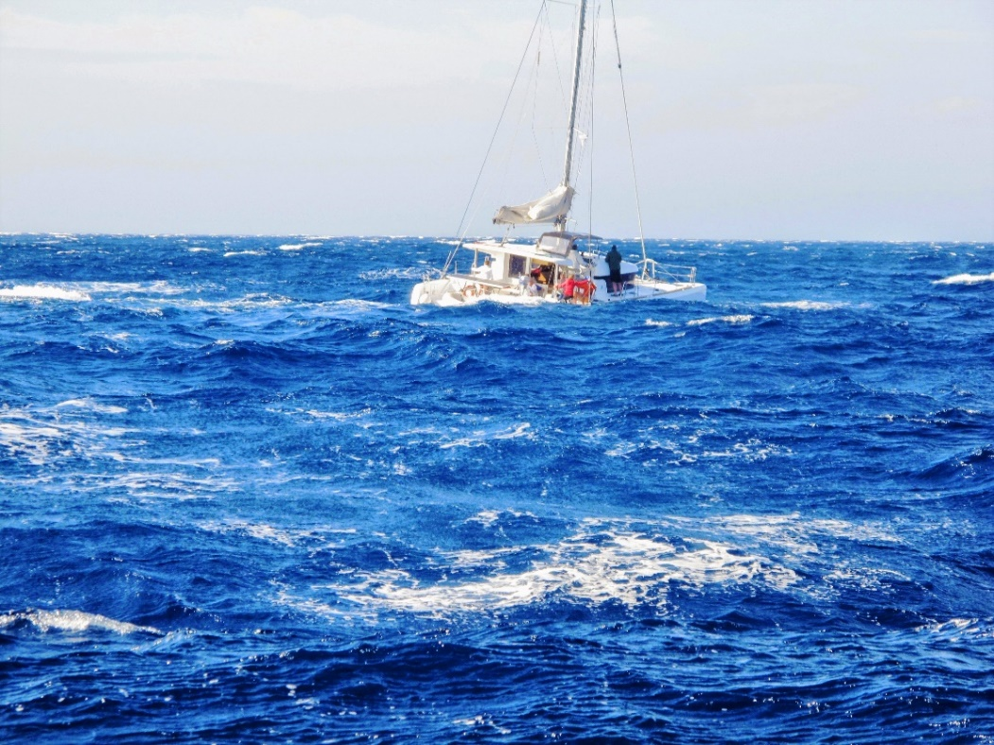
Struggling with a 25-30 knot Meltem near Delos (A. de Graauw, 2015).

The Western Mediterranean is subjected to low pressures travelling from west to east and inducing a counter-clockwise wind pattern. Hence, on the south coast of France, the wind will first blow from south to east and then turn to north to NW, generating the famous Mistral and Tramontana. This explains why it can be difficult to sail from Marseille to Cabo de Creus and why this must be done close to the coast to avoid high offshore waves induced by the Tramontana. The trip back may lead through the Baleares and Sardinia, where the westerlies will prevail, then along the western coasts of Sardinia and Corsica where a southerly wind may blow. Those going to Rome will take the dangerous Straits of Bonifacio between Sardinia and Corsica.
The coast of North Africa is prone to summer easterlies between Cap Bon and Oran, but has a lack of wind between Oran and Gibraltar … in addition to adverse east-going surface currents of Atlantic water compensating for Mediterranean evaporation.
The Tunisian Golfe de Gabes and Libyan Gulf of Syrt have a tidal range up to 1 m, inducing tidal currents that can be used by sailors in both directions. The summer winds may blow from north to east.
The access to the Black Sea is very difficult because of the strong southward surface current of fresh water flowing towards the Mediterranean Sea, in addition to NE winds. Inside the Black Sea, currents flow counter-clockwise favouring eastward travel along the Turkish coast, before crossing over to Crimea and the Azov Sea against the prevailing winds. Nevertheless, ancient seafarers are known to have sailed in large numbers along the western Black Sea coast to Crimea, possibly because this trip was free of pirates.
On the Red Sea, the wind blows from the north in its northern part (e.g. north of Port Sudan at 20° latitude), and the Red Sea Pilot states that "you should not count on any south winds from Ras Banas northwards" (Berenike at 24° latitude). The southern Red Sea has seasonal variations due to the monsoon regime and winds can be strong in the Straits of Bab el-Mandeb. In the Nile valley, the wind blows from the north against the current most of the time and the Nile delta is subject to seasonal variations with its famous summer northerlies. Ancient shippers therefore had three options when sailing back to Memphis (Cairo) and Alexandria: struggling against the wind on the Red Sea as far as Arsinoe/Clysma (Suez); unloading the cargo at Berenike (near Ras Banas) or Myos Hormos (Quseir al-Qadim) and carrying it across the western desert of Egypt as far as Coptos (Qift) and then down the Nile; or unloading the cargo at Leuké Komé (probably Sharm al-Wajh, acc. to Nehmé) or at Charmotas (possibly Sharm Yanbu) and transporting it overland with Nabataean carriers as far as Petra and Gaza. Another option was sailing to Charax Spasinou (Jebel Khayabir, about 50 km north of Basra), via the Gulf, in order to reach the Mediterranean coast near Palmyra, but with lots of NW winds there too.
Some of this is summarised below.

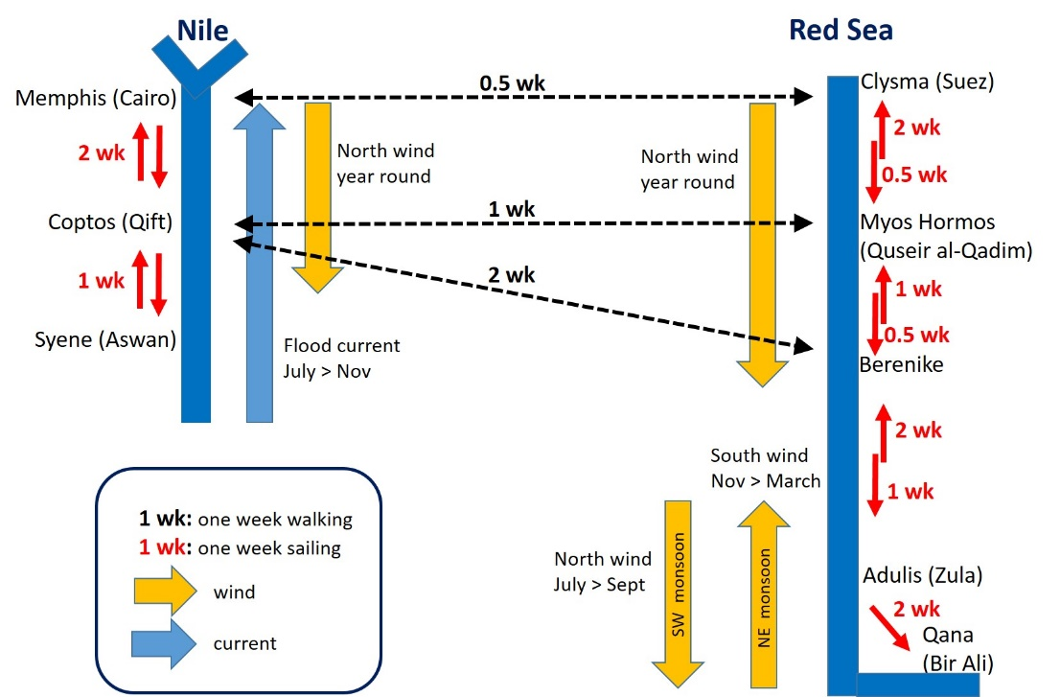

Physical conditions and journey times on the Red Sea and on the Nile.

It has hopefully been made clear in this brief survey of Mediterranean and Red Sea sailing that it was (and still is) a vast and complicated subject that requires a lot of experience.

History shows that Mycenaeans (ca. 1500-1200 BC), Phoenicians (ca 1200-150 BC) and Greeks (ca. 800-300 BC) were very good at sailing. Mycenaean sailors had a very difficult playground in the Aegean Sea. Perhaps their experience was later drawn on by Phoenicians, who used it to travel all over the Mediterranean Sea and beyond. The need for many shelters arises from the fact that sailors sometimes had to wait for proper wind conditions or to try to escape bad weather conditions. Even though they could sail 50 to 100 nautical miles in a day, it was important for the Gubernator to know where he could find a safe shelter within two to three hours of navigation, i.e. only approx. 10 miles.

But let’s go back to our ‘Ancient’ and ‘Modern’ comparisons.

Ancient  The picture below shows that a ship with a square sailing rig can sail to windward reaching an angle to the wind direction of around 60°, just as a modern sailing boat would do under spinnaker at beam reach.  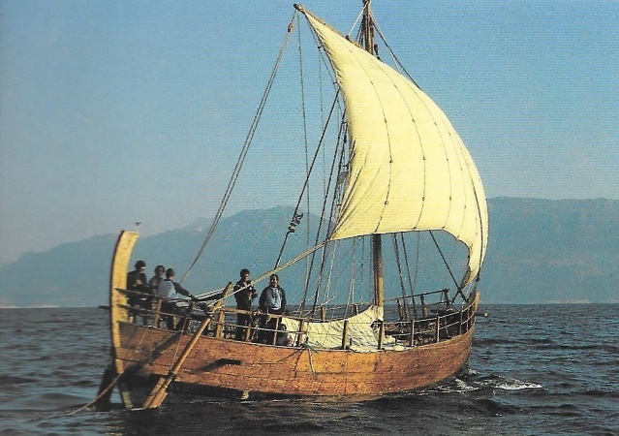  Kyrenia II (3rd c. BC) sailing at close reach with a square sail on the Aegean Sea in 1987 (picture Pomey, 1997).  This was a must for sailing on the Mediterranean Sea and on the Red Sea from east to west, but it certainly was (and still is) not a comfortable trip …  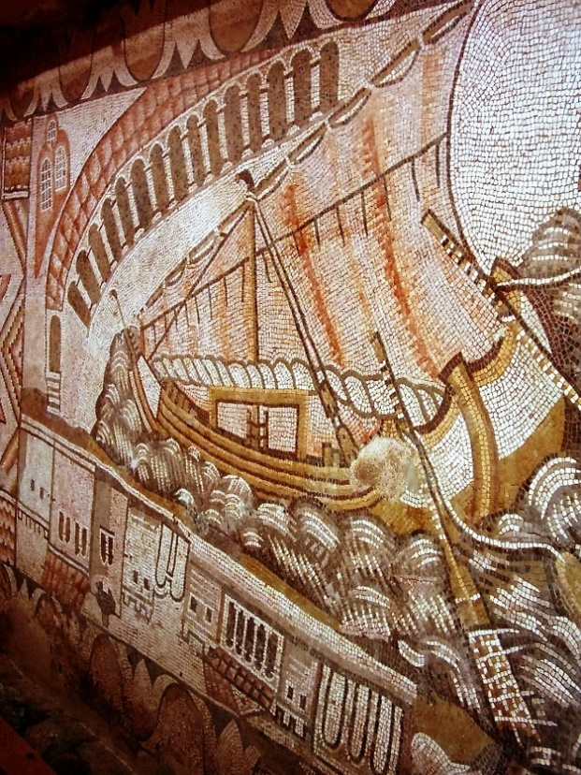  Kelenderis 5th c. AD mosaic discovered by Levent Zoroglu in 1992, showing a ship with partially brailed sail with the top yard pointing down to the bow, making the rig look like a lateen rig (picture Levent Zoroglu). Note that although the harbour city is depicted, the ship is sailing in rough seas with many waves. In this picture, you can almost feel the rough sailing conditions at close reach with a brailed sail. Such a picture of a sailing ship in full action is very rare, as artists never had an opportunity to see this from the shore.  From a sailor’s point of view, it was worth trying to reduce the length of sail-cloth prone to sagging on the luff side.  This sail setting probably led to the triangular shape of the lateen rig pointing into the wind. Furthermore, the lateen sail consisted of fewer components than the square sail, but it required more crew to handle it. The square rig and the lateen rig obviously had pros and cons and mariners made their own choices. Whitewright (2011) shows that the lateen rigs performed only very slightly better to windward than square sails and this explains why both coexisted for many centuries.  Sailors are not at all conservative when it comes to sail settings, and they may very well have used the triangular setting of the square sail for many centuries before the Kelenderis mosaic picture.  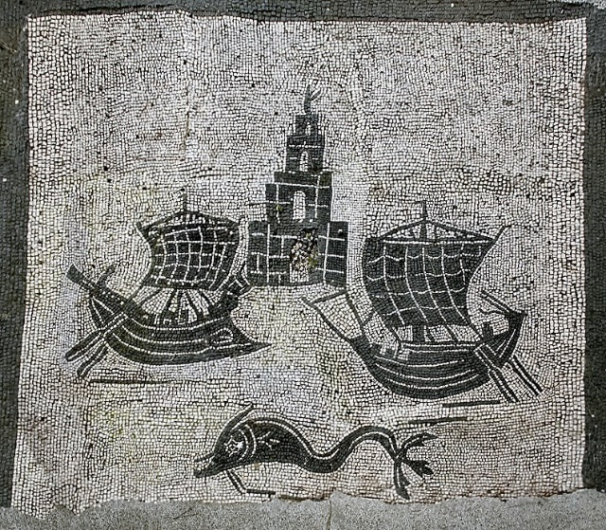  Mosaic at Piazzale delle Corporazioni, Statio 46 (from www.ostia-antica.org). | Modern  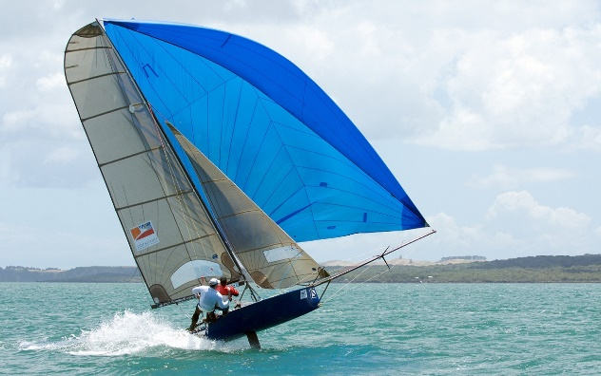  Modern sailing boat nearly flying under spinnaker at beam reach; compare with kite surfing: quite physically demanding! (picture http://www.hotel-r.net).  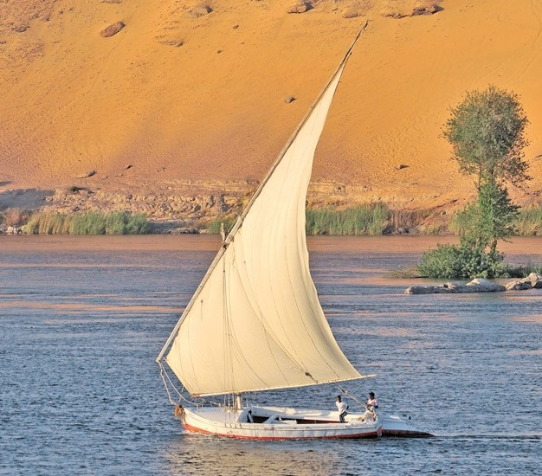  Modern felucca on the Nile (picture http://www.guidelouxor.com).  Container ships are not sailing ships; they are propelled by engine(s) totalling around 100 000 HP (say 1000 small cars!). However, they can be 50 m high, leading to a windage of 15 to 20 000 m², and this is now becoming a limit for manoeuvring them in winds over 35 knots (65 km/h, or Beaufort force 8). Consequently, modern ships are sometimes told to stay outside the port in order not to take any risks when entering the port under unfavourable conditions. This is financially unattractive as modern ships are on tight schedules and ‘time is money’.  It may be noted that similar problems occur with modern cruise ships, car carriers and LNG tankers, but not with loaded oil tankers.  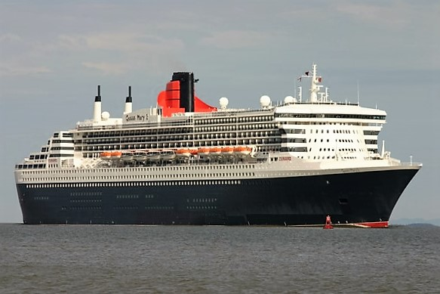  Cruise ship Queen Mary 2.  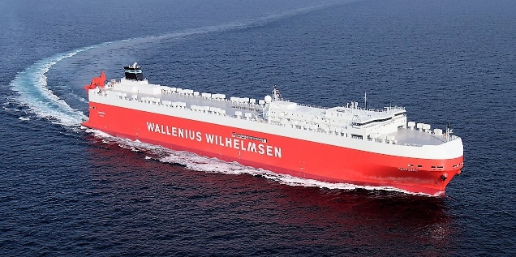  Car carrier Tonsberg.  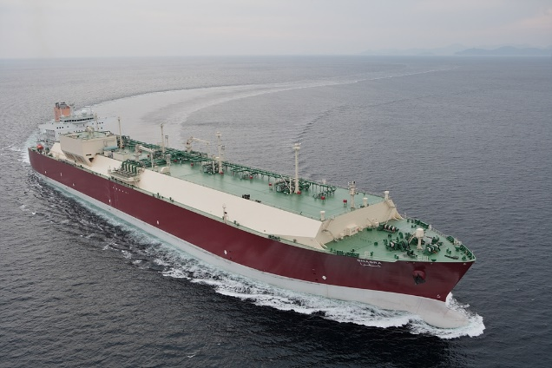  Q-Max LNG tanker Shagra  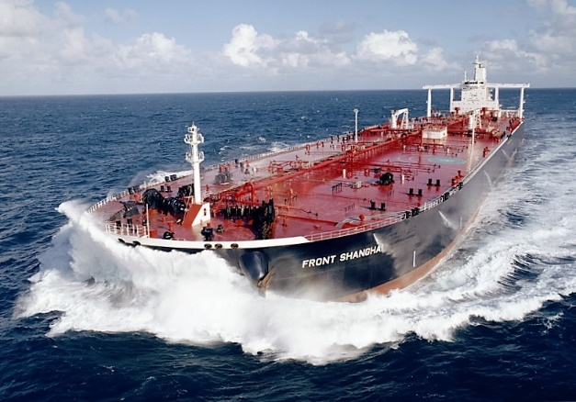  VLCC Oil tanker Front Shanghai.

- Return cargo
Ancient  Ballast of some kind is required, as a sailing boat would capsize immediately without it! Many clumps of ballast stones from all over the Mediterranean area have been found in ancient ports.  The impressive Monte Testaccio dump in Rome contains over 50 million amphorae, mainly Spanish and North African Dressel 20 olive oil amphorae. Perhaps these amphorae were too fatty and the smell of rancid oil prevented any further use, as a result of which they were disposed of. In addition, these foreign amphorae with a different shape may have been of no value to Roman merchants. Surprisingly, wine amphorae were been dumped in such large numbers and one might think they were reused, at least in Republican times when they were exported to Gaul, before the Gauls learned how to make their own wine ....  Other Italian products such as luxury clothes, glassware and tiles may have been exported too, but the volumes were probably much smaller than the volumes of imported wheat and exotic goods.  There is also a hypothetical export of pozzolana, which was needed for building large submerged structures. Hohlfelder estimates that 20 000 tons of pozzolana might have been imported for the Caesarea Maritima breakwaters. Pozzolana was also found in the Madrague de Giens shipwreck, where it was used for stabilising amphorae. It has been also suggested that African Red Slip ware from Proconsular Africa transported to Rome along with olive oil amphorae was re-exported to Alexandria as a return cargo in Annona ships, along with other goods such as garum and olive oil.  However, the main Roman export was gold and silver bullion used for payment of imported goods! | Modern  You will probably never see an empty container ship, except on her first sea trials. This is because containers are reused a number of times. This means that they are filled with goods for a trip say from China to Europe, and mostly empty when they travel back to China. The container ship will look fairly similar on both trips, except for her draught.  Note that the problem with oil tankers is even worse, as they never have return cargo and simply use sea water for their ballasting tanks.  This problem of return cargo is limited to freight liners, i.e. nearly all container ships and many oil tankers. However, tramp ships are free to sail to any place without a time schedule. Typically, some Ro-Ro ships are used as tramps as their ‘Roll-on/Roll-off’ capability provides them great flexibility to load and unload wheeled cargo (trailers, Mafis) anywhere.  A special market (the Baltic Exchange in London) brings together people who need cargo to be shipped and those who have ships (brokers, charterers, shipowners). Needless to say, this is a very speculative occupation where fortunes can be made and lost quickly.

- Roman economy
Compared to our modern economies, the Roman imperial state had little input in the economy. The emperor had to maintain Pax Romana to keep trade going. This was achieved by the army at the empire’s frontiers, and by feeding Rome’s plebs nearly for free with the Annona system. This was paid for by provincial tribute, bullion mining and import taxes (tetarte) taken on goods entering the empire. Warlords like Julius Cesar under the Republican era were hence replaced by trade billionaires under the empire.
Ancient  The empire’s population was around 50 million.  The annual imperial state budget was around 1100 million sesterces, broken down as follows:  Expenditure:  - Army: 650 to 700 million sesterces, for 25 to 30 legions & auxiliaries & navy & praetorian guard, totalling around 300 000 men (0.6% of the population),  - Other: around 250 million sesterces, for buildings, civil servants, the imperial household.  Revenues:  - Bullion: 150 to 200 million sesterces, from gold and silver mines in Spain, Dalmatia, Dacia,  - Tribute: 150 to 350 sesterces from 40 provinces, plus 300 to 600 million from Egypt alone,  - Import taxes: 25 to 250 million sesterces collected mainly at Gaza and Alexandria.  The Roman imperial budget was thus around 1 billion sesterces, that is 0.02% of a soldier’s annual pay per capita (1000 sesterces/year for 50 million inhabitants), nearly half of it coming from Egypt. Defence accounted for up to 70% of the budget.  Alexandria became ‘the greatest emporium in the inhabited world’ where goods were transferred from Nile boats onto seagoing ships sailing to places such as Rome. Many goods were also processed in Alexandria (where cotton and silk clothes and perfumes were produced). Alexandria was a nodal point of the Roman economy.  Additional nodes of a large-mesh Roman trade network might be located in Baetica (for garum, salted fish, olive oil) and in Proconsular Africa (for wheat and olive oil). | Modern  Europe’s population is around 500 million (28 EU countries).  The European armies encompass around 2 million people, i.e. 0.4% of the European population (for 2008-2009, and decreasing).  The French annual state budget is around €450bn (excluding Social Security & Health Care), i.e. 1 French RSA per capita par year. The US federal budget is around $2000bn (excluding Social Security & Health Care), leading to a similar per capita figure.  Our modern per capita state budgets are 50 times larger than the Roman imperial budget, showing that our modern states are involved not only in defence (10% in France, 30% in USA), but also in a much wider scope of activities, including education & research (22% in France).  Modern nodal points as mentioned by Attali (1984) include:  - Bruges, with wide use of a sternpost-mounted rudder on ships,  - Venice, with a new type of ship, the caravel,  - Antwerp, with the introduction of printing,  - Genoa, with new accounting methods,  - Amsterdam, with the first machines,  - London, with the steam engine,  - Boston, with the automobile,  - New York, with introduction of electricity.  … and the ongoing digital revolution is probably located in California.  Note that these cities are all ports … Attali’s conclusion is “Telle est la politique qu’il faut mettre en œuvre: produire l’offre par le progrès technique, et la demande par la culture”

- Conclusions
This paper aims to compare ancient and modern supply chains.
- Many aspects of shipping have not really changed since Antiquity:
  - Loading and unloading a ship has always required a lot of manpower;
  - Stowing and fastening cargo on board always required a lot of care;
  - A specific group of ship owners, agents, traders and customs officers has always been involved;
  - Sailing ships is a risky activity requiring much experience to use wind forces safely and avoid storms.
- Ancient maritime traffic was carried out with thousands of ships, the largest with a cargo capacity of several hundred tons, such as the 400 ton Madrague de Giens (40 x 9 m, draught around 3.5 m), the 600 ton Albenga or Hermapollon mentioned in the Muziris Papyrus, and the 1200 ton Isis described by Lucian of Samosate (55 x 14 m, draught around 4.5 m). As noted by De Romanis, similar volumes of cargo did not return to the seas until the 16th century. Today’s largest ships carry cargo values similar to those carried by the Hermapollon, i.e. in the order of 100 million euros and up to 1 billion euros, but ship length has increased significantly from 40-50 m to 300-400 m.
- The speed of maritime logistics has increased dramatically:
  - On shore, slaves are now replaced by machines: no mistakes, no rebellions, no corruption;
  - Flows of goods have been improved: they are now safer, faster, and on time, thanks to meteorological forecasting;
  - Flows of information have been improved: they are now more detailed and much faster, with reliable delivery;
  - Flows of money have been improved: they are now safer and faster (thanks to demonetisation). This is perhaps the most important improvement.
- As a nodal point of ancient maritime trade, Alexandria was the “greatest emporium of the world”, acc. to Strabo:
  - Goods were imported from South Arabia, East Africa and India, and paid for with gold and silver bullion. They were taxed at 25% by the Roman state, thereby providing a substantial part of its total income;
  - Some goods, such as perfumes and dyed silk, were transformed and manufactured in Alexandria, thereby adding great value to the imported goods;
  - Goods were exported to Rome and other cities of the empire: not only exotic spices and goods from beyond the Red Sea, but also vast quantities of grain produced in Egypt.
- Four major nodes should hence be mentioned: Rome, Alexandria, Proconsular Africa and Baetica. This coarse network shows 3 lines converging on Rome. A finer-mesh network might be added to the coarse one by including other nodal points such as the Tanaïs river area, Byzantium, Rhodes, Athens, Puteoli, Massalia, Arelate, Narbo, Tarraco, Carthago Nova and perhaps Gaza, if it was more than a place of transit such as Myos Hormos and Berenike. In addition to Indian places such as Muziris (unlocated near Cochin), a lesser known place such as Omana (possibly located at al-Dur, ed-Dur, in Umm al-Quwain Emirate) should be mentioned here too in order not to under-estimate ancient traffic in the Gulf.
Today, there are several major nodal points for maritime traffic (in China, in Japan, in Europe and on both US coasts) and the main streams of goods are in containers from China to Europe, USA and Japan. Goods to China are in bulk (oil, coal, iron ore).

Most of our modern maritime logistics were already in use more than 2000 years ago!
But …
In ancient times, today’s “time is money” was less important
than “have a safe trip back home”.

- Acknowledgements
I am deeply grateful to Pascal Arnaud for having challenged me on this subject and for providing me with support and thoughtful comments. I am also much indebted to Patrick Delaforge for his comments and suggestions on modern maritime logistics. I also wish to thank the Wikipedia community for providing so much useful information and pictures.
- Bios
Arthur de Graauw is a French/Dutch coastal engineer employed by a French Consulting firm, SOGREAH(now ARTELIA) until the end of 2015.
He graduated from Delft University of Technology in 1976 in civil engineering of coastal structures and areas. He used many hydraulic scale models and mathematical models in his work. He worked on numerous projects related to coastal erosion, industrial ports and marinas in the Mediterranean area including Lebanon, Gaza, Egypt, Libya, Tunisia and France.
From 2002 to 2015 he managed the Port Revel shiphandling training centre using manned models.
He has been active in ancient ports since 2000 and created a new catalogue of ancient ports encompassing over 4000 places. He is the webmaster of www.AncientPortsAntiques.com focusing on many technical aspects of ancient ports.

References
- ARNAUD, P., (2005), “Les routes de la navigation antique”, éd. Errance, Paris, (248 p).
- ARNAUD, P., (2010), “Systèmes et hiérarchie portuaires en Narbonnaise”, Colloque d’Arles, 28-29-30 octobre 2009, éd. Errance, Paris.
- ARNAUD, P., (2015a), “Inscriptions and port societies: evidence, “Analyse du discours”, silences, portscape… ”, International Conference on Roman Port Societies through the evidence of inscriptions, organized by Pascal Arnaud and Simon Keay as part of the ERC Advanced Grant-funded Rome’s Mediterranean Ports Project in conjunction with the British School at Rome, 29-30 January 2015.
- ARNAUD, P., (2015b), “Cities and Maritime Trade under the Roman Empire”, in Schäfer Chr. (ed.), Connecting the Ancient World - Mediterranean Shipping, Maritime Networks and their Impact, Rahden, Verlag Marie Leidorf, (pp 117-173).
- ARNAUD, P., (2016), “Conclusion”, in The Sea in History: The Ancient World – La Mer dans l’Histoire L’Antiquité, Edited by Pascal Arnaud and Philip de Souza, General editor Christian Buchet, Woodbridge, The Boydell Press, (pp. 617-642).
- ATTALI, J., (1984), “La figure de Fraser”, éd. Fayard, Pairs (194 p).
- BALLET, P., BONIFAY, M., MARCHAND, S., (2012), “Africa vs Aegyptus : routes, rythmes et adaptations de la céramique africaine en Égypte”, in Entre Afrique et Égypte : relations et échanges entre les espaces au sud de la Méditerranée à l’époque romaine, éd. Ausonius, Bordeaux, (310 p).
- BANG, P., (2007), “Trade and Empire - In Search of Organizing Concepts for the Roman Economy”, Past & Present, Number 195, Oxford University Press, (pp. 3-54).
- BRANDON, C. & HOHLFELDER, R. & JACKSON, M. & OLESON, J. et al., (2014) “Building for Eternity – The history and Technology of Roman Concrete Engineering in the Sea”, Oxbow Books.
- CASSON, L., (1990), “New Light on Maritime Loans: P.Vindob. G 40822”, in Zeitschrift für Papyrologie und Epigraphik 84, (pp 195-206).
- CASSON, L. (1971) “Ships and seamanship in the ancient world”, Princeton, (470 p).
- COOPER, J., (2011), “No easy option: Nile versus Red Sea in ancient and medieval north-south navigation”, in W.V. Harris & K. Iara (eds), Maritime Technology in the Ancient Economy: Ship Design and Navigation. Journal of Roman Archaeology Supplementary Series 84, (pp 189–210).
- DE GRAAUW, A., (2017), “Catalogue of ancient potential ports and harbours in the Black sea”, Journal Méditerranée. See also his www.AncientPortsAntiques.com .
- DE ROMANIS, F., (2012), “Playing Sudoku on the Verso of the 'Muziris Papyrus' : Pepper, Malabathron and Tortoise Shell in the Cargo of the Hermapollon”, Journal of Ancient Indian History, 27, (pp 75-101).
See also his 2014 conference at the Collège de France.
- DE ROMANIS, F. & MAIURO, M., (2015), “Comparative Perspectives on the Pepper Trade”, in Across the Ocean: Nine Essays on Indo-Mediterranean Trade, Brill, Leiden, (pp 127-194).
- ELINDER, M. & ERIXSON, O., (2012), “Gender, social norms, and survival in maritime disasters”, PNAS, August 14, 2012, vol. 109, no. 33, (32 p).
- HEIKELL, R., (2012), “The Adlard Coles Book of Mediterranean Cruising”.
- LEIDWANGER, J., (2014) “Maritime Networks and Economic Regionalism in the Roman Eastern Mediterranean”, Les Nouvelles de l’Archéologie, 135, éd. Errance, Paris, (pp 32-38).
- McLAUGHLIN, R., (2014), “The Roman Empire and the Indian Ocean”, Pen & Sword Books Ltd, (298 p).
- REDDE, M. & GOLVIN, J-C., (2005), “Voyages sur la Méditerranée romaine”, éd. Errance, Paris, (137 p).
- STOPFORD, M., (2003), “Maritime Economics, second edition”, Routledge, London, (562 p).
- STRAUSS, J., (2013), ” Shipwrecks Database”. Version 1.0. Accessed (date): http://oxrep.classics.ox.ac.uk/databases/shipwrecks_database/ .
- WHITEWRIGHT, J., (2011), “The Potential Performance of Ancient Mediterranean Sailing Rigs”, The International Journal of Nautical Archaeology, 40.1, (pp 2–17).
See also his 2008 PhD thesis at Southampton University, (229 p).
- WILSON, A., (2011), “Developments in Mediterranean shipping and maritime trade from the Hellenistic period to AD 1000”, in Maritime Archaeology and Ancient Trade in the Mediterranean, ed. D. Robinson & A. Wilson, Oxford Centre for Maritime Archaeology: Monograph 6, (pp 33-59).
- WILSON, A., SCHÖRLE, K., CANDACE, R., (2012), “Roman ports and Mediterranean connectivity”, in “Portus and the Mediterranean”, ed. Simon Keay, The British School at Rome, pp 367-392.

Egyptian rulers began sailing during the Early Bronze Age (ca. 3300-2100 BC); examples include Pharaoh Khufu-Cheops’ port at Wadi el-Jarf importing stones from the Sinai (ca. 2570 BC), Sneferu (ca. 2600 BC) and Sahure (ca. 2450 BC) sending ships to Byblos for wood and to Puntland for exotic goods.
Stopford (2003).
See short films produced by the European Harbour Masters’ Committee: http://www.harbourmaster.org/ehmc-films-chain.php
This is fortunate as it enabled experts in ‘amphorology’ to determine where and when amphorae found in wrecks were made.
University of Southampton (2014) Roman Amphorae: a digital resource
http://www.anticopedie.fr/dossiers/dossiers-gb/amphora.html
Wilson (2011).
http://donnees.banquemondiale.org/indicateur/IS.SHP.GOOD.TU?end=2014&start=2000&view=chart
https://www.cma-cgm.fr/produits-services/conteneurs
https://en.wikipedia.org/wiki/Madrague_de_Giens_(shipwreck)
http://www.cmacgm-marcopolo.com/
http://www.lantenne.com/LE-FRET-MARITIME-PRATIQUE_r114.html
Wilson (2011).
Leidwanger (2014).
http://ec.europa.eu/eurostat/statistics-explained/index.php/Maritime_transport_statistics_-_short_sea_shipping_of_goods
https://en.wikipedia.org/wiki/Cura_Annonae
Arnaud (2015)
The helmsman/pilot of a merchant ship may well have been the master. See Luke Acts, 27, 11, where reference is made to the « κυβερνήτῃ » (kyberniti) and the « ναυκλήρῳ » (naukliro) who are the obvious decision-making sailors on board, and usually translated as master for the first and shipowner for the latter (http://www.ellopos.net/elpenor/greek-texts/new-testament/acts/27.asp ). However, Virgil (Aeneïd, 5, 176-177) makes a clear distinction between master and pilot in « ipse gubernaclo rector subit, ipse magister hortaturque uiros clavumque ad litora torquet. » (he [Gyas] replaces the pilot, and as a master, he urges his men while steering shoreward, transl. Joseph Farrell, 2014) during the famous race between four navy ships at Drepana-Trapani (Sicily) (https://books.google.fr/books?id=kCZICgAAQBAJ&lpg=PP1&hl=fr&pg=PA43#v=onepage&q&f=false ). This is still the case on modern navy ships where the captain’s job is to conduct war more than to steer the ship by himself.
Arnaud (2015)
Arnaud (2015)
Casson (1990), for a complete translation into English. The papyrus is presently housed in the Austrian National Library in Vienna.
De Romanis (2012), for a brilliant reconstruction of the cargo on board the Hermapollon. See also his 2014 conference: http://www.college-de-france.fr/site/jean-pierre-brun/seminar-2014-12-09-10h00.htm
1 Roman sesterce = 6.5 €, based on the fairly low annual salary of a 1st century soldier or worker of 1000 sesterces/year (i.e. one denarius = 4 sesterces = 16 asses per day, acc. to Tacitus, Annals, I, 17, and on 250 days/year), compared to the French lowest revenue (RSA) of 6 420 €/year in 2016 for a single man. See also: https://web.archive.org/web/20130210071801/http://dougsmith.ancients.info/worth.html
Pliny, NH, 33, 47
https://en.wikisource.org/wiki/1911_Encyclop%C3%A6dia_Britannica/Bottomry
These aspects are quite clearly mentioned in the Muziris Papyrus.
http://kyrenia-collection.org/resources/PDF_Files/Great-Moments-Tzalas-reduced.pdf
Strauss (2013): Andrew Wilson’s Shipwreck Database: http://oxrep.classics.ox.ac.uk/databases/shipwrecks_database/
http://www.meretmarine.com/fr/content/mol-comfort-la-rupture-de-la-poutre-navire-lorigine-de-laccident
Elinder & Erixson (2012): 152 major accidents between 1854 and 2006 are recorded in The World Almanac and Book of Facts 2008.
https://en.wikipedia.org/wiki/List_of_maritime_disasters
Arnaud (2016).
Casson (1971), pp 184-189.
Pliny, NH, 6, 26, 6 (around 75 AD): « nullo anno minus HS·|D̅| imperii nostri exhauriente India et merces remittente, quae apud nos centiplicato veneant. ». NB: the number is |D̅| = 500 x 100 000 = 50 000 000, as explained in Pliny, NH, 33, 47: « Non erat apud antiquos numerus ultra centum milia; itaque et hodie multiplicantur haec, ut decies centena aut saepius dicantur » explaining that the Romans did not have numbers above 100 000 and therefore used multiples of 100 000 by putting vertical bars on each side, and one horizontal bar above the multiple. Pliny, NH, 12, 41, 2: « verum Arabiae etiamnum felicius mare est; ex illo namque margaritas mittit. minimaque computatione miliens centena milia sestertium annis omnibus India et Seres et paeninsula illa imperio nostro adimunt ». NB: the number here is 1000 times 100 000 = 100 000 000. If the factor 100 between cost price and selling price applies here too, then the pearls have been bought in India and China for 1 million and sold in Rome for 100 million sesterces. Good business, as transportation costs were low for pearls … and smuggling easy.
Strabo, Geogr., 2, 5, 12 (around 25 BC).
De Romanis (2015).
http://www.emsa.europa.eu/implementation-tasks/equasis-a-statistics/download/3640/472/23.html
Sportford (2003), pp 8-9.
https://de.wikipedia.org/wiki/Hakone_Maru
Arnaud (2005).
Rod Heikell (2012), Chap 6, pp 312-313.
Arnaud (2005), Reddé (2005) & Pliny, NH, 19, 1, 3 & Philo of Alexandria, in Flaccum, 26-27.
E.g. Stadiasmus, 273, 280, 281, 282 and 283.
Laila Nehmé, see her 2014 conference at College de France: http://www.college-de-france.fr/site/jean-pierre-brun/seminar-2014-11-25-10h00.htm
Sharm Yanbu closely fits Diodorus’ (Hist, 3, 44) description: > the total circumference is 23 km (close to his 100 stades); > the central island might now be connected to the mainland on the NE side where siltation occurred over time, near the outlet of the wadi; > the total area might have been between 2000 and 3000 ha (ample space for his 2000 ships); > the entrance is 300 m wide (more than his 200 feet = 60 m) but this depends greatly on coral growth, which may have varied over time and with urbanisation.
Cooper (2011) was used as a basis for this picture.
Should you read only one book on sailing, take Henry de Monfreid’s “Secrets of the Red Sea” …
De Graauw (2017). See also his catalogue of ancient ports on www.AncientPortsAntiques.com.
http://kyrenia-collection.org/styled-4/styled-7/index.html
Whitewright (2011), See also his 2008 PhD thesis at Southampton University.
Brandon et al. (2014), p 224-225.
Ballet, et al. (2012).
Pliny, NH, 12, 14, 4 & NH, 37, 77, 4, implying that renewable pepper and ginger was paid for with non-renewable gold and silver bullion, acc. to McLaughlin’s interpretation.
https://en.wikipedia.org/wiki/Tramp_trade
Bang (2007).
McLaughlin (2014), page x for Roman state spending, and pp 226-231 for an overview of Roman economy figures.
McLaughlin’s estimate of one billion sesterces of imports from India trade (p 94) might be somewhat over-estimated and could be lower by a factor of 20 acc. to Pliny, NH, 6, 26 (50 million sesterces).
Why was Egypt so rich?! Probably because it already had 3000 years of development and therefore had a very well organised state.
Strabo, Geogr. 17, 1, 13
RSA stands for “Revenu de Solidarité Active” and is the lowest French revenue for a single man: €535/month or €6420/year in 2016.
“This is the policy to be implemented: generate supply through technological progress, and demand through culture.”

