**Ancient ports & harbours   
in the Black Sea area**

**Arthur DE GRAAUW**ARTELIA, Director Port Revel Shiphandling

**Abstract –** xxxxx

1. **ANCIENT HARBOURS**

A harbour is a place where ships can seek shelter. In the concept of « shelter » must be included anchorages, landing places on beaches and ports with structures like access channels, breakwaters, jetties, landing stages, quays, warehouses for storage of commodities and equipment, shipsheds and slipways for ships. Shelters of interest include all places which may have been used by seafarers sailing over long distances. This means that shelters for e.g. local fishermen who may have landed their boats on the beach in front of their homes, are of lesser interest. Another limitation: only maritime harbours and some river ports that could be reached by deep-sea ships are considered.

Ancient seafarers often used beaches to land their ships on. It may be noted that a 37 m military trireme with 170 « strong » oarsmen could be hauled on the beach if the slope was mild enough, say no more than 1:7 (about 15%) which was also a maximum for slipways. This requires sand to be of a certain size, because, for a given wave climate, the slope of the beach depends mainly on the grain size. The very fine sands (or silts) found in large deltas yield a very flat slope which keeps ships far from land. Conversely, a shingle beach has a steep slope that is dangerous for landing ships on.

During military expeditions, 200 people had to be fed on board triremes. Ship masters could in no way fill their ship with tons of food. In the absence of ports, ship pilots had to find more or less sheltered beaches where drinking water could be found, and river estuaries could provide both. The Stadiasmus is an example of a collection of such knowledge, although we know that these “peripli” were written by passengers rather than by ancient pilots, the latter keeping their secrets by knowing them by heart.

Commercial ships obviously preferred sheltered creeks with clear landmarks on shore (such as a typical mountain). Many shelters were needed, as seafarers usually followed the coast, using safe shelters to spend the night and to escape bad weather. Even if they could sail 50 to 100 nautical miles per day, it was important to know about any safe shelter located within two-three hours of navigation; that is around only 10 miles. The length of the Mediterranean coast being around 25 000 nautical miles (according to Wikipedia), this would mean that a total of 2 500 shelters would be required around the Mediterranean Sea. This of course only gives no more than an order of magnitude.

Many of these sheltered creeks still exist today, but large changes have sometimes occurred:

* « tectonic » movements (e.g. Alexandria, Crete) that explain why ancient ports are sometimes buried under the modern ports;
* seismic events inducing tsunamis which devastated adjacent coastal plains (e.g. Crane/Agrostoli);
* « eustatic » sea level rise of 0.30 to 0.50 m over the past 2000 years (estimations range from nil to more than 1.50 m, see Nic Flemming’s work and Morhange, 2014);
* river estuaries usually tend to silt up, as rivers carry most of the materials that create beaches, and this explains why some ancient ports are now so far from the sea (e.g. Portus at Fiumicino) or just filled up with sand (e.g. Leptis Magna);
* the “old port” has sometimes been reclaimed in large cities to create a new waterfront area;
* beaches are subject to sedimentation and erosion by wave action, and the latter explains why some ancient ports were lost to the sea (e.g. Tunisia).

The authorof the present work compiled a list of ancient ports and harbours with latitude/longitude positioning, based on 66 ancient authors and some modern authors, e.g. Karl Lehmann-Hartleben (1923), Albert Grenier (1934), Honor Frost (1963), D.J. Blackman (1982), the Barrington Atlas (2000), N. C. Flemming (2002), Getzel Cohen (1995 & 2006), Tiverios (2008) and Nicolas Carayon (2008).  
This Catalogue of Ancient Ports contains around 3000 places. It can be viewed on:   
[www.AncientPortsAntiques.com](http://www.AncientPortsAntiques.com)

1. **BLACK SEA AREA**

Fig. 1 shows over 400 known ancient ports and harbours in the Black Sea area. Many of them are known from ancient authors like Arian, Pliny, Strabo and others. Others have been identified in the past centuries by modern archaeologists and are usually shown in the Barrington Atlas.

1. **REFERENCES**

DE GRAAUW, A. (2014) “Ancient Ports and Harbours, The Catalogue”, 4th ed., Port Revel.  
([www.AncientPortsAntiques.com](http://www.AncientPortsAntiques.com) )

BARRINGTON ATLAS of the Greek and Roman World (2000) Richard J.A. Talbert (ed.), Princeton University Press.

BLACKMAN, D. (1982) “Ancient harbours in the Mediterranean”, International Journal of Nautical Archaeology and Underwater Exploration, 11.2 (pp 79-104) and 11.3 (pp 185-211).

CARAYON, N. (2008) “Les ports phéniciens et puniques”, Université de Strasbourg II, Thèse soutenue le 17/5/2008.

COHEN, Getzel M. (1995 and 2006) “The Hellenistic settlements in Europe, the islands and Asia Minor » and « The Hellenistic settlements in Syria, the Red Sea basin and North Africa”, University of California Press.

FLEMMING, N. & WEBB, C. (1986) “Tectonic and eustatic coastal changes during the last 10 000 years derived from archaeological data”, Z. Geomorph. N.F, Suppl. Bd 62, pp 1-29, Berlin.

FROST, H. (1963) “Under the Mediterranean, Marine antiquities”, Routledge and Kegan Paul Ltd, London.

GRENIER, A. (1934) “Manuel d’archéologie gallo-romaine, Deuxième partie : l’archéologie du sol, Volume 2 : Navigation, Occupation du sol”, éd. Auguste Picard, Paris.

LEHMANN-HARTLEBEN, K. (1923) “Die antiken Hafenanlagen des Mittelmeeres”, Klio, Beihefte 14.

MORHANGE, C., (2014) “Ports antiques et variations relatives du niveau marin”, Géochronique n°130.

TIVERIOS, M. (2008) “Greek colonization of the Northern Aegean”, Brill, Leiden.

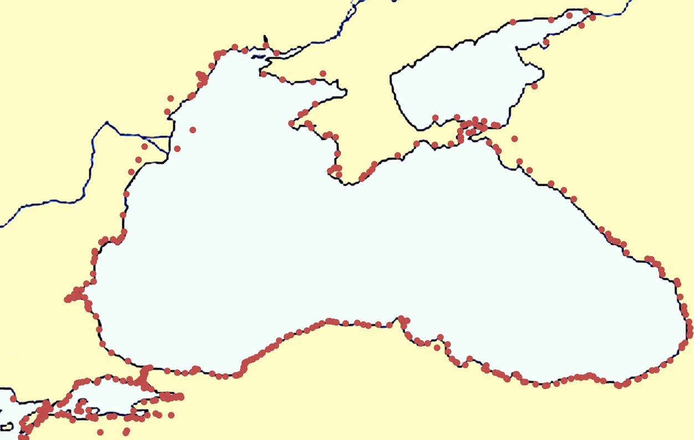

**Istanbul**

**Odessa**

**R. Danube**

**Crimea**

**Kerch**

**R. Dniepr**

**Batumi**

**Sinop**

**Samsun**

**Trabzon**

**Varna**

**Burgas**

**Novorossiysk**

**Sebastopol**

**Eregli**

**Constantza**

**BLACK SEA**

**AZOV SEA**

**R. Don**

**Sotchi**

**Çanakkale**

**MARMARA  
SEA**

Figure 1 – Ancient ports and harbours in the Black Sea area:   
246 places on the Black Sea and Azov Sea &  
166 places on the Marmara Sea and Bosphorus