Notes inserted by Nic Flemming

APOLLONIA (first draft for a www page)
Let me put things straight: I have never been to Apollonia (I did not go further than Leptis Magna) but I met some of the most knowledgeable persons (Nic Flemming, André Laronde (†), Jean-Pierre Misson, Claude Sintès) who convinced me that Apollonia hosts the most important ancient port remains, preserved mainly because they are now under water. I would not feel entitled to write anything on this port, was it not that Jean-Pierre Misson showed me some under water pictures made in the sixties and in 2012 that are not yet published elsewhere. He did me great honour to accept publication on this web site.
I therefore rely heavily on quotations from several authors.
In Nic Flemming’s words (personal communication, 9/2/2014):
“I have seen hundreds of other ports. […] Apollonia is unique.
The unique features of Apollonia are:
- Relatively early date, 6-7th century BC, and later during the epoch of trireme warfare. No other complete harbour of this date.
- Completeness of port area, shore side, and dock structures. It is a complete ‘deck of cards’ so to speak, with nothing missing. A complete range of different structures and ancient technological functions, some still unexplained.
- Completeness (although collapsing) of the original sea defences, sea walls, cut wave traps, rubble breakwaters, as a complete system.
- Multiple layers preserved in stratigraphic context of at least 3 generations of structures on the dockside, all submerged, in the period 600 BC to Roman/Hellenistic.
- Numerous structures and rock-cuttings which are still unexplained, like the nine ‘quays’.
- Excellent clear water, easy place to film or work, and layers of sand accumulated which will preserve pottery and other artefacts. Hardly any excavation in the underwater city, so a great deal still to be learned.
- Evidence that micro-features such as lead dowels, carvings, statues, pottery and other small items neglected in previous surveys still survive.”
Quoting Kalliopi Baika (2014):
History of Apollonia
“The ancient harbour of Apollonia in Cyrenaica was the epineion (out-port) of Cyrene, which lay 18 km inland. It is in a broad open bay, delimited to the east by Cape Naustathmos (Ras el-Hilal) 20 km away, and to the west by Phycus (Ras Aamer).
The natural harbour must have been in use since the foundation of Cyrene in 631 BC as a Greek colony from Thera. Apollonia is recorded as established in ca 600 BC as the ‘harbour of Cyrene’. Cyrenaica became a dependency of the Ptolemaic kingdom under Ptolemy I Soter in 322-321 BC. The cities of Cyrenaica became independent in 97 BC, after the kingdom passed to Rome. It received the name Apollonia. Mark Antony restored Cyrenaica to the Ptolemaic empire, and after the Battle of Actium it was combined with Crete, under Roman rule. Apollonia was an excellent naval base in a very strategic position in Cyrenaica, and Roman fleets were maintained there. The city was renamed Sozousa, when it became the capital of Upper Libya, a province created by Diocletian.
Port of Apollonia
Apollonia was served by two harbour basins accessible in all weathers, the prevailing winds on this coast being from the north-west. The basins were formed on the rocky coastline by a projection on the west, and by a projection (which is now two islands, Îlot Hammàm and the smaller Îlot Sharkéa on the east) which protects them from the north.
The western harbour, that was an inner harbour communicating with the eastern one via a channel, probably originally had an entrance on its north. The eastern harbour was open on its eastern side, between Îlot Sharkéa and the coast, with a lighthouse located on the southern end of this island. The channel connecting the two basins was later walled and protected on each side by two fortification towers that were part of the city fortification system. The western harbour, which was partly included in the city walls, contained the main complex of slipways. In general, the harbour underwent several reconstructions from the Classical period onwards. The channel between the harbours was deliberately filled in late antiquity so that the eastern harbour became the only harbour.
The western harbour had at least five rock-cut complexes on its perimeter. However, only one group is now identified with certainty as slipways. This is located on the Îlot Hammàm in the north-east corner of the western basin.
The small complex in the eastern harbour on Îlot Sharkéa, which was thought to be shipsheds, is now, after underwater exploration, identified as a quarry. The other harbour remains and rock-cut structures on the west and south edges of the western harbour and now submerged could have been ship-building areas, quays or warehouses.
Relative Sea Level Change at Apollonia
Arthur, is this still quoting Baika? There are many dubious statements. Above all, there is no reference to the obvious fact that the sea level has changed at least twice, and there is plenty of evidence for earthquakes. So it is odd that she says “gradual subsidence”. Also, the best data on sea level change, as opposed to tectonics/earthquakes, is Antonioli, Lambeck, Purcell, Tsimplis and others. It is a very complex question, and the reference cited is not really comprehensive. If this section is still direct citation from Baika, obviously we cannot edit it.
The harbours are today submerged as a result of a slow and gradual subsidence. The quays of the eastern and western harbours are generally 2 m below the present sea level, which correlates with the estimate of the geologist L. Moret in 1936 of a sea level rise of more than 3 m. From the depth of 2.80 m at the foot of the slipways on the Îlot Hammàm, Flemming estimated a relative sea level rise of (not) more than 2.50 m since their construction. The change resulted from a general depression of 1.8 to 2 m (caused by either a general rise of sea level or earth movement) which is combined with smaller earth movements which vary across the site by as much as 1 m or more. Flemming, on the basis of several investigations, suggested that the southern part of the site may have sunk slightly more than the northern. (How can the change be more than 2.5m if the next sentence says it is 1.8-2m?)
The French team that carried out supplementary investigations at the entrance towers to the western harbour estimated a difference in sea level of 3.50 m, with a small variation for the small tides. This evidence was based on indications of lithophaga on the sides of the fortification towers facing the channel. This level was tested on all features submerged in the harbour and gave satisfactory results for 90 per cent of them. In addition, in the channel the surfaces of the walls below the ashlar superstructure are rock-cut, suggesting that they were once above sea level. The artificial blocking of the channel, which terminates at the same level as the lithophaga lines, offers additional support for the suggestion of a difference of 3.70-3.80 m since the beginning of the Christian period.” (This is good. I like it. But we must follow later with a comment that this would leave the slipways high and dry). )
According to the latest research, the Glacial Hydro Isostatic (GIA) Sea Level Rise in this region was only 0.30 to 0.50 m during the past two millennia (Morhange, 2014). However, the relative SLR was much different in many places as it includes tectonic movements: in Apollonia, mainly subsidence.
In any case, what is now 2 m under water was 0.5 to 1.8 m above water!
Where does Baika’s quote end?

SUGGEST NEW SECTION ON SEA LEVEL CHANGE – IF THE DISCUSSION ABOVE IS ALL INCLUDED IN THE QUOTE FROM BAIKA.
RELATIVE SEA LEVEL AT APOLLONIA (new section)
Knowledge of the numeorus possible causes of change of local relative sea has increased greatly since the early days of research at Apollonia in the 1950’s to 80’s. Thus early observations in the field are generally correct, but the explanations in published articles are limited by the contemporary knowledge.
Factors which are now known to have influenced the local sea level are:
Glacial Hydro Isostatic Adjustment, that is the response of the sea level and the earth’s crust to the melting of the ice caps at the end of the last glaciation. The most accurate estimations of this cause of relative sea level change on the Tunisian-Libyan coast are by Anzidei et al. (2011) and Lambeck et al (….).
For tectonic processes see Ambrayseys… etc…
For an up-to-date analysis of how all the various causes interact, see Tsimplis et al (2011).
Estimation of the total net change of relative sea level at different parts of the city of Apollonia produce different results, and there is no reason to doubt these values. In order of depth:
French MAF results: Lithodomos borings at -3,0m-3,5m in the Christian era.
Piscina, Fish tank, Flemming (1971), walk way at -2,5m, therefore sea level lower than this in the Roman Empire period, probably around – 2.8m. Floor of slipway on thick deposits of rubble is at -30m, and the solid floor is deeper than this. (The fish tank is cut into solid rock, as were many piscine all over the Roman world, so they had no problem in cutting rock below the sea level).
West Island slipways, early period around 600-500BC, bottom of slips is at -2.8m.
Grid building: Depth on the harbour end of the grid, not on the masonry, is -2.8m.
Grotto Reef tunnel: Ceiling of tunnel just awash, so floor of the tunnel a bit shallower than – 2.0m, and the sea level change must have been more than 2.0m..
Quays/Warehouses: Depth in the neighbourhood of seaward end of the quays is 2.4m ( with some sand thickness on the seabed (unknown thicknes); and 2.2- 2.3m depth at landward end of quays.
DISCUSSION OF SEA LEVEL EVIDENCE.
1. If we take the 3.0m or more from the French data, then the slipways on the West Island are completely high and dry. They would be useless. Since there are small walls built on top of the slipways, and other walls built on the sea floor in the harbour basin below the foot pf the slipways, this is consistent with a change of level between 500 BC and the time of the Roman Empire.
2. The walkway of the Piscina would be dry by about 50cm with a sea level change of 3.0m, which seems a bit much, but not impossible. (A sea level of -3.5m would make the piscine almost dry!) So maybe the uplift continued into the “Christian era”.
3. The evidence from these two dates, about 500BC, and the Empire/Christian period indicate that the city of Apollonia was uplifted by about 50cm between these two dates. This must have been due to earthquake activity (tectonic) since there is no evidence at other archaeological sites for a GIA drop of sea level during this period.
4. During the last 2000 years the city has subsided by a total of about 3.0m, and this relative change of level is made up of about 0.3-0.5m of rising GIA sea level, and 2.5-2.7m tectonic subsidence.
5. The reversal of tectonic direction is quite common. Close to a subduction or normal fault the ground is dragged one way in a “stick” mode, and then an earthquake allows the fault to “slip”, and the ground moves the other way.
6. If these figures are correct, the relative sea level was about 2.5m lower than at present in the early years/centuries of the city after its foundation. The bottom of the slipways was at least 30cm underwater, and the sea lapped between the “Quays”.
7. In the early centuries BC the city was uplifted about 50cm, and the slipways and the “Quays” became high and dry. The diameter of the harbour contracted, and a secondary group of structures was built on a smaller diameter, varying from 25-50m in from the earlier circumference or water-front.
8. Finally, during the late Roman Empire, or later (perhaps in a famous earthquake), the city was submerged by about 3,0m-3.5m.
SUMMARY
The dates and events listed above are rough estimates, but it is absolutely evident that the buildings are adjusted to two different relative sea levels at different dates. After the uplift phase the inner harbour basin contracted in radius by about 25-50m, and some of the earlier waterfront structures become unusable. The outer harbour would then have been much more important.
End of notes.

Overall pictures:
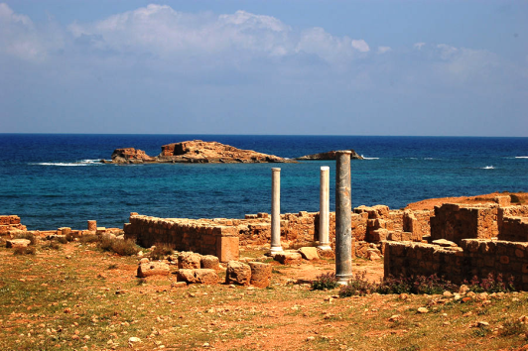  The ‘quays’ are under the sea, right behind the columns, Pic. by Misson, 60's | 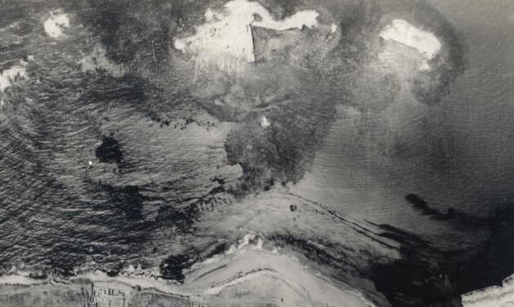  Pic. by AeroContractors , early 60's
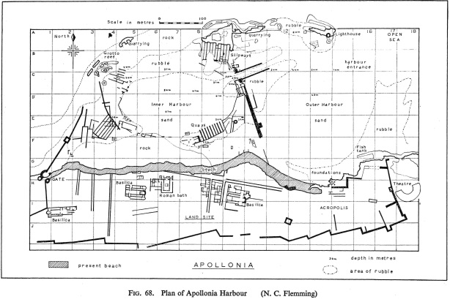  Dwg. by N.Flemming , 1971 | 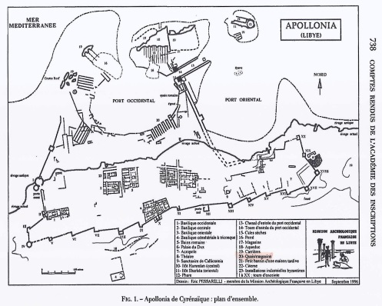  Dwg. by MAF 1996, Published by Laronde, 2001
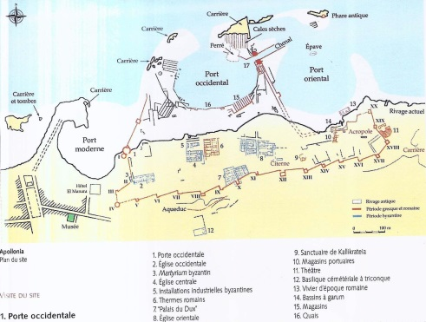  Dwg. by MAF date? Published by ??? | 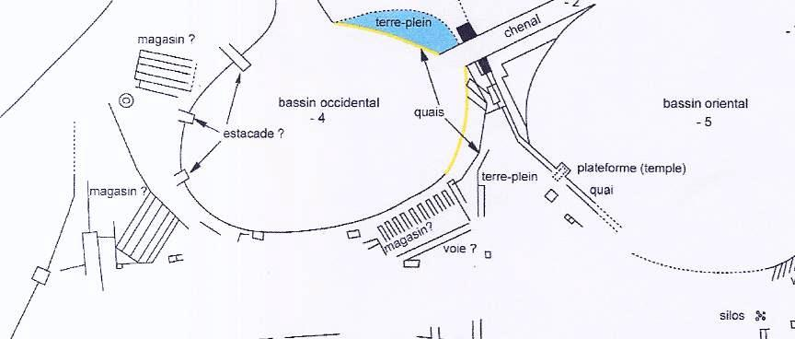  Dwg. by MAF, Published by Sintès, 2010

The first map was drawn by Nic Flemming on the basis of original drawings by the architect Nick Wood, a member of the diving team led by Nic Flemming , back in the late fifties. It can be found in the Geographical Magazine for 1959 and 1960. It was redrawn for publication in the book “Cities in the Sea” 1971 book and we provide a clean HD copy here. It is still considered as an accurate reference.

‘Quays’:
I choose to write ‘quays’ with inverted commas because the initial purpose of these structures is not agreed by all parties at this time. To put it in a few words, some believe these structures are quays for loading/unloading small oared battle ships, some believe they are warehouses. Let’s try to present the available information here.
Quoting Nic Flemming (1971):
“The ‘quays’ are not closely similar to any structure in other harbours, either ancient or modern, but can only have been used for the berthing of slender ships, either civil or military. […] the spacing of the ‘quays’ is only 3.5 m. Whether this is the maximum beam of the largest vessel, or whether only smaller vessels were berthed at the ‘quays’, is not certain. The docks between the ‘quays’ are 25 m long, and if the ships were this length they would have had a length-to-beam ratio of 7.1, which is high for a cargo boat, but very likely for a fast boat built more to be rowed than to carry a large sail area. From the rough rule that a stable rowing boat draws one third of its beam, these boats would have drawn about 1 m.
The top courses of stone on the ‘quays’ are complete in several cases, with the upper surface only 2 m wide, surprisingly narrow. It would have been impracticable to handle large cargoes in such a small area, and in any case, the heavy cargo ships of the second century BC and later had a beam of 10 m, though they were usually only 30 m long. Thus, if the ‘quays’ are of late date, they can only have been used for harbour lighters and local coastal boats and fishing boats, but if they were of early construction they may have been used for oar-powered military and light cargo vessels. Possibly both suggestions are partly correct, and as time went by, the docks which had once been suitable for the mightiest ships afloat were relegated to the status of a fish market much as the Vieux Port of Marseille is now restricted to fisherman and pleasure boats, while ocean-going cargo ships dock in the modern harbour outside.”
Quoting Baika (2014):
“Flemming investigated nine rectangular structures spaced 3.5 m apart and 2 m wide, identified as ‘quays’. The docks between the ‘quays’ were 25 m long. The ‘quays’ are constructed of ashlar masonry and the top courses are complete in several cases, with the upper surface 2 m below the water. If the identification is correct, they are too narrow to accommodate big commercial ships of any period. According to Flemming, because of their ‘exceptional breadth and solidity, they may have been used as ‘quays’ for small merchant vessels’. These installations were surveyed recently by the French mission, which concluded that they are warehouses, and excluded the possibility that they could be used as docks.”
Quoting Sintès (early 2014), diver, member of the Mission Archéologique Française (MAF):
“Pour les structures dont vous parlez, effectivement, la mission Laronde avait repris à l'origine l'hypothèse de N. Flemming, ce qui nous a amené à écrire et à parler de "docks" ou de "darses" dans les premières publications. Mais depuis, nos plongées ont prouvé que ces murs sont posés sur le sol rocheux et qu'il n'y a aucun espace entre eux permettant d'accréditer l'hypothèse de darses en eau pour petit bateaux. Cela a été vu à la suite de dégagements à la suceuse et seuls 30 à 50 centimètres de vases et sédiments se trouvent au-dessus de ce socle rocheux, présent absolument partout, en très légère pente douce de la mer vers la rive. C'est donc de magasins, ou de stockage particuliers (mâts ? barques tirées à terre?) dont nous parlons maintenant.”
This last statement was confirmed by Claude Sintès (personal communication, 24/10/2014): two trenches were dredged with an underwater vacuum cleaner across all of the nine docks; one trench was close to the tip of the ‘quays’ and the other was closer to the shore; both trenches were dredged to reach the bedrock level. The result was that the sand layer thickness that could be removed was never more than a few decimetres; it was found also that the bedrock was gently sloping from the shore down to the tip of the ‘quays’ by no more than 0.50 m over a distance of about 20 to 25 m.
We should note also that according to William Murray (personal communication 10/4/2014) “quays that are exposed to waves tend to use headers rather than stretchers for the walls exposed to sea action. A long rectangular structure with nothing but headers in the foundation courses would seem to indicate you had a quay instead of a warehouse. […] Your structures seem to have been built in quieter water and thus could have used stretchers.”

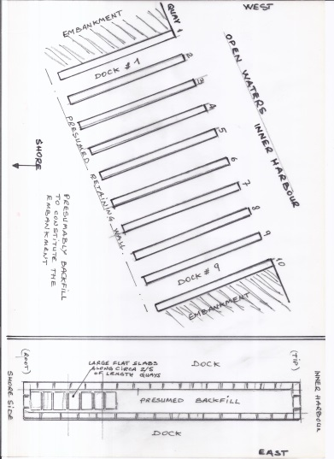  10 ‘quays’ and the resulting 9 docks with some details about the layout of a typical quay,  Sketch not to scale by Misson, 1965, redraw | 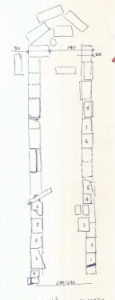scale?  ‘Quay’ 2, uppermost blocks along the perimeter of the quay, blocks at tip have fallen off,  Sketch with North on top, by Misson, 1965
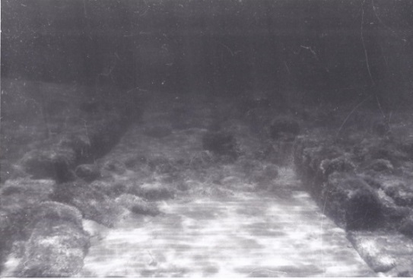  Between ‘quay’ 2 (right) & 3 (left), the dock is heavily sanded up and blocks from the top perimeter layer have fallen off  Pic. looking South, by Misson, 1965 | 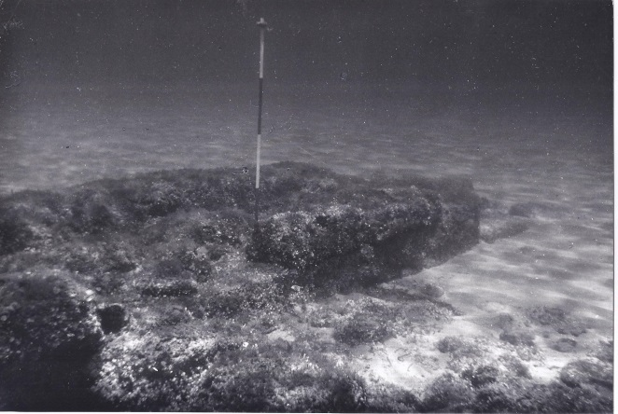  Tip of ‘quay’ 2, scale stick with 20 cm sections  Pic. from inside dock 2, by Misson, 1965
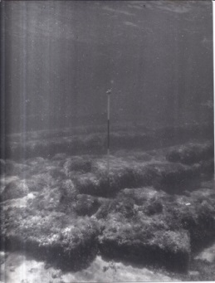  Tip of ‘quay’ 2, in the background: ‘quay’ 3 & ‘quay’ 4 (barely visible), Pic. by Misson, 1965 | 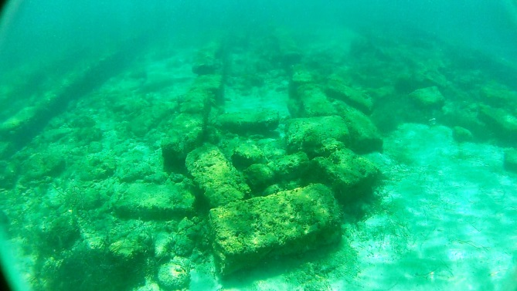  Tip of ‘quay’ 2, Pic. by Misson, 2012
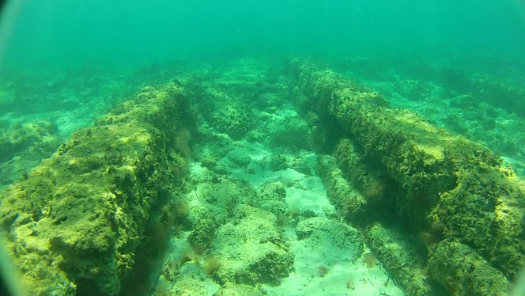  Inside of ‘quay’ 4 about halfway through its length  The inside of ‘quay’ 4 looks empty because the (light) backfill has been swept away or has disintegrated; the bedrock is not visible and as much as 3 layers of superimposed blocks can be seen (each circa 18-20 cm thick).  Pic. looking South, by Misson, 2012 | 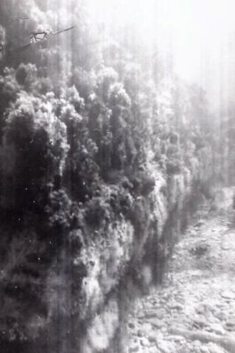  External side of a ‘quay’ (from inside a dock) after the winter storms had had a de-silting effect, the bedrock is not yet visible but 4 layers of blocks are visible, the total height of this ‘quay’ above the bedrock would be 4 x 18 to 20 cm = 72 to 80 cm.  Pic. by Misson, 1965
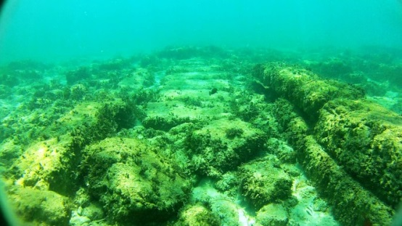
Inside of ‘quay’ 4, closer to shore, the series of heavy slabs can be seen in the background, top blocks of ‘quay’ are still in original position on the right, those on the left have fallen off, the heavy slabs in the centre are found on all ‘quays’, but only along circa 40% of their length, from the shore side
Pic. looking South, by Misson, 2012

Interpretation by JP Misson
“In Libya, at the time, there were practically no roads inland: the communications were mainly by sea with the major settlements located along the coast. The Libyan coast is rather unprotected: practically no island where to shelter and several stretches of rocky shore where the beaching of a fragile galley is impossible. The oared vessels that were used for the task had to be slim and light to be fast. This was the only way to cover the non-beachable stretches of coast on a day's duration. It was extremely rare for galleys to navigate after sunset. The galleys were undecked and had a very small draught when empty of their crew. This is what allowed their crews to beach them when needed and where possible.
Simultaneously beaching or launching of several galleys (especially in windy conditions) would not have been easy. The ‘quays’ may have been built for the dockers in charge of hauling the galleys in and out of the water to stand on a hard surface (not in sand) and for crews to embark and disembark in an orderly way. If the ‘quays’ were only needed for the crews to walk on firm ground the ‘quays’ could have been just awash (flush with sea level). If the ships were galleys with practically no cargo except crew, food and water; all easy loading and unloading: no need for a particularly ‘dry’ quay. In any case (prior to the subsidence) the inner harbour must have been a calm water area, much better protected from the open sea than today.
The ‘quays’ were used as mere ‘walkways’ to enable the people in charge of manoeuvring the galleys to work under dry conditions and for the crew to board or disembark at ease. Executing the launching or beaching operations with people breast-deep in the water would have required a lot more people if not been altogether impossible when several crafts had to be handled simultaneously. The galleys were moved from/into the water to/from the dry land behind. This was the practice in those times for the small and light galleys. Galleys of this size (20-30 m) could be beached by their only crew, during a voyage (where beach slope made it possible) to rest and resupply. With the ‘quays’ in Apollonia these operations were made easier and faster. Assuming that there were many more galleys on the beach behind the docks, the simultaneous launching or beaching of 9 galleys at a time must have been possible at Apollonia. The galleys were probably kept in-between the ‘quays’ for a limited amount of time: beaching or launching operations with corresponding unloading or loading. They were probably never ‘berthed’ there. Without a back wall, the galleys could be hauled on the beach, to be parked somewhere on the terrain South of the ‘quays’. The ‘quays’ could therefore be called ‘hauling quays’.
The docks in-between the ‘quays’ must have therefore been a good 70 to 80 cm deep.
Galleys 20-30m in length would surely have been easily floated and handled in these docks as their draught was very limited, surely much less than one meter.
Moreover, it would not have mattered had the keel of the galleys touched the seabed in the docks even halfway through their length: there would have been sufficient ‘quay’ length on each side to conduct any operation such as hauling, loading and unloading of the vessels. With a depth of as little as 50 cm at shore end, the docks would have been useable.
As for the top layer on the perimeter of the ‘quays’, seemingly above the level of the heavy slabs at the root of each quay: it could well be a raising of the structures after it appeared that the bedrock on which they were standing had started to subside. The space between the additional layer of blocks might have been simply backfilled on top of the initial slabs, and this backfill vanished with later wave action.”
This interpretation by Jean-Pierre Misson makes good sense from a pragmatic point of view, but it is hypothetical and obviously needs to be confirmed by more field investigations, as …
Such an arrangement is unheard of in any other ancient port.

Slipways:
Quoting Baika (2014):
The shipshed complex “has not been dated precisely. Due to its rock-cut nature, there are no stratigraphic elements in the complex itself to date its construction, apart from the Roman wall built across the seaward end of it. However, as the fortification walls which enclose the complex were built in a single construction phase in the second half of the second century BC, they provide a terminus ante quem for the complex's construction. […] The shipshed complex is the earliest harbour structure in Apollonia, according to Laronde (1996). The war fleet of Cyrene was equipped with triremes in the fourth century BC. Although the harbour would have been in use from the seventh century BC, there are no architectural remains in the harbour dated before the fourth century BC, Flemming proposed a date probably at the beginning of the Hellenistic period.”
The shipshed complex “is located on the central island, Îlot Hammàm, in the north-east ‘corner’ of the western harbour, just north-west of the channel connecting it to the eastern harbour. The slipways face south and are well protected from the north-west prevailing winds. The back ends of the slipways are partly above sea level, while their lower parts are today totally submerged. The site was reoccupied in Roman times, and there are traces of extensive later quarrying that has altered severely the original form of the area immediately to the north of the complex and, to a lesser (although not completely clear) extent, of the complex itself.
Ten slipways were described and planned by Flemming (1971) and later by Sintès (2010). They form a complex ca 63 m wide and at least ca 30 m long They are fairly well preserved.
The back walls of Slipways nos. 3 to 5 are aligned, as are those of slipways 7 to 10. Those of the latter set (nos. 7-10) lie slightly further north. Slipways 2 and 6 are shorter than the others, with their back walls 2.50 m and ca 3 m to the south respectively.
The internal width of the slipways varies, but cannot be precisely determined due to erosion. According to Sintès, they are generally a little less than 6 m (from 5.50 m for slipways 1 and 6 to 5.95 m for slipway 7). According to Flemming, they were preserved for a length of ca 40 m. This measurement coincided with the wall across their lower end which was subsequently found to be a later, probably Roman, feature. Only a maximum of 30 m were visible thirty years later, probably due to sand movement. Given the general accuracy of Flemming's plan it is reasonable to use his measurement, rather than speculate on it in the absence of any other.
The slope of the slipways varies between 3° (1:19) and 4° (1:14) for slipways 1 to 7. No change of inclination was observed in the upper part of the slipways. Slipways 8, 9, and 10 have an almost horizontal surface that may result from later stone extraction or occupation in the Roman period. […]
Flemming reported that each slipway has a shallow V-shaped cross-section, but this was not verified by recent research. Slipways 3, 4, 5, 7, and 8 were equipped with a central flat runner, while those in slipways 2 and 6 have three central grooves. As recorded by Sintès, these central runners are quite narrow: 0.70 m for no. 2; 0.80 m for no. 3; 0.73 m for no. 4; 'without doubt 0.70 m for no. 6; 0.74 for no. 7 (although uncertain due to later stone quarrying)'. Only the runner in slipway 5 is wider: 1.50 m on average. No runner was found in slipway 1, although its original inclined surface is preserved. It is not known whether slipways 8, 9 and 10 had central runners because their surfaces have been re-cut. None of the runners have signs of wear on them.
Flemming reported that the central runners splayed out, widening from 30 cm at their top end to just over 1 m at the bottom end, and were about 5 cm high. However, recent research has ascertained that the runners did not widen, at least not in the parts that are accessible today, with the exception of the one in slipway 2 (which has central slots) on which such a gradual widening is perceptible. According to Sintès, the stone blocks surviving in the upper ends of slipways 4 and 7 on the axis of each are not part of the original construction (they are irregularly placed and too unstable and small to support the stern of a ship).
The runners in slipways 2 and 6 have a central slot. The one in slipway 2, which is very well preserved, is 10 cm wide and up to 30 cm deep in places. The French team observed that this slot is flanked by a slot on either side, on average 10 cm wide and 5 cm deep. These two slots are 1.10 m apart at a point 11.50 m from the back wall of the slipways, and 1.30 m apart 25 m from it. At the same points, the central runner is 25 cm high (at 11.50 m) and almost flat at 25 m from the back wall. This progressive splaying out and increasing shallowness is clearly shown in Flemming’s cross-section of the ramp. He also reported that while the runner becomes flatter and broader, the slot becomes progressively shallower towards the bottom of the slipway from 10 cm at the top to 3 cm at the lower end. According to Sintès, although slipway 6 is much less well preserved, an identical central runner can be detected on it.
In slipway 2 there is a very eroded rock-cut projection (ca 70 cm long and 1.50 m wide) in the rock-cut back wall of the slipway on the axis of the central slot. In slipway 6 this has the form of two stumps of rock with a cutting in the centre still visible above the water at the point where the central slot should end. The preserved height (ca 0.60 m) of this projection has led Sintès to suppose that a ramp may have risen to this height at the back end of the slipway; but the debris in the back end of the slipways has made difficult the interpretation of this feature and its relationship to the central slot. These two slipways are apparently shorter than the others as their back walls are not cut as far north as the others. Sintès suggests tentatively that slipways 2 and 6 may represent a variant type of slipway.”

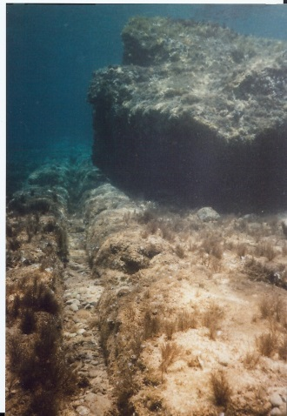  Slipway 2, with slot, Pic. by Misson?, 2010 | 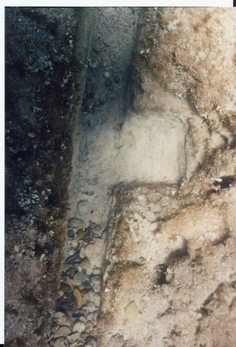  Slipway 2, with slot and 1 of 11 10x15 cm indentations spaced 1.1-1.2 m, Pic. by Misson?, 2010
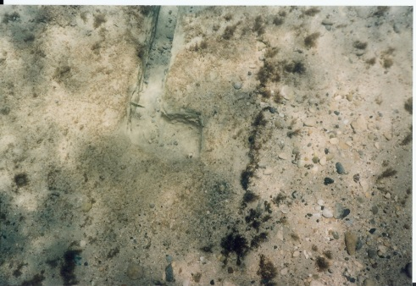  Slipway 2, curved offshore end of slot, Pic. by Misson?, 2010 | 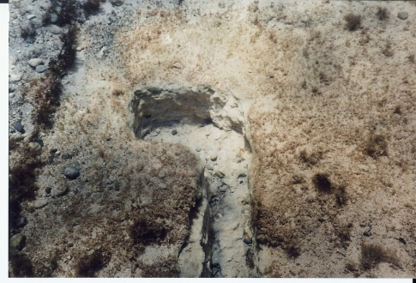  Slipway 2, curved offshore end of slot, Pic. by Misson?, 2010
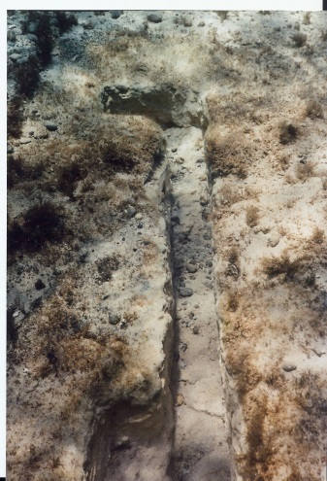  Slipway 2, curved offshore end of slot, Pic. by Misson?, 2010 | 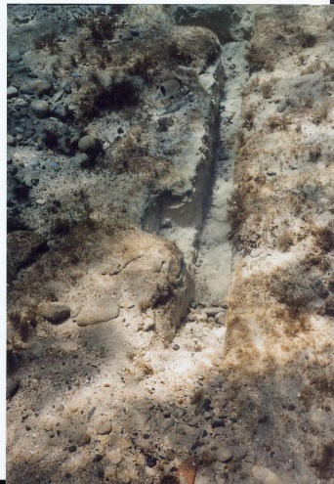  Slipway 2, curved offshore end of slot, Pic. by Misson?, 2010
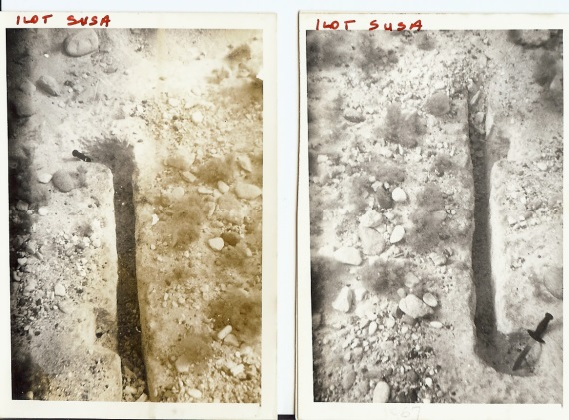  Slipway 2, curved offshore end of slot, Pic. by Misson?, 1965 | 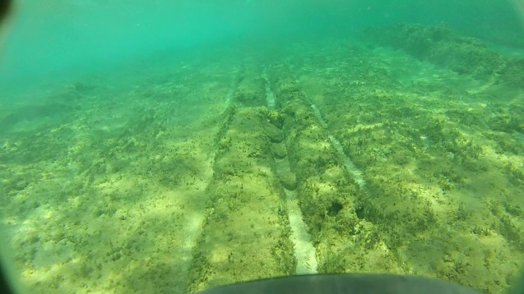  Slipway 7? or 6?, with central slot and 2 lateral slots, Pic. by Misson, 2012

APOLLONIA – References
BAIKA, K. (2014), “Apollonia” in “Shipsheds of the Ancient Mediterranean”, Cambridge University Press, eds. D. Blackman and B. Rankov, p 294-306.
FLEMMING, N. (1971), “Cities in the Sea”, Doubleday & co, New York.
LARONDE, A. (1996), “ Apollonia de Cyrénaïque : Archéologie et Histoire ”, in Journal des savants, Janvier-Juin 1996, pp. 3-49.
LARONDE, A., & QUEYREL, F. (2001), “Un nouveau portrait de Ptolémée III à Apollonia de Cyrénaïque”, in Comptes Rendus de l’Académie des Inscriptions et Belles-Lettres, 145e année, N° 2, 2001, p 737-782.
MORHANGE, C., (2014), “Ports antiques et variations relatives du niveau marin”, Géochronique N°130, p.21-24.
SINTÈS, C. (2010), “Les neosoikoi d’Apollonia de Cyrénaïque”, in “Ricoveri per navi militari nei porti del Mediterraneo antico e medieval”, Atti del Laboratorio di Ricerca: Ravello 4-5 Nov. 2005, eds. D. J. Blackman and M. C. Lentini, Bari, p 83-96.

